Suresh Shrestha
Module-2.2 Assignment
8/22/2026
1. JSP Project Structure and Scriptlet Code
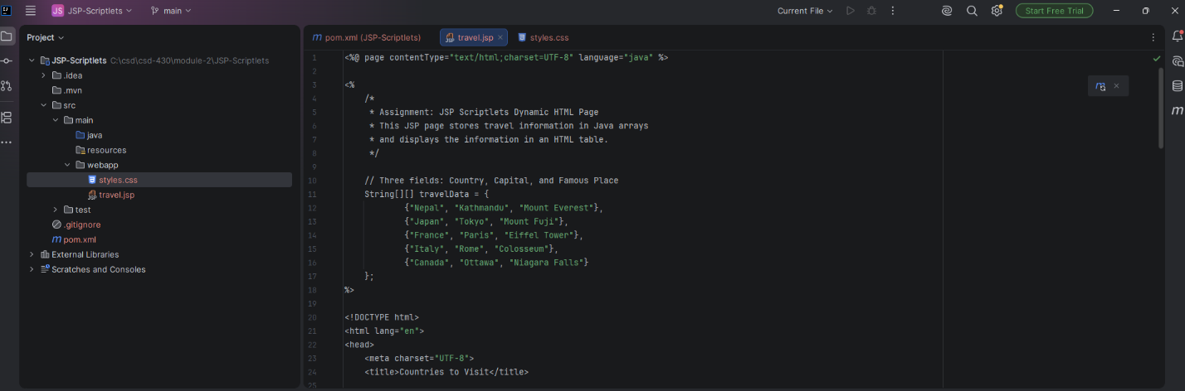

2. Maven Project Configuration
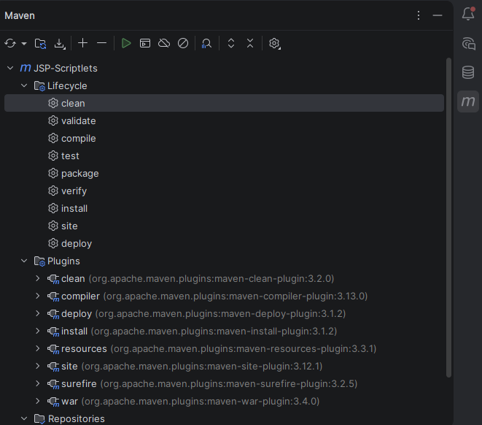
3.Maven build success
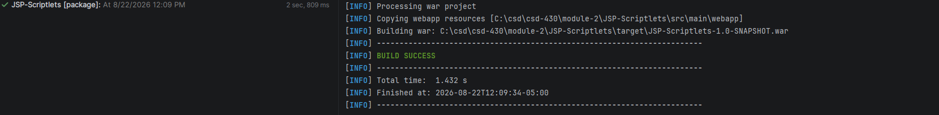

4. Final JSP Web Page Output
