Suresh Shrestha
Module-5&6 assignment
9/11/2026
1. Structure of the sureshmoviesdata table
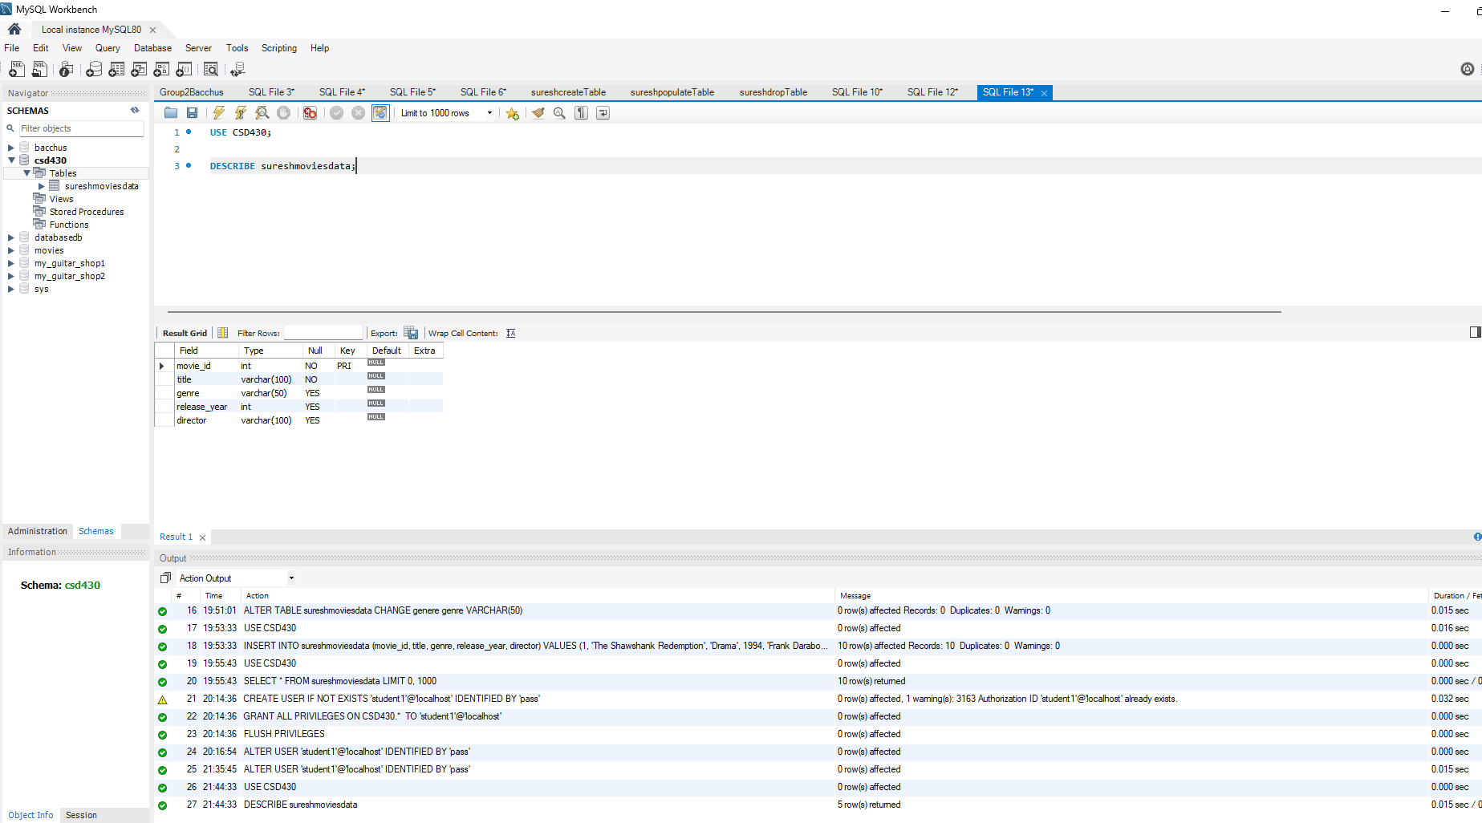

2. Populated sureshmoviesdata table with 10 records
