Suresh Shrestha
9/12/2026
Module-5.3 & 6.3 assignment Screenshots

1. Index page
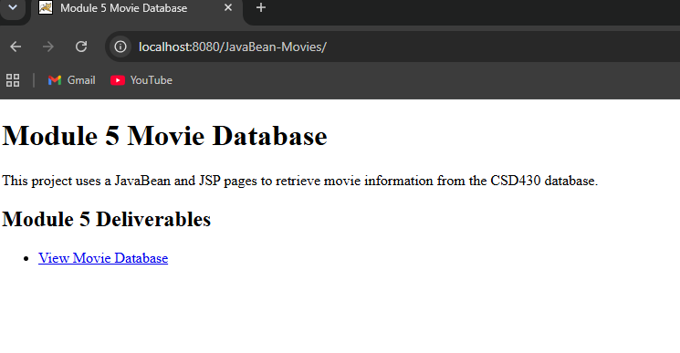

2. Movie ID Selection page

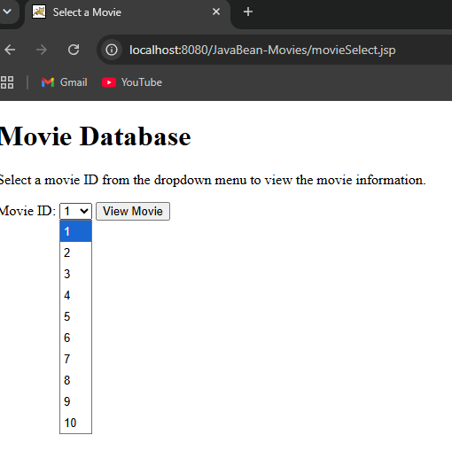
3. Selected Movie Record
