Suresh Shrestha
Module – 1.3 Assignment
8/14/2026

Java Installation and Configuration
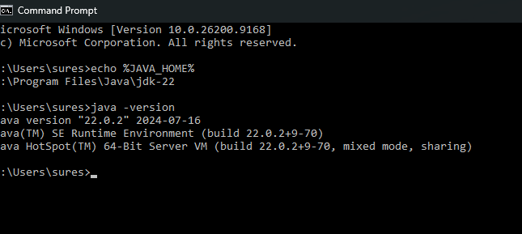
Apache Tomcat Successfully Installed and Running
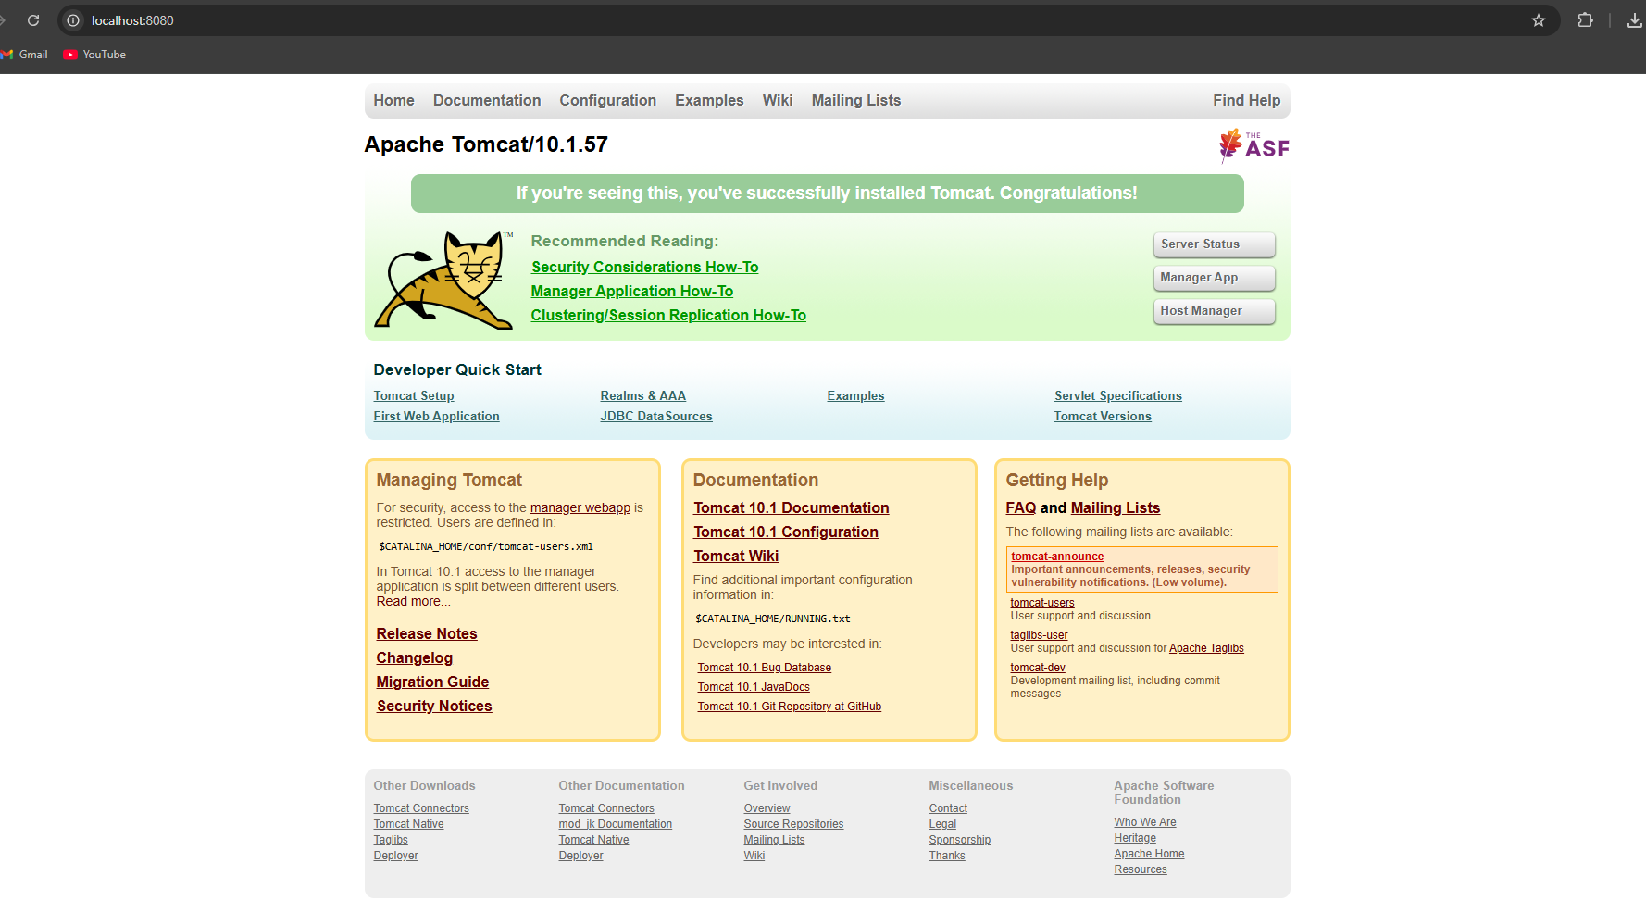
JSP Application Successfully running on Apache tomcat
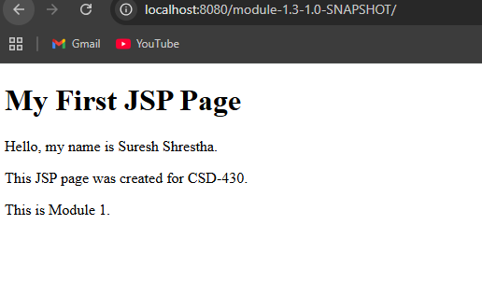
IntelliJ IDEA – JSP Source Code and Project Structure
