Suresh Shrestha
Module - 1: XAMPP Installation and PHP Program
10/22/2026
1. XAMPP Installation

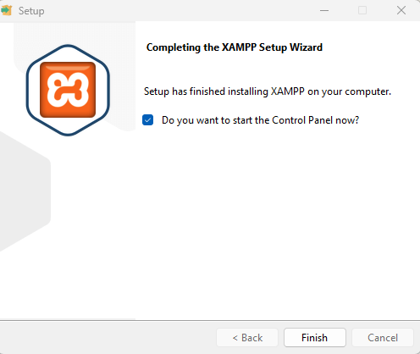

2. Apache Running

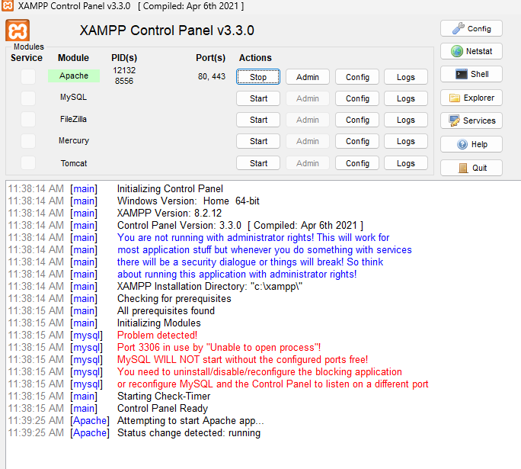

3. XAMPP Localhost

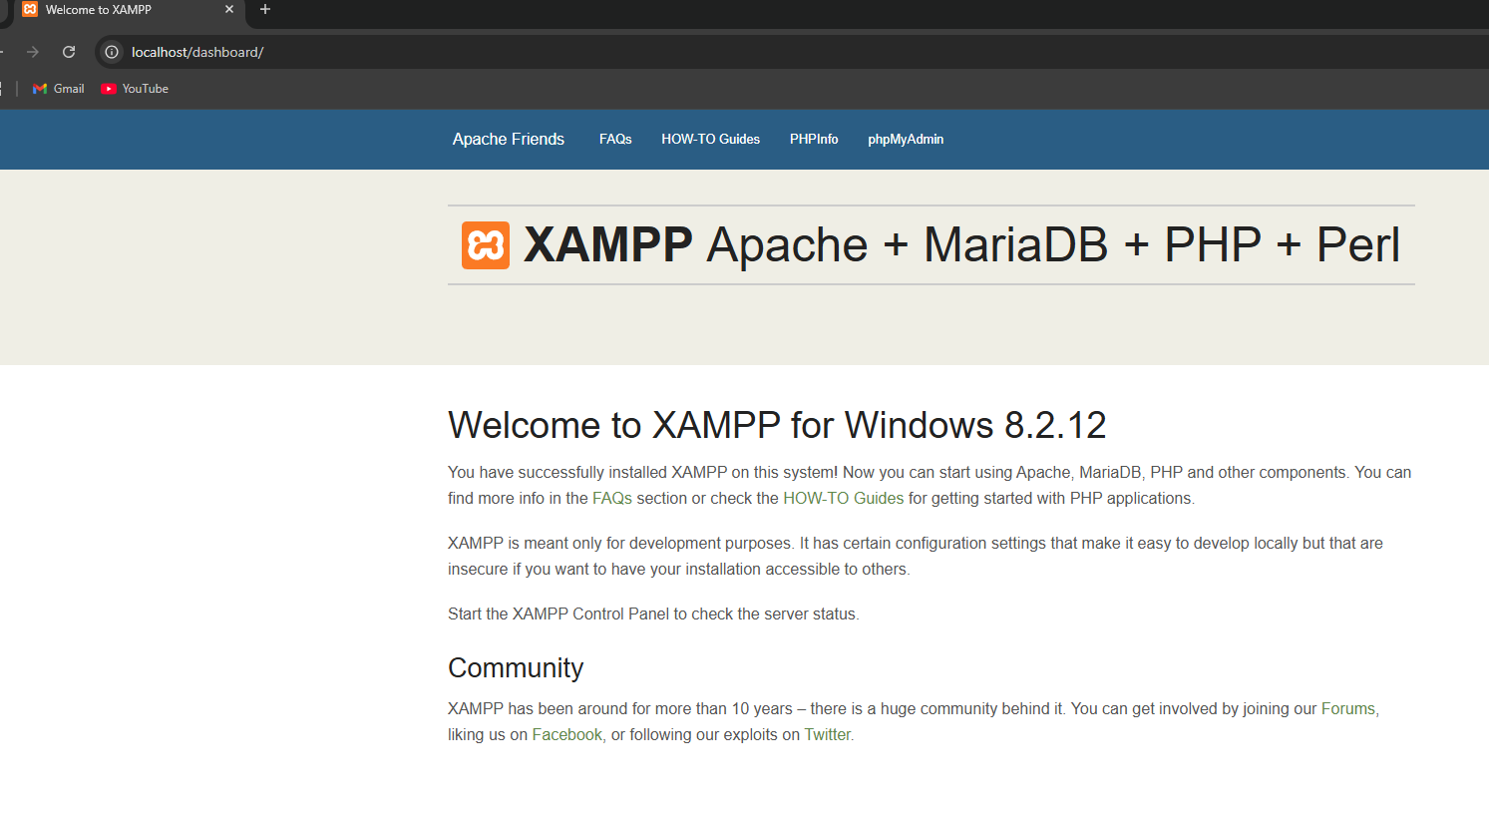

4. PHP source code screenshot
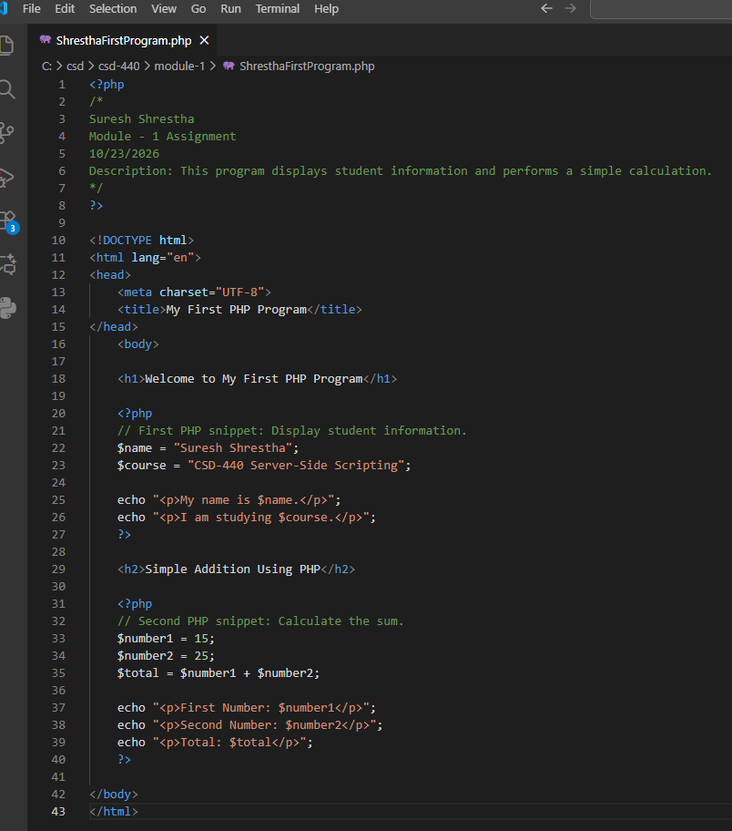

5. PHP output screenshot
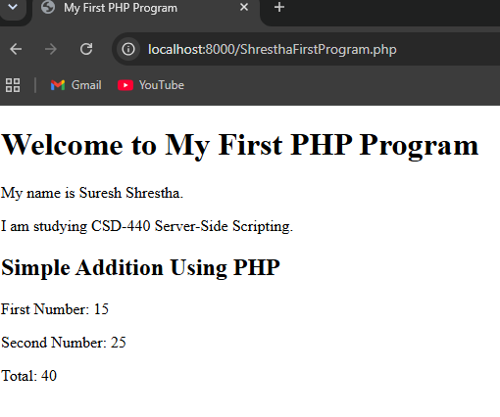

6. PHP Program Successfully Running Through XAMPP Apache.
