Suresh Shrestha
Module 1 GitHub Setup Assignment
10/20/2026
1. GitHub repository link
https://github.com/Suresh-Shrestha/csd-440

2. Screenshot of GitHub repository
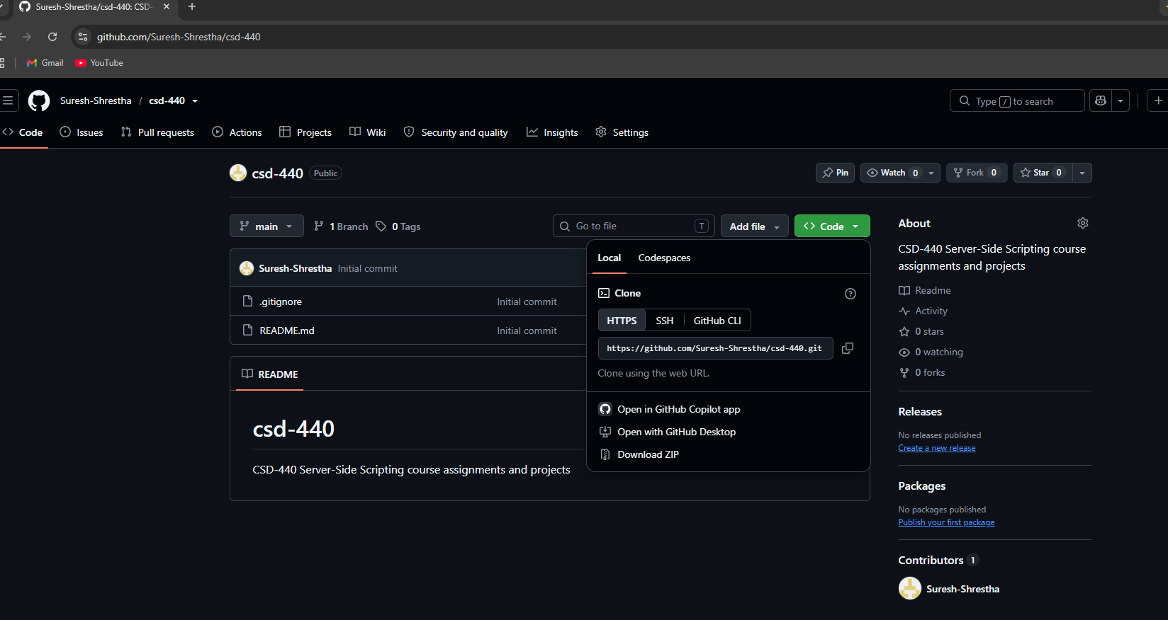

3. Screenshot of the local directory
