

**Tribhuvan University**

**Faculty of Humanities and Social Science**

**A Project Report**

**on**

**Real Estate Management System**

**Submitted to:**

**Department of Computer Application**

**Swoyambhu International College**

**Submitted by:**

Samir Thapaliya

Regd No. 6-2-927-8-2019

January 2024

Under the supervision of

**Sujit Gyawali**



**Tribhuvan University**

**Faculty of Humanities and Social Science**

**Swoyambhu International College**

**Supervisor’s Recommendation**

I hereby recommend that this project prepared under my supervision by Samir Thapaliya “**Real Estate Management System”** in partial fulfillment of the requirements for the degree of Bachelor of Computer Application is recommended for the final evaluation.

**SIGNATURE**

Sujit Gyawali

**SUPERVISOR**

Department of BCA

Swoyambhu International College

Lagankhel, Lalitpur



**Tribhuvan University**

**Faculty of Humanities and Social Science**

**Swoyambhu International College**

**LETTER OF APPROVAL**

This is to certify that this project prepared by Samir Thapaliya “**Real Estate Management System”** in partial fulfillment of the requirements for the degree of Bachelor in Computer Application has been evaluated. In our opinion it is satisfactory in the scope and quality as a project for the required degree.

|  |  |
| --- | --- |
| ………………………..………………..  **Signature of Supervisor**  **Sujit Gyawali**  Lecturer  Swoyambhu International College  Lagankhel, Lalitpur | ……………………………………………  **Signature of Coordinator**  **Raj Kumar Sah**  Coordinator  Swoyambhu International College  Lagankhel, Lalitpur |
| …………………………………………  **Signature of Internal Examiner** | ……………………………………………  **Signature of External Examiner** |

# ABSTRACT

The Online Real Estate Management System (OREMS) is an innovative digital platform designed to revolutionize and streamline the real estate industry by integrating cutting-edge technologies with seamless management and communication capabilities. This system aims to cater to the diverse needs of real estate professionals, property owners, buyers, and tenants, enhancing overall efficiency and transparency in the property market.

OREMS provides a comprehensive array of features, including property listing and searching, automated property valuation, document management, and secure transaction processing. It offers a user-friendly interface, ensuring ease of use and accessibility for all stakeholders. Through sophisticated algorithms and machine learning, the system can accurately assess property values based on market trends and historical data, empowering users to make informed decisions.

Furthermore, OREMS incorporates robust communication tools, enabling real-time interactions between property agents and clients, enhancing customer service and responsiveness. Property owners can easily manage their properties, update listings, and monitor property performance through intuitive dashboards.

Data security is a paramount concern in the OREMS. Advanced encryption techniques safeguard sensitive information, assuring users of their data's confidentiality and integrity. Additionally, the platform adheres to relevant data privacy regulations, ensuring compliance and earning users' trust.

With OREMS, real estate professionals can harness the power of data analytics to gain valuable insights into market trends and customer preferences, optimizing their marketing strategies and business operations. The system's scalability allows it to accommodate a growing number of users and expanding property databases.

In conclusion, the Online Real Estate Management System represents a paradigm shift in the real estate industry, bringing together advanced technology, efficient management, and enhanced user experiences. By fostering greater transparency, data-driven decision-making, and seamless communication, OREMS sets a new standard for online real estate platforms, benefiting stakeholders across the entire property ecosystem.

**Keyword:** Property Add, Blog Add, Advertise Property, Edit Property

# ACKNOWLEDGEMENT

First and foremost, I would really like to thank our Project Management Teacher (**Sujit Gyawali**) who guided in doing this project. He supplied with valuable recommendation and helped in hard periods. His motivation and assist contributed relatively to a hit finishing touch of the project. Besides, I would really like to thank all the lecturers who helped via way of means of giving recommendations and offering the system which is needed. Also, I would really like to thank my own circle of relatives and friends for his or her help. Without that help I couldn’t have succeeded in finishing this project. At last, however now no longer in least, I would really like to thank everybody who helped and stimulated to paintings in this project.

Samir Thapaliya

BCA, 6th Semester

Swoyambhu International College

**Table of Contents**

ABSTRACT i

ACKNOWLEDGEMENT ii

LIST OF TABLES iv

LIST OF FIGURES v

LIST OF ABBREVIATIONS vi

1. INTRODUCTION 1

1.1 Introduction 1

1.2 STATEMENT OF PROBLEM 3

1.3 OBJECTIVES AND FEATURES 4

1.3.1 Objectives: 4

1.3.2 Features: 4

1.4 Scope and Limitation 5

1.4.1 Scope 5

1.4.2 Limitation 5

1.5 Development Methodology 7

1.6 Report Organization 8

2. BACKGROUND STUDY AND LITERATURE REVIEW 9

2.1. Background Study 9

2.2. Literature Review 10

2.3. High Level Design of System 14

2.3.1. System Flow Chart 14

3. SYSTEM ANALYSIS AND DESIGN 15

3.1 System Analysis 15

3.1.1 Requirement Analysis 15

3.1.2 Feasibility Analysis 17

Technical Feasibility 17

Operational Feasibility 18

Economic Feasibility 19

3.1.3 Class Diagram 21

3.1.4 Sequence Diagram 22

3.1.5 Activity Diagram 22

3.2 System Design 23

3.2.1 Component Diagram 23

3.2.2 Deployment Diagram 23

3.3 Algorithm Details 24

# LIST OF TABLES

Table 3‑1: Scheduling 20

# LIST OF FIGURES

Figure 1‑1: Waterfall Software Development Model 7

Figure 2‑1: Use-Case Diagram 13

Figure 2‑2: System Flow Chart 14

Figure 3‑1: Design Architecture MVC. 19

Figure 3‑2: Gantt Chart 21

Figure 3‑3: Class Diagram. 21

Figure 3‑4: Sequence Diagram 22

Figure 3‑5: Activity Diagram 22

Figure 3‑6: Component Diagram 23

Figure 3‑7: Deployment Diagram 23

Figure 3‑8: Bubble sort algorithm flowchart. 25

# LIST OF ABBREVIATIONS

CSS : Cascading Stylesheet

HTML : Hypertext Markup Language

JS : JavaScript

My SQL : My Structured Query Language

OREMS : Online Real Estate Management System

PHP : Hypertext Preprocessor

# INTRODUCTION

## 1.1 Introduction

Online Real Estate Management System (OREMS) is a web-based software that helps real estate companies in Nepal to manage their properties, tenants and rental payments. It is an easy-to-use system that allows users to create and manage listings, search for properties, and keep track of rental payments. Online Real Estate Management System (OREMS) also provides features such as tenant screening, credit score monitoring, tenant reports and more. With Online Real Estate Management System (OREMS), real estate companies can easily manage their business operations from one platform. This will help them save time and money while improving customer service.

Nepal is a country with diverse and unique real estate opportunities. With the introduction of an online real estate management system, it has become easier for people to find, manage and invest in properties. This system allows users to search for properties, compare prices and make informed decisions about their investments. It also provides tools to help them manage their portfolios and track their investments over time. The online real estate management system also provides detailed information about the local market trends, making it easier for investors to make informed decisions.

Online Real Estate Management System is an efficient platform for tracking and managing all aspects of your real estate business. It helps you take ownership of your projects from start to finish, allowing you to maximize profits by taking full control of the buying, selling, renting, leasing processes.

This system allows for up-to-date market data on real estate trends in actions taking place within your network and offers valuable insights into customer preferences to help you close deals faster. It also simplifies and automates core tasks such as keeping records of income and expenses, making payments on time, tracking tenant information, creating detailed financial reports etc.

Online Real Estate Management System can boost productivity across organizations by reducing paperwork and manual work. It is a convenient tool that makes it easier to manage transactions within the real estate industry in Nepal hassle free.

Nepal is a developing country and its real estate market is growing rapidly. That’s why there is an increasing need to build an Online Real Estate Management System to facilitate both the buyer and seller. This system will identify the right property, help in managing finance efficiently, keep track of various legal documents, assist in transferring ownership of the property securely.

Users will be able to view properties in Nepal listed on the system with detailed information that can help them make a well-informed decision while buying or selling properties. The real estate management system also puts builders/developers at ease by providing up-to-date reports such as market trends analysis and customer preferences analysis that can be used for better decision making. It is aimed at improving transparency and efficiency for everyone involved in real estate transactions in Nepal.

The real estate market in Nepal is becoming increasingly popular and there is a huge demand for efficient management systems. Developing an online real estate management system can help streamline operations, improve productivity and ensure customer satisfaction.

This online system should be capable of listing your properties, tracking payments and record-keeping. It should also feature powerful search capabilities to make it easier for clients to find the right home or property for sale or rent. For Nepal-specific properties, additional features such as currency converters, precise location-based searches can be included. With this system in place, you can provide your customers with the best service possible while minimizing the time and cost associated with managing real estate operations.

## 1.2 STATEMENT OF PROBLEM

Real estate management involves a complex set of processes and tasks that require significant effort, resources, and time to manage effectively. There are several challenges associated with the traditional paper-based or manual systems for managing real estate, including data redundancy, errors, inconsistencies, and difficulty in accessing and updating information.

To address these challenges, there is a need for a comprehensive real estate management system that can automate and streamline the various processes involved in managing real estate properties. Such a system should be capable of managing the entire lifecycle of a property, from acquisition and development to sales and leasing.

The real estate management system should provide a centralized platform for managing all aspects of a property, including property details, tenants, leases, rent payments, maintenance, repairs, and financial reports. It should also be user-friendly, secure, and scalable to accommodate the needs of various users, including property owners, managers, tenants, and investors.

The system should be designed to be customizable to meet the specific needs of different types of real estate properties, such as residential, commercial, industrial, and retail properties. It should also integrate with other software systems, such as accounting, CRM, and marketing systems, to provide a seamless experience for users.

Overall, the development of a real estate management system that can automate and streamline real estate management processes is essential for enhancing efficiency, accuracy, and profitability in the real estate industry.

## 1.3 OBJECTIVES AND FEATURES

### 1.3.1 Objectives:

1. To automate and streamline real estate management processes to enhance efficiency, accuracy, and profitability.
2. To provide a centralized platform for managing all aspects of a property, including property details, tenants, leases, rent payments, maintenance, repairs, and financial reports.
3. To provide real-time access to property information for property owners, managers, tenants, and investors.

### 1.3.2 Features:

1. Registration Functionality: This feature allows users to create an account on the real estate management system. Users can provide their personal details such as name, email address, and contact information to register. The system will then create a unique username and password for the user to use for logging in to their account.
2. Login Functionality: This feature allows registered users to access the system by logging in using their username and password. Once logged in, users can view their account details, search for properties, post properties, and perform other actions that the system allows.
3. Search Functionality: This feature allows users to search for properties based on various criteria such as location, price range, type of property, and amenities. The system should be able to provide accurate and relevant search results to the user based on their search criteria.
4. Post Property Functionality: This feature allows property owners or real estate agents to post their properties for sale or rent on the real estate management system. Users can provide details about the property such as location, price, size, and amenities. The system should be able to display the property information accurately and attractively to potential buyers or renters. Additionally, the system should allow property owners or real estate agents to manage their posted properties, such as editing, deleting, or updating the property details.

## 1.4 Scope and Limitation

### 1.4.1 Scope

1. **Property Listing and Search:** OREMS provides a platform for property agents, property owners, and buyers to list and search for properties. It allows users to browse through various property types, locations, and other relevant filters.
2. **Property Valuation:** The system may include features that utilize data analytics and historical property data to provide automated property valuation, giving property owners and buyers insights into property worth.
3. **Document Management:** OREMS can facilitate the storage and management of property-related documents, such as property deeds, agreements, and legal paperwork.
4. **Communication and Notifications:** The system allows seamless communication between property agents, property owners, and buyers. It may include email notifications and real-time messaging features to keep users informed about property updates and inquiries.
5. **Secure Transaction Processing:** OREMS should provide secure payment gateways and transaction processing for property-related financial transactions, ensuring user trust and data security.
6. **User Management:** The system should support user registration, login, and access control, allowing different user roles (e.g., agents, buyers, admins) with appropriate permissions.
7. **Reporting and Analytics:** OREMS may offer insights into market trends, user behavior, and property performance through data analytics and reporting features.

### 1.4.2 Limitation

1. **Data Accuracy:** The accuracy of property data, including valuations, depends on the quality and reliability of the data sources. Inaccurate data could lead to misinformed decisions for buyers and sellers.
2. **Limited Reach:** OREMS's effectiveness relies on the availability and adoption of the platform within the real estate market. Limited user adoption could restrict the number of listings and potential buyers, affecting its success.
3. **Technical Challenges:** Building and maintaining an OREMS requires technical expertise, server infrastructure, and continuous software updates, which can be resource-intensive.
4. **Legal and Regulatory Compliance:** Real estate transactions often involve complex legal and regulatory requirements. Ensuring compliance with local laws and regulations may pose challenges for OREMS developers and users.
5. **Trust and Security:** Gaining trust from users is crucial for an online real estate platform. Security concerns, such as data breaches or fraud, can impact user confidence.
6. **Property Verification:** The system may not be able to verify the authenticity of all listed properties or ensure the accuracy of property-related information uploaded by users.
7. **Dependency on Internet Connectivity:** OREMS heavily relies on stable internet connectivity for users to access and interact with the platform effectively.
8. **User Learning Curve:** OREMS may require users, especially older or less tech-savvy individuals, to learn and adapt to the platform, which could be a barrier to adoption.

## 1.5 Development Methodology

The developed system is vital to highlight and take into account several models used in software development and deployment given that this project involves the design and implementation of a software system, regardless of whether it is web-based.

The construction of this website meets the waterfall model. The key benefit of employing this method is that we can concentrate on each component of the model while it is being developed and return to it as necessary. Based on this model, the project can be simply divided into various components.

The real estate management system is developed using this model. The entire software development process will, however, permit feedback loops. The project's chosen model must favor two developers per project. Considering that we will be the only ones to carry out this job. This example seems appropriate for us to use.

The stages listed below must be followed during software development:

1. Requirements are to be proposed.
2. System design should be made according to the requirements.
3. Implementation of the features according to the design.
4. Integration and testing of the system.
5. Deployment of the system.
6. Maintenance of the system.

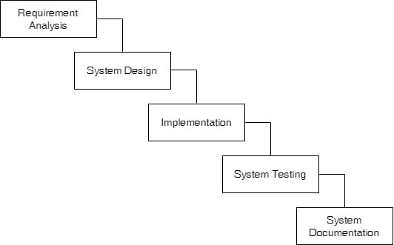

Figure 1‑1: Waterfall Software Development Model

## 1.6 Report Organization

This report document contains five chapters including this chapter. Chapter two defines and describes Background Study and Overview of related existing systems and their pros and cons. Chapter three presents System Analysis and Design including Requirement Analysis and Feasibility Analysis. Chapter four presents the Implementation and Testing are explained. In chapter five, Conclusion, Limitations and Future Enhancement are briefly explained.

# BACKGROUND STUDY AND LITERATURE REVIEW

## Background Study

In today's digital era, the internet has become an integral part of our lives, transforming the way we interact and conduct various activities. The real estate industry is no exception, where the emergence of Online Real Estate Management Systems (OREMS) has revolutionized property management, transactions, and interactions between property agents, owners, and buyers. OREMS leverages the power of the internet to provide a seamless and efficient platform for users to create accounts, access property information, and engage in property-related activities online.

**Concept and Terminology:**

1. Create New Account: OREMS offers users the convenience of creating an account through a straightforward registration process. With internet access, users can provide their relevant details, such as name, email, and password, to create their personal accounts. This process enables users to gain access to a personalized and secure environment within the system.
2. Login: Once users have successfully created their accounts, they can log in to the OREMS platform using their registered credentials. The login process ensures that only authorized users can access their accounts and perform various factions within the system.
3. Surfing: Upon successful login, users can explore the OREMS platform and browse through various property categories and listings. The system presents an extensive range of properties with detailed information, enabling users to make informed decisions.
4. Order: When users find a desirable property, they can proceed to place an order for the property in the desired quantity. This process involves initiating property transactions, expressing interest in purchasing or renting a property, and further communication with property agents or owners.

**Significance of OREMS:**

OREMS plays a pivotal role in reshaping the real estate industry by bringing convenience, accessibility, and efficiency to property-related activities. The following key aspects highlight the significance of OREMS:

1. Accessibility and Convenience: With OREMS, users can access property listings and information anytime and anywhere, as long as they have an internet connection. This convenience allows busy individuals to engage in property searches and transactions at their own pace.
2. Streamlined Transactions: OREMS streamlines property transactions by facilitating direct communication between property agents, owners, and buyers. This seamless interaction enhances the overall efficiency of the real estate process, reducing delays and paperwork.
3. Enhanced User Experience: The user-friendly interface and intuitive design of OREMS contribute to an enhanced user experience. Users can easily navigate through property listings, view high-quality images, and find comprehensive property details.
4. Increased Property Visibility: OREMS provides a platform for property owners and agents to showcase their properties to a broader audience. This increased visibility attracts potential buyers and expedites property sales or rentals.

## Literature Review

The literature review provides a comprehensive analysis of existing research, studies, and publications related to Online Real Estate Management Systems (OREMS). The aim is to gain insights into the development, implementation, challenges, and benefits of such systems in the real estate industry. The review explores various aspects of OREMS, including its impact on real estate processes, user experiences, security, and future trends.

**Impact of OREMS on Real Estate Industry:**

Several studies have highlighted the significant impact of OREMS on the real estate sector. Ghani and Shetty (2017) examined how OREMS transformed traditional property listing and search processes, leading to enhanced accessibility for buyers and sellers. The study reported improved transaction times and increased property visibility as key outcomes of OREMS adoption.

**User Experience and Satisfaction:**

User experience is a critical factor in the success of any online platform. A study by Chakraborty et al. (2018) evaluated the user experience of OREMS users and found that ease of property search, interactive interfaces, and quick response times were key contributors to user satisfaction. Positive user experiences were associated with higher customer retention rates.

**Security and Trust in OREMS:**

As OREMS involves financial transactions and sensitive user information, security is a crucial concern. Shah and Choudhary (2019) conducted a security analysis of OREMS platforms and identified potential vulnerabilities. The study recommended implementing encryption, two-factor authentication, and regular security audits to enhance platform security and user trust.

**Challenges in OREMS Development:**

The development of OREMS presents various challenges. A research study by Khan and Arfeen (2016) identified data accuracy, data integration, and performance scalability as common challenges faced by OREMS developers. Additionally, maintaining data integrity and ensuring real-time synchronization were highlighted as critical considerations.

**Applications and OREMS:**

With the rise of mobile technology, OREMS applications have gained prominence. Han et al. (2019) explored the adoption and user perception of OREMS apps. The study found that mobile apps with seamless navigation and property tracking features were preferred by users, leading to increased user engagement.

**Future Trends in OREMS:**

Researchers have also speculated on the future trends of OREMS. Wang et al. (2020) proposed the integration of blockchain technology to enhance transparency and security in property transactions. Blockchain-enabled OREMS could provide immutable property records and simplify verification processes.

**Review of Similar Projects**

Ghar Jagga Bazar is a real estate website in Nepal. It provides a platform for buyers and sellers of property to connect with each other. The website has a wide variety of properties for sale, including houses, apartments, land, and commercial space. It also offers a variety of services, such as property valuation, property management, and home loans.

Ghar Jagga Bazar was founded in 2010 by two entrepreneurs who saw a need for a more efficient and transparent real estate market in Nepal. The website has since become one of the most popular real estate websites in the country. It has helped thousands of people buy and sell property, and it has made the real estate market more accessible to everyone.

Ghar Jagga Bazar is a great resource for anyone looking to buy or sell property in Nepal. The website is easy to use and it has a wide variety of properties to choose from. It is also a great way to get information about the real estate market in Nepal.

Here are some of the features of Ghar Jagga Bazar:

1. A wide variety of properties for sale, including houses, apartments, land, and commercial space
2. A variety of services, such as property valuation, property management, and home loans
3. An easy-to-use website
4. A wide range of information about the real estate market in Nepal [1]

Ghar Jagga Nepal is a real estate company in Nepal. It was founded in 2010 and is headquartered in Kathmandu. The company provides a variety of services related to real estate, including property listing, property valuation, property management, and home loans.

Ghar Jagga Nepal has a team of experienced professionals who are dedicated to providing the best possible service to their clients. The company has a strong network of real estate agents and brokers who are able to help clients find the perfect property for their needs. Ghar Jagga Nepal also offers a variety of financial services, such as home loans and mortgages, to help clients finance their property purchase.

Ghar Jagga Nepal is a trusted and reliable real estate company that has helped thousands of people buy and sell property in Nepal. The company is committed to providing its clients with the best possible service and helping them achieve their real estate goals.

Here are some of the services offered by Ghar Jagga Nepal:

Property listing: Ghar Jagga Nepal can help you list your property for sale or rent. The company will create a detailed listing for your property and market it to potential buyers or renters.

1. Property valuation: Ghar Jagga Nepal can help you determine the value of your property. The company will use a variety of factors, such as location, size, and condition, to determine the fair market value of your property.
2. Property management: Ghar Jagga Nepal can manage your property for you. The company will take care of all aspects of property management, such as finding tenants, collecting rent, and maintaining the property.
3. Home loans: Ghar Jagga Nepal can help you get a home loan. The company has a team of experienced mortgage lenders who can help you find the best possible loan for your needs. [2]

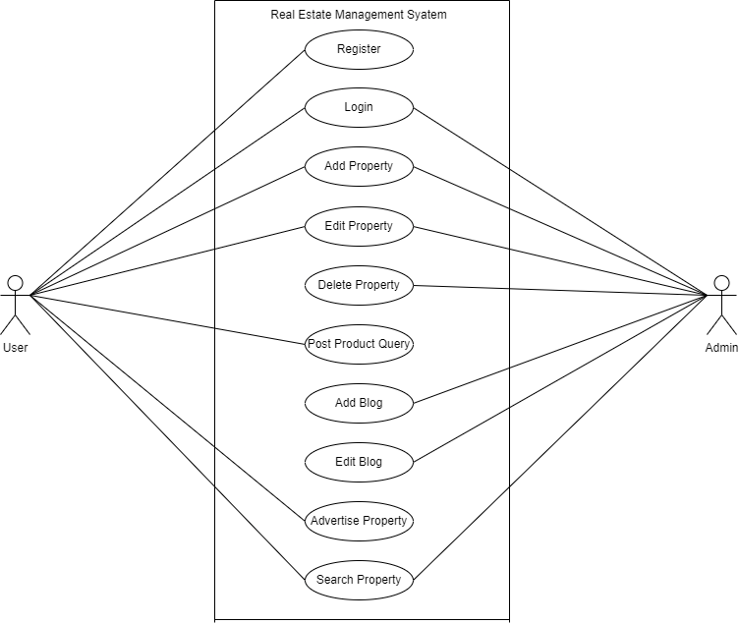

Figure 2‑1: Use-Case Diagram

## High Level Design of System

### System Flow Chart

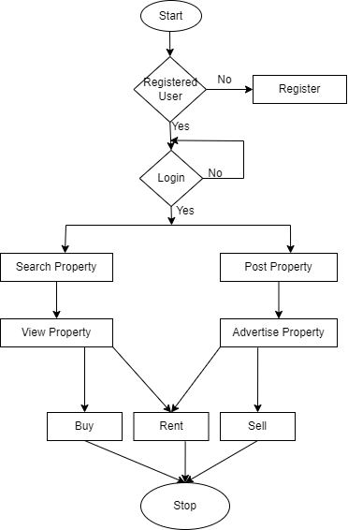

Figure 2‑2: System Flow Chart

# SYSTEM ANALYSIS AND DESIGN

## System Analysis

The developed system is vital to highlight and take into account several models used in software development and deployment given that this project involves the design and implementation of a software system, regardless of whether it is web-based.

The construction of this website meets the waterfall model. The key benefit of employing this method is that we can concentrate on each component of the model while it is being developed and return to it as necessary. Based on this model, the project can be simply divided into various components.

The E-Commerce system is developed using this model. The entire software development process will, however, permit feedback loops. The project's chosen model must favor two developers per project. Considering that we will be the only ones to carry out this job. This example seems appropriate for us to use.

The stages listed below must be followed during software development:

1. Requirements are to be proposed.
2. System design should be made according to the requirements.
3. Implementation of the features according to the design.
4. Integration and testing of the system.
5. Deployment of the system.
6. Maintenance of the system.

### 3.1.1 Requirement Analysis

A system's requirements are analyzed as it is being developed, and before it is put into use, the entire system's requirements must be examined. It is divided mostly into two parts:

1. Functional Requirement
2. Non-functional Requirement

When determining the needs of the system, both functional and non-functional requirements must be taken into account. The system's stakeholders often start the user-visible functional needs, which include things like report generation, login, and signup. The system's usability, reliability & availability, performance, security, and maintainability are a few examples of nonfunctional criteria that explain how the system will carry out its intended functions.

**Functional requirement**: The requirement that has been used in the project as the functional requirements generally includes the function such as inputs, the processing and the final output. The functional requirements in the project are mentioned below.

1. **User Module**

* User can view the properties listed on the system.
* User can publish enquiry for the property.
* User can register as an agent.

1. **Agent Module**

* Agent can register on the system.
* Agent can login to the system.
* Agent can add, edit, update their properties.
* Agent can add, edit, update blogs posted by them.
* Agent can advertise their properties.
* View the user enquiries.

1. **Admin Module**

* Admin can login to the system.
* Admin can add, edit and update properties.
* Admin can add, edit and update blog.
* Admin can add, edit and update section.
* Admin can add, edit and update category.
* Admin can add, edit and update content.
* Admin can view the subscribers.
* Admin can view the contacts filled by the users.

**Non-functional requirement**: Non-functional requirements for an Online Real Estate Management System (OREMS) are the criteria that define the system's behavior, performance, and characteristics rather than specific functionalities. These requirements focus on how the system should work, perform, and be maintained. Here are some non-functional requirements for OREMS:

1. **Usability:** The system is user-friendly, with an intuitive and easy-to-navigate interface. It provides clear instructions and help users accomplish tasks efficiently.
2. **Performance:** The system is responsive and provide quick response times for user interactions, such as property searches and listing updates.
3. **Reliability:** The system is reliable and available for use at all times, with minimum downtime and a robust error handling mechanism.
4. **Security:** The system ensures the confidentiality and integrity of user data. It has secure authentication and authorization mechanisms to prevent unauthorized access to sensitive information.
5. **Scalability:** The system is able to handle a growing number of users, properties, and transactions without a significant decrease in performance.
6. **Compatibility:** The system is compatible with various devices and web browsers to accommodate a wide range of users.
7. **Maintainability:** The system is designed and developed in a way that allows for easy maintenance, updates, and future enhancements.
8. **Flexibility:** The system is flexible enough to accommodate changes in real estate regulations, market trends, and business rules.
9. **Performance:** The system is able to handle a large number of concurrent users and database transactions without significant performance degradation.
10. **Accessibility:** The system will be accessible to users with disabilities, complying with accessibility standards and guidelines.
11. **Documentation:** Comprehensive documentation is provided for the system, including user manuals, technical documentation, and system architecture details.

## 3.1.2 Feasibility Analysis

### Technical Feasibility

When developing a real estate management system on Android, here are some key factors to consider for technical feasibility:

1. Platform compatibility: The system should be compatible with the Android operating system and should work seamlessly on different versions of the platform.
2. Screen size and resolution: The system should be designed to work well on different screen sizes and resolutions of Android devices, ranging from small smartphones to larger tablets.
3. Performance: The system should be optimized to perform well on Android devices, with no significant delays or lags that could impact the user experience.
4. Network connectivity: The system should work well with different types of network connections, such as cellular data and Wi-Fi, and should provide offline access where possible.
5. Mobile device capabilities: The system should leverage the features and capabilities of Android devices, such as GPS, camera, and notifications, to enhance the user experience and functionality of the system.
6. Security: The system should provide robust security measures to protect sensitive information and ensure user privacy, taking advantage of Android's built-in security features such as app permissions and secure storage.
7. Integration: The system should be able to integrate with other Android apps and services, such as Google Maps, to provide a seamless experience for users.
8. Maintenance: The system should be designed to be easily maintainable, with no significant downtime or maintenance requirements that could impact the user experience.

### Operational Feasibility

Operational feasibility is the assessment of whether a proposed real estate management system can be operated effectively in the organization or industry. Here are some key factors to consider for operational feasibility when developing a real estate management system on Android:

1. User acceptance: The system should be user-friendly and intuitive to use, with a design that is familiar and easy to navigate for users.
2. User training: The system should be accompanied by sufficient training and support materials to ensure that users can learn how to use the system effectively.
3. Availability of resources: The system should not require significant additional resources or staffing to operate, and should be able to work within the existing resources of the organization.
4. Compatibility with existing systems: The system should be compatible with other existing systems and processes used by the organization, such as accounting and payment processing systems.
5. User feedback and testing: The system should be tested and refined based on feedback from users to ensure that it meets their needs and is effective in meeting the goals of the organization.
6. Adequate support: The system should be backed by adequate technical support to ensure that any issues or problems can be resolved quickly and efficiently.
7. Cost-effectiveness: The system should provide a cost-effective solution for managing real estate assets, with a reasonable return on investment for the organization.

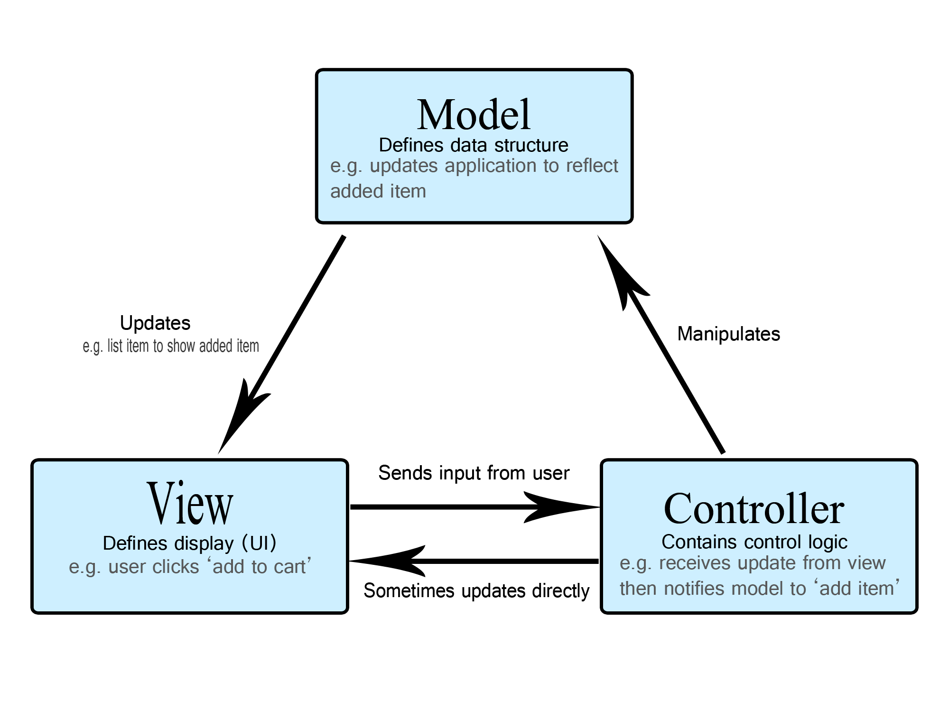

Figure 3‑1: Design Architecture MVC.

### Economic Feasibility

Economic feasibility is an important aspect to consider when developing a real estate management system on Android. Here are some key factors to consider for economic feasibility:

1. Development cost: The cost of developing the system should be reasonable and should provide a reasonable return on investment for the organization.
2. Operating cost: The ongoing operating cost of the system, including maintenance, support, and licensing fees, should be reasonable and sustainable over the long term.
3. Cost savings: The system should provide cost savings over existing manual or outdated systems for managing real estate assets, such as reducing paperwork, streamlining processes, and reducing errors and redundancies.
4. Revenue generation: The system should have the potential to generate revenue for the organization, such as through increased sales or rentals, or through the provision of additional services to clients.
5. Market demand: There should be sufficient market demand for the system among potential clients and users, with a clear understanding of the value proposition of the system.
6. Competitive advantage: The system should provide a competitive advantage for the organization, such as through improved customer service, increased efficiency, or better data management.

Scalability: The system should be scalable, with the ability to adapt and grow as the organization's needs and requirements change over time.

**Scheduling Feasibility**

The process of gathering information about different products and their quality requires additional time. The subsequent development phase can begin within a month of data collection. Gantt diagrams a bar chart called a Gantt chart offers a visual representation of tasks that are planned out over time. A Gantt chart is used to plan projects of all kinds and is an effective tool for outlining the tasks that will be completed on a given day. Additionally, it enables you to see a project's start and conclusion dates in a single, straightforward chart. We created the Gantt chart for our project using Ms. Excel, as shown in the figure below.

Table 3‑1: Scheduling

|  |  |  |
| --- | --- | --- |
| **Work** | **Starting Date** | **Ending Date** |
| Requirement Gathering | 2nd Apr 2023 | 12th May 2023 |
| System Design | 13th May 2023 | 23rd May 2023 |
| Implementation | 24th May 2023 | 12th June 2023 |
| Integration and Testing | 13th June 2023 | 1st July 2023 |
| System Documentation | 2nd July 2023 | 18th Aug 2023 |

**Gantt Chart**

Figure 3‑2: Gantt Chart

## Class Diagram

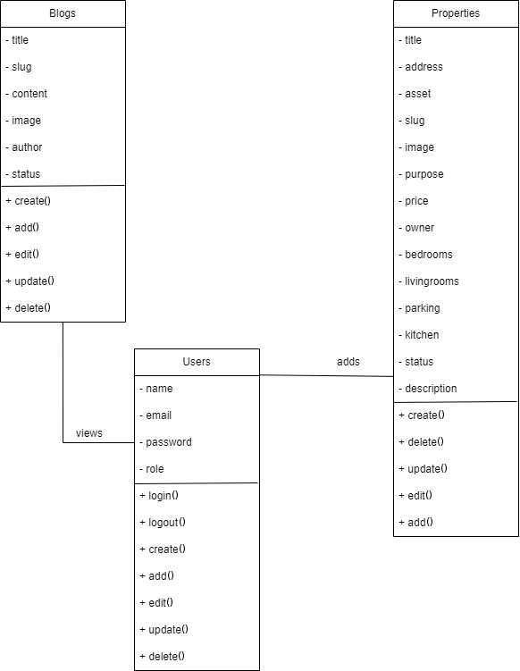

Figure 3‑3: Class Diagram.

## Sequence Diagram

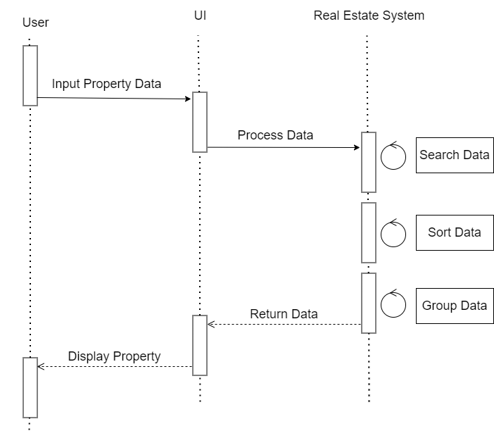

Figure 3‑4: Sequence Diagram

## Activity Diagram

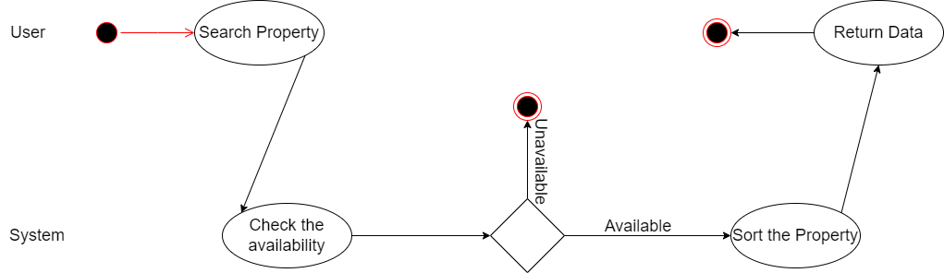

Figure 3‑5: Activity Diagram

## 3.2 System Design

## Component Diagram

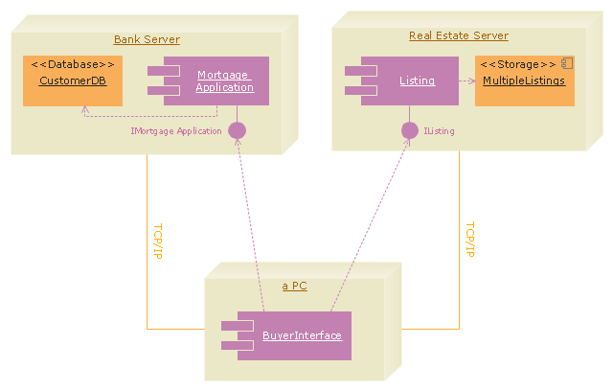

Figure 3‑6: Component Diagram

## Deployment Diagram

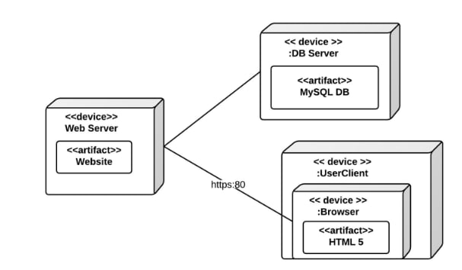

Figure 3‑7: Deployment Diagram

## Algorithm Details

1. Bubble sort is a simple sorting algorithm that works by repeatedly comparing adjacent elements and swapping them if they are in the wrong order.
2. It iterates through a list from start to end, comparing every pair of elements and swapping them if the first is greater than the second. This causes the larger elements to "bubble up" towards the end of the list.
3. After one full iteration, the largest element reaches the end of the list. The algorithm repeats this process until the list is fully sorted in ascending order.
4. Bubble sort has a worst-case time complexity of O(n^2) as it needs to make multiple passes through the list to ensure it is fully sorted. The average and best-case time complexity is also O(n^2).
5. Space complexity is O (1) as only a single additional memory space is required for the temporary variable used for swapping.
6. Bubble sort is inefficient for large datasets. However, it has the advantage of being simple to implement and not requiring additional storage space.
7. It is used in computer graphics for z-ordering of 2D data and educational settings to introduce students to sorting algorithms. Other algorithms like insertion sort, merge sort, quick sort is faster in practice.

In summary, bubble sort compares adjacent elements and swaps them until the list is sorted. It is easy to implement but has quadratic time complexity in all cases. Faster algorithms exist for sorting large data sets.

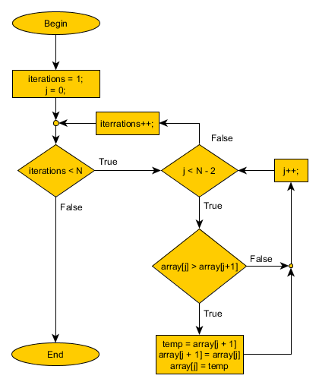

Figure 3‑8: Bubble sort algorithm flowchart.