

**Tribhuvan University**

**Faculty of Humanities and Social Science**

**PropertyLord web Application**

**A Proposal Report**

Submitted to

**Department of Computer Application**

**Swoyambhu Int’l College**

***In partial fulfilment of the requirements for the Bachelors in Computer* Application**

Submitted by

**Ronix malla()**

**Suresh Tamang()**

**Feb-26-2024**

Under the Supervision of

**Mr. Sujit Gyawali**



**Tribhuvan University**

**Faculty of Humanities and Social Science**

**Swoyambhu Int’l College**

**Supervisor’s Recommendation**

I hereby recommend that this project prepared under my supervision by **Ronix Malla** & **Suresh Tamang** entitled “**PROPERTYLORD WEB APPLICATION**” in partial fulfilment of thee requirements for the degree of Bachelor of Computer Application is recommended for the final evaluation.

…………………

**SIGNATURE**

Mr. Sujit Gyawali

**SUPERVISOR**

Department of BCA

Swoyambhu Int’l College

Lagankhel, Lalitpur



**Tribhuvan University**

**Faculty of Humanities and Social Science**

**Swoyambhu Int’l College**

**LETTER OF APPROVAL**

This is to certify that this project prepared by **Ronix Malla** & **Suresh Tamang** entitled “**PROPERTYLORD WEB APPLICATION**” in partial fulfilment of the requirement of the degree of Bachelor in Computer Application has been evaluated. In our opinion it is satisfactory in the scope and quality as a project for the required degree.

|  |  |
| --- | --- |
| **………………**  **SIGNATURE OF SUPERVISOR**  Mr. Sujit Gyawali  Department of BCA  Swoyambhu Int’l College  Lagankhel, Lalitpur | **………………**  **SIGNATURE OF HOD/ Coordinator**  Mr. Kishore Kafle  Department of BCA  Swoyambhu Int’l College  Lagankhel, Lalitpur |
| **………………**  **SIGNATURE of Internal Examiner** | **………………**  **SIGNATURE of External Examiner** |

**Abstract**

This system “**PROPERTYLORD**” will provide facility to the user to search Residential and Commercial property and view property. This system will provide facility to view the property by admin and user. User will be able to upload the property information to the site and able to manage it. This system will provide facility to the user to fill up their requirement and according to their Requirement Admin can add the Requirement property. This system was developed using PHP as (Backend) and HTML, CSS, JS as (Frontend).

The real estate business deals with the development of the property and the lease, rent or sale of establishment. It is one of the fastest growing enterprises in Nepal. It has potentially never-ending growth.

As the real estate agent, one has to maintain a lot of data. He is involved with the clients who has to lease out, rent or sale the property and with the customer who intends to buy, rent or lease the property. Hence it involves lot of information exchange.

The advent of computers can ease out this hassle. With help of our system “**PROPERTY LORD**” which allows faster search time, interaction. This system minimizes the risk of scams for buyers while maintaining fair commission rates. With the organized data storage system it allows faster search time and data manipulation. Indeed, the advent of RDBMS application can be a boom to the field of real estate.

**Acknowledgement**

Our earnest appreciation to the Supervisor **Mr. Sujit Gyawali** for directing me all through the arranging and advancement period of the framework. Without his vital role and direction, I would not have achieved the last phase of the improvement. We would also like to thank whole faculty of the college for their cooperation and important support. We would like to thank all other teaching staff for their valuable teaching and constant advice which made us to finish this project successfully. I would like to thank my close peers and classmates for being supportive and encouraging throughout the project development journey here in **Swoyambhu Int’l College.**

Finally, yet importantly, I would like to thank my family. Their endless support has been unconditional. Their hopes and faith on me had me keep going even when the days were challenging

We perceive this opportunity as a big milestone in our career development. We will definitely use these gained skills and knowledge to its best possible way, and we will continue to work on their improvement, in order to attain desired career objectives. Hope to continue cooperation with all of you in future

Table of Contents

Chapter 1: Introduction 4

Chapter 2: Problem Statement : 4

Chapter 3: Objective : 4

Chapter 4: Features of the proposed system : 5

Chapter 5: Methodology 5

5.1 Requirement analysis 5

5.1.1 Interviewing the clients 5

5.1.2 Study of existing system 5

5.2 feasibility study 5

5.2.1 Technical feasibility 5

5.2.2 Operational feasibility 5

5.2.3 Economical feasibility 6

5.3 Methodology used 7

5.4 Use case Diagram 8

5.5 Entity Relation (ER) Diagram 9

5.6 system flow chart 10

5.7 Context Diagram (Level 0) 11

6. Conclusion 11

# List of Abbreviations

|  |  |
| --- | --- |
| Abbreviation/ Acronym | Description |
| RMS | Real Estate Management System |
| HTML | Hypertext Markup Language |
| CSS | Cascading Style Sheet |
| PHP | Hypertext Preprocessor |
| WAMP | Cross-platform, Apache, MariaDB(MySQL), PHP |
| MS | Microsoft |
| MYSQL | Structured Query Language |
| DFD | Data Flow Diagram |
| IS | Information System |
| CRUD | Create, Retrieve, Update & Delete |
| CASE | Computer-aided System Engineering |
| CAPTCHA | Completely Automated Public Turning  Test to tell Computer & Human Apart |
| UML | Unified Modeling Language |

**Table of Figures**

Figure 1: Waterfall Methodology 3

Figure 2: Use case diagram 4

Figure 3: Entity Relation Diagram 5

Figure 4 : System Flow Chart 6

Figure 5 : Context Diagram 7

**Table of Tables**

# Chapter 1: Introduction of the Project

* 1. **Introduction**

With PropertyLord clients may fully utilize the potential of real estate applications in the digital age, thereby revolutionizing the real estate industry. In the current peak digitalization era, real estate trading is surging at a rate never seen before by dealers. In light of this, we are launching a multi-tenant system that will simplify the process of locating and renting a home, as well as purchasing and renting out lands and other types of properties.

With just a few clicks on our real estate application, you may find your ideal home! Welcome! We can assist you whether you're looking for a large family house in the suburbs, a comfortable apartment, or rooms in the city.

* 1. **Problem Statement**

Nowadays, purchasing or renting a home takes a lot of time. Making decisions and gaining knowledge about the location and values of properties takes a lot of time. It takes a long time to visit the property's location. Furthermore, after the purchase is sealed, the broker bears a great deal of responsibility.

Real estate buying and selling services are offered by a number of applications such as “dalaydai.com” .Upon examining this applications, we have discovered that some crucial elements are missing that are crucial for customers, such as requesting the necessary prerequisites before purchasing, selling, or renting real estate.

* 1. **Objectives**

This project aims to create a new system which will focus on having a user-friendly interface and a simplistic design which can be easily understood by any user.

Our objective is to carryout this project with the quality requirements as mentioned below:

* To offer an intuitive user interface for accessing further details about properties that are advertised.
* To shorten the time it takes to deal with real estate.
* To locate appropriate real estate based on client requirements
* To eliminate human errors and miscalculations from the process.

* 1. **Scope and Limitation**
     1. **Scope**
* Design the system to accommodate future growth and expansion.
* It supports the current process but centralizes it and makes it possible for decisions to be made earlier and easy way.
* This system allows people to post their property making it easier to sale.
* All the types of property listed in single place, easy to access and find.
  + 1. **Limitations**
* Cannot be used offline because it is an online program. So, internet connection is must.
* Basic computer knowledge is required to operate this system.
* Cannot receive feedbacks of buyer and sellers.
* Most of the features that must be included in real management system are not implemented.
* No payment gateways.

# Chapter 2: background Study and Literature Review

**2.1. Background Study**

Real estate refers to real, or physical, property, and can include land, buildings, rights above the land, and underground rights below the land. As a business term real estate also refers to producing, buying, and selling property.

In present system, most of people goes to agents who sales or provide rental properties and lands. People have to visit the organization with there requirement about the properties. This gives unnecessary burden to people who are willing to buy or rent properties, land and room. This system solves all the problem. This project will focus on providing high quality usability experiences to users mainly following Google’s user interface guideline.

This system helps in elimination of human error and miscalculations. And saves users time and money.

**2.2. Literature Review**

**Chapter 3: System Analysis and Design**

Systems analysis is the process by which an individual studies a system such that an information system can be analysed, modelled, and a logical alternative can be chosen. Systems analysis projects are initiated for three reasons: problems, opportunities, and directives. The process by which systems are developed can be described by the systems development life cycle. This is the initial phase for any software being developed in waterfall software development model. This system will be following the waterfall software development methodology. As shown in the figure below, we will be developing the system in five different phases.

1. Requirement

2. Design

3. Implementation

4. Testing

5. Maintenance

In this methodology, while working in one phase another phase isn’t touch before completing previous one. While jumping into another phase we should go thoroughly about the previous phase, which helps to understand the system.

The proposed system has well defined and constant requirements and no needs to increment or add new features so best software methodology for this system is waterfall system development model.

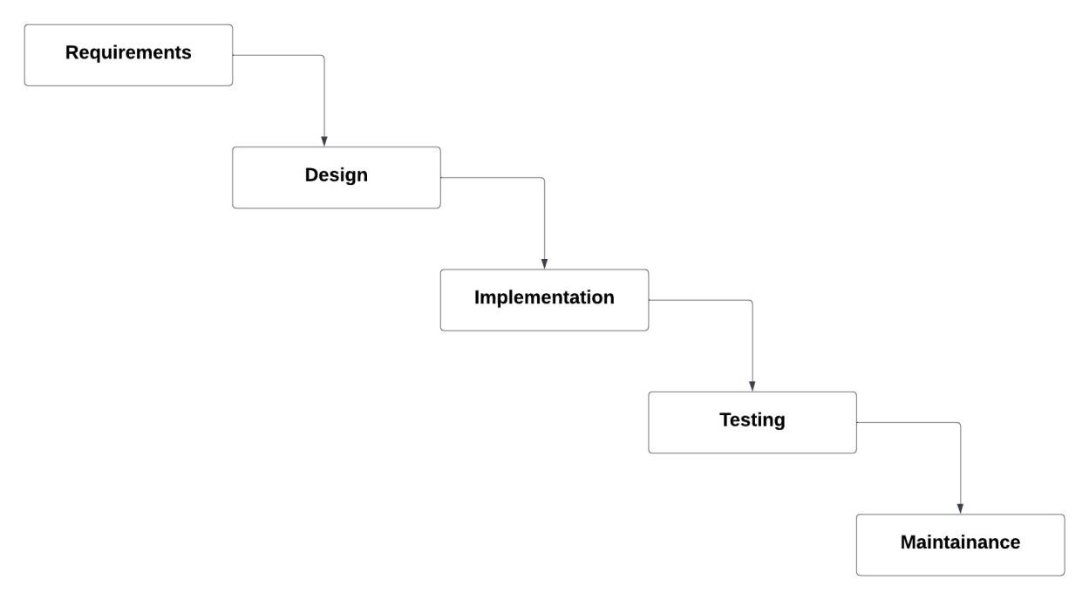

Figure 1: Waterfall Methodology

**3.1.1. Requirements Analysis**

This system needs the following functional and non-functional requirements.

* **Functional Requirements**

1. This system includes search engine for the users.
2. Admin can view the information of the user.
3. Admin has full control over the properties, add new properties, delete properties as well as edit the properties.
4. Users can as well add properties they wish to sell.

A use case is a methodology used in system analysis to identify, clarify and organize system requirement.

Use case diagram for the proposed system is given below:

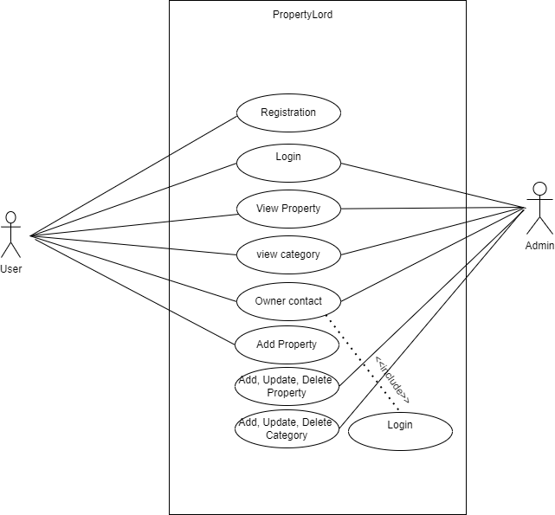

Figure 2: Use case diagram

* **Non-Functional Requirements.**

1. **Security:** only authorized person can have access to this system.
2. **Performance:** This system is designed for smooth performance with goodoptimization and good response.
3. **Reliability:** This system will be reliable for the users. the system will run 24/7
4. **User friendly:** The system is very interactive**.**

**3.1.2. Feasibility Analysis**

A feasibility study is simply an assessment of the practicality of a proposed project plan or method. This is done by analysing technical, economic, legal, operational and time feasibility factors. Following feasibilities were studied before building the system:

* **Technical Feasibility:**

To develop the proposed system we have Hypertext Markup Language(HTML), Cascading Style Sheet(CSS) and JavaScript for frontend and Hypertext Preprocessor(PHP) for the server side scripting which are Opensource and free to use.

The main tools and technology to be used in this system to make this project more feasible are:

**Table 1:** **Technical Feasibility Study Table**

|  |  |  |
| --- | --- | --- |
| **Technological requirements** | **Hardware requirements** | **Software requirements** |
| HTML | Laptop | MS WORD |
| CSS | Keyboard | Photoshop |
| Java Script | Mouse | Visual studio code |
| MYSQL |  | WAMP Sever |
| PHP |  | Figma |

* **Operational Feasibility:**

To make the system work, we have various web hosting service providers for domain registration and web servers, as well as cPanel’s to manage and serve the listing properties within the system.

* **Economic Feasibility:**

Study of the Estimated cost to develop and deploy is affordable. We have various web servers to host the system at a low cost.

Upon the requirement of the System, we can easily update the resources such as database size increment, servers increment at an affordable cost.

* **Schedule Feasibility:**

This assessment is the most important part for project success. After all, a project will fail if not completed in time.

In this project, Gantt Chart is used for Schedule feasibility study.

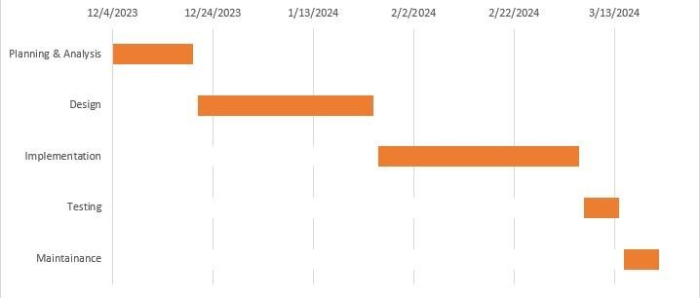

Figure 3: Gantt Chart

**3.1.3. Data Modelling (ER-Diagram)**

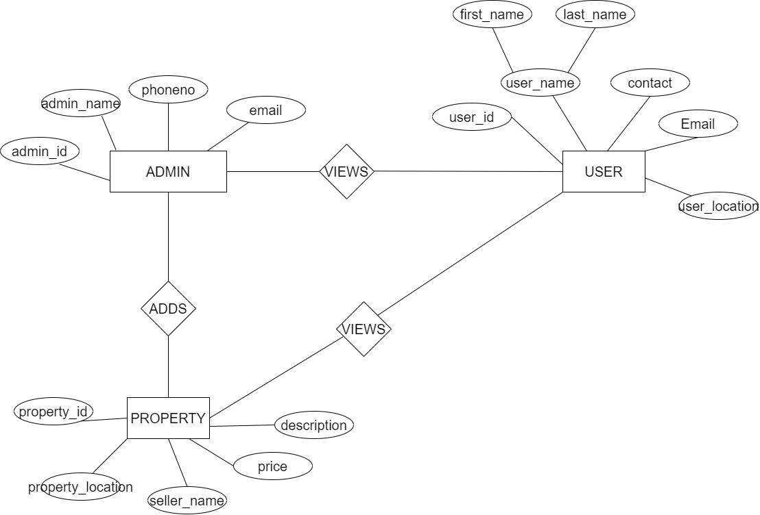ER Diagram stands for Entity Relationship Diagram, also known as ERD is a diagram that displays the relationship of entity sets stored in a database. In other words, ER diagrams help to explain the logical structure of databases. ER diagrams are created based on three basic concepts: entities, attributes and relationships

Figure 4: Entity Relation Diagram

**3.1.4. Process Modelling (DFD)**

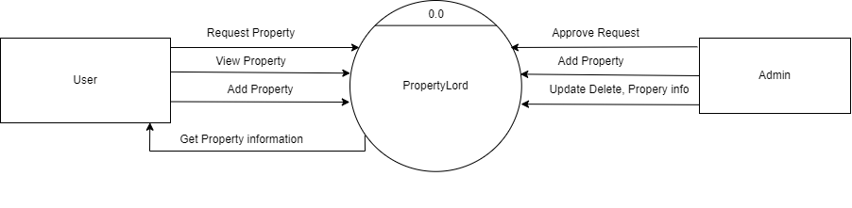A Data Flow Diagram (DFD) is a graphical representation of the “flow” of data through an information system, modelling its process aspects. Often it is a preliminary step used to create an overview of the system that can later be elaborated. DFDs can also be used for the visualization of data processing (structured design) and show what kind of information will be input to and output from the system, where the data will come from and go to, and where the data will be stored. It does not show information about the timing of processes or information about whether processes will operate in sequence or in parallel.

Figure 5: DFD level 0

**3.2. System Design**

System Design is the process of designing the architecture, components, and interfaces for a system so that it meets the end-user requirements.

**3.2.1. Architectural Design**

This phase of design will be planning the architecture of the application. There will be in some cases a separation of the user interface and data. The business layer will be totally independent and not embedded in the views of the website. Data will be stored in an SQL database. To query the database and code behind for server-side scripting will be in PHP. The other business objects will have their own layer. The architecture of the application is shown in the figure below:

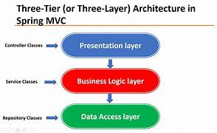Figure 5: Three-tier Architecture

* **Client layer:**

It is also called as Presentation layer which contains user interface part of application. This layer communicates with other through Application Program Interface calls.

* **Application layer:**

In this layer all business logic written like validation of data, calculations, data insertion etc. This acts as an interface between user tier and database tier for faster communication.

* **Database layer:**

In this layer actual database is comes in the picture. Database Layer helps to connect with database and to perform insert, update, delete, get data from database based on user input data. These data are kept independent of application layer.

Following are the reasons behind choosing three tier-architecture:

* It makes the logical separation among three different layers.
* It makes the maintenance process easier.
* It makes us easier to update one tier without involving other.

**3.2.2. Database Schema Design**

A database schema is the skeleton structure that represents the logical view of the entire database. It defines how the data is organized and how the relations among them are associated. It formulates all the constraints that are to be applied on the data. A database schema defines its entities and the relationship among them.

Below shows the database scheme design of our system:

*Figure 6: Schema Design*

**3.2.3. Flow Charts**

A flowchart is a type of diagram that represents a workflow or process. A flowchart can also be defined as a diagrammatic representation of an algorithm, a step-by-step approach to solving task.

The working mechanism of the system is explained below with the help of system flow chart. In this system there are two modules namely user module & admin module.

**User module Flow-Chart**

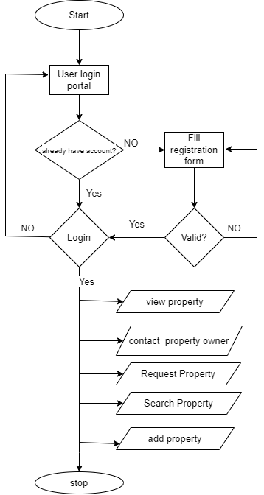

*Figure 7: User login Flow-chart*

*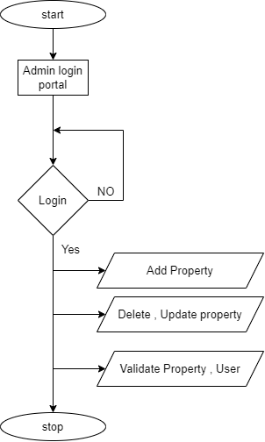***Admin module Flow-Chart**

*Figure 8: Admin login Flow-chart*

**3.2.4. Interface Design**

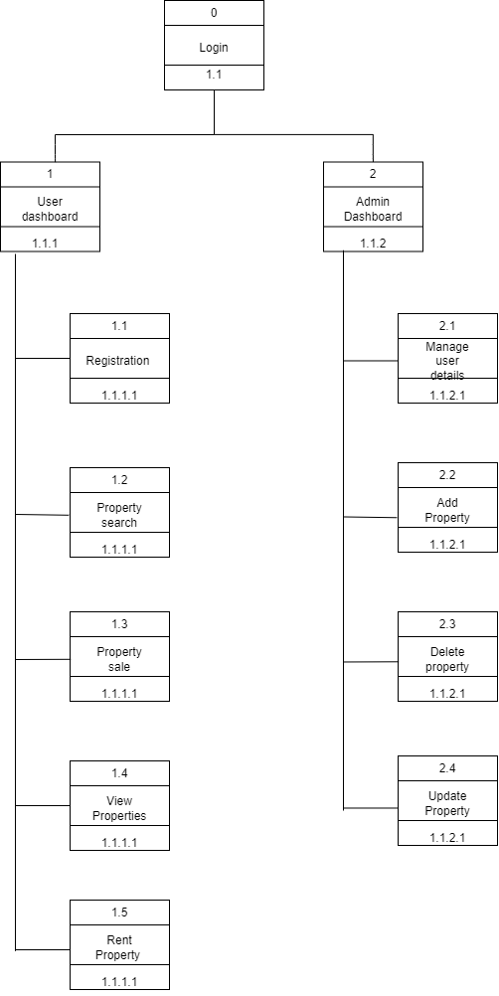

*Figure 9: Interface Design*

According to this interface diagram, we can login to the system to visit either user dashboard or admin dashboard. When we are in user dashboard we can register, search property, sale property and many more.

Similarly, when we are in admin dashboard, we can Delete, Update and Insert properties.

**3.2.5. Physical DFD**

# Chapter 4: Features of the proposed system :

The proposed system has following features:

1.  User Registration

2. Login

3. View Properties

4.Search Properties

5. Get Properties Info

6. Add, Update, Delete Properties

7. Add, update delete, view category.

# Chapter 5: Methodology

The methodologies used to make the proposed system is given below:

## 5.1 Requirement analysis

### 5.1.1 Interviewing the clients

Conducting structured or semi-structured interviews with the users and property owners to gather their needs, preferences, and feedback.

## 

### 5.1.2 Study of existing system

Real estate buying and selling services are offered by a number of applications such as “dalaydai.com, <https://dalaydai.com/>” .Upon examining this applications, we have discovered that some crucial elements are missing that are crucial for customers, such as requesting the necessary prerequisites before purchasing, selling, or renting real estate.

# 

# 6. Conclusion

Clearly , the PropertyLord project will provide numerous advantages to both client and the property owners. To sell and give for renting rooms, houses, lands to the clients who are willing makes easy.

The property owners can list out their houses, lands for the sell and the user who are willing to buy properties can easily make deals directly with the property owner.