SSH Brute Force Incident
Investigation and Escalation Report
Splunk SIEM | Linux SSH authentication telemetry | 28 October 2026 evidence window
PRIORITY  HIGH | STATUS  Investigating | ALERT  Possible SSH brute force | EVENT COUNT  671 dashboard count

Executive assessment
Splunk evidence shows a concentrated sequence of failed SSH password attempts and a dashboard detection for one potential brute-force source. The SOC dashboard reports 671 failed SSH events and labels the source HIGH priority; a separate search screenshot displays 271 matching events over its own visible time range. Because the searches and time windows are not identical, these counts must not be treated as one reconciled total. The activity is consistent with password-guessing behavior. The project owner previously described running a brute-force simulation in this lab; confirm that this evidence matches that approved exercise and its target scope. Keep the detection-validation case open pending validation of the 671-versus-271 discrepancy and the index mismatch.

Incident record
Field | Assessment
Incident ID | SOC-SSH-2026-1028-01 (portfolio identifier)
Detection | Possible SSH Brute Force
Priority | High, provisional; based on 671 dashboard count and repeated failures
Observed event source | Splunk search screenshot: index=main; sourcetype linux_auth
Host shown in events | kali
Source field shown | 192.168.1.5 (src_ip; private LAN address)
Targeted account values shown | admin and kali
Evidence dates | 28 October 2026; Splunk UI showed Last 24 hours for dashboard/search views
Current disposition | Open - validate test authorization, scope, and count discrepancy

Scope and source notes
This report covers the SSH authentication-failure activity visible in the supplied Splunk dashboard and search screenshots. The detailed search explicitly uses index=main and sourcetype=linux_auth. Separate index-wide ingestion screenshots show index=blue receiving Windows and Linux data, including linux_auth and linux_syslog. Treat main and blue as distinct evidence contexts until the Splunk configuration confirms whether the Linux events are duplicated, routed differently, or viewed in separate environments. Unrelated Windows/Sysmon events are not treated as part of this SSH incident.

Observed evidence
Evidence | What it shows | Interpretation
SOC dashboard | 671 failed SSH authentication events; one potential source; HIGH; host kali; src_ip 192.168.1.5; targeted users admin and kali. | Primary summary; dashboard's search logic and exact absolute bounds should be preserved/exported.
Failed-password search | 271 matching events; host kali; user kali; src_ip 192.168.1.5; displayed interval 27 Oct 2026 18:30 to 28 Oct 2026 19:26 in the Splunk UI. | Separate query/time interval; do not add to 671 or assume identical filters.
Raw event details | SSH daemon log lines include repeated 'Failed password' events and source address 192.168.1.5. | Supports repeated authentication failure; account and event count depend on parsing/search.
Ingestion summaries | A separate search shows index=blue includes linux_auth and linux_syslog plus Windows event sourcetypes. | Different index from the SSH search screenshot; validate routing and avoid combining counts.

Timeline
Time / interval | Event
27 Oct 2026 18:30 (UI start) | Detailed failed-password search interval begins, as shown in Splunk.
28 Oct 2026 19:18 (sample event) | One failed SSH password event appears in the detailed result list; individual rows span seconds.
28 Oct 2026 19:26 (UI end) | Detailed search interval ends, as displayed. Dashboard separately shows a Last 24 hours view.
Investigation now | Confirm the dashboard search definition and run both queries with a fixed, identical absolute time range.

The raw event timestamp in one screenshot uses an explicit -04:00 offset while Splunk's displayed _time is rendered in a different local zone. Preserve raw timestamps and the Splunk user's time-zone setting when exporting the final case record; do not compare clock values without normalizing them.

Detection logic
The visible search uses index=main and sourcetype=linux_auth and extracts a source address from Linux authentication messages containing 'Failed password'. The repository SPL example follows that observed index. Validate the main-versus-blue index routing, field extraction, time range, and thresholds before operational use.
index=main sourcetype=linux_auth "Failed password"
| rex "Failed password for (?:(?:invalid user )?)(?<user>\S+) from (?<src_ip>\S+)"
| stats count AS failed_attempts values(user) AS targeted_users earliest(_time) AS first_seen latest(_time) AS last_seen by host src_ip
| where failed_attempts >= 5
| eval severity=case(failed_attempts>=100,"HIGH",failed_attempts>=20,"MEDIUM",true(),"LOW")
| convert ctime(first_seen) ctime(last_seen)
| sort 0 - failed_attempts

Analysis and confidence
- Repeated failed SSH password events from a single displayed source are consistent with password guessing.
- The dashboard's 671 total and the detailed search's 271 results are different observations. Their query text, time boundaries, duplicate handling, and aggregation must be compared before using either as a final incident count.
- The project owner previously described this activity as a brute-force lab exercise. The screenshots do not establish the authorization record, source role, or target system, so confirm that the evidence belongs to that test and document the lab topology.
- The SSH search uses index=main, while separate telemetry summaries show index=blue. Confirm whether these are separate environments or data-routing paths before asserting ingestion completeness.
- No successful SSH login is established by the supplied SSH screenshots. Search for accepted password/public-key events and correlate subsequent sessions before assessing compromise.
- Provisional confidence: Medium that repeated SSH authentication failures occurred; low-to-medium that this was unauthorized activity until lab authorization and target context are verified.

Escalation and response
Stage | Trigger / owner | Required action
L1 triage - immediate | SOC analyst; current open case | Preserve the search job, exact SPL, absolute start/end, raw events, source/host fields, and dashboard export. Resolve count discrepancy. Check whether 192.168.1.5 is the approved Kali test source and identify the actual destination/target host.
L2 / Detection Engineering | Escalate if counts do not reconcile, parsing is uncertain, or repeated activity is outside the approved test window | Review linux_auth parsing, `Failed password` versus `Accepted` records, invalid-user handling, duplicate events, time zones, and alert scheduling/thresholds. Confirm whether one event is counted once and validate dashboard panel SPL.
Incident Response / Security lead | Escalate promptly if activity is unauthorized, a production asset is involved, or a successful login follows the failures | Follow the organization's incident process. Preserve logs, identify affected account/host, review successful authentication and post-login activity, contain only with owner approval, rotate credentials if compromise is supported, and document chain of custody.
Close as authorized test | L1 plus lab owner confirms the matching controlled simulation | Attach the test plan and time window; mark as authorized simulation, record detection success and count variance, tune the rule if needed, and close with no production containment.

Recommended next actions
- Match the screenshots to the reported lab exercise; confirm source role, target host, and exact test window with the lab owner.
- Verify whether index=main and index=blue are separate environments or data-routing paths for Linux authentication events.
- Run the dashboard search and detailed search over the same fixed absolute period and compare raw event counts, extracted users, and source fields.
- Search for successful SSH authentication and new sessions from the same source or targeted accounts; document the result explicitly.
- Confirm whether 192.168.1.5 is the scanner/test host or another endpoint; preserve the direction and meaning of each field.
- Escalate to L2/IR using the thresholds above if the activity is not authorized, affects a production asset, or has a successful-login correlation.

Closure criteria
Close only after the activity is confirmed as an authorized lab simulation or the incident owner records a supported disposition; the count discrepancy is explained; relevant successful-login checks are documented; and evidence, SPL, and time-zone details are attached. Otherwise retain the case as open and escalate according to the trigger table.

Evidence register
Ref | Repository file | Use
E-01 | 06-Evidence/SSH-Brute-Force/soc-dashboard-ssh-summary.png | Dashboard count, severity, host, source, and target accounts
E-02 | 06-Evidence/SSH-Brute-Force/ssh-failed-password-search.png | Detailed failed-password results and visible time interval
E-03 | 06-Evidence/SSH-Brute-Force/ssh-auth-event-details.png | Raw Linux authentication event context
E-04 | 06-Evidence/Splunk-Ingestion/ingestion-summary-2026-10-30.png | Index and sourcetype ingestion summary
E-05 | 06-Evidence/Splunk-Ingestion/daily-event-summary-2026-10-30.png | Separate day-scoped event summary

Evidence exhibits
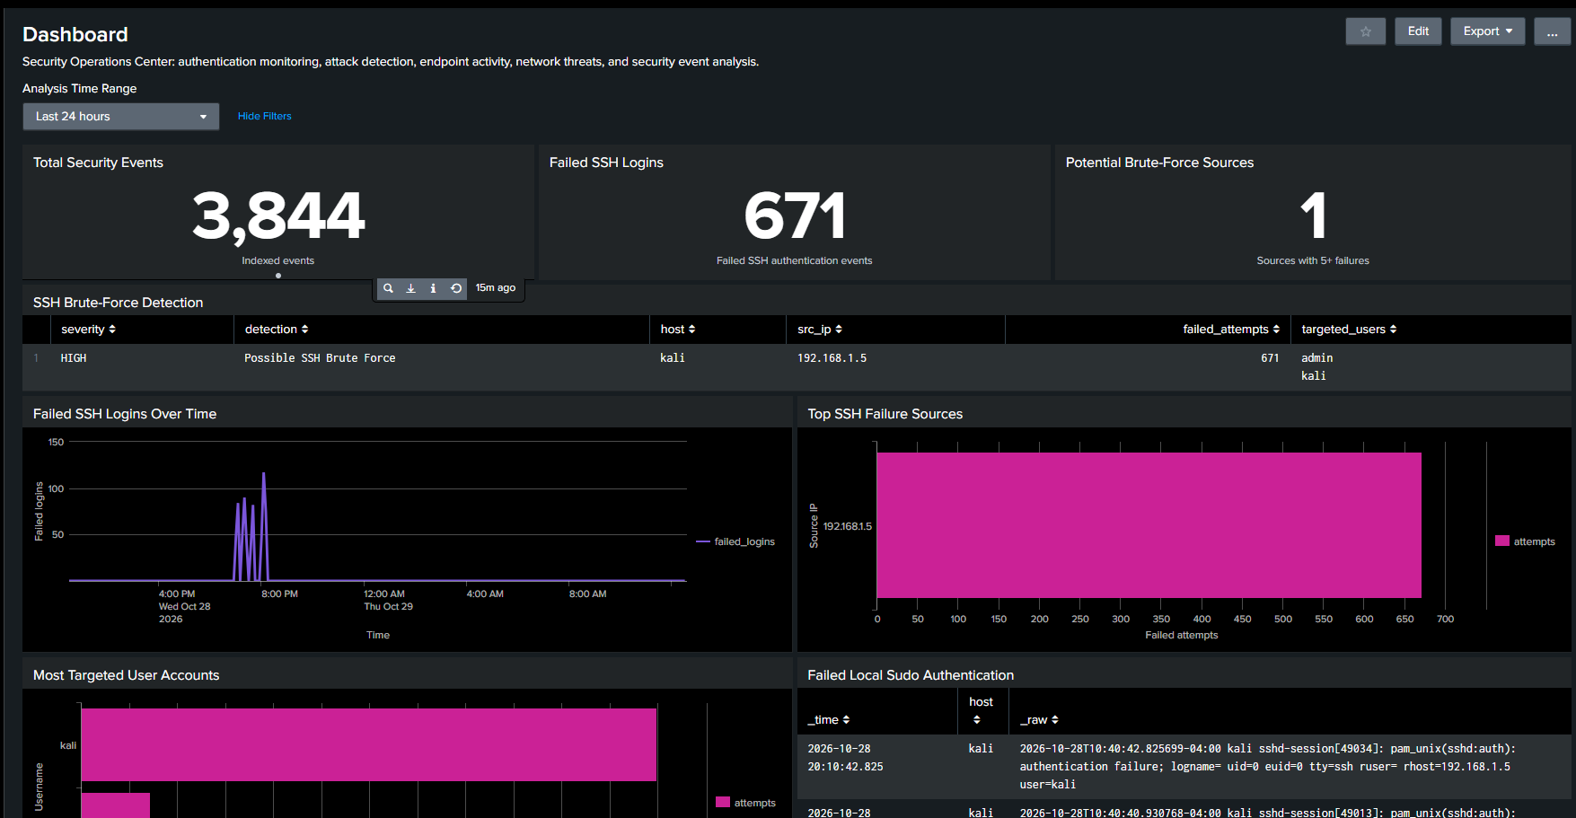
Exhibit E-01 SOC dashboard summary
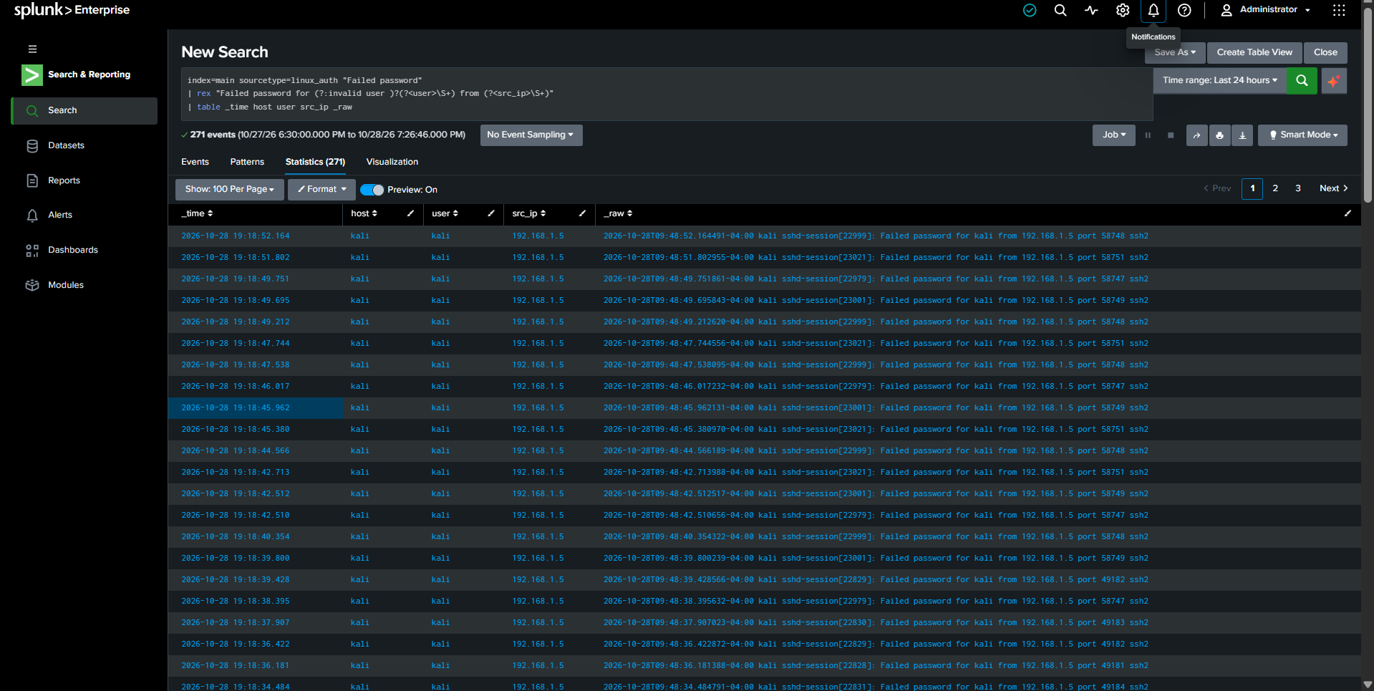
Exhibit E-02 Failed-password search results
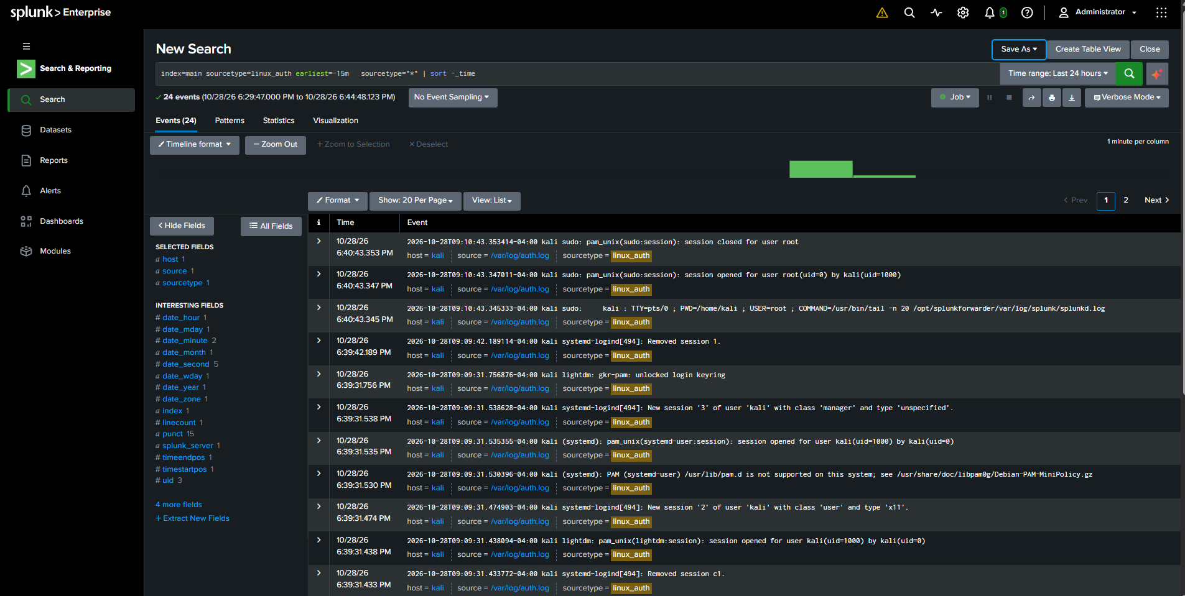
Exhibit E-03 Raw authentication event details

Report handling
Classification: private lab evidence. The screenshots include an internal LAN address and environment identifiers. Review and sanitize them before any public release. The report treats the activity as a reported lab simulation and a high-priority detection-validation case; it does not claim a confirmed compromise.

