CNN-based Approach for Efficient Bell Pepper Leaf Disease Recognition

***Abstract —*** Convolutional Neural Networks (CNNs) have achieved remarkable results in the detection of diseased plant leaves, providing highly accurate predictions. This project presents an in-depth analysis of current systems for plant-based disease detection. Using CNN trained on a dataset of bell pepper plant images, various simulation approaches for neurons and layers were employed. Plant diseases have significant impacts on agricultural productivity, leading to economic losses, reduced crop quality, and decreased yield. Consequently, the timely detection of plant diseases in large crop fields has garnered increased attention. By obtaining reliable data on plant health and accurately identifying diseases, effective management strategies can be implemented to mitigate the spread of diseases.

Therefore, our model plays a crucial role in the classification of healthy and diseased bell pepper plant leaves. In this context, it is highly recommended to promptly remove any infected plants to prevent the spread of disease throughout the entire garden. Taking immediate action upon identifying issues with the pepper crop helps minimize further contamination and ensures better overall crop health. (By using Convolutional neural networks (CNN) we obtained maximum accuracy of 99.99 %.)

Keywords: Bell-pepper, Plant disease, Convolutional Neural Networks (CNN), Bacterial spot Disease

**I . INTRODUCTION**

Pepper bell leaves, also known as capsicum leaves or sweet pepper leaves, are the foliage of the pepper bell plant (Capsicum annuum). Pepper bell leaves are typically large, broad, and glossy. They have an elliptical or lanceolate shape with a smooth or slightly wavy edge. While the peppers are the main focus of the plant, the leaves can also be used in cooking. They have a mild, slightly peppery flavor similar to the bell peppers themselves, but milder. The leaves are often used in traditional cuisines of some regions, including parts of Southeast Asia, Africa, and the Caribbean. They can be added to soups, stews, curries, or stir-fries to impart a subtle pepper flavor.

Pepper bell leaves are a good source of essential nutrients. They contain vitamins A, C, and K, as well as folate and dietary fiber. They also provide small amounts of minerals like potassium and manganese. However, the exact nutritional composition may vary depending on the variety of pepper plant. In some traditional medicine practices, pepper bell leaves are believed to have medicinal properties. They are thought to possess antioxidant, anti-inflammatory, and digestive benefits. However, scientific research on the specific health benefits of pepper bell leaves is limited, and further studies are needed to substantiate these claims. Pepper bell leaves can be harvested throughout the growing season once the plants have reached a sufficient size. It’s best to pick the leaves while they are still young and tender. After harvesting, the leaves should be stored in a plastic bag or container in the refrigerator, where they can stay fresh for up to a week. While pepper bell leaves are not as widely recognized as the peppers themselves, they can add a unique flavor to dishes and are worth exploring if you have access to them. Remember to consult local culinary traditions and recipes for guidance on how to best incorporate pepper bell leaves into your cooking.

Bacterial spot disease causes characteristic lesions and spots on pepper bell leaves. These spots are usually small, water-soaked, and initially appear on the lower side of the leaves. As the disease progresses, the spots can enlarge and turn dark brown to black in color. They may have a raised or rough texture. Infected pepper bell leaves can become deformed due to bacterial spot. The presence of lesions and spots can lead to curling, distortion, and malformation of the leaves. This deformation can affect the overall growth and development of the plant. Severe bacterial spot infections can cause infected pepper bell leaves to drop prematurely. As the disease progresses, the leaves may turn yellow or brown and eventually detach from the plant. Leaf drop can lead to reduced photosynthesis, weakening of the plant, and decreased yield.

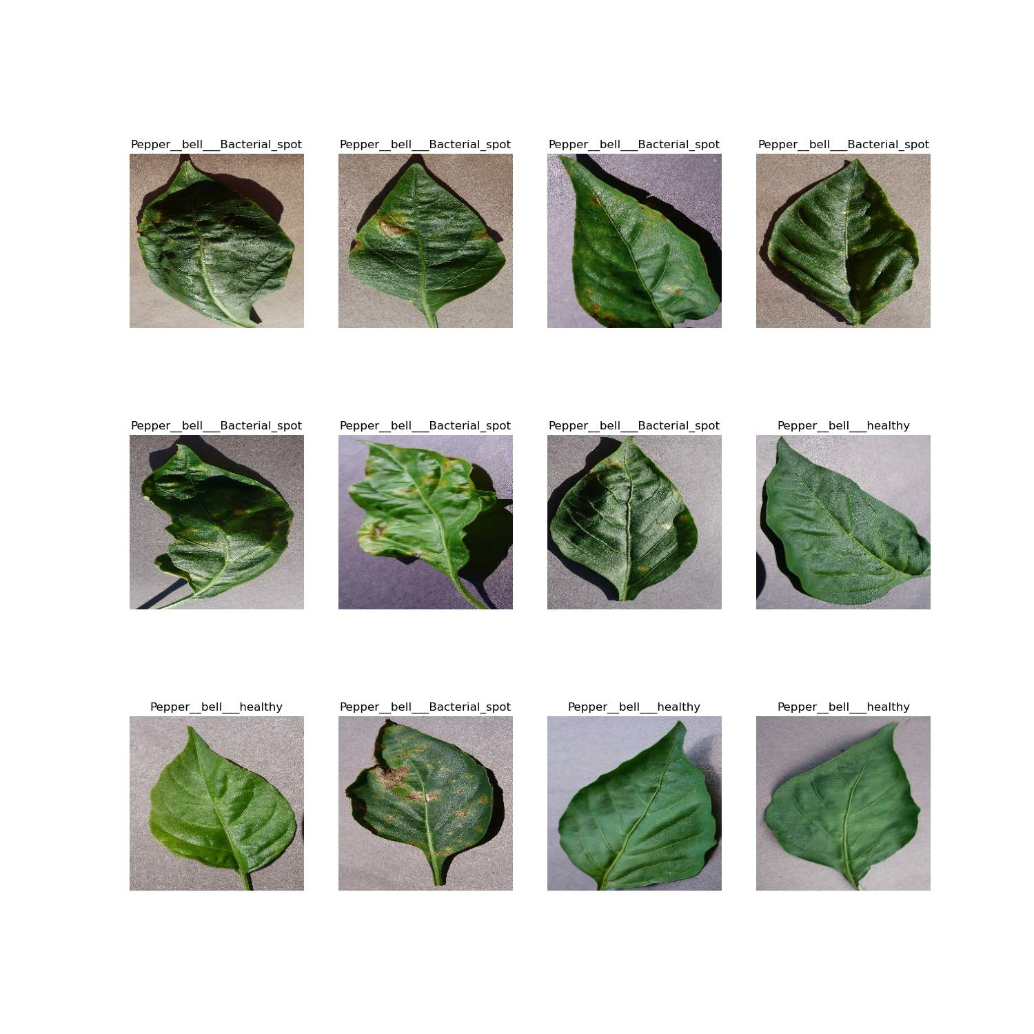

Bacterial spot can also affect the fruit of pepper bell plants. Infected fruit may develop small, dark spots or lesions, which can affect their appearance and marketability. In severe cases, the spots can enlarge and coalesce, leading to fruit rot and decay. The overall effect of bacterial spot on pepper bell leaves can result in reduced yield. Infected plants may produce fewer fruits, and the quality of the harvested fruit may be compromised due to the presence of spots or lesions. The disease can impact the plant’s vigor, nutrient uptake, and photosynthetic capacity, ultimately affecting the productivity of the crop. It’s important to notice that the severity of the effects can vary depending on the specific strain of bacteria causing the infection, environmental conditions, and the plant’s overall health and resistance. Proper disease management practices, including sanitation, crop rotation, and the use of resistant varieties, can help mitigate the impact of bacterial spot on pepper bell leaves.

In the past, CNN was only used for handwriting recognition and image recognition. At present, this network architecture is also used for text classification tasks (including sentiment analysis). Therefore, the use of CNN in all artificial neural networks presented previously achieved good results in terms of classification rate and execution time accordingly to multiple works from the literature. The secret behind these great successes is the structure of CNN, which is designed to become similar to the cat’s visual cortex. Indeed, the cat’s visual cortex is composed of a complicated arrangement of neurons. These neurons are responsible for covering small sub-areas of the visual area, named the receptive area. Then, the receptive areas are tiled to detect the overall visualarea. Hence, receptive areas are deemed as filters in the CNN deep learning model. In summary, the main aim behind CNNs is to innovate a solution for diminishing the total number of parameters and constructing a deeper neural network with fewer parameters.

In this paper we used the dataset from Kaggle which contains 2475 images with two classes. One class name is ‘Pepper_bell_healthy’ and another class name is ‘Pepper_bell_diseases’. These two classes are further divided into nearly 62 batches and each batch contains 32 images. Based on this classification, our model will be executed with in short period of time. we divided the given dataset into 80% of data in to training and 10%of dataset for validation (testing the dataset while training) and remaining 10% dataset is for testing (testing the model after model) which is unseen or unknown data to our model. The further procedure will be detailly explained in methodology.

**II. LITERATURE REVIEW**

Following are the early implementations of Neural Networks and some other methods In order to classify the leaf diseases: Rehan Mohmood et al.[1], This paper gives an overview analysis of current plant-based disease detection systems. In this analysis, using a CNN, equipped with a bell pepper plant image dataset, a variety of simulation approaches for neurons and layers were used and this paper gots the accuracy of 96.78%. Shivkumar Bagde et al.[2] ,The main goal of the research work is to increase the efficiency of the disease detection technique, techniques used are K-means clustering, SGDM Matrix Generation, Texture Statistics Computation, Color Cooccurrence Method, Otsu method, Artificial neural networks and resultant is An algorithm to detect whether a plant is healthy or unhealthy using the images of plant leaves and machine learning algorithms. Md. Nazrul Islam et al.[3], This paper proposes a method of classification of plant species using automated plant identification systems, techniques used are End-to-end CNN, cross-dataset fine tuning, Deep Learning features and this method got average classification accuracy up to 95% on datasets Flavia Swedish Leaf UCI Leaves Plant village. Siddhartha Singh Chauhan et al.[4], This paper proposes a method of automatically using some artificial intelligence approach to recognise and classify plant leaf diseases, techniques used are Bacteria foraging algorithm, radial basis function neural network and Average specificity of K Means is 0.7914 Average specificity of Genetic-Algorithm is 0.8139 Average specificity of BRBFNN is 0.8558. Artzai Picon et al.[4], This paper proposed an adapted Deep Residual Neural Network algorithm to detect multiple plant diseases under real conditions of acquisition, techniques used are Residual Neural Network and The algorithm results for an image of the leaf of a plant affected with Septoria shows the results Sensitivity– 0.94 Specification – 0.96 BAC – 0.96. Srdjan Sladojevic et al.[5], This paper proposes a method to recognize plant diseases using leaf image classification with Deep Neural Networks and techniques used are Neural Network Training, Fine-Tuning and An accuracy of 96% was achieved after fine tuning. This paper works with very less number of epochs which results maximum accuracy. Because of less number of epochs, the code will be executed in short time than other methodologies.

**III. METHODOLOGY**

Before going to what method we adopted in this project. Let us look about the how the data is preprocessed. We can use different techniques for preprocessing the data. In this paper, we adopted data augmentation techniques, which helps in resizing the image and rescaling the images. It used for converting all images into one fixed size. It also helps in finding the flipped images also…

The CNN structure was first suggested in 1988 by Fukushima, which is one of the most common and effective deep convolutional learning Network. CNN has been used in this project to detect bacterial spot in bell pepper leaves. CNNs are widely used for image recognition and classification tasks. They can identify objects and patterns in images. The main advantage with CNNs is to innovate a solution for diminishing the total number of parameters and constructing a deeper neural network with fewer parameters. The use of CNNs in medical image identification is particularly important. The process of CNN involves the following steps:

1. CONVOLUTION LAYER :-

This is the essential block in CNN and is always the premier layer in the overall structure of CNN. The major target of this layer is to detect and capture the features from an obtained matrix by applying one of the word embedding methods on the given input sentence. The convolution layer uses a slid filter over the embedding matrix and produces a convolved feature. Multiple filters are applied over the embedding matrix to obtain multiple features maps. In this convolutional layer,we use ReLU activation function was used instead of LeNet.

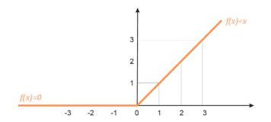

1. POOLING LAYER:

After convolving the embedding matrix with multiple filters in the first stage (convolution layer), the second phase is the application of the pooling layer to reduce the dimensionality of obtained feature maps in the first step. Then the total number of CNN parameters is diminished. Pooling helps to reduce computational complexity, control overfitting, and extract invariant features. In this model, we are using Max Pooling. 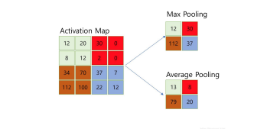

1. FULLY CONNECTED LAYER

This layer is also termed as dense layer, which used in this work to calculate the sentimental scores of each input sentence (PSS and NSS) from the obtained single column from a pooling layer in the previous phase. We can summarize its functionality as a linear process in which each input is linked to all output by different weight.

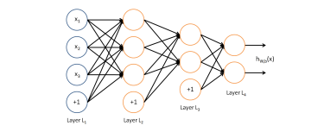

A fully connected layer is an ordinary neural network layer as in other neural networks. Typical activation function is the *sigmoid* function.

These are the basic steps in CNN, which is the architecture we are using in this project. We flatten our matrix into a vector and feed it like a neural network into a fully connected layer. CNN is mostly suitable for our project.

**IV. RESULTS AND DISCUSSIONS**

In this model, we utilized 2475 images with data augmentation. Our model is built using popular Python libraries, Keras and TensorFlow. The algorithm employs neural networks to classify two types of leaves: healthy or infected. Using our model, we achieved an accuracy of 99.49% and a loss of approximately 0.015%.

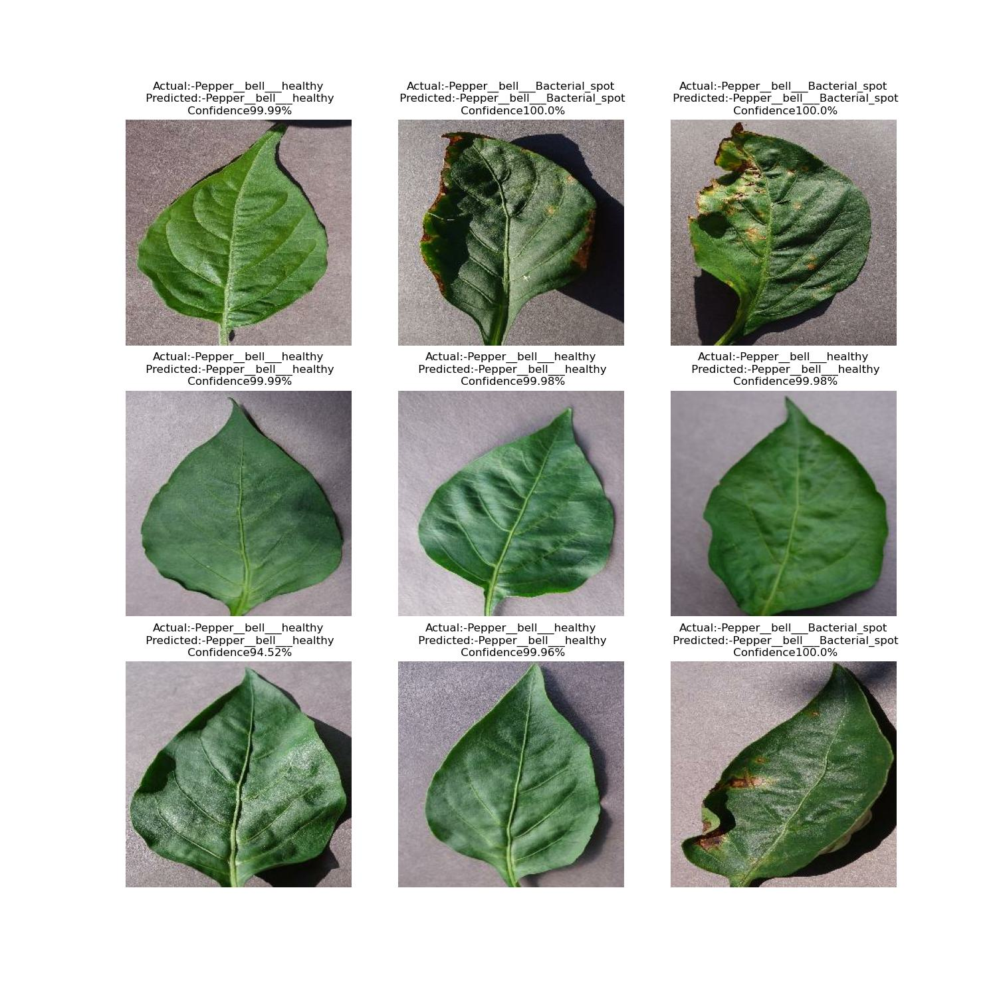One key advantage of our model is that we can achieve the same level of accuracy with fewer epochs, resulting in a shorter training time. Since many diseases affect leaves, successfully classifying healthy and infected leaves can greatly enhance crop production. We plotted a graph illustrating the validation and testing accuracy as well as the losses. Notably, the training accuracy and validation accuracy are very close. This indicates that our model can efficiently and quickly classify unseen images. One significant advantage of our model is its ability to classify an image as diseased or healthy within seconds.

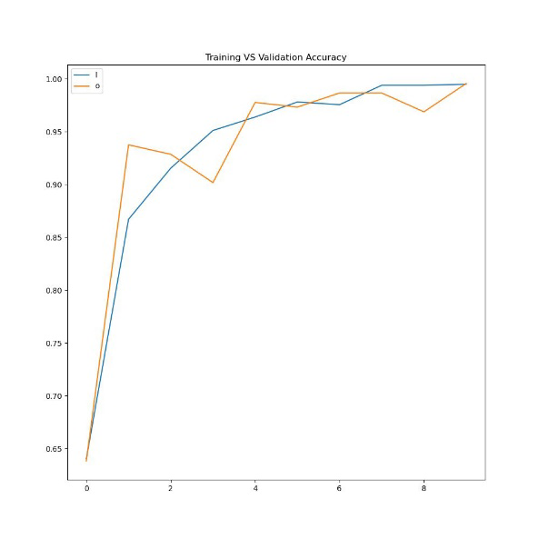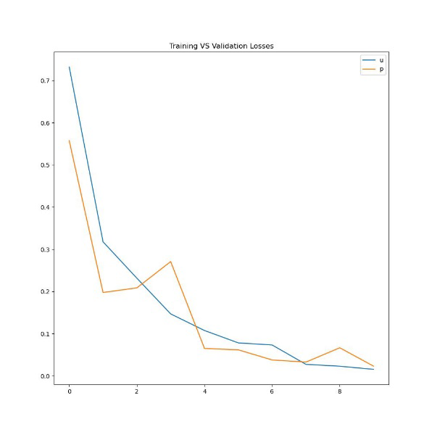

**V. CONCLUSION**

This model utilizes deep learning techniques, specifically a convolutional neural network (CNN), to classify images of pepper bell plant leaves as healthy or diseased. CNN-based approaches are found to be the most effective for this type of classification task. The model achieves high accuracy with a reduced number of epochs, making it efficient and time-saving. We believe that this project will have a significant impact on the agriculture sector, particularly for farmers in Indian villages who may lack literacy and knowledge about plant diseases. By utilizing this model, we aim to improve the situation for capsicum growers in India. The experiments conducted on healthy and diseased leaf images demonstrate that the proposed method effectively identifies various types of bell pepper leaf diseases.

**REFERENCE**

[1] Monu B, Rehan Mahmood, Monu ‘Bell Pepper Leaf Disease Classification Using CNN’(2020)

[2] Bagde, S., Patil, S., Patil, S., and Patil, P. Artificial neural network based plant leaf disease detection. International Journal of computer science and mobile computing (2015)

[3] Islam, M. N., Kashem, M., Akter, M., and Rahman, M. J. An approach to evaluate classifiers for automatic disease detection and classification of plant leaf. In International Conference on Electrical, Computer and Telecommunication Engineering, RUET, Rajshahi6204, Bangladesh (2012), pp. 626-629

[4] Chouhan, S. S., Kaul, A., Singh, U. P., and Jain, S. Bacterial foraging optimization based radial basis function neural network (brbfnn) for identification and classification of plant leaf diseases: An automatic approach towards plant pathology. IEEE Access 6 (2018), 8852-8863.

[5] Picon, A., Alvarez-Gila, A., Seitz, M., Ortiz-Barredo, A., Echazarra, J., and Johannes, A. Deep convolutional neural networks for mobile capture device-based crop disease classification in the wild. Computers and Electronics in Agriculture 161 (2019), 280290