**How to Use JavaScript Web Resource in PowerApps?**

**1.Introduction:**In this guide, I’ve documented a simple yet powerful use case where I added a custom JavaScript Web Resource in a Power Apps Model-Driven App to extend form logic. This use case involves showing a popup alert and automatically updating a field when a user selects a vehicle in the Parking Request form.

This document walks through the exact steps I followed — from uploading the script, configuring it, and testing it in a real-world app scenario.

**Model Driven App:**

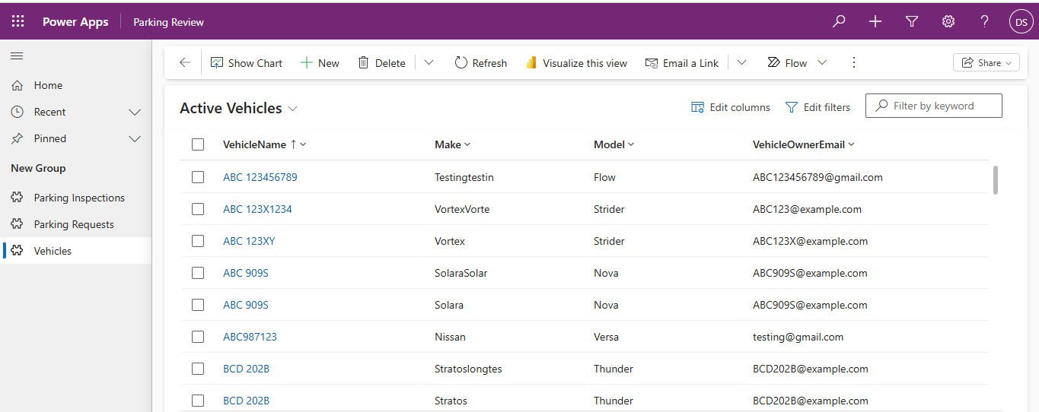

**2.JavaScript Code Overview:** The script I wrote handles the “On Change” event of a lookup field (Vehicle) and triggers an alert message while also pre-filling the Parking Request Name. This kind of dynamic interaction improves user experience and reduces manual input errors.

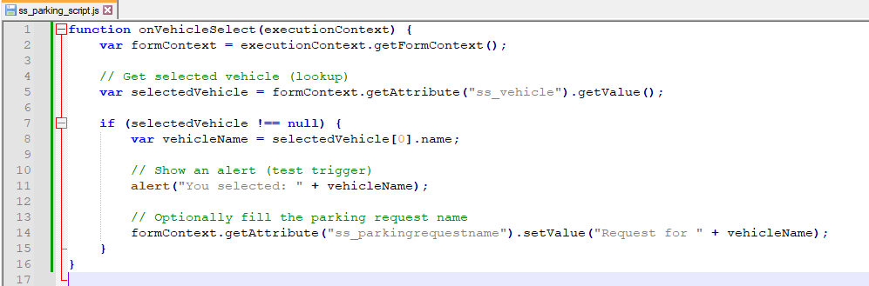

**3.How to Upload the Web Resource:**

Once the code was ready, I uploaded it into my solution in Power Apps as a Web Resource. This makes it reusable and available across forms.

Here’s how I did it:

1. Open the Power Apps maker portal: https://make.powerapps.com
2. Go to **Solutions** → open your solution (e.g., *Parking Challenge*)
3. Click **+ New > Web Resource**
4. Fill the details:

* Name: ss_parking_script.js
* Type: JavaScript (JS)
* Upload the saved .js file

1. Save and **Publish**

**Web Resource upload screen**

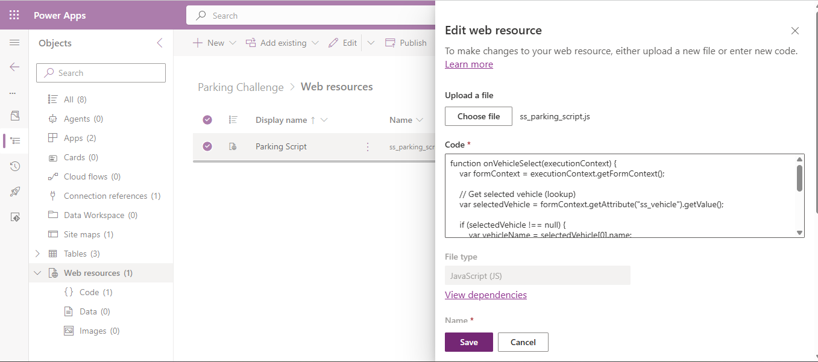

**4. How to Attach to Form:**

After uploading the script, I added it to the relevant form (Parking Request). This allows the script to run during field events like OnChange.

Steps I followed:

1. In the same solution, go to **Tables > Parking Request > Forms**
2. Open the **Main Form**
3. Click **Form Settings > Form Libraries**
4. Click **Add Library** → select ss_parking_script.js
5. Click **Done** and **Save**

**5.Event Configuration:**

To make the script run when the Vehicle field is changed, I added an event handler to that control.

Here’s how I configured it:

1. Select the **Vehicle** field
2. Switch to the **Events** tab
3. Under OnChange:
   * Click **+ Add Event Handler**
   * Choose Library: ss_parking_script.js
   * Function Name: onVehicleSelect
   * ☑️ Check “Pass execution context as first parameter”
4. Click **Done**, then **Save and Publish**

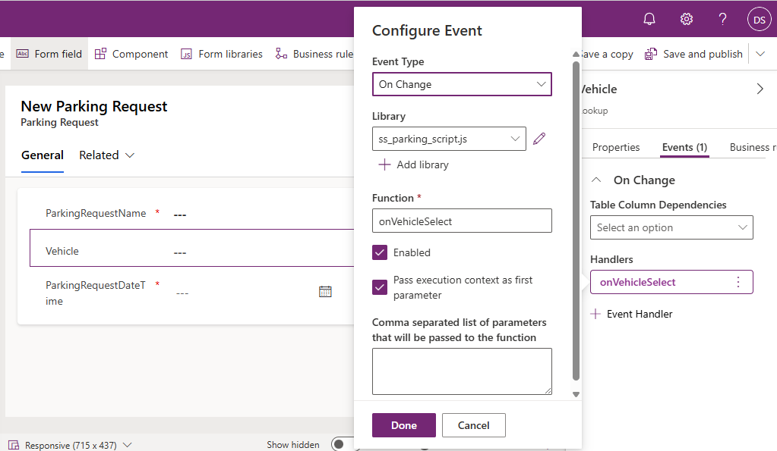

**6.Testing the Setup:**

Once published, I opened my Model-Driven App and tested the Parking Request form.

When I selected a vehicle:

* An alert popped up showing the vehicle name
* The Parking Request Name field was automatically filled

This confirmed that the JavaScript was successfully integrated into the app.

An alert popped up showing the vehicle name

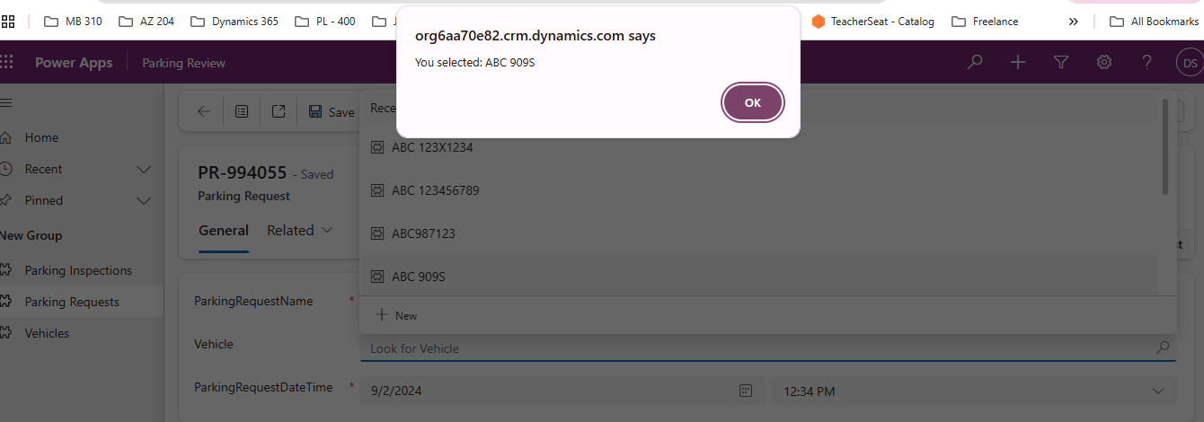

The Parking Request Name field was automatically filled

