1. Find all the information about each products

Answer : find() method will return first 20 records only . If you want next 20 records use the it command. But in given product.json file has only 20 records. Please refer below screen shot for your reference.

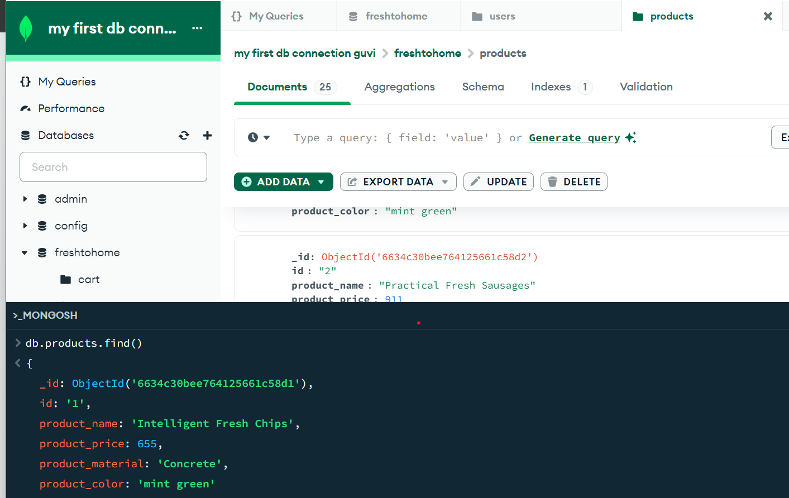

1. Find the product price which are between 400 to 800

Answer : $gte and $lte operator using

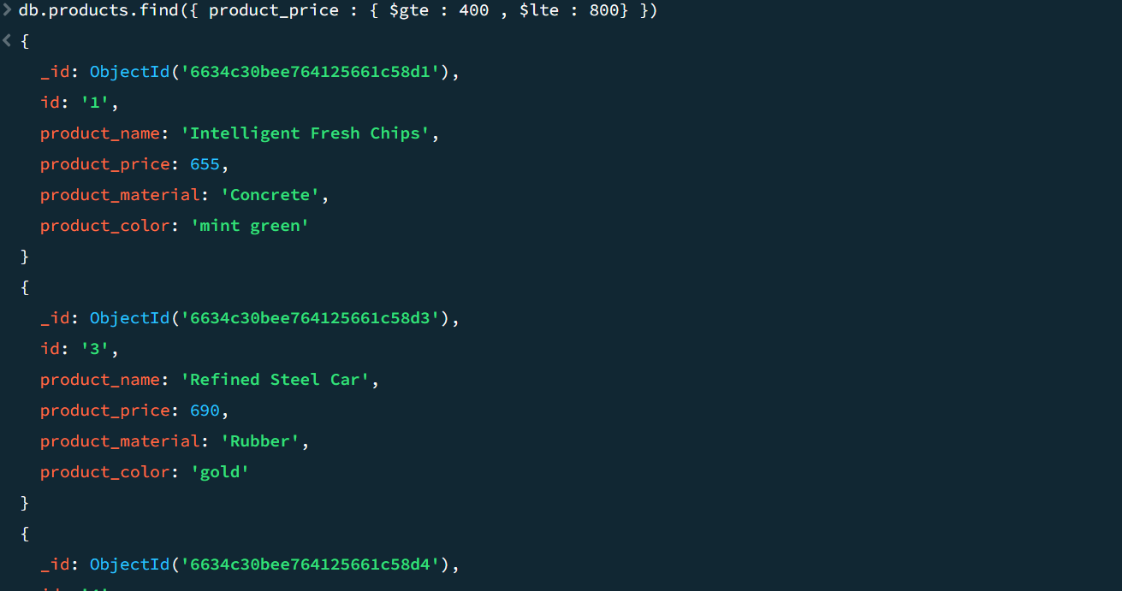

1. Find the product price which are not between 400 to 600

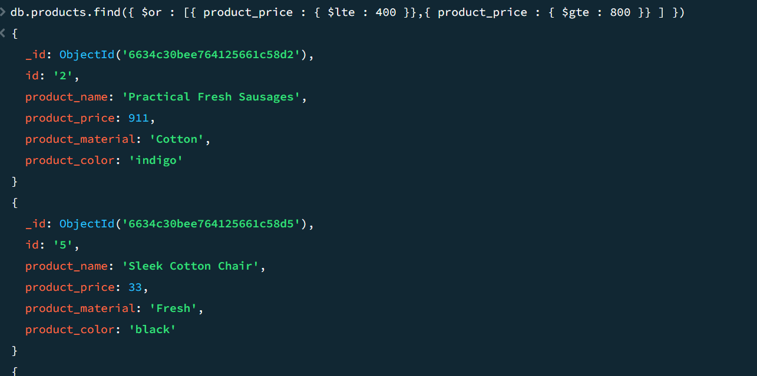

1. List the four product which are greater than 500 in price

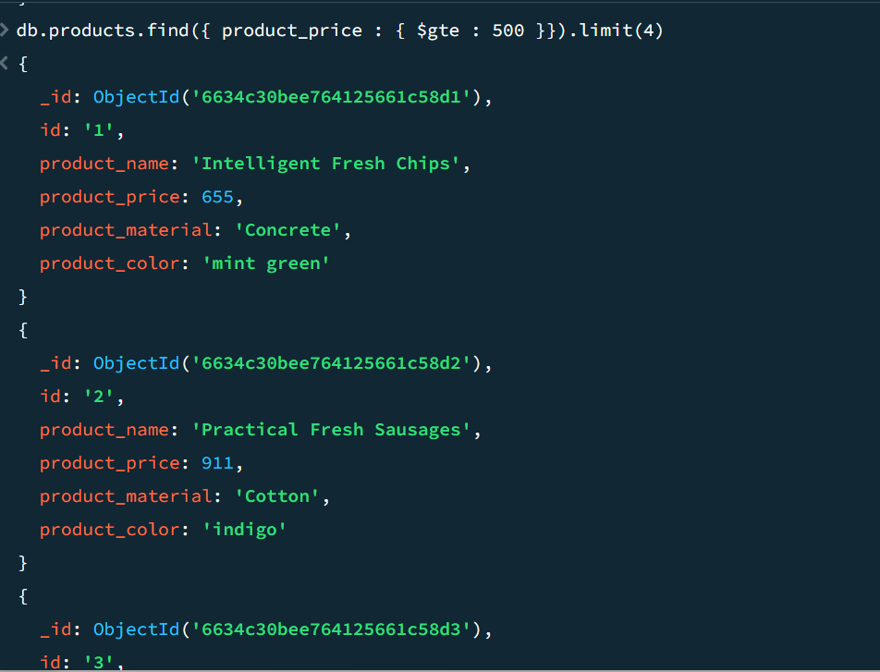

5.Find the product name and product material of each products

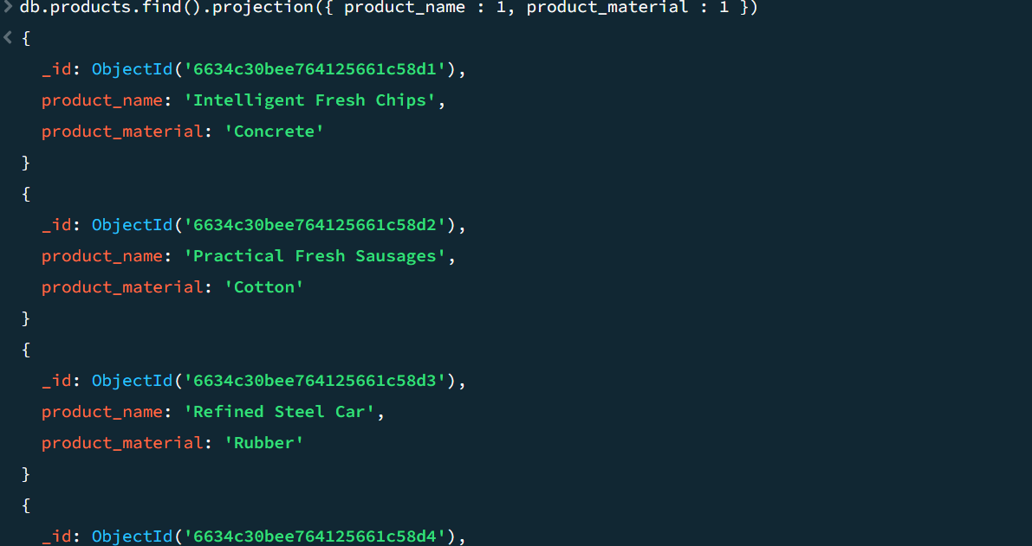

6. Find the product with a row id of 10

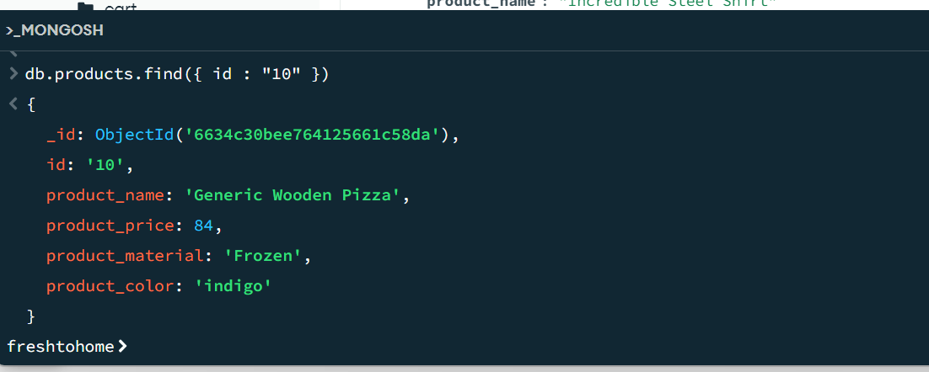

7. Find only the product name and product material

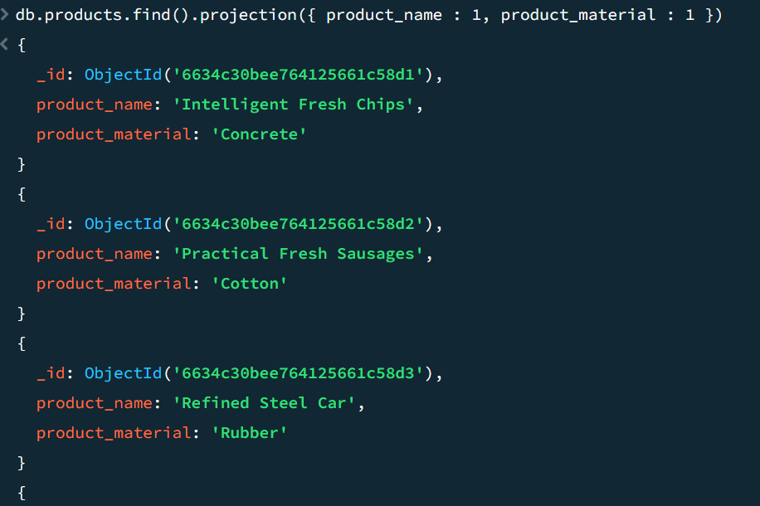

8.Find all products which contain the value of soft in product material

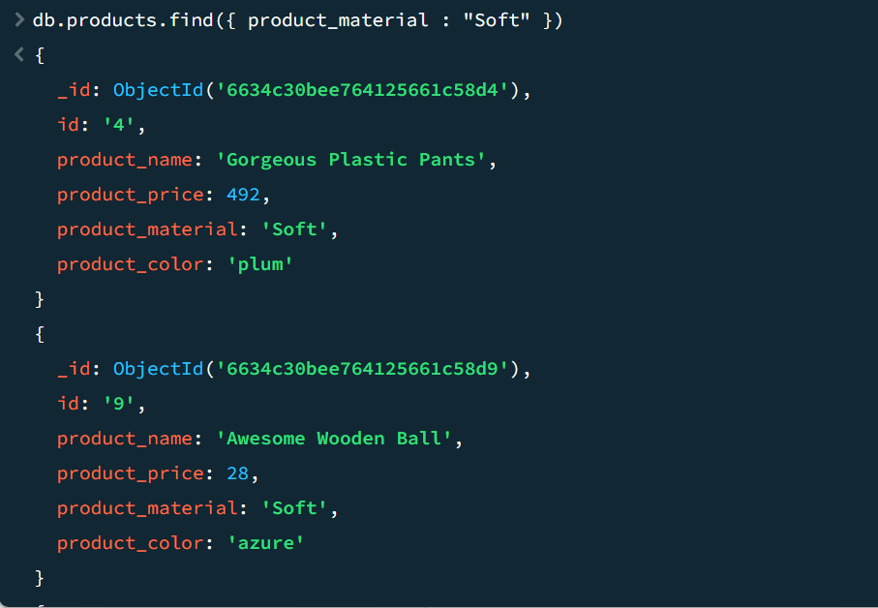

9.Find products which contain product color indigo  and product price 492.00

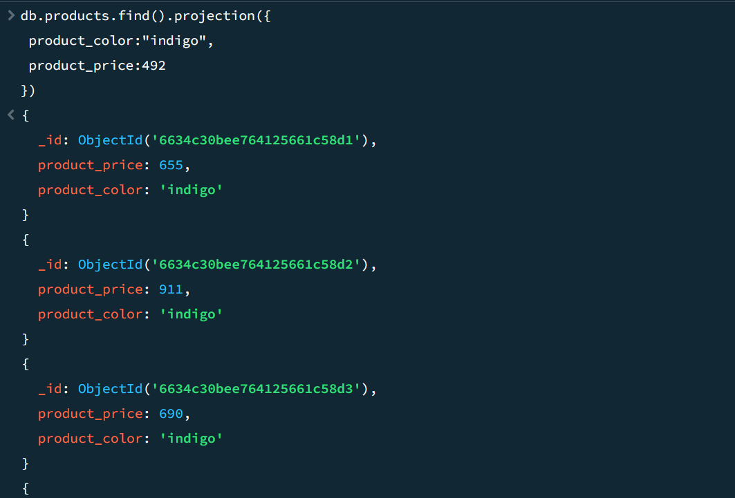

10. Delete the products which product price value are 28

