1. Do the below programs in anonymous function & IIFE
   1. Print odd numbers in an array

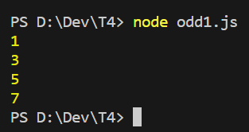

* 1. Convert all the strings to title caps in a string array

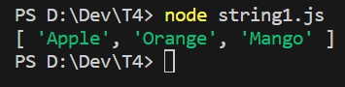

* 1. Sum of all numbers in an array

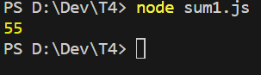

* 1. Return all the prime numbers in an array

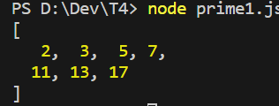

* 1. Return all the palindromes in an array



* 1. Return median of two sorted arrays of the same size.



* 1. Remove duplicates from an array

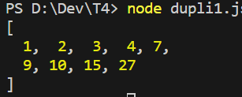

* 1. Rotate an array by k times



1. Do the below programs in arrow functions.
   1. Print odd numbers in an array

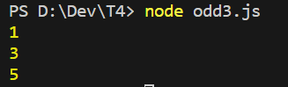

* 1. Convert all the strings to title caps in a string array



* 1. Sum of all numbers in an array



* 1. Return all the prime numbers in an array

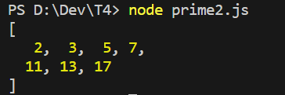

* 1. Return all the palindromes in an array

