Kubernates project images

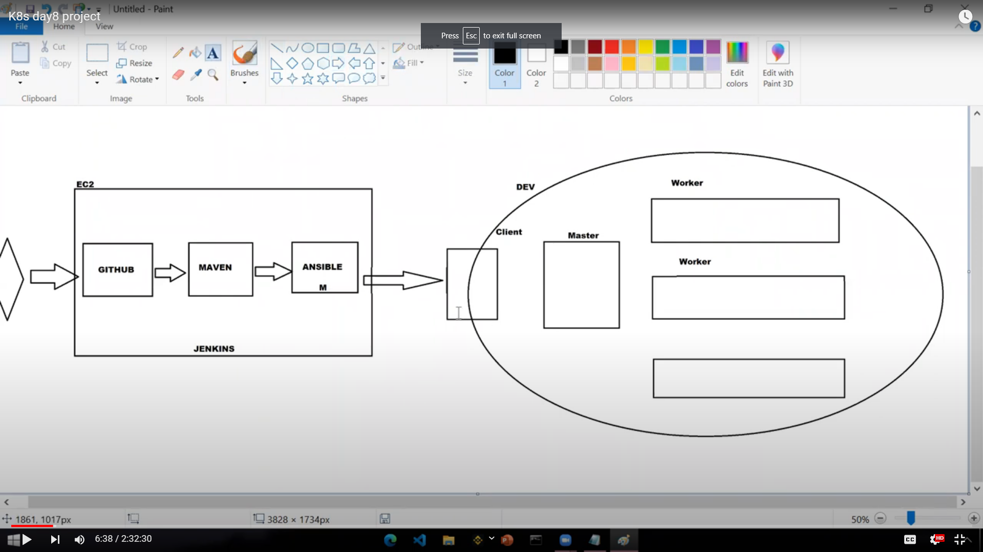

All in one machine master machine and kops docker slave machine

**All in one machine**

Install github

Maven

Ansible

Sudo yum install python-pip -y

Sudo amazon linux-extras install epel -y

Sudo yum install ansible

Ansible –version

Sudo vi /etc/ansible.cfg

Uncommand

Inventory

Sudo_user

Host_key_checking = false

Sudo Vi /etc/ansible/hosts

[kops]

Node1 ansible_host=slave ip ansible_user=ec2-user ansible_ssh_private_key_file=/etc/ansible/newkey.pem

Create file newkey.pem

Ansible all -m ping completed ansible connective

Jenkins -> <https://www.jenkins.io/doc/tutorials/tutorial-for-installing-jenkins-on-AWS/>

Manually plugin install

Github, ansible, maven integration, maven invoker

To find the path of jre. Use the following command

Find /usr/lib/jvm/java-1.8* | head -n 3

(or)

sudo update-alternatives --config java

Ls -a

Hidden file

Sudo vi .bash_profile

JAVA_HOME=/usr….

Source ~/.bash_profile

Echo “$JAVA_HOME”

Manage jenkins ->global tool configuration->

Add JDK

Name JAVA_HOME

Path save

Sudo yum install git -y

Environment varaable—--> <https://www.serverlab.ca/tutorials/linux/administration-linux/how-to-set-environment-variables-in-linux/>

Maven LINk-> <https://maven.apache.org/download.cgi>

Cd /opt/

Wget http…..

-lrt

Tar -xvzf apach….

Mv apach to maven rename it

Sudo vi ./bash_profile

M2_HOME=/opt/maven

M2=/opt/maven/bin

PATH=$PATH:$HOME/bin:$JAVA_HOME:$M2:$M2_HOME

Export PATH

Maven jenkins

M2_HOME

/opt/maven

—--------------------------------------------

Slaven machine

Sudo yum install docker -y

Kubernates installation document

{Add Iam user

Access id password

Bucket create version enables}

Jenkins create jobs

Source code management->git->repositore link

Build -> invoke top-level maven targets -> clean install package

Create another job for trigger the package using playbook ansible

/var/lib/jenkins/workspace/runplay job name

Ansdeploy.yaml jenkins server workspace job

- hosts: kops

become: yes

tasks:

- name: delete the war if it already exists

command: rm -rf /opt/proj/myweb-0.0.5.war

- name: Copy file from master to slave

ansible.builtin.copy:

src: /var/lib/jenkins/workspace/createwar/target/myweb-0.0.5.war

dest: /opt/proj

mode: '777'

- name: build docker image

command: docker build -t "sureshwaran06/k8proj" /opt/proj

- name: push docker image to docker hub

command: docker push sureshwaran06/k8proj

- name: do deployment using kubectl

command: kubectl apply -f /opt/proj/deployment.yaml

build-> invoke ansible playbook

Ansible

/var/lib/jenkins/workspace/runplay/filename

Sudo service docker start

Cd /opt/proj/

Vi Dockerfile

FROM tomcat:latest

ADD myweb-0.0.5.war /usr/local/tomcat/webapps

Sudo docker login

Password

Post-build actions

Projects to build

runplay

/opt/proj

apiVersion: v1

kind: Service

metadata:

name: nodeport-svc

spec:

selector:

app: hello

ports:

- name: http

port: 8080

targetPort: 8080

nodePort: 30008

type: NodePort

---

apiVersion: apps/v1

kind: Deployment

metadata:

name: loadbalancer-pod

spec:

replicas: 1

selector:

matchLabels:

app: hello

template:

metadata:

labels:

app: hello

spec:

containers:

- name: hello

image: sureshwaran06/k8proj

ports:

- containerPort: 8080

Sudo docker images

Sudo docker rmi sureshwaran06/k8proj