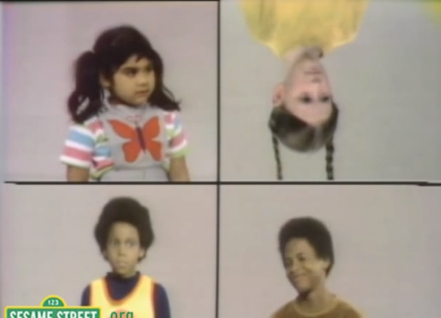

Which of These Does Not Belong?

Anomaly Detection in Images Using a Deep Neural Network and Isolation Forest

*Mark Wilber,* Galvanize Hiring Day

“... as we know, there are known knowns; ... things we know we know. We also know there are known unknowns; ... we know there are some things we do not know. But there are also unknown unknowns ~ the ones we don't know we don't know.”

Donald Rumsfeld, 2002

Much of anomaly detection is done using classifiers, *supervised learning*

* Use existing data sets, label anomalies (fraud, network intrusions, etc.)
* Train on anomalies we know about: *known knowns*

Motivation

Motivation

Alternatives exist

* Suppose that data can be fit by multi-variate Gaussian
* flag as anomalies those points sufficiently far into tail

*Will not work if “ordinary” data are in widely-spaced*

*clusters*

* Distance-based methods, which become impractical in high-dimensional space, or which require knowledge of how many clusters of normal points there are.

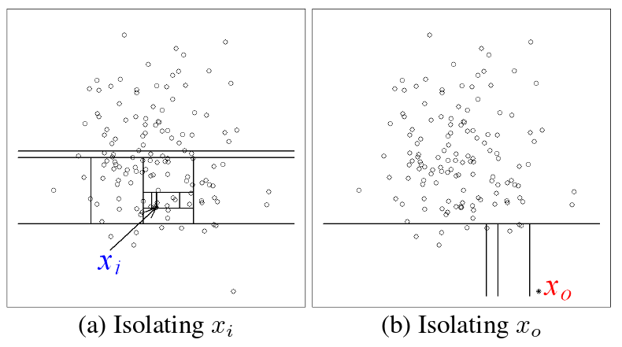

Isolation Forest1

* Un-supervised method of statistically isolating points that have no close neighbors in feature space
* Advantage: no need to compute large numbers of distances to find which points are distant from others.

Solution

1Liu, F.T. et al, ICDM `08b, 2008.

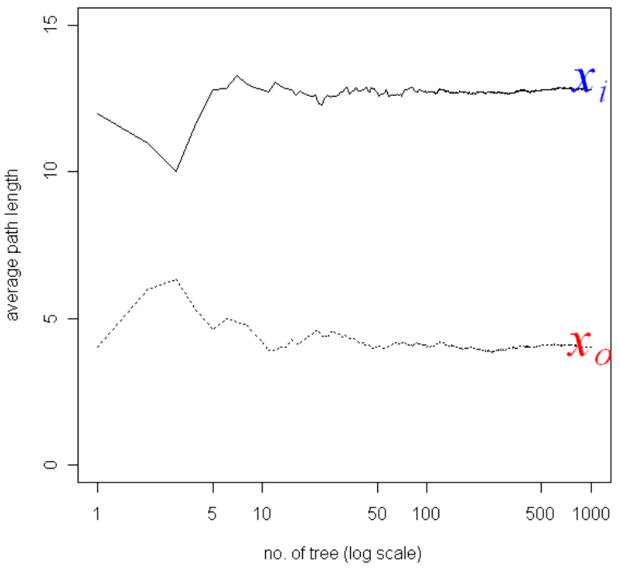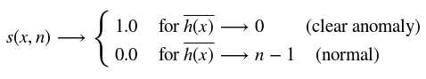

Solution

Isolation Forest1

Anomaly score, makes use of ensemble averages for trees to isolate each point, with:

1Liu, F.T. et al, ICDM `08b, 2008.

Appropriate Features

When data are in the form of images, could work with raw pixels, *but ...*

* Identical images translated by a few pixels can be located far apart in p-dimensional feature space
* Should take advantage of excellent work done in image feature representation ― deep neural nets (DNN)

“Featurizing” Images

Introduce available pre-trained deep neural network2

* Re-size images, subtract training average, insert into DNN
* Extract (4096) high-level feature weights for each image
* Apply Isolation Forest to these features
* Determine anomaly score threshold:
  + That which matches some significance criterion
  + That which yields true positive rate that can afford to investigate in detail.

2Krizhevsky, A, et al, *Imagenet classification with deep convolutional neural networks,* 2012.

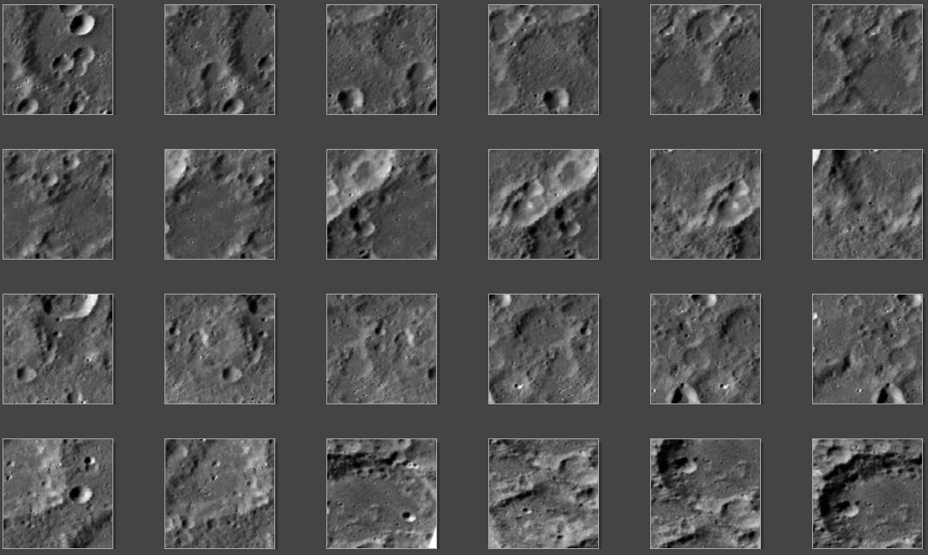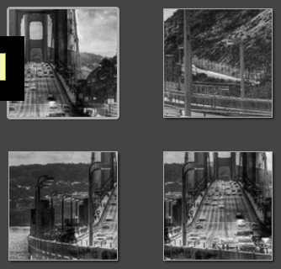

Results

Starting with 2000+ photos of lunar landscapes, with a few sections from a photo of the Golden Gate Bridge.

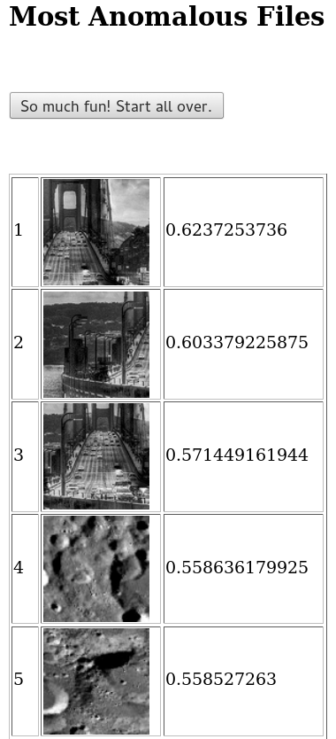

Results

Out of 2000+ images, the anomaly scores for the Golden Gate Bridge are at the top, separated by all others by 10% or more.