| **APPLICATION SCREENSHOTS** |
| --- |

| **APPLICATION NAME** | LockedMe.com |
| --- | --- |
| **DEVELOPED BY** | Suresh Kirsagar |
| **DATE** | 14th Aug 2021 |

**TABLE OF CONTENTS :**

1. **Main Menu ---------------------------------------- 3**
2. **Displaying all files in a folder -------------- 4**
3. **Adding a file in a folder ---------------------- 5**
4. **Deleting a file in a folder -------------------- 6**
5. **Exiting the application ------------------------ 7**

**1. Main Menu**

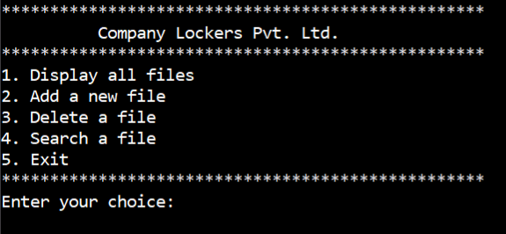

**2. Displaying all files in a folder.**

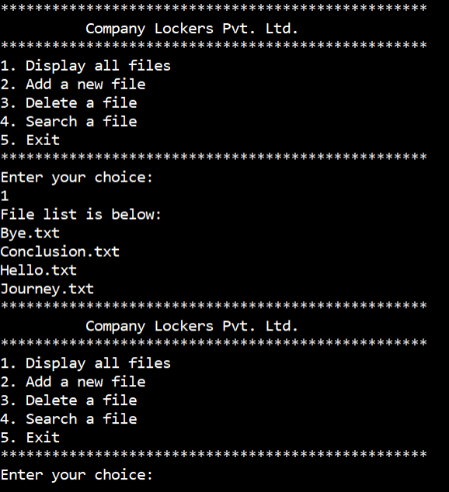

**3. Adding a file in a folder.**

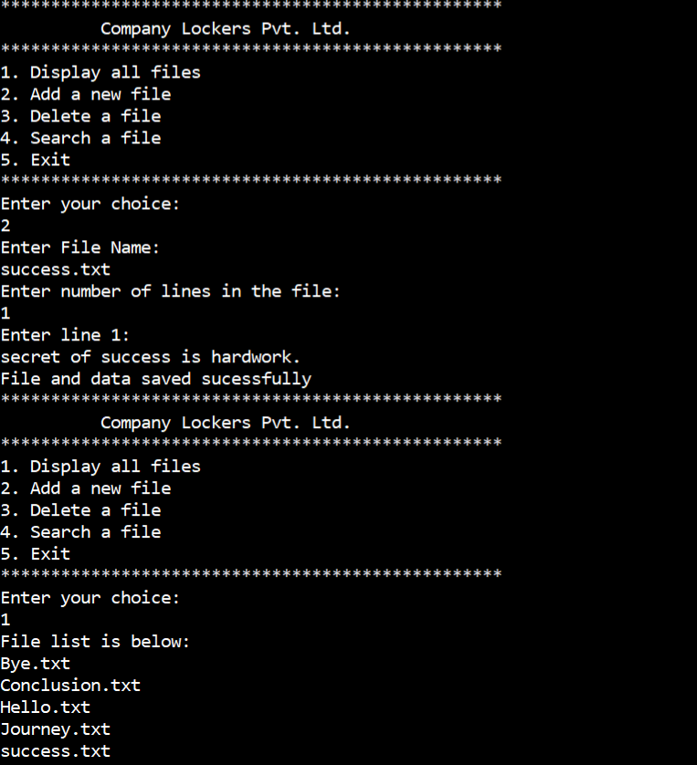

**4. Deleting a file in a folder.**

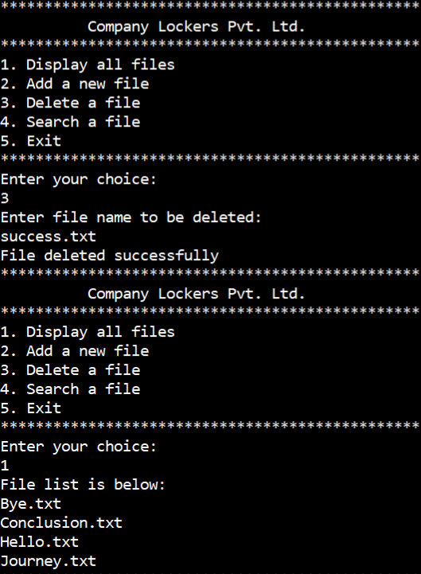

**5. Exit the application.**

