Below is my repository link for the webpage created.

<https://github.com/SureshKumarSingamsetti/My-second-Web-page>

Below are my source files created as part of this repository. Also attached them here and posted in my repository path shared.

1. homepage.html
2. about.html
3. site.css
4. site1.css
5. picture.png
6. meal1.png
7. meal2.png

 

homepage1.html displays my website homepage. From there user can navigate to about us page.

Site.css & site1.css provides the CSS style to the website.

Below screenshot is the page which gets displayed when homepage.html is opened in a browser.

Next when you click on About us link the user will be navigated to other page about.html.

And then user can again come back to the home page by clicking the link provided.

Then user once comes to the home page, when he click on book button, it provides the customer care number to contact and book the meal.

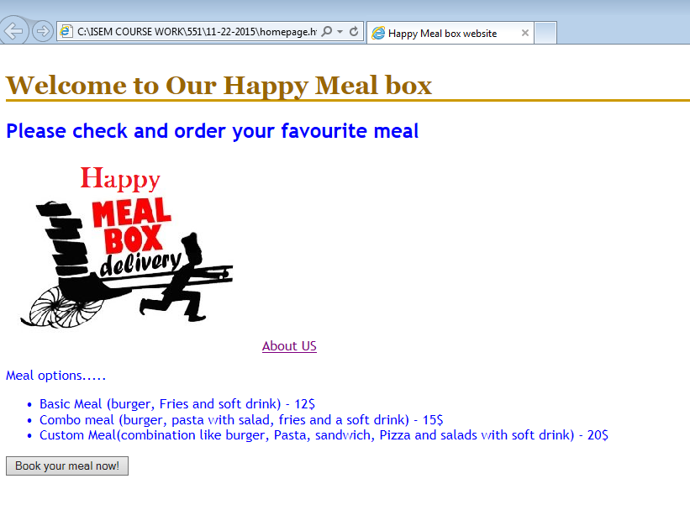

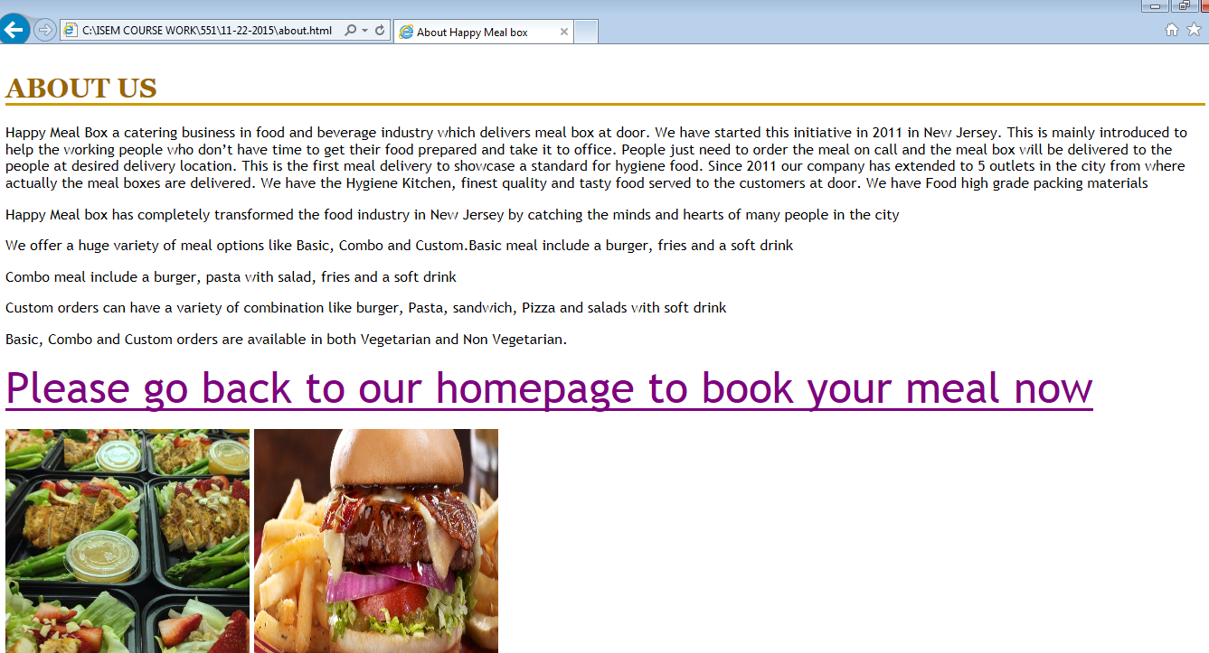

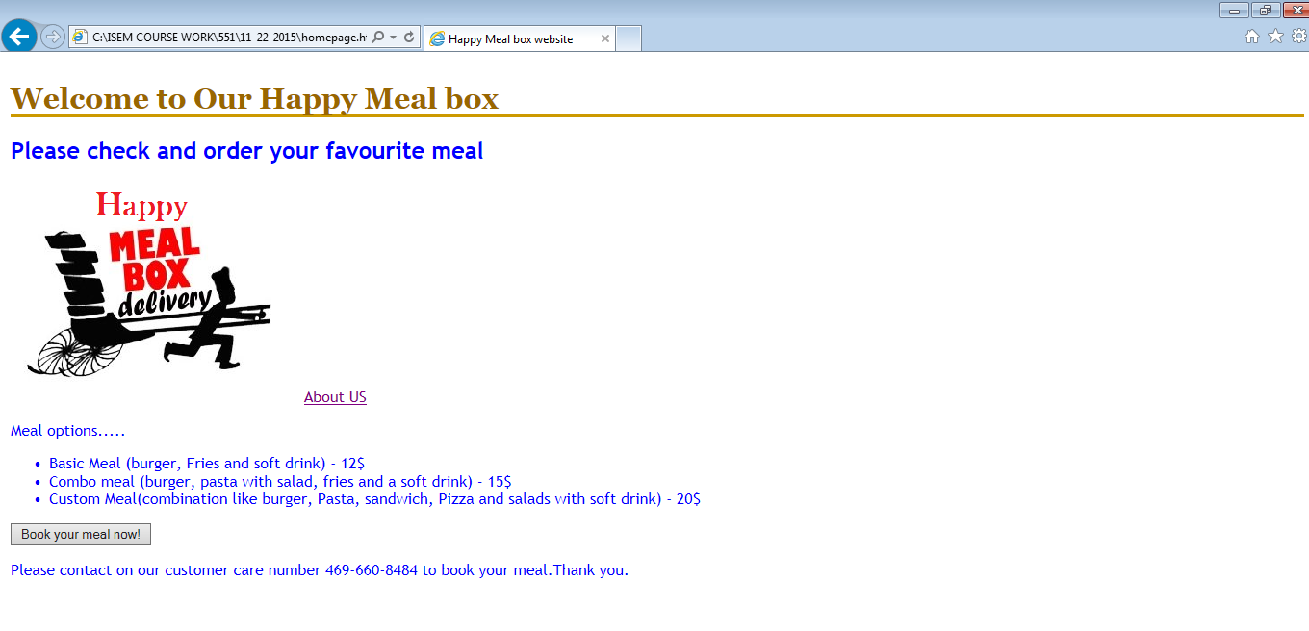

Thank you.