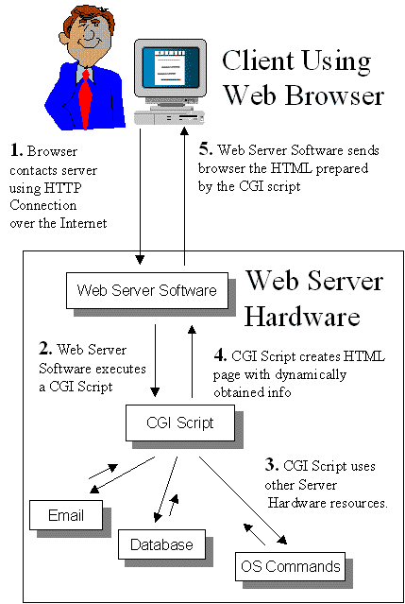

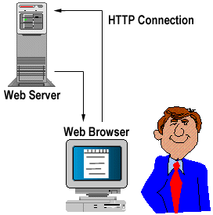

What is ASP?
It wouldn't be any use to you if we just wrote down what's in ASP. We could just sell you a cheat sheet. Syntax is nothing if you don't know what surrounds that code, how the code fits into the environment it's built for and how to fix the code when it's broken. So in this chapter, before we hit the specifics, we'll cover the generalities, namely:
What ASP is and where to get it
What you'll find in an Active Server Page
An overview of the ASP object model
Scripting objects and components
How ASP works
What languages we can use to write an Active Server Page
Good ASP coding techniques
Where else to look for help with your ASP
Let's start with one of the key questions…

What is ASP?
In the dim and distant past, web developers wishing to create more than just static displays of information turned to CGI (Common Gateway Interface) and Perl to introduce some sort of interaction to their pages. While this approach worked (and indeed, many sites still use it today), CGI was not by any means fast and the quest for an alternative means to create a page dynamically continued. ISAPI came and went – primarily because it required more knowledge to create a dynamic filter than web programmers were prepared to learn. Finally came web scripting languages and with them Microsoft's Active Server Pages: a server-side scripting technology for building web pages that are both dynamic and interactive.
An Active Server Page itself is simply a text file script with the extension .asp containing HTML, client- and server-side script. The implementation behind the ASP page was created by Microsoft and intended as an open technology server-side framework, giving web developers the freedom to develop dynamic web sites using information accessed from the many COM-compliant data sources available to them.
The syntax and grammar of ASP is easy to comprehend, and yet powerful enough to:
support some interaction between page user and server
allow web page access to databases and directory services
incorporate and make use of high-powered COM components
It's also server-based, and therefore browser-independent, leaving you only the problems of which cross-browser client-side script and stylesheet you want to use.
Writing ASP pages is straightforward:
The static content of the page is created using HTML and text. We can also use standard HTML forms to question the client and, using ASP, create a page that incorporates their answers into the text. This is the simplest form of client-server interactivity using ASP.
We make calls to one or several of the ASP intrinsic objects to create the dynamic element of the page. ASP provides a set of intrinsic objects – Response, Request, Application, Server and Session – that allow us to access information about the request being made of the server, as well as the response that the server will send.
We also have access to the functionality of our standard scripting languages (VBScript, JScript and JavaScript) and the scripting objects they expose.
Finally, we can incorporate any standard COM object (or active server component, as we call them) into a page. There are many third-party companies who specialize in writing such components and if you do use them, then you have the added guarantee that they've been stress-tested and fully debugged. On the other hand, if you need your component to do something unique, COM components are easy to develop in any established language. Visual Studio would be a good investment at this point.

What is the Active Server Pages Object Model?
In this chapter, we have looked at how a physical object can be represented by a programmatic object. This programmatic object has all of the interfaces of the physical object, and it can be used as an interface between an application and the physical object itself. But what about objects that don't have a physical counterpart?

In the Active Server Pages programming model, there is a wide range of functionality that is accessible to the programmer. ASP helps us to track the state of a user, dynamically generate HTML output, and take data from forms to be inserted into a database. All of this functionality makes ASP a rather complex beast. Microsoft was tasked with finding the best compromise between offering a simple programming model and providing access to all of the power that ASP provides. To do this, the functionality was grouped into a set of objects. These objects were then related together into what is known as an object model.

An object model is a representation of a set of objects and their relationships to one another. These relationships can take the form of containment, where one object is embedded inside of another. Or, they can take the form of a parent–child relationship, where one object has a set of child objects associated with it.

We will not be examining the various methods for grouping objects together in this book. What is important to us is what the objects that make up Active Server Pages are, and how they are related to each other.

Object Model Structure
Seven objects make up the core of Active Server Pages. These are known as the built-in objects. The objects are:

-  Server object
-  Application object
-  Session object
-  Request object
-  Response object
-  ObjectContext object
-  ASPError object

Each of these objects interacts with a different part of the ASP system. This chart shows how they are related to each other, and how they are related to the client and to the server.

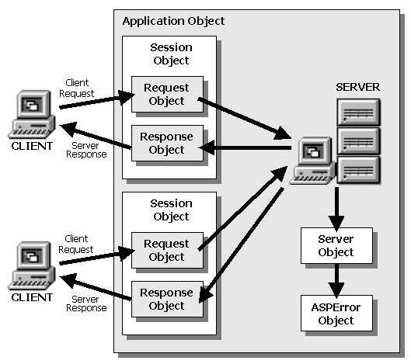

The following chapters in the book will go into each of these objects in greater detail. They will also provide a series of basic examples that will quickly show you how to use these objects to create ASP scripts. But for now, we will just take a quick look at what each object is for.

The Server Object
The Server object is an object that provides a home to a miscellaneous ragbag of properties and methods that can be used in almost every Active Server Page. While seemingly unrelated, these methods and properties are in fact abstractions of the properties and methods provided by the web server itself. This object will allow you to do things such as:

-  Set the amount of time a script can run before an error occurs
-  Take a user-supplied string and encode it into HTML format
-  Convert a virtual path to a physical path on the server
-  Take a user-supplied string and encode it into the proper format for a Uniform Resource Locator (URL) string
-  Create an instance of an ActiveX component. You saw this earlier in the chapter with the CreateObject method of the Server object.
-  Change the course of execution by jumping to another page using the Transfer and Execute properties.

These methods and properties are provided as utility functions for you to use in your pages. They are not directly used to affect the display of the page, but they still provide valuable support in creating Active Server Pages. Chapter 11 will cover this object in greater detail.

Application Level Objects
As the web is moving from just serving up pages to providing access to dynamic information from a wide range of systems, the sites that a user may access are beginning to look more like a traditional desktop application. We touched in Chapter 2 on the idea of a web application, and that all dynamically generated web sites are in fact web applications The application object represents your site and all of its visitors.

The Application Object
Since these pages are functioning together as an application, naturally the developer would want some control over the application as a whole. This is the responsibility of the Application object. This object will be covered in detail in Chapter 8, but let's just introduce a few things that it can do.

With this object, you can:

-  Be notified when an application is first started, so that you can perform some startup processing.
-  Be notified when an application is ending, so that you have the opportunity to perform functions to enable the application to close down cleanly.
-  Store information that can be accessed by all clients accessing the application.

There is one instance of the Application object for each web application running on the web server. There may be many clients accessing the same application. They each can get a reference to the same Application object. Next, we will look at an object that is unique to each client of an application.

The Session Object
There is one Application object for each application on the web server. Every client accessing that application can get a reference to it. Each of these clients opens a Session, therefore, each of them has a reference to a unique Session object. This object will be covered in Chapter 8, but here is a little of what it can do. The Session object will allow you to:

-  Be notified when a user session begins, so that you can take appropriate actions for a new client.
-  Be notified when a client has ended their session. This can either be caused by a timeout or an explicit method called Abandon.
-  Store information that can only be accessed by that particular client throughout the session.

The Session object is the most powerful object for continuity when using an application in Active Server Pages. One of the problems that have existed in creating web-based applications is that the connection between the client and the server is stateless. The web server itself has no mechanism for tying a request for a page by a client back to a previous request for a page by the same client. This means that each request that one client makes of a web server is treated independently from the rest. While this allows for a very efficient and fast web server, it makes writing applications nearly impossible.

Think of it this way. If you are writing an application using a standard web server, then every request to the server must carry along with it everything that you have done related to the application up to this point. Since the web server has no way of storing and retrieving that information, it is up to you to provide it every time you make a request of the server. Sounds pretty cumbersome? Well, with the Session object, Active Server Pages allows you to store and retrieve information about the client accessing your application. Nevertheless, this is just to whet your appetite. Stay tuned for Chapter 8 when the Session object will be explored in detail.

Page Scoped Objects
As we traverse our way through the object model, we now move from the Session level down to the individual page level. When working with pages of the application, we need to look at the basic function of a web server.

Basically, a web server operates by receiving a request from a client and then sending a response back to it. This request could be for an HTML page, or it could be the data from a Form submission that the user has made. To make our pages dynamic in ASP, we need to take the information that has been submitted and craft a customized response to send back to the client.

Active Server Pages provides two objects that allow you to interact at the page scope. The information that is sent from the client to the server is held, or encapsulated, in the Request object. The information that the server prepares to send back to client is encapsulated in the Response object. These two objects are good examples of objects that have physical manifestations, like our telephone. They are modeled on the HTTP request and response.

The Request Object
When a web browser or other client application asks for a page from a web server, this is called making a request. Along with the actual page that the client wants, it can send a great deal of information to the server as well. The Request object is responsible for packaging up that information to make it easily accessible to the ASP application.

The client asks the server to create an html page, by requesting an .asp script. When the server sees this request, it interprets this type of page as an Active Server Page. All of the information that the client is sending along with the request is then packaged into the Request object. This information is then accessible to the actual ASP script that is used to construct the page.

The information is categorized into five sets of information. Since each set of information can include multiple individual pieces of information, each set is stored as a collection. In a collection, each piece of information is stored as a name-value pair. We talked about name-value pairs earlier when we introduced object properties.

The collections in the Request object will be explained in detail in Chapter 7, but we will quickly introduce them here. The collections hold information about:

-  The values that are provided in the URL that are sent by the client. In the URL, the client can include name-value pairs of information after the file name. This information is stored in the collection called QueryString.
-  If the client is sending a Form request, then the values of the form elements are stored in another collection – the Form collection.
-  The web server itself has a great deal of information about the request, response and general information about the server itself. These are called the HTTP Server Variables. This information is made available as a collection as well.
-  If the client is sending any cookies along with the request, these are included in their own collection.
-  In addition, if the client is sending any security certificates to the server, then these are included in their own collection.

By using the information that is included with the request, along with the script code in the Active Server Pages script file, the server can dynamically generate a page for the client to display. In order for the client to display the information, the server needs a mechanism to relay the data back to the client. This is the job of the Response object.

The Response Object
The primary feature of Active Server Pages is the ability to dynamically create web pages. The basic task needed to execute this feature is the ability to tell the client what information to display. There are a number of different ways to shape what the client will be displayed. The Response object exists to provide an efficient interface to control the output to the client.

The Response object provides the ASP script with a set of interfaces that allow the script to control what information is being sent back to the client. The details of the Response object will be covered in Chapter 8. For now, we will just touch on some of the functions that the Response object provides.

With the Response object, the ASP script can:

-  Insert information into the page being sent back to the client.
-  Send instructions to the browser to create cookies on the client.
-  Send the client to another page via a redirection.
-  Control whether the page is sent as it is created, or whether it is completely built and then sent at one time.
-  Control the various properties of the page, such as the HTML headers or the type of content.

These interfaces give the designer of the script the ultimate flexibility to decide how the information is presented back to the client.

The ObjectContext Object
The ObjectContext object helps you to develop applications out of components. It does this by allowing you to handle transactions from within an ASP page. A transaction is a single unit of work, that must either succeed in its entirety or if it fails, then must be undone completely returning the system to the state it was before the transaction was started.

When using applications made of out of components, its common to use transactions. If for example an action handled by a particular component fails, then you'd want details of the failure, and be able to take an alternative course of action. If a user tried to change details of their bank account and then bombed out mid-track, it would be logical to want track back to what the bank account details were previously, before trying to change the details again or continuing on alternative course.

The second type of application that uses transactions would be one that features data processing. If someone makes an alteration to a database via a web page, and somebody else makes another alteration at the same time, you need to be able to accept one alteration, while canceling, or postponing, the other. The management of these types of transactions was handled in IIS 4.0 and PWS 4.0 by a piece of software known as Microsoft Transaction Server (MTS). However, with IIS5 and Windows 2000, the functionality of MTS is now integrated directly into part of the Windows 2000 operating system known as COM +.

The ObjectContext object allows access to what is known as MTS to start or terminate a transaction. We don't want to go into how it does that now, that's a topic for later in this book, but this hopefully gives you an overview of this useful object.

The ASPError Object
The ASPError object contains details of any errors generated by an ASP script or by the asp.dll itself. Previously, there was no facility in ASP for storing details of errors that occurred. The ASPError object with help from the Server.GetLastError method, allows more complex customized handling of error messages. It directs the user to a standard error page, or to a user-created page depending on the option selected in MMC.

So now that we know what ASP is, where can I get an ASP scripting engine from?

Where Can I Get ASP?
ASP is a web enhancement tool that was developed and distributed by Microsoft. As such, the ASP scripting host (which translates ASP into HTML) is distributed within Microsoft's web-specific products – its web servers, Internet Information Server (IIS) and Personal Web Server (PWS) and its HTML editors (FrontPage 9x and Visual Interdev, though not Notepad ;-). In the spirit of the open standard that ASP wants to be, the scripting host has also been taken by third parties and rewritten for use with other, non-Microsoft web servers – more on that later.
To date, there have been two versions of ASP for development use. The first, ASP 1.0, appeared in 1996 with Windows NT4 Service Pack 3 as part of IIS 3.0. ASP 2.0 reared its head about nine months later, much improving on its previous incarnation – it is this version which is available for installation with a web server/html editor from quite a few sources. The latest version, ASP 3.0, is due to ship some time in the first half of 1999 with IIS 5.0 (as part of Windows 2000. Since ASP 3.0 is currently not widely available (and is still in beta), we'll concentrate on ASP 2.0 in this book, which you can install from the following sources.

Windows NT 4.0 Option Pack
Contrary to its rather specific name, the Windows NT 4.0 Option Pack comes in two different flavors (the choice depends on which operating system you are using). If your system set-up is based upon Windows 95 or Windows NT 4 Workstation, then ASP will be installed with Personal Web Server. If you use Windows NT 4 Server, then ASP is installed with Internet Information Server.
The Option Pack is available from several different sources:
MSDN subscribers will find it on Disk 2 of the BackOffice Test Platform or
Disk 13 of the Development Platform.
Other users can download it from the Microsoft home site at http://www.microsoft.com/ntserver/nts/downloads/recommended/NT4OptPk/default.asp. The total pack is 27Mb, so be prepared for a long wait – and no, there isn't an option to download just IIS and ASP.

Windows 98 Install Disk
The Windows 98 Install Disk includes a version of Personal Web Server and ASP as an extra to the operating system itself. Simply run setup.exe from the add-ons/pws directory of the disk and all will be well.

Visual Studio 6
Personal Web Server and IIS, and therefore ASP, are included with this product.

Installation and Setup under Windows NT 4.0
Windows NT4.0 can be a tricky beast to set up, and getting the latest version of ASP running with the latest hotfixes for security holes and other bugs can be a matter of trial and error unless you know the right order in which to install your software. For an NT 4.0 web server running ASP, it would be preferable to get a copy of the NT 4.0 Option Pack and then install in this order:
Windows NT 4.0 Server/Workstation
NT 4.0 Service Pack 3
Internet Explorer 4.01 (or later)
NT 4.0 Option Pack (or other source of ASP)
NT 4.0 Service Pack 4
Service Pack 3 is required to install the Option Pack, but in its turn the Option Pack contains older files than SP4 which contains the latest hotfixes (upto November 1998 anyway). Check out the Microsoft security or downloads sites for the fixes after SP4 (see Appendix H for URLs).

Setting up ASP under IIS
If you've installed Internet Information Server, there's a couple of other things you need to do in order to make sure ASP is running and will run in your test code. Checking that ASP has been installed properly is simplicity itself. IIS documentation comes installed as a set of .asp files – you can test your ASP installation simply by choosing to run those help files from the Start menu (at Programs | NT 4.0 Option Pack | Product Documentation). If the help files display correctly, then ASP is running. If they don't, then it isn't.
The other quick check to make is to ensure that the virtual root for your web site is set up to run .asp files. In the MMC, expand the IIS folder and select either a web site or a virtual directory beneath it. Bring up the Properties dialog for that virtual directory by right-clicking on it and selecting Properties from the menu that appears. Select the Documents tab, add Default.asp to the default documents listbox and promote it above Default.htm using the arrows on the right-hand side.
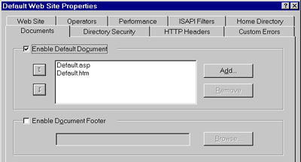
Finally, click on the Home Directory tab (this will be the Virtual Directory tab if you are setting the properties of a virtual directory instead of a web site). Under the Permissions heading at the bottom of the dialog, make sure the Script radio button is checked – this ensures the ASP scripting host will parse the page when it is requested by a client.
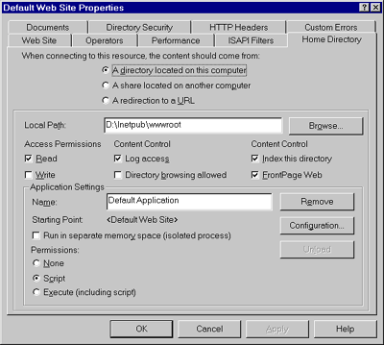
This applies to IIS4.0 only. In IIS3.0 the Script button doesn't exist, so you have to select the Execute button. It was only when IIS3.0 was being used in production setups, that anyone noticed that selecting Execute allows any executable file to be run in that directory – which imposed a security threat on the website . Thus, in IIS4.0 the Script button appears in the Permissions dialog to allow only the 'secure' execution of scripts in the relevant directory.

Setting Up ASP Under PWS
Personal Web Server is really just a scaled down version of Internet Information Server and to ensure that ASP is running correctly and is available for your site, the checks are the same. The PWS documentation can be run from the Start menu under Programs | Personal Web Server | Product Documentation to confirm that ASP is running, and once you have created a virtual directory for your web site, the default document dialog can be found in the Advanced Options window of PWS.
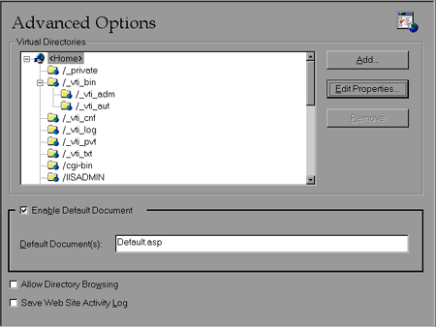
Meanwhile, the Scripts permission button can be found by selecting Edit Properties. Again, make sure that Scripts is checked along with Read.
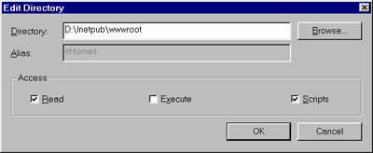

ASP is not just for IIS
The core of ASP is the ASP Scripting Host, which you can find in asp.dll – without it, we would have no working .asp files. However, although the vast majority of ASP developers are currently using either Personal Web Server or Internet Information Server to base their pages on, these web servers are no longer the only products that contain a productive ASP engine for us to work with.
The really attractive part of having open standards – even wannabe ones like ASP – for the Internet is that once a standard has been released, it can be implemented by anyone. Soon after Microsoft's release of ASP 1.0, a company called Chili!Soft began to develop a fully-functional parser for other web servers besides IIS and PWS.
On the Windows NT platform, Netscape's Enterprise and Fasttrack servers are now ASP-enabled thanks to their product Chili!ASP, as are Lotus' Domino and Go Webservers. A version for NT Apache is currently in beta. Chili!ASP also offers ASP and ADO to Netscape servers on the Sun Solaris platform and has plans in the works for more non-PC-based servers too. It will be interesting to see how Chili!soft react to the release of ASP 3.0. The question of whether or not they'll upgrade their current products is pressing, but whatever the answer there, ASP is no longer just for IIS.

The ASP Object Model
We mentioned earlier, that "we make calls to one or several of the ASP intrinsic objects to create the dynamic element of an active server page". These objects are immediately accessible to the ASP developer and neatly cover all the key aspects of creating dynamic and interactive pages. Together, the five intrinsics and their parent object form the hierarchy that is the ASP Object Model, which looks something like this:
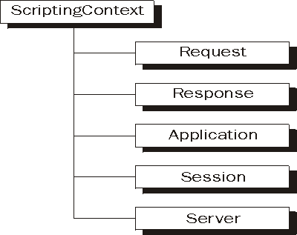
Each of the objects has a set of collections, methods, properties and events which provide them with all their functionality. The following chapters will take you through the calls and syntax of the five objects, but for now we'll have a brief look at how the objects divide up their work.

The Scripting Context Object
It's a bit of a cheat to include the scripting context object at the root of the ASP object model. Even though this is its rightful place, you'll never have to reference it directly because it simply represents the scope under which any scripting in ASP runs. Whenever a block of ASP code is run, ScriptingContext is created automatically, making the ASP intrinsics available to the scripting host along with the scripting objects. Similarly, when the scripting host finishes parsing an ASP page, it destroys the instance of ScriptingContext automatically.
In Visual Basic you can create an instance of the ScriptingContext object to get access to the ASP object model – this is what Visual Basic's new WebClass feature does.

The Conversation Objects - Request and Response
One of the main reasons that first scripting languages and then ASP were developed was that by themselves, HTML pages did not 'respond' to the client. They were static. The advent of scripting languages brought us the ability to determine what was going on within a page and react to that but these 'interactions' were limited to a developer second-guessing a user's actions and pre-programming a reaction. Only with ASP did the technology come into being that allowed a client's action (his response) to be 'seen' by the server and dealt with by the server. For an ASP developer, a website 'listens' to the client browser with the Request object and then answers using the Response object.

The Objects of State - Application and Session
As time has gone by, we have seen the transformation of static web content into fully competent web-based applications. We can now check our bank account, buy a computer, or hire a llama over the web – and most of the web applications (or weblications, if you prefer hideous contractions) online today are written and developed just as they would be if they were to be packaged in a box. ASP pages provide the user interface while COM components encapsulate the necessary business logic and let us access databases where our business information is stored. The only difference between developing applications for commercial distribution and web applications is the question of state.
The protocol over which web applications are run – HTTP – is stateless. It cannot remember from one page request to the next who you are, what you are doing or even what page you last looked at. Nor can it retain, for example, what items you're currently buying from amazon.com or CDNow. This is where the Application and Session objects come in, providing the virtual memory for a web application to run correctly and retain state.

The Server Object
Finally, we have the Server object, the least populated but arguably most useful object of them all. This contains four miscellaneous methods that the server performs, the most utilized of which is CreateObject – which allows us to create an instance of an ASP component.

The Scripting Objects
The third ingredient(s) in our ASP recipe are the Scripting Objects, which are available to us through the VBScript scripting engine – the FileSystemObject object, the TextStream object and the Dictionary object.
The FileSystemObject object allows us to code a page that accesses the file system of the web server itself. If we use the FileSystemObject object correctly we could create a website with the same functionality as Windows Explorer if we so wished. The key to this ability is the hierarchy of collections and objects of which it is the root:
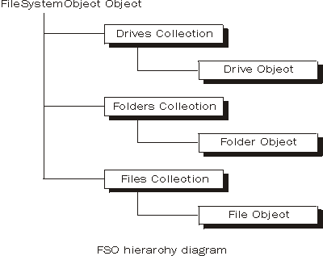
A Textstream object is created by a call to one of FileSystemObject methods, OpenTextFile or CreateTextFile, or to a File object's OpenAsTextStream method. Once created, it gives you read/write access to the contents of the text file specified in the method. Of course, this will only work if the file actually contains valid ASCII characters. Naturally, .txt files work with TextStream, and so will .htm or .asp files, which are displayed as source code. You might also wish to inspect .log files with this object as well. But don't expect decent results using TextStream to inspect a .dll or a .bin file.
The last of the three scripting objects, the Dictionary object, acts as aneasily accessible store for name/value (or key/item as they are properly known) pairs, generated by the application during a session. Dictionary objects usually last for the duration of the page but can be stored in a Session object for use in a more 'mobile' role.

Using ASP Components
The final piece to the core-ASP puzzle is the use of ASP Components in a web application to encapsulate some or all of the key actions and rules that the application runs under. Heavily-hit sites become much more efficient when some or all of their functionality is coded within components, with ASP used as the adhesive to synchronize the program flow and integrate the components' functionality together.
The phrase ASP Components is a bit of a misnomer, because they're actually COM objects – written not in ASP but in C++, Visual Basic or Java. They are standalone .dll or .exe files that have entries in the Windows registry and make available extra properties and methods to the developer using them. At a low level, practically everything in the Windows world is based on COM (Microsoft's Component Object Model architecture) – even ASP. The intrinsics are also COM objects, stored in asp.dll, and can be used by any programmer who knows the correct way to reference them.
The key to ASP components is that the functionality within them has been pre-compiled and will run faster than if the code was parsed by the ASP Scripting Host. The performance gain is quite noticeable and, of course, they can be reused on many different sites as well.
There are four broad 'categories' of ASP component, as follows:
Presentation Components. The one aspect of an application seen from the moment it starts is its user interface. Presentation components take the trouble out of the graphic side of web application creation and allow a developer to code the invisible back-end part of his site.
Business Components. Developers building applications for the web may use ASP components to encapsulate their business logic rather than put it in an ASP page with the presentation code or in with the data server. The advantage to this approach is that if business logic needs to be updated, you only need to alter it within the component – you can leave both the data access and presentation code alone. A good example here is a component that encapsulates standard rules to validate credit card information for an e-commerce site.
Data Components. Rather than use a great deal of code in a page querying (for example) an SQL database, a developer may choose to use a component to perform the queries and just call the component from the code. Alternatively, he could use a data component to access information from another non-database type of system.
Utility Components. There are plenty of ASP components that perform some function that does not fall neatly into any of the three tiers of the classic application development model. We refer to these as utility components. For example, consider a component that allows us to upload files from one location to another over HTTP. It might even let us store these files within a database for good measure.
ASP components are fairly easy to come by. Some are automatically installed along with PWS and IIS, others are available from the IIS Resource Kit, and many more are available for download free of charge from the web. There is a thriving market in reliable third-party components too – however, these ones cost – or you can of course write your own.

How Does ASP Work?
How does an .asp file, full of calls to the ASP intrinsic objects and other components, get translated into an HTML page that a standard browser can view (and execute)? In fact, the process is reasonably simple:
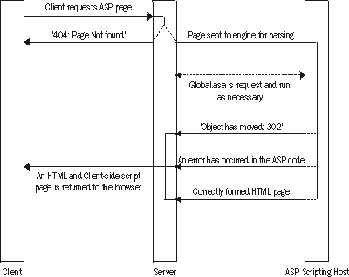
The client requests an ASP page by sending an HTTP Get or Post Request to the server. All things being equal, one of two things will happen here. If the server cannot find the file then it responds with the familiar HTTP 404 Not Found message. If the file is found, it will be recognized as an Active Server Page because of its .asp extension and sent to the ASP Scripting engine to be parsed. (All things not being equal, then something untoward – like a Server Error – may occur.)
The Scripting Host, located in asp.dll, can now do two things. If this is the first ASP page to be sent to this client from the server, this means a new session, and possibly a new application too, has begun and it will check global.asa for anything to do before it gets to the requested page. Once that has been done, or if this is not the first ASP page the client has requested, the host then executes all the server-side scripting code in the page as delimited by either <% ... %> or <SCRIPT RUNAT=SERVER> ... </SCRIPT> tags. Once this has been done, the engine passes back one of three things: an error page, an object moved status code, or an HTML page.
If either an error page or a correctly-formed HTML page is passed back, it is then displayed. If the ASP page contained a call to Response.Redirect, the server will pass back to the client the HTTP code 302 telling it that the page requested has moved temporarily. Note that if response buffering had previously been set to true, it will seem to the client that the server automatically transferred him to the new location of the page. If response buffering is set to false, which is the current ASP default, they will see an error page telling them the page they wanted has moved temporarily.

ASP Applications
Before we go any further, it would be a good idea to tie a few loose ends together and explain a few of the concepts that we've encountered in a little more detail, starting with exactly what a web application is. As we mentioned earlier, more sites are being developed for the web that mimic the functionality of an application you would go and buy from a shop.
A web application is really no more than a collection of ASP pages and server components, and a website can contain several. The distinction between them is made by the definition of the application's starting-point or root directory within the site. All the content within this directory and the physical directory structure underneath it is considered to be part of the application until another application root directory is found (although ideally one application shouldn't exist below another – we'll come to this in a moment). Thus the scope of an application is defined by the directories under the root not belonging to another application. The scope itself specifies the reach of changes to application state or to server-related attributes.
Each application has its own set of variables and attributes that define its current state, and these are maintained throughout the lifetime of the application from the moment it is first run until the end of the last session is closed. As we pointed out earlier, the problem with web-based applications is that the under-lying protocol of the web, HTTP, has less memory than a goldfish and retains no information from one client request to the next. ASP gets around this by using the Application and Session objects to store information for the duration of the application, and for the duration of a user's session, respectively. Both application and session states are initialized and destroyed by code contained in the global.asa file. Global.asa can be found in the root directory of any web application. Code in global.asa is triggered off at the initialization and termination of the application, and also at the beginning and end of each user session, governing the lifecycle of the state variables. Global.asa might also contain some 'global code' for use throughout the application.
An application's global.asa file is valid throughout the scope of that application, i.e. the application root directory and its physical subdirectories. If at all possible, you should avoid creating another application below an existing application, because this new application's root directory will be a subdirectory of the existing application. If both application root directories contain global.asa files, it's possible that they will conflict, with the wrong global.asa being executed. The safest option is to preserve a separate directory structure for each application.

Which Language for ASP?
Now that we've seen what goes into an ASP page, and how ASP pages are interpreted by the ASP Script Host, it's time to consider some practicalities. First up, what language do we create our ASP pages with?
Aside from the rule that it must be a scripting language, the ASP scripting host is language-independent. So if you're already familiar with, say, Python, Rexx or PerlScript, you could very well use them. For the purposes of this book however, we'll restrict our attention to the two scripting languages most associated with ASP – JScript and VBScript.
From an ASP point of view, both languages support the object.method syntax and the naming convention for procedures fired by an event. The main difference is how we access the various collections attached to, for example, the Response object.

Iterating through Collections
You may recall from earlier that the Dictionary scripting object is simply a collection of miscellaneous key/value pairs that you may want to make use of within a page (or possibly during an entire session). Like the Dictionary, the collections associated with the intrinsic objects also hold a number of key/value pairs but in these cases, those pairs are created in association with something specific. For example, the Response.ClientCertificate collection automatically contains information about the certificate a client has that allows access to your site.
As we do for the Dictionary, to retrieve the value of a specific key we need to know its name:
strValue = objDictionary.Item("KeyName")
This syntax works in both languages and we'll see plenty of examples of this later in the book.
Sometimes, though, we will also need to extract the contents of the entire collection – for example, to iterate through all the values stored in it. The approach here depends on our choice of scripting language, as we'll see next.

In VBScript
Iterating through a collection in VBScript is made very easy thanks to the For Each ... Next construct. Consider the following code fragment that displays each key in the Response.Form collection together with the stored within it.
For Each Item In Response.Form

strKeyName = Item

strValue = Response.Form(Item)

Response.Write strKeyName & "&nbsp;&nbsp;" & strValue & "<BR>"

Next
For every key/value pair in the collection, we store the name of the key in strKeyName and its value in strValue and then display them to the screen using Response.Write, separating the two with a couple of spaces for clarity's sake.

In JScript
In JScript (Microsoft's implementation of the ECMAScript scripting language standard), the For Each ... Next construct does not exist. Instead we make use of a special JScript object whose sole reason for being is to provide access to collections - the Enumerator object.
First we create an Enumerator for the collection that we want to access:
new Enumerator(collection)
Now we have access to its methods, moveFirst and moveNext and its properties AtEnd and Item. A fragment that performs the same task as the one we saw in VBScript would like this:
FormItems = new Enumerator(Response.Form)

while (!FormItems.atEnd())

{

i = FormItems.item();

strKeyName = i

strValue = Response.Form(i)

Response.Write (strKeyName + "&nbsp;&nbsp;" + strValue + "<BR>");

FormItems.moveNext();

}
Once we've created an Enumerator that will run through the Response.Form collection, we use a while loop instead of the for each ... next loop to get each item, checking each time that we haven't reached the end of the collection. If not, then we MoveNext to retrieve the next key/value pair. The rest of the code within the loop is basically the same with only a few syntactical differences.

Which Language is Best?
Which language should you choose? Really, it's up to you. The language you choose should be one that you are comfortable with and that offers you the most functionality with respect to your project. The releases of VBScript and JScript version 5 are just around the corner and both offer some new features (like error-catching and support for regular expressions) that you should take into consideration. There's no reason why you can't use more than one language on the same page – however, for the sake of readability and maintenance it's not recommended.
Most of the code samples in this book are written in VBScript, because it's currently the preset default language for writing ASP pages.

Writing Good ASP
Knowing the vocabulary, grammar and syntax of a language does not mean you are automatically a best-selling novelist. You may make mistakes, use inelegant and inefficient code, not consider scalability issues and not document your code well enough for it to be maintained by others, to name but a few things. We don't pretend to be any better at it either (Response.Wirte? Doh!) but we have spotted a few things that do make for a good page. Most of these you should do already, but a little memory-jogging never hurts.

Give Your Site A Structure
People are getting employed these days as 'information architects' to come into to an organization and devise a data infrastructure that allows information in different geographical locations, different devices and different formats to be integrated into one easily accessible whole. The adoption of an intranet (or extranet) is often at the forefront of their ideas and it's then up to developers to implement their grand scheme.
Usually, when a website is begun, little consideration is given to problems that will be faced when they become medium or large sized. Developers who begin their construction with a well-organized and easily navigable directory structure are already one step ahead of those whose random page locations are hard to discern and impossible to scale with under the strain of a great deal of information. Even if you don't anticipate your site containing a great deal of content (things change!), you will still benefit from this approach. | 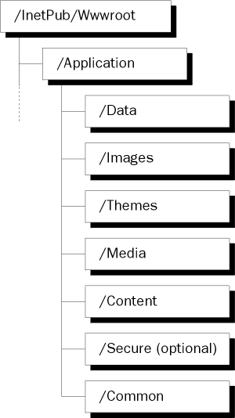
You may want to consider this example structure as a place to start.
Here, the root of the application hangs off the InetPub/Wwwroot directory and contains just a couple of files; probably global.asa and the default home page for the application. Underneath this root are a number of directories that contain the contents of the site according to what type of content a file contains.
/Common will contain server-side include files that can help to make site development and maintenance less of a chore. More on these in a minute.
/Content will contain all the .htm and .asp files that this site can display. Thus scripting permission will be enabled for this directory and disabled for all others.
/Data will contain all the rich data sources that ASP makes use of. For example, this directory might hold a couple of .mdb Access databases.
/Images will contain all the graphics files used in the site.
/Media will hold all the video and sound files
/Secure will hold the subset of the site that is to be sent to a client using the secure HTTPS protocol, for example the section of an e-commerce site that asks for credit-card details.
/Themes holds the template graphic files that give the site a regular look and feel.
It is a simple matter to create a strong directory structure like this for your application, which you can then only benefit from as your site content grows larger.

At The Top Of The Page
The first lines of your ASP page (as opposed to global.asa) are very important – they can define the basic handling instructions for the rest of your page. Consider this segment of code:
<% @Language = "VBScript" %>

<%

Option Explicit

Response.Buffer = true

Response.Expires = -1000

%>
The first line – <% @Language = "VBScript" %> – declares the default language in which the server-side script on the page is to be written. Even if you are using VBScript (which is the default anyway), it is good programming practice to use this line.
Following on (not unlike the English national cricket team), the use of Option Explicit in your pages will save you a great deal of time when debugging your pages. How? The VBScript scripting engine allows you to use variables without first declaring them. This is great until you misspell one of your variables – VBScript simply treats it as a new variable and carries on as if there's nothing wrong. For example, suppose you declare NoOfHorses as a variable and use it throughout your page; then when you try to display the final tally of our four-legged friends, you accidentally mistype Response.Write(NoOfForses). This will echo '0' to the screen because the engine thinks you've specified a new variable, NoOfForses.
The Option Explicit command gives us control over this – by writing Option Explicit at the top of your page, you force the parser to throw an error if it comes across an undeclared variable in the ASP code.
By setting Response.Buffer = true, we tell the server not to send a page and its contents down to the client until it has finished processing all the server-side script on the page. The server then has only to send one set of HTTP headers down to the client along with the requested page instead of perhaps two or three, making the communication between client and server more efficient.
Buffering is also useful in debugging, allowing you to hold back content from your test client until you Flush it at a point you think a bug might have occurred. With ASP 2.0, the default for response buffering is off (false) although in the next release of ASP, the default will be on (true). There's more about buffering in Chapters 3 and 10.
Finally, if you know that your page will change at regular intervals, don't forget to expire your page accordingly. When your ASP is 'translated' into a static page and stored in the client's cache, it is given an expiry date after which the client requests an up-to-date page from the server. On the other hand, if your pages don't change often then it's not worth setting a short expiry period – the shorter the expiry period, the more work your server will have to do to redeliver requested pages.
You can force a client's request to call a fresh version of your page (i.e. from your server, not from the client's cache) by making the page expire the instant it is received by the client. To do this, declare Response.Expires=-1441. Why -1441? This declares that the page expired twenty-four hours and one minute ago, with respect to the internal clock on the server and not the client. Why doesn't Response.Expires=0 work? Well, it might work – but (for example) if the server delivers a page to a client 5.00pm, then the page will expire at 5.00pm on the client; if the client's internal clock is running behind the server's internal clock, then you won't get immediate expiry. By setting the expiry period to at least 24 hours will almost certainly ensure the client expires the page instantly.

In General
Within the <BODY> </BODY> of the page, there are a few more tips and tricks to be aware of.

Use Include Files
By including frequently-used pieces of code within server-side include files, your pages become easier to read and easier to create. Instead of 10 or 15 lines of code that, for example, setup your HTML meta tags, you would instead write the simple line:
#include virtual="/Common/metatags.inc"
This gets those tags from the file metatags.inc. In the above statement, this is assumed to be found in the Common subdirectory of the website's root folder. We can also specify its location in a physical directory on the server's hard drive with the line:
#include file="d:\wwwroot\includes\metatags.inc"
Consistent use of one of these lines throughout your site would also mean that you can update the tags for all those pages simply by updating the include file. Thus, the use of server-side include files makes it easier to handle and maintain code, and also brings the web developer closer to the programming ideal of modular code and reusable code components.
Note that it's a bit safer to use the .asp extension for include files. With this, you do not have to worry about turning off Script permissions for the directory that holds them, as you should do if you use the .inc extension shown above. On the other hand, using .inc does distinguish include files from ASP pages.

Remove Comments From Live Pages
Comments in your code seriously reduce the ability of the ASP parser to zip through pages and serve them up to the client. Make sure to keep copies of your work that are well commented so you can maintain and improve them, but when you are ready to release your work to a live production server, remove all the comments from your site.

Minimize Context Switching
There is a time cost involved in the switch between parsing server-side scripting code and looking through HTML and client-side script for the next <% .. %> block. Consider this code:
<% Response.Write ("Hello Mum") %>

<% Response.Write ("<BR>") %>

<% Response.Write ("I'm fine thanks") %>
The code above will incur six time penalties when being parsed. Now consider this:
<%

Response.Write ("Hello Mum")

Response.Write ("<BR>")

Response.Write ("I'm fine thanks")

%>
This incurs only two time penalties, because we've used fewer ASP <% .. %> blocks.

Don't Rely On Cookies
Cookies are undoubtedly very useful. They allow us to query the client machine for a user identity with which we can personalize our ASP pages. However, there remains a myth that cookies are inherently unsafe – consequently, some users may prohibit a server from placing cookies on their machine. Alternatively, the cookie may have been deleted from the client machine or have been tampered with, rendering it invalid. If your site does use cookies for some purpose, try to minimize what you put in them. For example, a user's complete identity could be stored in a database on the server, while the cookie at the user's end would solely contain a unique key in that database which references the correct ID.

Performance Testing
Your task is not done, even when you've finished writing your pages. It is the developer's responsibility to make sure that his code is as robust, reliable, tight and efficient as he can make it.

Try and Break Your Own Code
The people who have created a site are generally the most likely to know where the possible problems and weaknesses are. They should see if they can break the site and cause it to produce unaccounted-for results, errors and other faults. Web sites should not be exempt from alpha testing – they're still just code.

Load Testing
These days, several utilities, like InetMonitor 3.0 (available from http://www.microsoft.com/msdownload/#itool), are available which can stress test your site and the server that hosts it. They do this by simulating very large numbers of clients trying to access the site at the same time and present very detailed results about the degradation of performance as more clients are introduced. Those of you creating a commercial site should give serious thought to acquiring a copy of such load testing software and using it before you put the site live.

Summary
In this chapter, we tried to cover the massive topic of ASP in as concise a form as possible. You should now have some idea of what ASP is, how it works, how you might use it and how you might want to code with it. The rest of the book should now serve as a reference as you put your plan of ASP development into action.

1. FEATURED ARTICLE: 10 Reasons to Develop in ASP

Active Server Pages are a server-side scripting technology primary
developed to work under IIS (Internet Information Server) on
Windows NT Server (3rd party products exist enabling the use of ASP
on other server platforms). ASP enables the server to deliver
dynamic, database driven content to the client with minimal effort.

The goal of this article is not to move developers from other
wonderful technologies to ASP, but to explain the advantages of
Active Server Pages to Web designers, programmers and anyone
interested in Web development. ASP is not my first server-side
scripting technology. I was developing with Netscape Server-Side
JavaScript, Borland IntraBuilder and Oracle Web Application Server
before I moved to ASP. Now I'm an ASP developer, and I will try
to explain why I think ASP is currently the best choice for general
Web developer.

>Ease of Use

Active Server Pages are plain HTML pages with ASP code embedded
into them enclosed in <% and %> tags. You just place ASP files
into a directory on the server with scripting or execute
permissions and your ASPs are ready to run. Whenever you need to
change something you just edit the .asp files and that's it, your
changes are applied.

>Language Independence

ASP is a scripting engine enabling you to develop in virtually any
language of your choice. The two languages available by default
are VBScript and JScript (Microsoft's version of JavaScript);
however, modules for Perl, Python and other languages already
exist and there are virtually no limits for support for other
languages to be implemented. This enables the novice ASP developer
to utilize his or her previous programming experience. If you
have ever programmed in Visual Basic or VBA (the version of Visual
Basic used in the MSOffice suite), you will have no problems
starting with VBScript. If you're familiar with JavaScript, then
JScript is your choice. Unix gurus will find that Perl can be
used readily.

>Short Learning Curve

As you have seen, you may use your current expertise in some
programming language or technology to jump into ASP in short time.
Even if you know only HTML, it will not be difficult for you to
learn how to insert ASP commands into your HTML files. Why, you
ask? Just keep reading....

>Tons of Information

There are currently more than 150 sites listed in Open Directory's
ASP category. This is more than for any other server-side
development engine or language. Lots of online magazines will
deliver new articles on ASP to your mailbox on a weekly or even
daily basis. There's a lot of resources out there for ASP, folks.

>Huge Community

There are plenty of professional ASP developers ready to answer
your questions in numerous ASP newsgroups and forums. For instance,
on the day I write this article, there are more than 50 new threads
in the microsoft.public.inetserver.asp.general newsgroup alone.

******************************************************************

Running a server farm? If you're managing multiple servers
in your organization, securing all of them can quickly become
complicated. But now, you can learn how to simplify security
administration through a single point of management - with
a valuable new guide from VeriSign.

Request the FREE Guide "Securing Intranet and Extranet Servers" at:
http://www.verisign.com/cgi-bin/go.cgi?a=n016101950150000

******************************************************************

>Low Cost of Ownership

This mainly applies to site owner, not directly to the developer.
Nowadays it's easier to find an NT administrator and ASP developer
than a UNIX guru. You may think that for you as a developer, this
isn't a compelling reason to use ASP. However, low cost and
abundance of support is just one more reason you can give to your
employer/customer as to why they should do business with you. You
can explain that they won't get left high and dry if one day you
decide to part company, so while you're with them they will feel
safe and satisfied.

>Extensibility

There are virtually no limits to what can be done with ASP thanks
to unlimited extensibility provided via COM components. This
approach, in my opinion, is a key success factor of ASP. For
example, there's no way to send email using standard ASP functions
but there are lots of components (both free and commercial)
enabling you to do this, as well as chosing the methods and
features you want implemented. Recent introduction of Java Server
Pages - an ASP style scripting language developed to work in
conjunction with server-side Java, shows that the approach is
recognized as powerful by one of the biggest Microsoft competitors,
Sun Microsystems.

>Hosting

Hosting companies widely support ASP. A search on HostIndex
(http://www.hostindex.com/) returned 889 matches for hosting
companies supporting ASP with hosting prices starting below $10.
This is quite enough to find the host that meets all your needs
for a reasonable price and you will be able to switch hosting
companies easily if your current doesn't satisfy you.

>Tools

Microsoft has two tools supporting ASP: their most popular WYSIWYG
editor - FrontPage (though I would not personally recommend it for
ASP editing) and Visual InterDev. Other vendors have also
implemented ASP support into their products, including the popular
HTML coding package HomeSite from Allaire (http://www.allaire.com).
There's also scheduled support for ASP in upcoming versions of
other widely-used code based editors, such as HotDog Pro from
Sausage Software (http://www.sausage.com/).

>You Can Get a Good Job

A search for ASP on high tech job search engine dice.com
(http://www.dice.com) returned more than 10000 matches with average
salary around $70K. I think it will be hard for you to chose the
best from such a quantity, but very simple to find good one.

There are of course more reasons to develop in ASP, but I hope
these ten were enough to convince you that developing in ASP can
make your life happier and get you to the next level of your
career.

