QA Automation Execution Report
Scenario: Open the browser, navigate to https://www.saucedemo.com, login with username standard_user and password secret_sauce, verify the Products page loaded, and close the browser.
Generated: 2026-09-29 13:03:02
Total Steps: 6 | Passed: 6 | Failed: 0

Step: launch_browser - PASS
Time: 2026-09-29 13:01:26
Details: Browser launched


Step: navigate to https://www.saucedemo.com - PASS
Time: 2026-09-29 13:01:34
Details: navigate to https://www.saucedemo.com succeeded
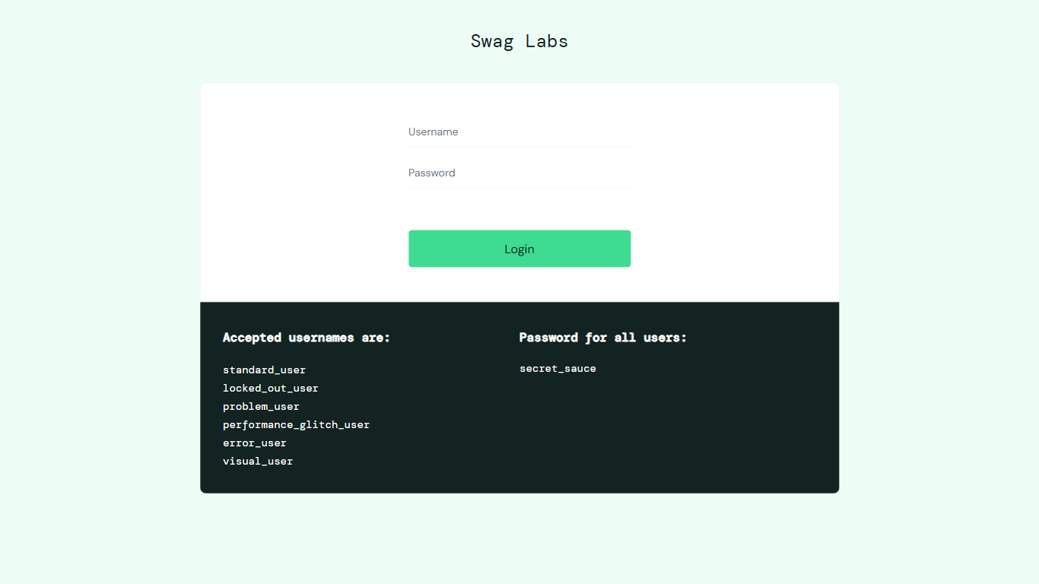

Step: fill #user-name - PASS
Time: 2026-09-29 13:02:24
Details: fill #user-name succeeded
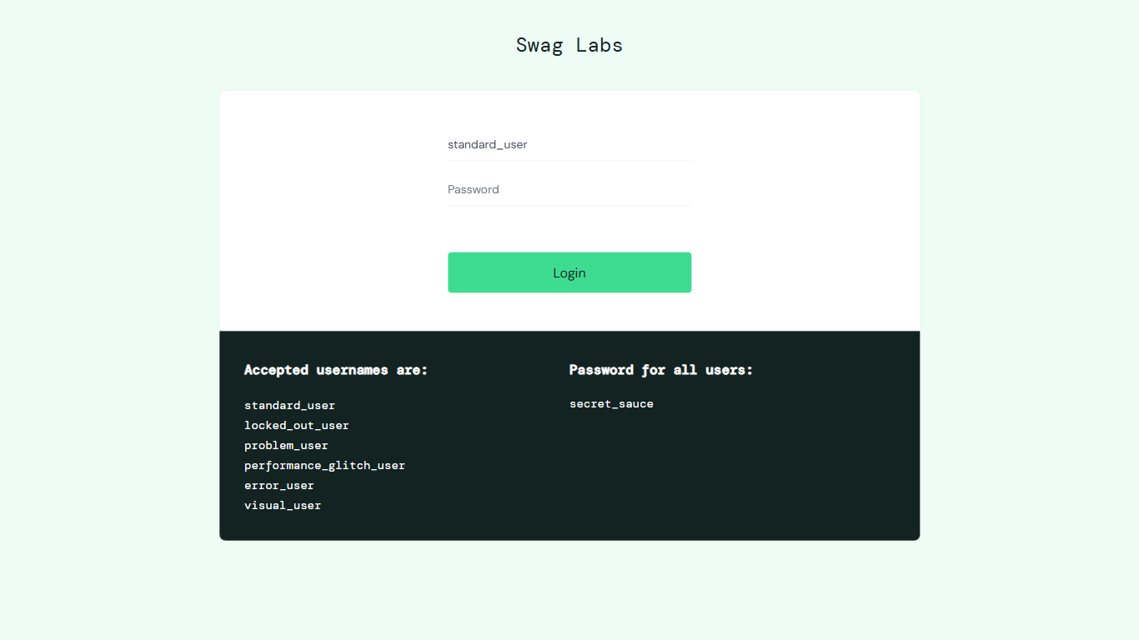

Step: fill #password - PASS
Time: 2026-09-29 13:02:33
Details: fill #password succeeded
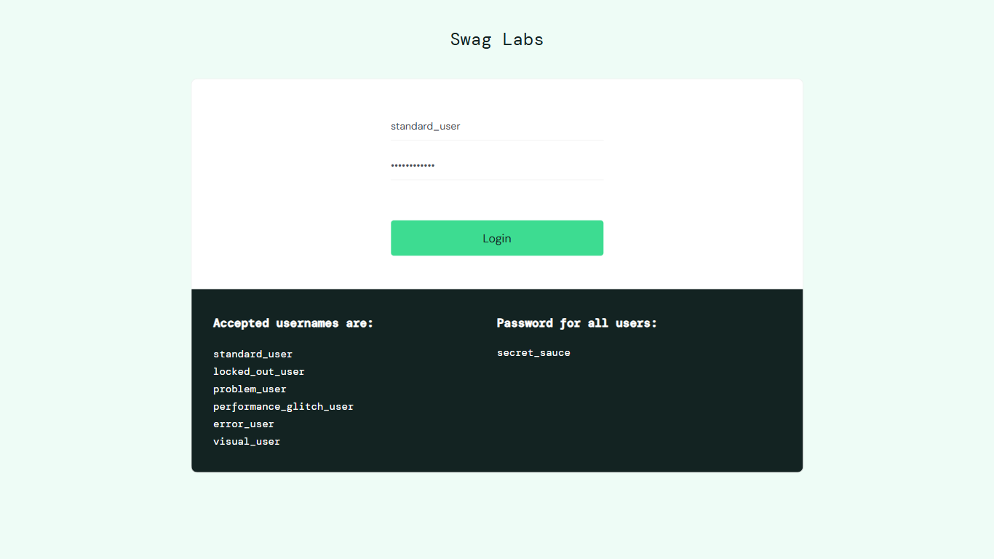

Step: click #login-button - PASS
Time: 2026-09-29 13:02:45
Details: click #login-button succeeded
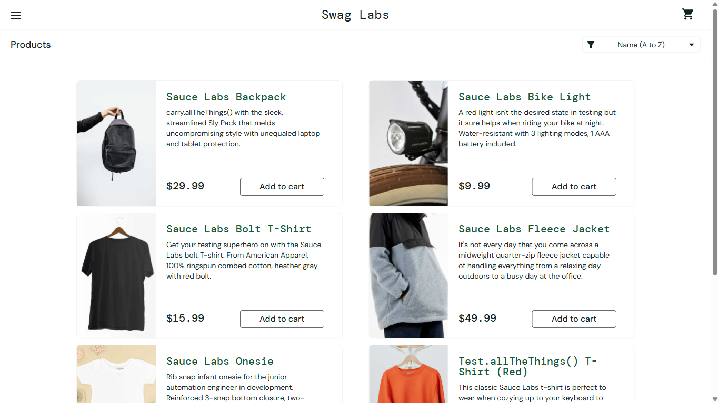

Step: assert 'Products' visible - PASS
Time: 2026-09-29 13:02:50
Details: visible=True
