QA Automation Execution Report
Scenario: Open the browser, navigate to https://www.saucedemo.com, login with username standard_user and password secret_sauce, verify the Products page loaded, and close the browser.
Generated: 2026-09-29 13:07:13
Total Steps: 4 | Passed: 4 | Failed: 0

Step: launch_browser - PASS
Time: 2026-09-29 13:05:55
Details: Browser launched


Step: navigate to https://www.saucedemo.com - PASS
Time: 2026-09-29 13:06:00
Details: navigate to https://www.saucedemo.com succeeded
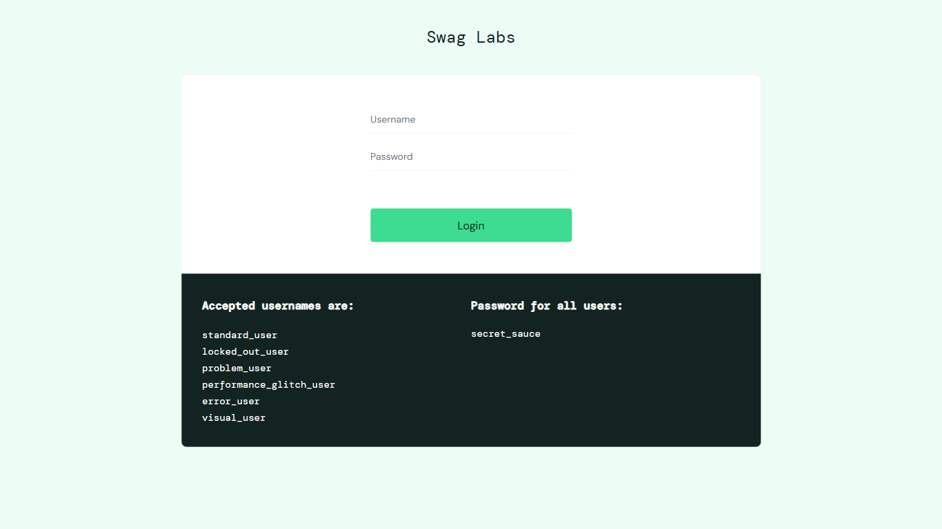

Step: fill #user-name - PASS
Time: 2026-09-29 13:06:19
Details: fill #user-name succeeded
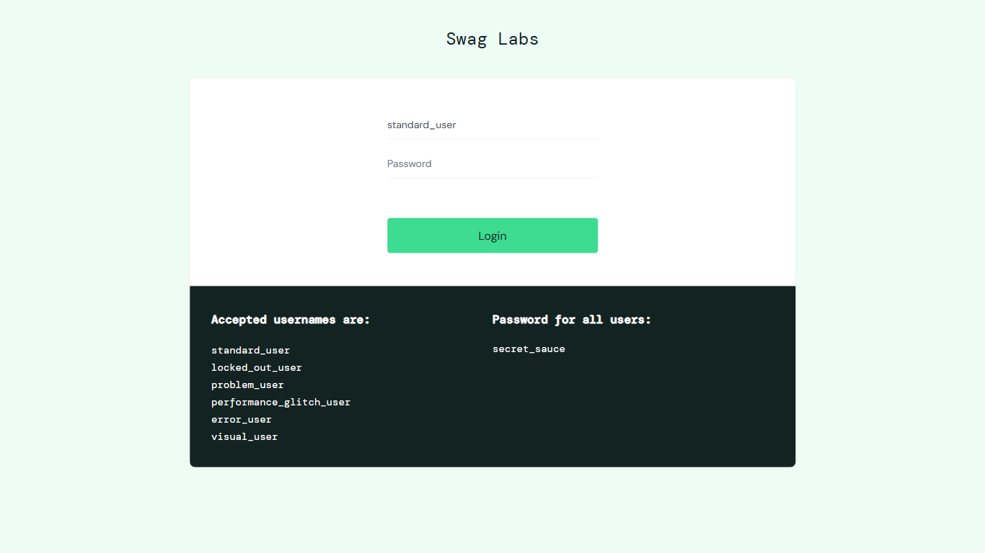

Step: fill #password - PASS
Time: 2026-09-29 13:06:35
Details: fill #password succeeded
