Assignment 4
Module 5 – Files, Exceptions and Errors in Python

Task 1 : Read a File and Handle Errors –
In this task, a file named ‘sample.txt’ is opened in read mode and its contents are read line by line. While opening the file, the error is handled if the file does not exist.
Code -
#Task 1 of Assignment 4 - Read a File and Handle Errors
import io
file_name = "sample11.txt"
try:
fh = open(file_name,"rt") #opening file for reading purpose
print("Reading file content:")
except FileNotFoundError: #handling error if file not exists
print(f"Error: The file \'{file_name}\' was not found.")
exit()
except io.UnsupportedOperation as e: #handling error if unable to read file
print(f"Error: File \'{file_name}\' cannot be opened.")
exit()
else:
l_count = 0
while line := fh.readline():
l_count += 1
print(f"Line {l_count}: {line}",end="")
print()
fh.close()
finally:
print("Bye!!!")
#end of program
Output –
- If the file exists
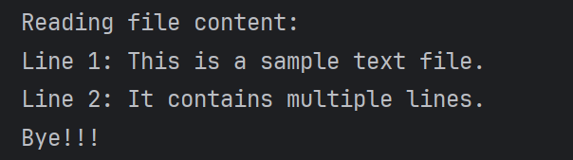
- If file does not exists
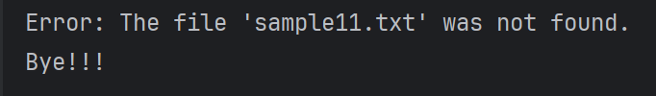
Task 2 : Write and Append Data to a File –

In this task, a file named ‘output.txt’ is opened in write mode. An input is accepted from the user and written to the file. After this additional input is taken from the user and appended to the file. Finally entire content of the file is displayed.

Code –
#Task 2 of Assignment 4 - Write and Append Data to a File
import io
file_name = "output.txt"
try:
text = input("Enter text to write to the file: ")
with open(file_name,"wt") as fh: #opening file in write mode
fh.write(text + "\n")
print(f"Data successfully written to the file \'{file_name}\'.\n")
text = input("Enter additional text to append to the file: ")
with open(file_name,"at") as fh: #opening file in append mode
fh.write(text + "\n")
print(f"Data successfully appended to the file \'{file_name}\'.\n")
with open(file_name,"rt") as fh: #opening file for reading purpose
print(f"Final content of the file \'{file_name}\':")
while line := fh.readline():
print(f"{line}",end="")
print()
except FileNotFoundError: #handling error if file not exists
print(f"Error: The file \'{file_name}\' was not found.")
exit()
except io.UnsupportedOperation as e: #handling error if unable to read file
print(f"Error: File \'{file_name}\' cannot be opened.")
exit()
finally:
print("Bye!!!")
#end of program

Output -



