Assignment 5
Module 6 – Data Structures and Strings in Python

Task 1 : Create a Dictionary of Student Marks –
In this task, a dictionary having student names as keys and their marks as values is created. Then after accepting student name as user input, corresponding marks are retrieved and displayed. If student’s name is not found in the dictionary, appropriate message is displayed.
Code -
# Task 1 of Assignment 5 - Create a Dictionary of Student Marks
dict_student = { "Arun":85, "Balraj":90, "Vishal":65, "Chetan":78, "Rajan":65, "Varun":91}
name = input("Enter the student's name: ") #accepting user input
for std in dict_student: # iterating dict
if name == std: # check for name match
print(f"{std}\'s marks: {dict_student[std]}")
print("Bye!!!")
exit()
print(f"Student \'{name}\' not found.")
print("Bye!!!")
# end of program

Output –
- If the student name exists in dictionary:
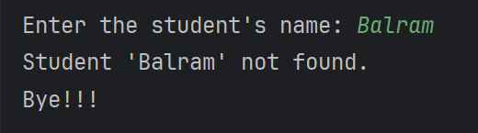
- If the student name does not exist in dictionary:
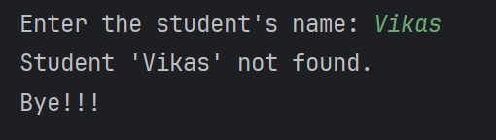
Task 2 : Demonstrate List Slicing –

In this task, a list of numbers from 1 to 10 is created. Then first five elements of the list are extracted into a new list. Then this extracted list is reversed into another list. Then these extracted and reversed list are shown.

Code –
# Task 2 of Assignment 5 - Demonstrating List Slicing
org_list = [i for i in range(1,11)] # creation of list
print(f"Original List: {org_list}")
ext_list = org_list[0:5] # extraction of first five elements from list
print(f"Extracted first five elements of list: {ext_list}")
rev_ext_list = ext_list[::-1] # reversal of extracted list
print(f"Reversed extracted list: {rev_ext_list}")
# end of program

Output -



