**PROMETHEUS**

Prometheus is an open-source systems monitoring and alerting toolkit originally built at SoundCloud. The project is part of the Cloud Native Computing Foundation (CNCF) and is widely used in loud-native and containerized environments.

Prometheus collects and stores its metric as time series data, i.e, metrics information is stored with the timestamped at which it was recorded, alongside optional key-value pairs called labels.

**Features:**

* A multi-dimensional data model with time series data identified by metric name and key/value pairs.
* PromQL, a flexible query language to leverage this dimensionality
* No reliance on distributed storage; single server nodes are autonomous
* Time series collection happens via a pull model over HTTP
* Pushing time series is supported via an intermediary gateway
* Targets are discovered via service discovery or static configuration
* Multiple modes of graphing and dashboarding support.

**Metrics:**

Metrics are numerical measurements in layperson terms. The term series refers to the recording of changes over time. What users want to measure differs from application to application. For a web server, it could be request times; for a database, it could be the number of active connections or active queries.

**Components:**

The Prometheus ecosystem consists of multiple components, many of which are optional:

* The main Prometheus server which scrapes and stores time series data
* Client libraries for instrumenting application code
* A push gateway for supporting short-lived jobs
* Special purpose exporters for services like HAProxy, StasD, Graphite, etc
* An alert manager to handle alerts
* Various support tools

**Architecture:**

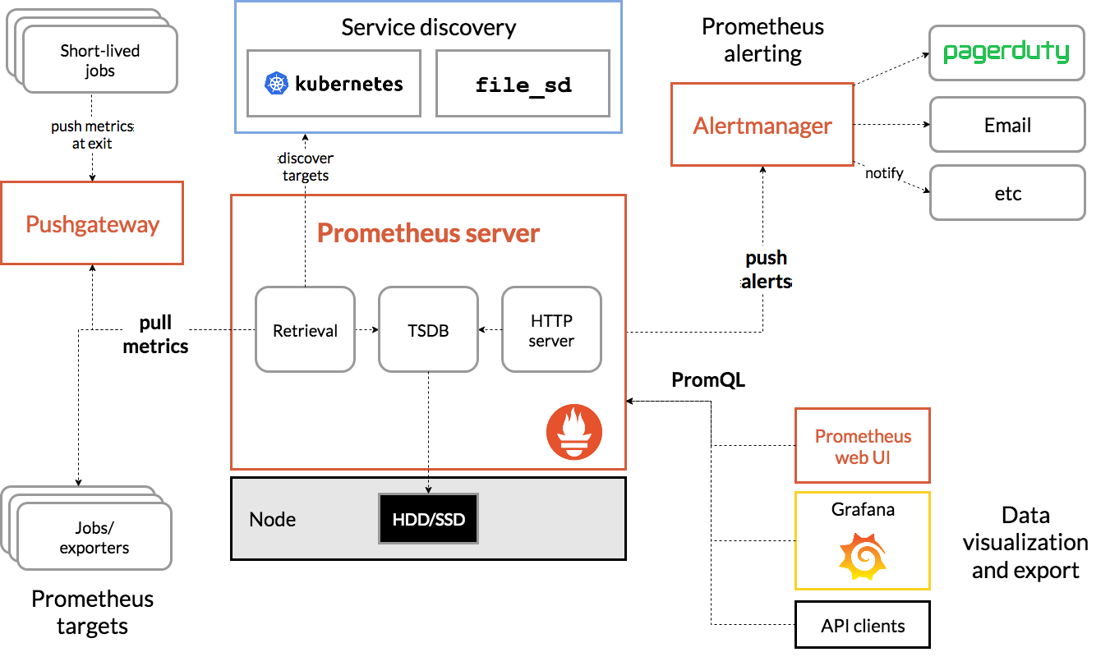

**Installation and Configuration:**

**Download Prometheus:**

1. Visit the Prometheus official download page to get the latest release.
2. Select the appropriate binary for the operating system. For Linux choose the Linux version.

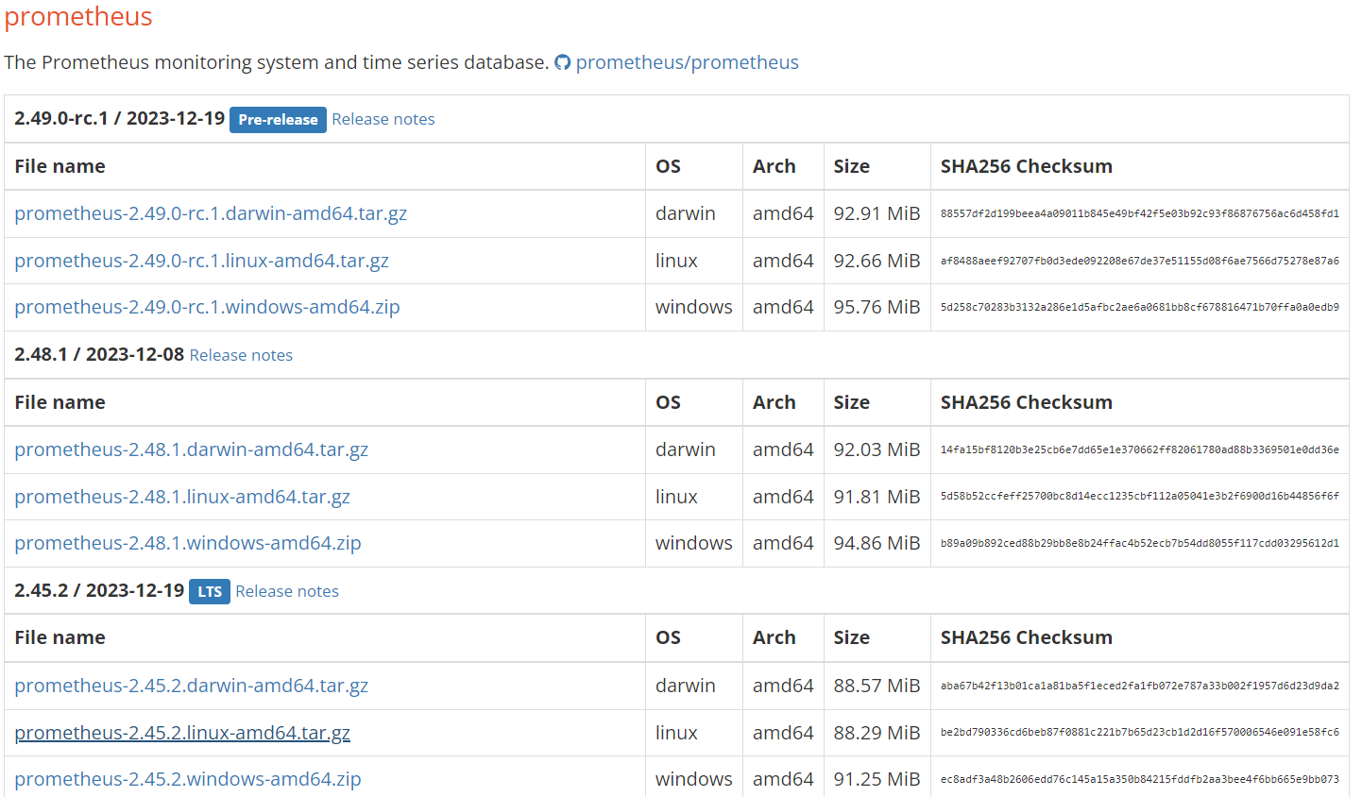

3. Download ant Extract the tarball

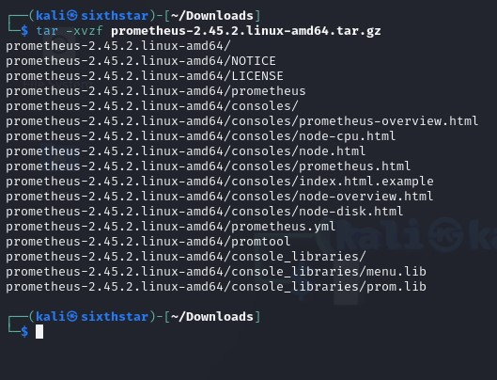

**Create a configuration file:**

Create a configuration file named Prometheus.yml to define the targets and any additional configurations.

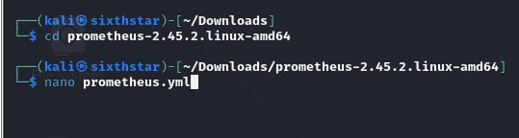

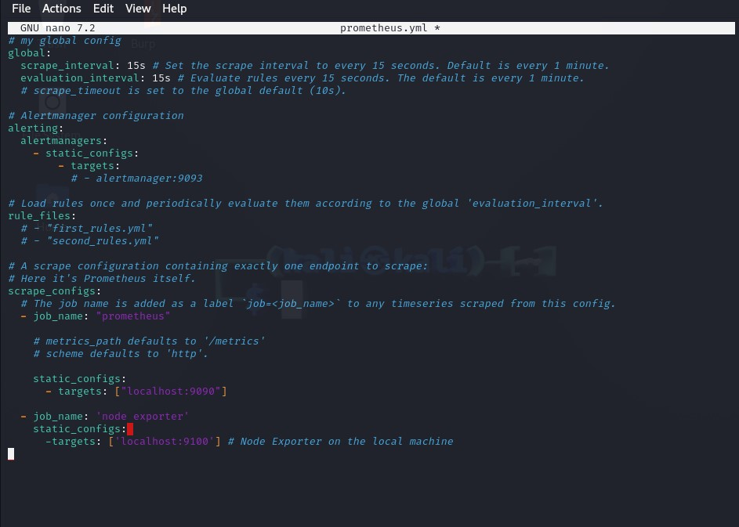

**Start Prometheus:**

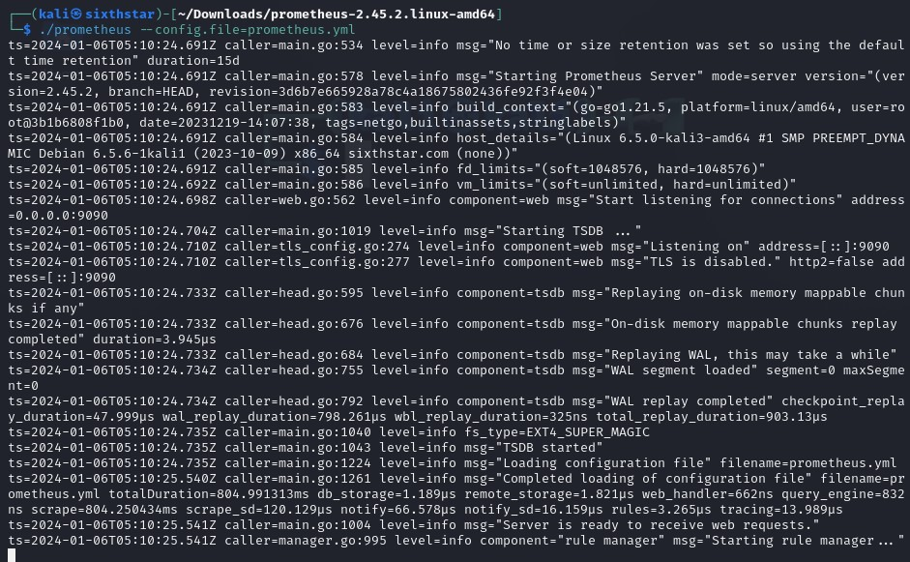

**Access Prometheus Web UI:**

Open a web browser and access the Prometheus web interface by navigating to ‘http:localhost:9090’. This provides a user interface for querying and visualizing metrics.

