**VULNERABILITY ASSESSMENT AND PENETRATION TESTING**

**Introduction:**

VAPT stands for Vulnerability Assessment and Penetration Testing. It is a comprehensive security testing approach that combines both automated vulnerability scanning and manual penetration testing to identify and address security vulnerabilities in an organization's IT infrastructure.

**Vulnerability Assessment (VA):**

* VA involves scanning systems, networks and applications to identify potential vulnerabilities. This process typically utilizes automated tools to discover known vulnerabilities such as missing patches, misconfigurations and weak passwords.
* The Goal of VA is to identify weaknesses in the target environment that could be exploited by attackers.

**Penetration Testing (PT):**

* PT is a controlled attempt to exploit identified vulnerabilities to assess the security of a system or network further. Penetration tester simulate real-world attacks to evaluate the effectiveness of defensive measures.
* PT goes beyond automated scans by attempting to exploit vulnerabilities manually, mimicking the techniques and tactics of malicious actors.

**Steps involved in VAPT:**

1. Preparation
2. Reconnaissance
3. Vulnerability scanning
4. Vulnerability analysis
5. Exploitation
6. Post-Exploitation
7. Reporting
8. Remediation
9. Continuous Monitoring and Improvement

**Tools used for Automated Vulnerability Scanning:**

1. **Nessus** – Nessus is a widely used vulnerability scanner that can detect vulnerabilities across a wide range of platforms, including operating systems, applications, databases and network devices. It provides comprehensive vulnerability assessments, including detailed reports and remediation guidance.

**Installation of Nessus in Linux:**

**Step 1:** Download Nessus from the official page: <https://www.tenable.com/downloads/nessus>

**Step 2:** Navigate to the Downloads directory: **“cd Downloads”**

**Step 3:** Install Nessus**: “sudo dpkg -i Nessus<version>.deb”**

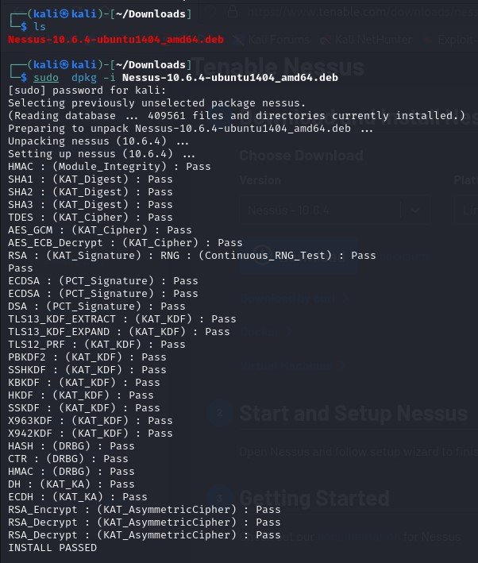

**Step 4:** Start the Nessus service**: “sudo systemctl start nessusd”**

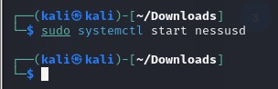

**Step 5:** Access the Nessus web interface :

* Open a web browser and go to <https://localhost:8834>
* You will see a security warning about the SSL certificate. Click on “Advanced” and then “Accept the risk and continue”

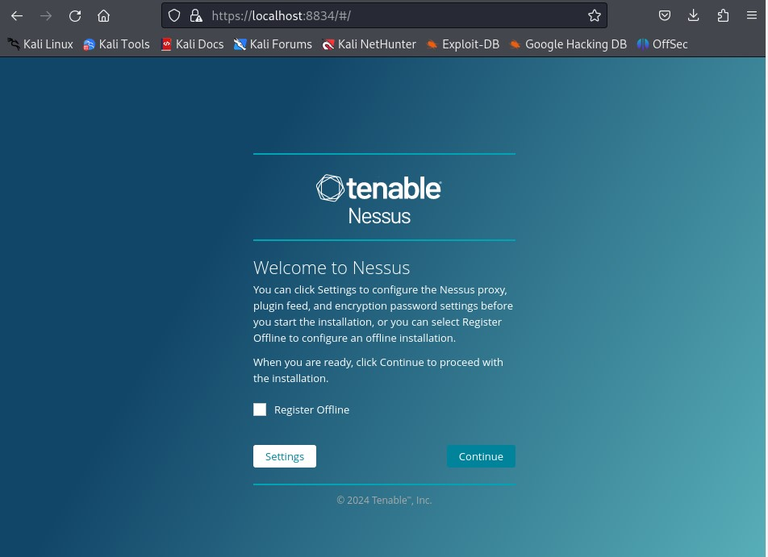

**Step 6:** Select the Nessus product: Choose the Nessus product you want to use (eg: Nessus Essentials)

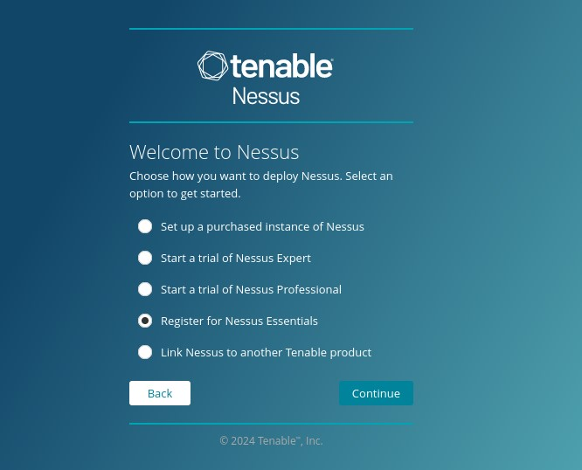

**Step 7:** Register for a Nessus Essentials account:

* Enter the name and email address to receive an activation code. Paste the activation code into the space provided and choose a username and password

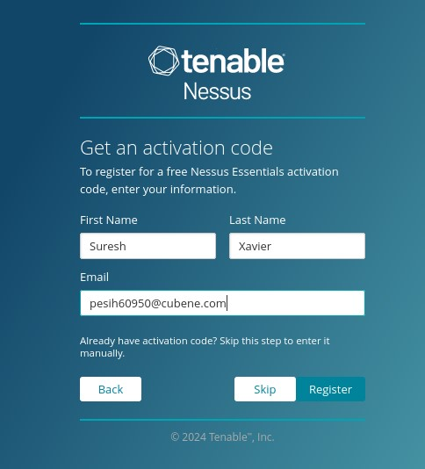

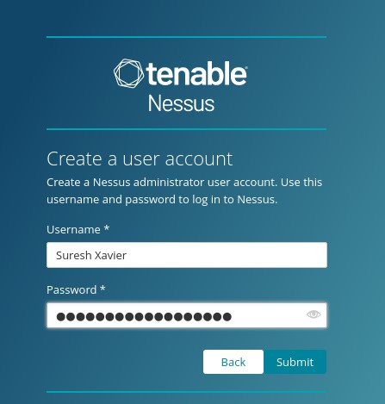

**Step 8:** Wait for Nessus to download plugins

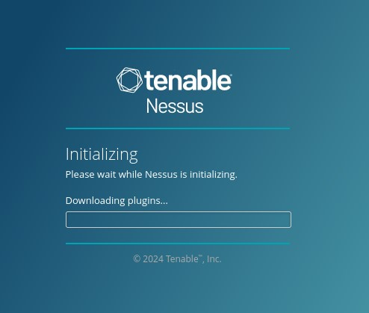

**Nessus:**

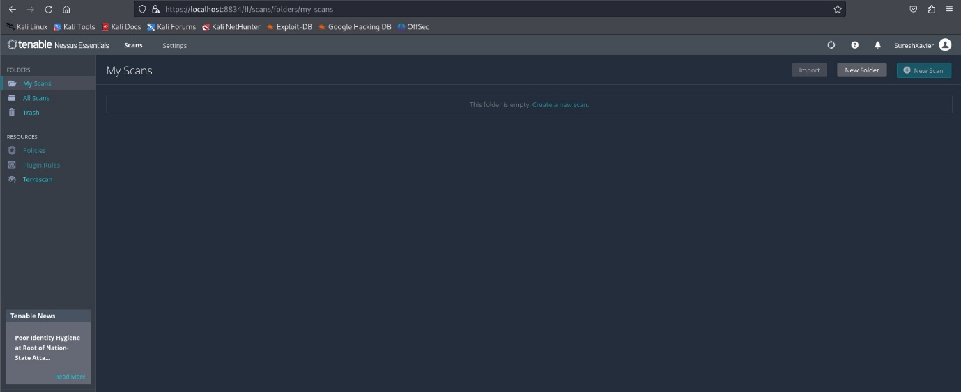

1. **OpenVAS (Open Vulnerability Assessment System) –** OpenVAS is an open-source vulnerability scanner that offers a comprehensive set of features for detecting security issues in networks and hosts. It includes a database of thousands of known vulnerabilities and can perform regular scans to identify potential risks.
2. **Qualys Vulnerability Management –** Qualys offers a cloud-based vulnerability management platform that provides continuous monitoring and assessment of security vulnerabilities. It offers automated scanning, asset discovery and prioritization of vulnerabilities based on severity and potential impact.
3. **Burp Suite –** Burp Suite is a web vulnerability scanner and security testing tool widely used by security professionals for web application penetration testing. It includes features such as automated scanning, manual testing and advanced vulnerability detection techniques.

**Tools used for Penetration Testing:**

1. **Nmap** – A powerful network scanning tool used for port scanning, host discovery and service enumeration. It helps identify open ports, running services and potential vulnerabilities.
2. **Metasploit Framework** – A comprehensive penetration testing platform that provides a range of exploitation and post-exploitation tools. It includes exploits, payloads and auxiliary modules for attacking and compromising systems.
3. **OWASP ZAP –** OWASP ZAP is an open-source web application security testing tool designed to help developers find security vulnerabilities in web applications during the development and testing phases.
4. **Wireshark –** A network protocol analyzer used for capturing and analyzing network traffic in real-time. It helps penetration testers analyze network communication and identify security vulnerabilities.
5. **Aircrack**-**ng –** A suite of wireless network security tools used for assessing the security of Wi-Fi networks. It includes tools for capturing, cracking and analyzing Wi-Fi traffic, as well as testing the security of WEP, WPA and WPA2 encryption protocols.
6. **SQLMap** – A popular tool for detecting and exploiting SQL injection vulnerabilities in web applications. It automates the process of identifying SQL injection flaws and extracting sensitive information from databases.

**Website Security:**

Website security is a critical aspect of overall cybersecurity, as websites sere as the primary interface between an organization and its customers or users. Ensuring the security of a website involves implementing various measures to protect against a wide range of threats and vulnerabilities.

1. **Secure Coding Practices –** Follow secure coding practices when developing web applications to prevent common vulnerabilities such as SQL injection, Cross-site scripting (XSS), Cross-Site Request forgery (CSRF) and insecure direct object references (IDOR).

* **CSRF –** CSRF is a type of web security vulnerability that allows an attacker to trick a user into unintentionally executing actions on a web application in which the user is authenticated. CSRF attacks exploit the trust that a website has in a user’s browser by forging malicious requests that are sent to the targeted website.
* **IDOR –** Insecure Direct Object References is a vulnerability that occurs when an application exposes internal implementation details, such as file paths, database keys or other references, directly to users without proper access controls. This vulnerability can allow attackers to manipulate these references to gain unauthorized access to sensitive data or perform unintended actions within the application.

1. **Secure Authentication and Authorization –** Implement strong authentication mechanisms, such as multi-factor authentication (MFA) to verify the identify of users accessing the website. Enforce proper authorization control to ensure that users can only access the resources and functionalities they are authorized to use.
2. **Data Encryption –** Encrypt sensitive data transmitted between the web server and client browsers using HTTPS (HTTP over SSL/TLS) to protect against eavesdropping and man-in-the-middle attacks. Implement encryption for data at rest using strong encryption algorithms and secure key management practices to protect sensitive information stored on the web server and backend databases.
3. **Security Headers and Content Security Policy (CSP) –** Implement security headers, such as Content Security Policy (CSP), HTTP Strict Transport Security (HSTS) and X-Content-Type-Options, to mitigate common web security risks and protect against various types of attacks, including XSS and Clickjacking.

**Tools used in Website Security:**

* OWASP ZAP (Zed Attack Proxy)
* Burp Suite
* Nessus
* Acunetix
* OpenVAS

**Network Security:**

Network Security encompasses the measures and practices implemented to protect the integrity, confidentiality and availability of data and resources within a computer network. It involves the use of various technologies, policies and procedures to prevent unauthorized access, mitigate threats, and ensure the secure transmission and storage of information across networked systems.

1. **Firewalls –** Firewalls are devices or software applications that monitor and control incoming and outgoing network traffic based on predetermined security rules. They act as a barrier between internal and external networks, filtering traffic to prevent unauthorized access and malicious activities.
2. **Intrusion Detection Systems (IDS) and Intrusion Prevention Systems (IPS) –** IDS and IPS solutions monitor network traffic for signs of suspicious or malicious activity. IDS detects potential security breaches and alerts administrators, while IPS can automatically take action to block or prevent detected threats in real-time.
3. **Virtual Private Networks –** VPNs provide secure remote access to network resources by encrypting communication channels between remote users and the corporate network. They enable users to securely access data and application over public networks, such as the internet while maintaining confidentiality and privacy.
4. **Network Segmentation –** Network Segmentation involves dividing a larger network into smaller, isolated segments to restrict access and contain security threats. By separating critical assets and sensitive data from less secure areas of the network resources.
5. **Encryption –** Encryption is used to secure data in transit and at rest by encoding information in a way that can only be deciphered by authorized parties with the appropriate

**Tools used in Network Security:**

* Firewalls(pfSense)
* Intrusion Detection Systems (snort)
* Intrusion Prevention Systems (snort with inline mode)
* Virtual Private Networks (OpenVPN)
* Network Traffic Analysis Tools (Wireshark, TCPdump)

**Email Security:**

Email Security is the set of measures and practices implemented to protect email communication systems from unauthorized access, data breaches, malware infections, phishing attacks and other threats.

1. **Authentication Mechanisms –** Implementing strong authentication mechanisms, such as SPF, DKIM, and DMARC helps verify the authenticity of email senders and prevent email spoofing and phishing attacks.
2. **Encryption –** Encrypting email communication using protocols like TLS (Transport Layer Security) ensures that email content is transmitted securely over the internet and protects it from interception by unauthorized parties.
3. **Anti-Spam Filtering –** Deploying anti-spam filtering solutions helps detect and block unsolicited and malicious emails, including spam, phishing attempts and emails containing malware or malicious attachments. Advanced spam filters use heuristic analysis, machine learning and reputation-based techniques to identify and filter out spam emails effectively.
4. **Anti-Malware Protection –** Deploying anti-malware solutions helps detect and quarantine email-borne threats, such as viruses, ransomware, trojans and other types of malware. These solutions scan email attachments, links and content for known malware signatures and behavior patterns to prevent malicious payloads from reaching user’s inboxes.

**Malware:**

* Malware is any software intentionally designed to cause damage to a computer, server, network or device or to steal sensitive information.Malware comes in various forms, including viruses, worms, trojans, ransomware, spyware, adware and rootkits
* Malware can infect systems through various vectors, including email attachments, malicious websites, infected USB drives, software vulnerabilities and social engineering tactics.
* Protecting against malware requires as a multi-layered approach, including deploying antivirus software, keeping software and systems up to date with security patches, using firewalls and intrusion detection/prevention systems, implementing email and web filtering, conducting regular security awareness training for users and practicing safe browsing habits.

**Spoofing:**

* Spoofing refers to the act of falsifying information to impersonate someone or something else in order to deceive or trick recipients into taking actions they otherwise wouldn’t. Common types of spoofing include email spoofing, IP address spoofing, DNS spoofing, website spoofing (phishing), caller ID spoofing and MAC address spoofing.
* Spoofing attacks can be used for various malicious purposes, such as phishing, distributing malware, launching social engineering attacks, conducting man-in-the-middle attacks and bypassing security controls.
* Preventing spoofing attacks requires implementing authentication mechanisms, using cryptographic protocols like TLS for secure communication, configuring network security controls to detect and block spoofed traffic and educating users about the risks of spoofing and how to identify suspicious communications.

**Server-Side Penetration Testing:**

Server-side penetration testing, also known as infrastructure penetration testing, involves assessing the security of servers, applications and services hosted on target server infrastructure.

**Purpose:**

The Server-side penetration testing is to identify and mitigate security vulnerabilities that could be exploited by attackers to gain unauthorized access, disrupt services or steal sensitive data.

**Steps to do Penetration Testing in Server side:**

1. **Preparation –** Define the scope and objectives of the penetration test, including the target servers, applications and services to be tested.Gather information about the target servers, including IP addresses, domain names, operating systems, services running, software versions and network topology.
2. **Reconnaissance –** Conduct passive reconnaissance to gather information about the target servers, such as DNS records, WHOIS information, public-facing websites, and publicly available documentation.
3. **Vulnerability Assessment –** Scan the target servers for known vulnerabilities using vulnerability scanning tools like Nessus, OpenVAS or Nikto. Identify missing patches, misconfigurations, default credentials, weak encryption protocols and other security weaknesses.
4. **Exploitation –** Exploit identified vulnerabilities to gain unauthorized access to the target servers or escalate privileges. Attempt common exploitation techniques such as SQL injection, cross-site scripting (XSS), command injection, directory traversal and buffer overflow attacks.
5. **Post**-**Exploitation –** Maintain access to the target servers by establishing persistent backdoors, creating new user accounts or modifying existing privileges.Gather sensitive information from the target servers, such as user credentials, configuration filles and proprietary data.
6. **Document and Reporting** – Document all findings, including vulnerabilities discovered, exploited and mitigated. Provide detailed explanations of the impact and severity of each vulnerability along with recommendations for remediation.
7. **Remediation** – Work with the organization’s IT and security teams to prioritize and address identified vulnerabilities and weaknesses. Implement security best practices, patches, configuration changes and other remediation measures to improve the security posture of the server infrastructure.

**Possible Vulnerabilities in Server Side:**

1. **Operating System Vulnerabilities:**

* Unpatched or outdated operating systems (OS) can contain known vulnerabilities that attackers exploit to gain unauthorized access or execute malicious code.
* Weak default configurations or unnecessary services enabled by default may increase the attack surface and expose the server to exploitation.

1. **Application vulnerabilities:**

* Software vulnerabilities in web applications, databases, content management systems (CMS), and other server-side applications can be exploited to gain unauthorized access, execute arbitrary code or steal sensitive data.
* Common application vulnerabilities include SQL injection, cross-site scripting (XSS), command injection, insecure direct object references (IDOR), and insecure deserialization.

1. **Misconfigurations:**

* Insecure server configurations, such as weak password, default credentials, unnecessary open ports, and improper access controls, can create security weaknesses that attackers exploit.

1. **Inadequate Authentication and Authorization:**

* Weak authentication mechanisms, such as default or easily guessable passwords, lack of multi-factor authentication (MFA), or insecure password storage, can lead to authorized access to server resources.

1. **Insecure Network Protocols:**

* Insecure network protocols, such as unencrypted communication over HTTP, FTP, Telnet or outdated versions of SSL/TLS, can expose sensitive data to interception, eavesdropping or man-in-the-middle (MITM) attacks.

1. **Denial-of-Service (DoS) Attacks:**

* Server-side vulnerabilities, such as buffer overflow vulnerabilities, resource exhaustion, or improper input validation, may be exploited by attackers to launch DoS attacks, causing service disruption or downtime.

1. **Information Disclosure:**

* Server-side vulnerabilities, such as error messages revealing sensitive information, directory listings exposing directory structures, or debug information disclosing internal server details, may lead to information disclosure and facilitate further attacks.

**Tools used in Server-Side Pentest:**

* Nmap
* OpenVAS
* Metasploit Framework
* Burp Suite
* Nikto
* SQLmap
* Dirb
* Hydra
* Wireshark
* Aircrack-ng

**Exploitation Techniques:**

* **SQL Injection –** SQL injection involves inserting malicious SQL queries into input fields or parameters of web applications to manipulate the underlying database and retrieve sensitive information, modify data, or execute arbitrary commands.
* **Cross**-**Site Scripting –** Cross-site scripting occurs when attackers inject malicious scripts into web applications, which are then executed by unsuspecting user’s browsers. XSS vulnerabilities can be exploited to steal session cookies, redirect users to malicious websites or deface web pages.
* **File Inclusion** – File inclusion vulnerabilities allow attackers to include and execute arbitrary files on the server. This can lead to information disclosure, remote code execution, or unauthorized access to sensitive files and directories.
* **Remote Code Execution** – Remote code execution vulnerabilities enable attackers to execute arbitrary code on the server remotely. RCE vulnerabilities can be exploited to gain full control over the server, install backdoors, execute malicious payloads or escalate privileges.

**Server-Side Penetration Testing within an organization:**

1. **Testing/Staging Environment:** Organizations often maintain separate testing or staging environments that closely mirror the production environment. These environments are used for testing software updates, configurations, and new features before deploying them to production. Server-side penetration testing can be conducted in the testing/staging environment to assess the security of servers, applications, and services without impacting critical production systems.
2. **Development Environment**: Development servers and applications can also serve as suitable environments for server-side penetration testing. Development environments typically have fewer restrictions and controls compared to production environments, making them conducive to security testing activities. Conducting penetration tests in the development environment helps identify and remediate security vulnerabilities early in the software development lifecycle.
3. **Dedicated Penetration Testing Lab:** Some organizations set up dedicated penetration testing labs equipped with hardware, software, and networking infrastructure specifically for conducting security assessments. Penetration testing labs provide a controlled environment for testing various attack scenarios, evaluating defensive measures, and validating security controls without risking disruptions to production systems.
4. **Virtualized Environments:** Virtualization platforms such as VMware, VirtualBox, or Hyper-V allow organizations to create virtualized server environments for security testing purposes. Virtualized environments provide flexibility, scalability, and isolation, making them ideal for conducting server-side penetration testing while minimizing the impact on production systems.
5. **Cloud-based Environments**: Organizations may leverage cloud service providers to provision virtual servers, containers, and applications for testing purposes. Cloud-based environments offer on-demand access to scalable resources and can be used to simulate complex server infrastructures for penetration testing activities.
6. **Third-party Hosting Providers:** Some organizations engage third-party hosting providers or managed service providers (MSPs) to host dedicated testing environments or provide infrastructure-as-a-service (IaaS) solutions for security testing. Third-party hosting providers offer secure and isolated environments for conducting server-side penetration testing without affecting internal infrastructure.

**Mitigation Strategies for Server-side:**

After conducting a server-side penetration test and identifying vulnerabilities in server infrastructure, applications, and network services, it's crucial to implement mitigation strategies to address the identified security risks and enhance the overall security posture.

1. **Patch Management:** Regularly update and patch server operating systems, applications, and software to address known vulnerabilities and security issues. Establish a formal patch management process to ensure timely deployment of security patches and updates across all servers.
2. **Vulnerability Remediation**: Prioritize and remediate vulnerabilities based on their severity and potential impact on the confidentiality, integrity, and availability of data and systems. Implement security patches, configuration changes, or compensating controls to mitigate identified vulnerabilities.
3. **Secure Configuration:** Configure server infrastructure and applications securely according to best practices and security guidelines. Harden server configurations, disable unnecessary services and features, and enforce strong authentication mechanisms to reduce the attack surface and minimize security risks.
4. **Access Control and Least Privilege:** Implement access control measures to restrict access to sensitive server resources and data based on the principle of least privilege. Enforce strong password policies, implement role-based access control (RBAC), and regularly review and audit user permissions to prevent unauthorized access.
5. **Network Segmentation:** Segment and isolate critical server infrastructure and applications from less secure network segments using network segmentation techniques. Implement firewalls, VLANs, and access control lists (ACLs) to control traffic flow and restrict communication between server segments.
6. **Intrusion Detection and Prevention:** Deploy intrusion detection and prevention systems (IDPS) to monitor server traffic for signs of suspicious or malicious activity. Configure IDPS rules and signatures to detect and block known attack patterns, exploits, and abnormal behaviors on servers.
7. **Log Management and Monitoring:** Implement centralized logging and monitoring solutions to collect, analyze, and correlate logs from server infrastructure and applications. Monitor for security events, anomalies, and indicators of compromise (IOCs) to detect and respond to security incidents in a timely manner.
8. **Incident Response Planning:** Develop and maintain an incident response plan to effectively respond to security incidents and breaches affecting server infrastructure. Define roles and responsibilities, establish communication channels, and conduct regular incident response exercises to ensure readiness to handle security incidents.
9. **Backup and Disaster Recovery:** Implement regular data backups and disaster recovery procedures to protect critical server data and ensure business continuity in the event of a security incident or data loss. Store backups securely and test restoration procedures regularly to verify data integrity and recoverability.
10. **Security Awareness Training:** Provide security awareness training and education to system administrators, IT staff, and other stakeholders to raise awareness of security best practices, common attack vectors, and emerging threats affecting server infrastructure.

**Client-Side Penetration Testing:**

Client-side penetration testing focuses on assessing the security of client-side applications, systems and devices, such as desktops, laptops, mobile devices and web browsers.

**Purpose:**

The objective is to identify vulnerabilities and weaknesses that could be exploited by attackers to compromise client-side systems, steal sensitive information, or launch further attacks.

**Steps to do Client-side penetration testing:**

* **Scope Definition:** Define the scope and objectives of the client-side penetration test, including the types of client-side applications, systems, and devices to be assessed. Consider factors such as operating systems, web browsers, email clients, productivity software, and mobile applications.
* **Reconnaissance:** Gather information about the target client-side environment, including the types of devices and software used, operating system versions, patch levels, installed applications, network configurations, and user behavior.
* **Vulnerability Assessment:** Perform vulnerability scanning and assessment of client-side systems and applications using automated tools such as Nessus, OpenVAS, or Qualys. Identify known vulnerabilities, misconfigurations, insecure settings, and outdated software versions that could be exploited by attackers.
* **Social Engineering:** Conduct social engineering attacks to manipulate users into performing actions that could compromise the security of client-side systems, include phishing emails, malicious links, fake websites, phone calls, or physical access attempts to deceive users into disclosing sensitive information or downloading malware.
* **Exploitation:** Exploit identified vulnerabilities and weaknesses in client-side systems and applications to gain unauthorized access, execute arbitrary code, or steal sensitive information. This may involve exploiting vulnerabilities in web browsers, plugins, email clients, document viewers, or other software installed on client devices.
* **Payload Delivery:** Deliver and execute malicious payloads on client-side systems to demonstrate the impact of successful exploitation. Payloads may include malware, remote access tools (RATs), keyloggers, ransomware, or backdoors designed to maintain access and control over compromised systems**.**
* **Post-Exploitation:** Maintain access and persistence on compromised client-side systems by establishing backdoors, creating new user accounts, modifying system configurations, or escalating privileges. Perform lateral movement to pivot from compromised client devices to other systems within the network.
* **Documentation and Reporting:** Document all findings, including vulnerabilities discovered, exploited, and mitigated during the client-side penetration test. Provide detailed explanations of the impact and severity of each vulnerability, along with recommendations for remediation. Prepare a comprehensive penetration test report summarizing the methodology, findings, risk assessment, and remediation recommendations for stakeholders.
* **Remediation:** Work with the organization's IT and security teams to prioritize and address identified vulnerabilities and weaknesses in client-side systems and applications. Implement security best practices, patches, configuration changes, and other remediation measures to improve the security posture of client-side environments.
* **Training and Awareness:** Provide security awareness training and education to users to help them recognize and respond to common security threats and social engineering attacks targeting client-side systems. Promote best practices for secure browsing, email hygiene, software updates, and password management to mitigate the risk of client-side vulnerabilities.

**Possible Vulnerabilities in Client-Side:**

**Operating System Vulnerabilities:**

* Exploiting vulnerabilities in the underlying operating system (e.g., Windows, macOS, Linux) to gain unauthorized access, escalate privileges, or execute arbitrary code.
* Examples include buffer overflows, privilege escalation vulnerabilities, and insecure default configurations.

**Software Vulnerabilities:**

* Exploiting vulnerabilities in client-side software applications (e.g., web browsers, email clients, media players) to execute arbitrary code, steal sensitive information, or compromise the integrity of systems.
* Examples include memory corruption vulnerabilities (e.g., buffer overflows, use-after-free), input validation flaws, and insecure deserialization.

**Web Application Vulnerabilities:**

* Exploiting vulnerabilities in web applications accessed by client-side browsers to perform various attacks, such as SQL injection, cross-site scripting (XSS), cross-site request forgery (CSRF), and file inclusion.
* Examples include SQL injection, XSS, CSRF, directory traversal, and insecure direct object references (IDOR).

**Phishing and Social Engineering:**

* Using deceptive tactics such as phishing emails, malicious links, fake websites, or phone calls to trick users into disclosing sensitive information, installing malware, or performing actions that compromise the security of client-side systems.
* Examples include phishing emails impersonating legitimate organizations, fake login pages, and malicious attachments or links.

**Malware Infections:**

* Delivering and executing malware on client-side systems through malicious downloads, email attachments, infected USB drives, or compromised websites.
* Examples include ransomware, spyware, keyloggers, Trojans, and remote access tools (RATs) designed to steal data, monitor user activities, or provide unauthorized access to systems.

**Browser Exploitation:**

* Exploiting vulnerabilities in web browsers (e.g., Chrome, Firefox, Edge) or browser plugins/extensions to execute malicious code, steal browser cookies, hijack sessions, or bypass security controls.
* Examples include browser-based exploits targeting vulnerabilities in JavaScript engines, HTML5 features, or browser extensions.

**Man-in-the-Middle (MitM) Attacks:**

* Intercepting and manipulating network traffic between client-side devices and servers to eavesdrop on communications, steal sensitive information, or inject malicious content.
* Examples include SSL/TLS stripping, session hijacking, and DNS spoofing attacks.

**USB-based Attacks:**

* Exploiting vulnerabilities in USB devices or using malicious USB drives to deliver malware, steal data, or execute arbitrary commands on client-side systems when plugged into USB ports.
* Examples include USB-based malware infections, auto-run exploits, and USB rubber ducky attacks.

**Outdated Software and Patch Management:**

* Exploiting vulnerabilities in outdated software versions or unpatched systems to gain unauthorized access, compromise systems, or perform other malicious activities.
* Examples include exploiting known vulnerabilities with publicly available exploits targeting outdated software versions or unpatched security flaws.

**Remote Code Execution (RCE):**

* Exploiting vulnerabilities that allow attackers to execute arbitrary code on client-side systems remotely. RCE vulnerabilities can lead to complete system compromise and unauthorized access.
* Examples include remote code execution vulnerabilities in client-side applications, network protocols, or services accessible from the client-side environment.

**Tools used in client side pentest:**

* Burp Suite
* Nessus
* Metasploit Framework
* OWASP ZAP
* BeEF
* Maltego
* Social Engineering Toolkit (SET)
* Empire

**Exploitation Techniques in Client Side:**

1. **Social Engineering –** Social engineering attacks target users to manipulate them into performing actions that compromise the security of client-side systems. Examples include phishing emails, fake websites, malicious attachments, and deceptive phone calls aimed at tricking users into disclosing passwords, downloading malware, or clicking on malicious links.
2. **Phishing and Spear Phishing –** Phishing attacks involve sending fraudulent emails that appear to be from legitimate sources to trick users into revealing sensitive information or executing malicious actions. Spear phishing targets specific individuals or organizations with personalized messages tailored to their interests or roles.
3. **Drive-By Downloads –** Drive-by downloads occur when users unknowingly download and execute malicious code from compromised or malicious websites. Attackers exploit vulnerabilities in web browsers, plugins, or scripting languages (e.g., JavaScript) to deliver malware to client-side systems without user interaction.
4. **Malicious Attachments –** Attackers send email attachments containing malware disguised as legitimate documents, images, or executables. When users open or download these attachments, the embedded malware is executed, leading to system compromise or data theft.
5. **Exploiting Browser Vulnerabilities –** Exploiting vulnerabilities in web browsers (e.g., Chrome, Firefox, Edge) to execute malicious code, steal browser cookies, hijack sessions, or bypass security controls. Attackers may exploit browser vulnerabilities such as buffer overflows, memory corruption, or insecure browser extensions to compromise client-side systems.
6. **Client-Side Scripting Attacks –** Client-side scripting attacks exploit vulnerabilities in scripting languages (e.g., JavaScript, VBScript) used in web applications to execute arbitrary code or steal sensitive information from client-side systems. Cross-site scripting (XSS), cross-site request forgery (CSRF), and HTML injection are common client-side scripting attacks.
7. **Browser-Based Exploits –** Browser-based exploits target vulnerabilities in web browsers or browser plugins (e.g., Adobe Flash, Java) to execute arbitrary code, escalate privileges, or compromise client-side systems. Exploiting browser vulnerabilities often involves delivering exploit payloads through malicious websites or advertisements.
8. **File Format Vulnerabilities** – Exploiting vulnerabilities in file formats (e.g., PDF, Microsoft Office documents) to execute malicious code or launch attacks on client-side systems. Attackers may leverage vulnerabilities in document parsers or file viewers to exploit buffer overflows, code execution flaws, or memory corruption issues.
9. **Mobile Device Exploits –** Exploiting vulnerabilities in mobile operating systems (e.g., iOS, Android) or mobile applications to compromise smartphones, tablets, or other mobile devices. Mobile exploits may involve exploiting vulnerabilities in mobile apps, operating system components, or device firmware to gain unauthorized access or steal sensitive information.
10. **Physical Access Exploits** – Physical access exploits involve gaining physical access to client-side devices (e.g., laptops, smartphones) to bypass security controls, extract sensitive information, or install malware. Attackers may exploit vulnerabilities in device lock screens, BIOS/UEFI firmware, or hardware components to gain unauthorized access.

**Where to do client-side penetration testing:**

1. **End-user Devices**: Client-side penetration testing is conducted on end-user devices such as desktops, laptops, smartphones, and tablets. These devices are used by employees, customers, or partners to access applications, data, and services.
2. **Operating Systems and Applications**: Client-side penetration testing assesses the security of operating systems (e.g., Windows, macOS, Linux) and applications installed on end-user devices. This includes web browsers, email clients, productivity software, media players, and other applications used for work or personal use.
3. **Network Access Points**: Client-side penetration testing may involve assessing vulnerabilities and weaknesses in network access points used by end-user devices, such as Wi-Fi networks, VPN connections, and remote access solutions. Attackers may exploit vulnerabilities in network protocols, authentication mechanisms, or encryption protocols to gain unauthorized access to client-side systems.
4. **Remote Locations and Branch Offices**: Client-side penetration testing may be conducted in remote locations, branch offices, or off-site locations where end-user devices are used. This includes home offices, coffee shops, airports, and other public places where users connect to corporate networks or access sensitive information.
5. **Cloud-Based Applications and Services**: Client-side penetration testing may involve assessing the security of cloud-based applications, services, and storage solutions accessed by end-user devices. This includes software-as-a-service (SaaS) applications, cloud storage providers, and collaboration platforms used for work-related tasks.
6. **Mobile Devices and Applications**: Client-side penetration testing may focus on assessing the security of mobile devices (e.g., smartphones, tablets) and mobile applications installed on these devices. This includes testing mobile operating systems (e.g., iOS, Android), mobile app permissions, and data protection mechanisms.
7. **Physical Security Controls**: Client-side penetration testing may evaluate physical security controls implemented to protect end-user devices, such as device encryption, screen locks, biometric authentication, and hardware-based security features (e.g., Trusted Platform Module).
8. **Remote Work Environments**: Client-side penetration testing may assess security risks associated with remote work environments, telecommuting, or bring-your-own-device (BYOD) policies. This includes evaluating the security of remote access solutions, virtual private networks (VPNs), and collaboration tools used for remote work.

**Mitigation strategies in Client Side:**

1. **Patch Management**: Regularly update and patch client-side operating systems, applications, and software to address known vulnerabilities and security issues. Establish a formal patch management process to ensure timely deployment of security patches and updates across all end-user devices.
2. **Endpoint Protection**: Deploy and configure endpoint protection solutions, such as antivirus/antimalware software, host-based intrusion detection/prevention systems (HIDS/HIPS), and endpoint detection and response (EDR) solutions, to detect and prevent malicious activities on client-side systems.
3. **Secure Configuration**: Configure client-side applications, systems, and devices securely according to best practices and security guidelines. Disable unnecessary services and features, enable security controls (e.g., firewall, encryption), and enforce strong authentication mechanisms (e.g., multi-factor authentication).
4. **User Awareness Training**: Provide security awareness training and education to end users to help them recognize and respond to common security threats, such as phishing emails, social engineering attacks, and malicious websites. Educate users on best practices for secure browsing, email hygiene, password management, and data protection.
5. **Web Filtering and Content Filtering**: Implement web filtering and content filtering solutions to block access to malicious or suspicious websites, URLs, and content that may pose security risks to client-side systems. Use URL categorization, reputation-based filtering, and threat intelligence feeds to identify and block malicious web traffic.
6. **Email Security Controls**: Enhance email security controls to prevent phishing attacks, malware infections, and other email-based threats targeting client-side users. Implement spam filters, email authentication mechanisms (e.g., SPF, DKIM, DMARC), and email encryption solutions to protect against email-borne threats.
7. **Browser Security**: Secure web browsers and browser extensions/plugins by keeping them updated with the latest security patches and updates. Configure browser security settings to block or restrict the execution of JavaScript, Flash, and other potentially risky content. Use browser security features such as sandboxing, pop-up blockers, and privacy settings to mitigate security risks.
8. **Mobile Device Management (MDM)**: Implement mobile device management solutions to centrally manage and secure mobile devices (e.g., smartphones, tablets) used by employees. Enforce security policies, device encryption, remote wipe capabilities, and application whitelisting to protect sensitive data and prevent unauthorized access to corporate resources.
9. **Network Segmentation**: Segment and isolate client-side systems and devices from critical internal network resources using network segmentation techniques. Implement firewalls, VLANs, and access control lists (ACLs) to restrict communication between client-side systems and sensitive network segments.
10. **Incident Response Planning**: Develop and maintain an incident response plan to effectively respond to security incidents and breaches affecting client-side systems. Define roles and responsibilities, establish communication channels, and conduct regular incident response exercises to ensure readiness to handle security incidents.

**Application-Side Penetration Testing:**

Application-side penetration testing, also known as application security testing or application security assessment, focuses on assessing the security of web applications, mobile applications, APIs, and other software applications.

**Purpose:**

The purpose of application-side penetration testing, also known as application security testing or application security assessment, is to identify and address vulnerabilities and weaknesses in web applications, mobile applications, APIs, and other software applications.

**Steps to do Application-Side penetration testing:**

1. **Define the Scope**: Define the scope and objectives of the penetration test, including the specific applications, components, and functionalities to be tested. Identify the target environment (e.g., development, staging, production), application architecture, and relevant regulatory requirements.
2. **Reconnaissance**: Gather information about the target application, including its functionality, technologies used, third-party components, APIs, and underlying infrastructure. Conduct passive reconnaissance to identify potential attack vectors and areas of focus for the penetration test.
3. **Vulnerability Assessment**: Perform vulnerability scanning and assessment of the target application using automated tools such as Burp Suite, OWASP ZAP, or Nessus. Identify common vulnerabilities such as SQL injection, cross-site scripting (XSS), cross-site request forgery (CSRF), insecure direct object references (IDOR), and other security flaws.
4. **Manual Testing**: Conduct manual testing of the application to identify complex vulnerabilities, logic flaws, business logic vulnerabilities, and other security issues that may not be detected by automated tools. Use techniques such as parameter manipulation, input validation testing, authentication bypass, and session management testing.
5. **Authentication and Authorization Testing**: Test the authentication and authorization mechanisms implemented in the application to ensure they are secure and properly implemented. Verify that user authentication is performed securely, passwords are stored securely, and access controls are enforced correctly to prevent unauthorized access to sensitive functionality and data.
6. **Session Management Testing**: Test the session management mechanisms implemented in the application to ensure they are secure and resilient against session hijacking, session fixation, and session replay attacks. Verify that session tokens are securely generated, transmitted, and invalidated after logout or session timeout.
7. **Data Validation and Encoding**: Test input validation and data encoding mechanisms implemented in the application to prevent injection attacks such as SQL injection, command injection, and LDAP injection. Verify that user input is validated, sanitized, and properly encoded before being processed by the application.
8. **Error Handling and Information Leakage**: Test the error handling mechanisms implemented in the application to ensure they do not reveal sensitive information or expose internal details about the application's architecture and functionality. Verify that error messages are generic, non-descriptive, and do not disclose sensitive information to attackers.
9. **API Security Testing**: If the application exposes APIs (Application Programming Interfaces), test the security of the APIs to ensure they are secure and properly authenticated, authorized, and protected against common API vulnerabilities such as insecure API endpoints, broken authentication, and inadequate rate limiting.
10. **Reporting and Remediation**: Document all findings, including vulnerabilities discovered, exploited, and mitigated during the application-side penetration test. Provide detailed explanations of the impact and severity of each vulnerability, along with recommendations for remediation. Prepare a comprehensive penetration test report summarizing the methodology, findings, risk assessment, and remediation recommendations for stakeholders.

**Possible Vulnerabilities in Application-Side:**

1. **Injection Attacks:**
   * Command Injection: Allows attackers to execute arbitrary commands on the server by injecting malicious commands into input fields or parameters.
   * LDAP Injection: Similar to SQL injection, but targets Lightweight Directory Access Protocol (LDAP) queries, allowing attackers to manipulate directory services.
2. **Cross-Site Scripting (XSS):** Allows attackers to inject malicious scripts into web pages viewed by other users, leading to the theft of session cookies, account takeover, or defacement of web pages.
3. **Cross-Site Request Forgery (CSRF):** Allows attackers to execute unauthorized actions on behalf of authenticated users by tricking them into submitting malicious requests via a trusted application.
4. **Broken Authentication and Session Management:**
   * Weak Passwords: Allows attackers to guess or brute-force weak passwords to gain unauthorized access to user accounts.
   * Session Fixation: Allows attackers to hijack user sessions by fixing a valid session identifier (SID) and tricking users into using it.
   * Session Hijacking: Allows attackers to steal session cookies or session tokens to impersonate authenticated users.
5. **Insecure Direct Object References (IDOR):** Allows attackers to manipulate object references (e.g., URLs, parameters) to access unauthorized data or perform unauthorized actions on objects within the application.
6. **Insecure Deserialization:** Allows attackers to manipulate serialized data exchanged between components of the application, leading to remote code execution, denial of service, or unauthorized access to sensitive data.
7. **Security Misconfiguration:** Insecure configuration settings, default credentials, unnecessary features, or exposed debug endpoints can lead to unauthorized access, data leakage, or other security issues.
8. **Broken Access Control:** Inadequate access controls, missing authorization checks, or improper enforcement of permissions can allow unauthorized users to access restricted functionality or data.
9. **XML External Entity (XXE) Injection:** Allows attackers to exploit XML processing functionality to disclose confidential data, execute remote code, or cause denial of service by including malicious external entities in XML documents.
10. **Insecure Cryptography:** Weak encryption algorithms, improper key management, or insufficient encryption strength can lead to the compromise of sensitive data or the bypassing of authentication mechanisms.

**Tools Used in Application-side Penetration Testing:**

* Brakeman
* MobSF
* Postman

**Exploitation Techniques:**

1. **Cross-Site Request Forgery (CSRF)**:
   * **CSRF Exploitation**: Craft malicious HTML pages or scripts that generate unauthorized requests to perform actions on behalf of authenticated users without their consent.
2. **Insecure Direct Object References (IDOR)**:
   * **IDOR Exploitation**: Manipulate object references (e.g., URLs, parameters) to access unauthorized data or perform unauthorized actions on objects within the application.
3. **Authentication Bypass**:
   * **Session Fixation**: Exploits session fixation vulnerabilities by fixing a valid session identifier (SID) and tricking users into using it, allowing attackers to hijack user sessions.
   * **Weak Passwords**: Exploits weak or default passwords to gain unauthorized access to user accounts.
4. **XML External Entity (XXE) Injection**:
   * **XXE Exploitation**: Exploits XML processing functionality to disclose confidential data, execute remote code, or cause denial of service by including malicious external entities in XML documents.
5. **File Upload Vulnerabilities**:
   * **Malicious File Upload**: Uploads malicious files containing shell scripts, web shells, or malware to exploit file upload vulnerabilities and gain remote code execution on the server.
6. **Insecure Deserialization**:

* **Deserialization Exploitation**: Exploits insecure deserialization vulnerabilities to execute arbitrary code, cause denial of service, or access unauthorized data by manipulating serialized data exchanged between application components.

**7. API Abuse**:

* **API Abuse**: Exploits insecure API endpoints, insufficient rate limiting, or lack of authentication/authorization controls to gain unauthorized access to sensitive data or perform unauthorized actions.

**8. Business Logic Flaws**:

* **Business Logic Exploitation**: Exploits flaws in business logic to bypass access controls, manipulate transactions, or abuse functionality in unintended ways to achieve malicious objectives.

**Mitigation strategies:**

1. **Patch Management**: Regularly update and patch the software applications, operating systems, libraries, and dependencies to address known vulnerabilities and security issues identified during penetration testing.
2. **Secure Coding Practices**: Implement secure coding practices and guidelines to develop resilient and secure software applications. This includes input validation, output encoding, parameterized queries, and other secure coding techniques to prevent common vulnerabilities such as SQL injection, XSS, and CSRF.
3. **Security Headers and Configurations**: Configure security headers (e.g., Content Security Policy, X-Content-Type-Options, X-Frame-Options, X-XSS-Protection) and security-related configurations (e.g., HTTPS, HSTS, secure cookie flags) to enhance the security of web applications and protect against various attack vectors.
4. **Authentication and Access Controls**: Implement strong authentication mechanisms (e.g., multi-factor authentication, password policies) and access controls (e.g., role-based access control, least privilege principle) to enforce proper authentication and authorization checks and prevent unauthorized access to sensitive functionality and data.
5. **Session Management**: Implement secure session management mechanisms to protect against session fixation, session hijacking, and session-related vulnerabilities. This includes securely generating session identifiers, using secure cookies, and implementing session timeout and logout functionality.
6. **API Security**: Secure APIs by implementing authentication mechanisms, access controls, rate limiting, and input validation to prevent unauthorized access, data leakage, and abuse of APIs. Use secure API design principles and standards (e.g., OAuth 2.0, OpenID Connect) to protect sensitive data and resources.
7. **Vulnerability Remediation**: Prioritize and remediate vulnerabilities identified during penetration testing based on their severity and potential impact on the confidentiality, integrity, and availability of data and systems. Implement security patches, configuration changes, or compensating controls to mitigate identified vulnerabilities.
8. **Security Awareness Training**: Provide security awareness training and education to developers, QA engineers, and other stakeholders involved in the software development lifecycle. Raise awareness of common security vulnerabilities, attack techniques, and best practices for secure coding and application security.
9. **Continuous Monitoring and Testing**: Implement continuous monitoring and testing processes to detect and respond to new security vulnerabilities, emerging threats, and changes in the application environment. Conduct regular security assessments, including penetration testing, code reviews, and vulnerability scans, to identify and address security issues proactively.
10. **Incident Response Planning**: Develop and maintain an incident response plan to effectively respond to security incidents and breaches affecting applications. Define roles and responsibilities, establish communication channels, and conduct regular incident response exercises to ensure readiness to handle security incidents.

**Network Penetration Testing:**

Network penetration testing, also known as network security testing or infrastructure penetration testing, is a cybersecurity assessment that focuses on evaluating the security of an organization's network infrastructure, devices, and systems.

**Purpose:**

The primary objective of network penetration testing is to identify vulnerabilities, misconfigurations, and weaknesses in network components that could be exploited by attackers to gain unauthorized access, disrupt operations, or compromise sensitive data.

**Steps in Network Penetration Testing:**

1. **Preparation and Planning**:
   * Define the scope of the penetration test, including the target network segments, IP ranges, systems, and services to be tested.
   * Obtain proper authorization from stakeholders and communicate the testing objectives, scope, and timeline.
   * Gather information about the target network, including IP addresses, domain names, network topology, and active services using techniques such as network scanning and reconnaissance.
2. **Reconnaissance**:
   * Conduct passive reconnaissance to gather information about the target network, such as domain names, IP addresses, subdomains, email addresses, and employee names, from publicly available sources like search engines, social media, and company websites.
   * Perform active reconnaissance by using network scanning tools such as Nmap, Masscan, or Nessus to discover live hosts, open ports, and services running on target systems.
3. **Vulnerability Scanning**:
   * Perform vulnerability scanning using automated scanning tools such as Nessus, OpenVAS, or Qualys to identify known vulnerabilities, misconfigurations, and weaknesses in network devices, operating systems, and applications.
   * Configure the scanning tools to scan the target network based on the defined scope, including specific IP ranges, protocols, and ports.
4. **Enumeration**:
   * Enumerate services and resources discovered during reconnaissance and vulnerability scanning to gather additional information about target systems, such as user accounts, shares, network shares, and directory structures.
   * Use enumeration techniques and tools such as Nmap scripts, SNMP enumeration, LDAP queries, and SMB enumeration to collect detailed information about target systems.
5. **Exploitation**:
   * Exploit identified vulnerabilities and weaknesses to gain unauthorized access to target systems, escalate privileges, or execute arbitrary commands.
   * Use penetration testing tools such as Metasploit, Burp Suite, or ExploitDB to exploit known vulnerabilities, conduct brute-force attacks, or execute custom exploits against target systems.
   * Document successful exploitation attempts and potential impact on target systems, including compromised credentials, sensitive data access, and system compromise.
6. **Post-Exploitation**:
   * Maintain access to compromised systems and establish persistence to maintain control over target systems after initial exploitation.
   * Conduct further reconnaissance and lateral movement within the target network to escalate privileges, pivot to other systems, and gather additional information about the network environment.
   * Document post-exploitation activities, including compromised systems, user accounts, and sensitive data accessed during the penetration test.
7. **Reporting**:
   * Prepare a comprehensive report documenting the findings, observations, and recommendations from the penetration test.
   * Include an executive summary, methodology, scope, identified vulnerabilities, exploitation techniques, risk ratings, and remediation recommendations in the report.
   * Prioritize vulnerabilities based on severity, likelihood of exploitation, and potential impact on the organization's security posture.
   * Present the findings to stakeholders, including technical teams, management, and decision-makers, and discuss remediation strategies and next steps.
8. **Remediation and Follow-Up**:
   * Work with stakeholders to prioritize and address identified vulnerabilities and weaknesses based on the recommendations provided in the penetration test report.
   * Implement security patches, configuration changes, and security controls to mitigate identified risks and improve the security posture of the network infrastructure.
   * Conduct follow-up testing to verify the effectiveness of remediation efforts and ensure that identified vulnerabilities have been adequately addressed.

**Possible vulnerabilities:**

1. **Unpatched Systems**: Failure to apply security patches and updates to network devices, servers, and applications can leave them vulnerable to known exploits and attacks targeting known vulnerabilities.
2. **Weak Authentication Mechanisms**: Weak or default passwords, lack of password policies, and improper authentication configurations can lead to unauthorized access to network resources, accounts, and sensitive data.
3. **Insecure Network Protocols**: The use of insecure network protocols, such as Telnet, FTP, and HTTP, can expose sensitive information, credentials, and data to interception, eavesdropping, and man-in-the-middle attacks.
4. **Misconfigured Firewalls and Access Controls**: Improperly configured firewalls, access control lists (ACLs), and security policies can result in unauthorized access to network resources, services, and systems.
5. **Open Ports and Services**: Unnecessary open ports and services on network devices and servers can provide attackers with entry points to the network and increase the attack surface, allowing them to exploit vulnerabilities and gain unauthorized access.
6. **Vulnerable Applications and Services**: Vulnerabilities in network services, such as web servers, databases, and file transfer protocols (FTP), can be exploited to compromise systems, steal data, and disrupt operations.
7. **Wireless Network Weaknesses**: Insecure Wi-Fi configurations, weak encryption, and lack of access controls in wireless networks can enable unauthorized users to connect to the network, intercept traffic, and launch attacks.
8. **Insufficient Network Segmentation**: Lack of network segmentation and isolation can allow attackers to move laterally within the network, escalate privileges, and access sensitive systems and data.
9. **Default Configurations**: Failure to change default configurations and settings on network devices, routers, switches, and firewalls can make them vulnerable to known exploits and attacks targeting default credentials and settings.
10. **Missing Security Controls**: Absence of security controls, such as intrusion detection/prevention systems (IDS/IPS), antivirus software, and network monitoring tools, can result in inadequate detection and response to security incidents and breaches.
11. **Insecure Remote Access**: Weak remote access mechanisms, such as Remote Desktop Protocol (RDP), Virtual Private Networks (VPNs), and Remote Procedure Call (RPC), can be exploited to gain unauthorized access to internal networks and systems.
12. **DNS and DHCP Vulnerabilities**: Vulnerabilities in Domain Name System (DNS) and Dynamic Host Configuration Protocol (DHCP) implementations can lead to DNS spoofing, cache poisoning, and IP address conflicts, potentially disrupting network operations and compromising data integrity.

**Tools used in Network Penetration Testing:**

* Nmap
* Wireshark
* Aircrack-ng
* Tcpdump
* Netcat

**Network Penetration Testing within an Organization:**

1. **External Network Perimeter**: Test the security of external-facing network devices, such as routers, firewalls, and web servers, to identify vulnerabilities that could be exploited by external attackers to gain unauthorized access to the organization's network.
2. **Internal Network Segments**: Assess the security of internal network segments, including LANs, VLANs, and subnets, to identify potential weaknesses that could allow attackers to move laterally within the network and escalate privileges.
3. **Wireless Networks**: Test the security of wireless networks, including Wi-Fi access points, wireless routers, and associated protocols (e.g., WEP, WPA/WPA2), to identify vulnerabilities that could be exploited by unauthorized users to gain access to the network.
4. **Remote Access Solutions**: Evaluate the security of remote access solutions, such as Virtual Private Networks (VPNs), Remote Desktop Protocol (RDP), and SSH, to ensure secure access for remote users while minimizing the risk of unauthorized access and data breaches.
5. **Cloud Infrastructure**: Assess the security of cloud-based infrastructure, including Infrastructure-as-a-Service (IaaS), Platform-as-a-Service (PaaS), and Software-as-a-Service (SaaS) offerings, to identify misconfigurations, vulnerabilities, and security risks associated with cloud deployments.
6. **Virtualized Environments**: Test the security of virtualized environments, such as hypervisors, virtual machines (VMs), and containerized applications, to identify vulnerabilities that could be exploited to compromise virtualized infrastructure and sensitive data.
7. **Network Devices and Appliances**: Evaluate the security of network devices and appliances, such as switches, routers, firewalls, and intrusion detection/prevention systems (IDS/IPS), to identify vulnerabilities, misconfigurations, and weaknesses that could impact network security.
8. **Third-party Connections**: Test the security of connections with third-party vendors, partners, and suppliers to ensure secure data exchange and communication while minimizing the risk of unauthorized access and data breaches through third-party connections.
9. **Backup and Recovery Systems**: Evaluate the security of backup and recovery systems, including backup servers, storage devices, and data replication mechanisms, to ensure data integrity, availability, and confidentiality in the event of a data breach or disaster.

**Exploitation Techniques:**

1. **Port Scanning and Enumeration**: Port scanning is the process of scanning target systems for open ports and services. Enumeration involves gathering information about the target network, such as user accounts, shares, and system configurations. Exploitation can begin by targeting services running on open ports to identify vulnerabilities and weaknesses.
2. **Vulnerability Exploitation**: Exploiting known vulnerabilities in network services, applications, and operating systems is a common technique in network penetration testing. Attackers leverage publicly available exploits, Metasploit modules, or custom scripts to exploit vulnerabilities such as buffer overflows, SQL injection, command injection, and remote code execution.
3. **Brute-force Attacks**: Brute-force attacks involve systematically guessing passwords or authentication credentials to gain unauthorized access to network devices, accounts, and services. Tools like Hydra, Medusa, and John the Ripper can be used to perform brute-force attacks against protocols like SSH, FTP, Telnet, and SNMP.
4. **Man-in-the-Middle (MitM) Attacks**: MitM attacks intercept and modify communication between two parties to eavesdrop on sensitive information or tamper with data. Techniques like ARP spoofing, DNS spoofing, and SSL stripping can be used to conduct MitM attacks and intercept network traffic.
5. **Packet Injection and Modification**: Injecting or modifying network packets in transit can be used to exploit vulnerabilities and manipulate network communications. Tools like Scapy and ettercap can be used to craft and inject custom packets into the network to perform attacks such as packet sniffing, session hijacking, and denial-of-service (DoS) attacks.
6. **Exploiting Misconfigured Network Devices**: Exploiting misconfigured network devices, such as routers, switches, firewalls, and access points, can lead to unauthorized access, privilege escalation, and network compromise. Common misconfigurations include default credentials, insecure protocols, weak encryption, and improper access controls.
7. **File and Directory Traversal**: File and directory traversal attacks exploit vulnerabilities in web applications and file servers to access sensitive files and directories outside of the intended directory structure. Attackers can manipulate input parameters to bypass access controls and retrieve confidential information.
8. **Exploiting Weak Authentication Mechanisms**: Weak authentication mechanisms, such as default passwords, weak encryption, and insecure authentication protocols, can be exploited to gain unauthorized access to network devices, services, and accounts. Tools like Hydra, Medusa, and Ncrack can be used to perform brute-force attacks against authentication mechanisms.
9. **Exploiting Trust Relationships**: Exploiting trust relationships between network entities, such as domain trust relationships, shared credentials, and compromised accounts, can facilitate lateral movement and privilege escalation within the network. Attackers leverage compromised credentials or trust relationships to gain access to additional systems and resources.
10. **Social Engineering**: Social engineering techniques, such as phishing, pretexting, and impersonation, can be used to manipulate users into disclosing sensitive information, credentials, or access to network resources. Social engineering attacks target human vulnerabilities rather than technical vulnerabilities and can be used to gain unauthorized access to the network.

**Mitigation Strategies:**

1. **Patch Management**: Regularly apply security patches and updates to network devices, operating systems, and software applications to address known vulnerabilities and security weaknesses. Establish a patch management process to ensure timely patch deployment across the network.
2. **Secure Configuration Management**: Implement secure configuration baselines for network devices, such as routers, switches, firewalls, and servers, to minimize the attack surface and reduce the risk of exploitation. Configure devices to disable unnecessary services, enforce strong authentication mechanisms, and restrict access to sensitive resources.
3. **Network Segmentation**: Segment the network into separate zones or segments based on security requirements, data sensitivity, and trust levels. Implement network segmentation using firewalls, VLANs, access control lists (ACLs), and virtual private networks (VPNs) to contain breaches and prevent lateral movement within the network.
4. **Access Control**: Enforce strong access controls and authentication mechanisms to restrict access to network resources, systems, and data based on the principle of least privilege. Implement role-based access control (RBAC), multi-factor authentication (MFA), and least privilege policies to limit the exposure of sensitive information and resources.
5. **Intrusion Detection and Prevention**: Deploy intrusion detection systems (IDS) and intrusion prevention systems (IPS) to monitor network traffic, detect suspicious activities, and block malicious traffic in real-time. Configure IDS/IPS sensors to analyze network packets, signatures, and anomalies to identify and respond to security threats.
6. **Encryption**: Use encryption protocols, such as Transport Layer Security (TLS) and IPsec, to secure data in transit and protect sensitive information from eavesdropping and interception. Encrypt network traffic, communications, and data stored on network devices and servers to maintain confidentiality and integrity.
7. **Network Monitoring and Logging**: Implement robust network monitoring and logging mechanisms to track and record network activities, events, and security incidents. Monitor network traffic, logs, and alerts for signs of unauthorized access, suspicious behavior, and security breaches.
8. **Security Awareness Training**: Provide regular security awareness training and education to employees, contractors, and users to raise awareness of common security threats, phishing attacks, and social engineering tactics. Train users to recognize and report suspicious activities, phishing emails, and potential security incidents.
9. **Incident Response Plan**: Develop and maintain an incident response plan to guide the organization's response to security incidents, breaches, and cyber attacks. Establish procedures for incident detection, analysis, containment, eradication, and recovery to minimize the impact of security incidents on the organization's operations and reputation.
10. **Continuous Monitoring and Assessment**: Implement continuous monitoring and assessment of the network infrastructure to identify emerging threats, vulnerabilities, and security risks. Conduct periodic security assessments, vulnerability scans, and penetration tests to assess the effectiveness of security controls and measure the organization's security posture over time.

**Cloud Penetration Testing:**

Cloud penetration testing, also known as cloud security testing, is a cybersecurity assessment focused on evaluating the security of cloud environments, services, and resources. As organizations increasingly migrate their data, applications, and infrastructure to cloud platforms, ensuring the security of cloud deployments becomes paramount.

**Purpose:**

The purpose of cloud penetration testing is to assess the security of cloud environments, services, and resources to identify vulnerabilities, misconfigurations, and security weaknesses that could be exploited by attackers.

**Steps to do Cloud Penetration Testing:**

1. **Define Scope and Objectives**: Clearly define the scope and objectives of the penetration test, including the cloud services, platforms, applications, and data repositories to be tested. Identify the target environment (e.g., AWS, Azure, Google Cloud) and specify the testing goals, such as compliance validation, vulnerability assessment, or incident response testing.
2. **Gain Authorization and Permissions**: Obtain proper authorization from relevant stakeholders, including cloud service providers (CSPs), cloud administrators, and legal and compliance teams, before conducting penetration testing in the cloud. Review and adhere to CSPs' terms of service, acceptable use policies, and rules governing security testing.
3. **Gather Information**: Collect information about the target cloud environment, including network architecture, cloud services, virtual machines, containers, storage, and access controls. Use publicly available information, documentation, and cloud management consoles to identify potential attack vectors and entry points.
4. **Perform Vulnerability Assessment**: Conduct vulnerability scanning and assessment of cloud assets using automated tools and manual techniques to identify known vulnerabilities, misconfigurations, and security weaknesses. Scan for common vulnerabilities, such as outdated software, insecure configurations, and open ports and services.
5. **Exploit Vulnerabilities**: Exploit identified vulnerabilities and weaknesses using penetration testing tools, techniques, and scripts to assess the impact of potential attacks and compromise of cloud resources. Exploit common vulnerabilities, such as SQL injection, cross-site scripting (XSS), insecure direct object references (IDOR), and misconfigured access controls.
6. **Test Identity and Access Controls**: Evaluate identity and access management (IAM) policies, user roles, permissions, and federation mechanisms to identify misconfigurations, privilege escalation opportunities, and unauthorized access paths. Test authentication mechanisms, multi-factor authentication (MFA), and single sign-on (SSO) implementations.
7. **Assess Data Security**: Evaluate data encryption, key management, and data privacy controls to ensure the confidentiality, integrity, and availability of sensitive information stored in the cloud. Test encryption at rest, encryption in transit, and encryption of data backups to protect data from unauthorized access and disclosure.
8. **Review Network Security**: Assess network security controls, including virtual networks, subnets, security groups, network access controls, and firewall rules, to prevent unauthorized network traffic and communication between cloud resources. Test network segmentation, traffic filtering, and intrusion detection/prevention systems (IDS/IPS).
9. **Simulate Attack Scenarios**: Simulate realistic attack scenarios and threat vectors to assess the effectiveness of security controls, incident detection capabilities, and incident response procedures in the cloud. Test for common attack techniques, such as man-in-the-middle (MitM) attacks, denial-of-service (DoS) attacks, and data exfiltration attempts.
10. **Document Findings and Recommendations**: Document findings, observations, and recommendations from the cloud penetration test in a comprehensive report. Provide actionable remediation advice, prioritized based on risk severity, to help the organization address identified vulnerabilities, improve cloud security posture, and mitigate security risks.
11. **Communicate Results and Follow-up**: Present the findings and recommendations to relevant stakeholders, including cloud administrators, security teams, and management. Discuss identified vulnerabilities, potential risks, and proposed remediation strategies. Follow up with stakeholders to ensure that remediation efforts are implemented and security gaps are addressed effectively.
12. **Continuous Improvement**: Continuously monitor, assess, and improve the security of cloud environments through regular penetration testing, vulnerability management, security awareness training, and proactive security measures. Stay informed about emerging threats, vulnerabilities, and best practices in cloud security to adapt and evolve security strategies accordingly.

**Possible Vulnerabilities in Cloud**

1. **Insecure Authentication and Access Controls**: Weak or misconfigured authentication mechanisms, including weak passwords, default credentials, and lack of multi-factor authentication (MFA), can lead to unauthorized access to cloud resources.
2. **Misconfigured Identity and Access Management (IAM)**: Misconfigured IAM policies, user roles, permissions, and access controls can result in excessive privileges, privilege escalation, and unauthorized access to sensitive data and resources.
3. **Insecure APIs and Interfaces**: Insecure application programming interfaces (APIs) and interfaces used to interact with cloud services can expose sensitive data, enable unauthorized access, and facilitate attacks such as injection, manipulation, and enumeration.
4. **Data Breaches and Leakage**: Inadequate data encryption, weak encryption keys, and misconfigured data storage settings can result in data breaches, data leakage, and unauthorized access to sensitive information stored in the cloud.
5. **Insecure Network Configurations**: Misconfigured virtual networks, subnets, security groups, firewall rules, and network access controls can expose cloud resources to unauthorized network traffic, communication, and attacks.
6. **Shared Resources and Tenancy Risks**: Shared infrastructure, multi-tenancy, and resource pooling in cloud environments can introduce risks such as cross-tenant data leakage, side-channel attacks, and resource exhaustion.
7. **Lack of Visibility and Monitoring**: Inadequate logging, monitoring, and auditing of cloud environments can hinder visibility into security events, threats, and unauthorized activities, making it challenging to detect and respond to security incidents.
8. **Insufficient Data Protection**: Insufficient data protection measures, including inadequate encryption, data masking, and data anonymization, can expose sensitive data to unauthorized access, interception, and manipulation.
9. **Vulnerability to Insider Threats**: Insider threats, including malicious insiders, compromised accounts, and negligent employees, can exploit vulnerabilities, abuse privileges, and compromise cloud resources from within the organization.
10. **Inadequate Security Configuration Management**: Inadequate security configuration management practices, including failure to apply security patches, updates, and configuration changes in a timely manner, can leave cloud environments vulnerable to known vulnerabilities and exploitation.
11. **Denial-of-Service (DoS) Attacks**: Cloud environments are susceptible to DoS attacks, including distributed denial-of-service (DDoS) attacks, which can disrupt cloud services, impair availability, and degrade performance for legitimate users.
12. **Supply Chain and Third-party Risks**: Dependencies on third-party providers, cloud service integrations, and supply chain partners can introduce risks such as supply chain attacks, data breaches, and unauthorized access through interconnected systems and services.

**Tools used in Cloud Penetration Testing:**

* OWASP Amass
* CloudSploit
* Prowler
* CloudMapper
* AWS CLI
* Google Cloud SDK

**Exploitation Techniques:**

1. **Instance Enumeration**: Enumerating cloud instances, virtual machines, containers, and serverless functions to identify potential targets for exploitation. This includes discovering exposed APIs, services, and endpoints running in the cloud environment.
2. **Misconfigured Identity and Access Management (IAM)**: Exploiting misconfigured IAM policies, user roles, permissions, and access controls to gain elevated privileges, access sensitive data, or perform unauthorized actions within the cloud environment.
3. **Insecure API Endpoints**: Exploiting vulnerabilities in cloud API endpoints, such as insecure authentication mechanisms, lack of input validation, and insufficient access controls, to manipulate cloud resources, execute arbitrary commands, or extract sensitive information.
4. **Container Vulnerabilities**: Exploiting vulnerabilities in container images, orchestrators, and runtimes, such as Docker, Kubernetes, and Docker Swarm, to gain unauthorized access to containerized applications, escalate privileges, or execute container escape techniques.
5. **Server-Side Request Forgery (SSRF)**: Exploiting SSRF vulnerabilities in cloud services, such as AWS Metadata Service (IMDS) or Azure Instance Metadata Service (IMDS), to retrieve sensitive metadata, access internal resources, or perform reconnaissance within the cloud environment.
6. **Data Exfiltration**: Exploiting insecure data storage configurations, weak encryption, or misconfigured access controls to exfiltrate sensitive data stored in cloud databases, object storage buckets, or file storage systems.
7. **Serverless Function Exploitation**: Exploiting vulnerabilities in serverless functions, such as AWS Lambda, Azure Functions, or Google Cloud Functions, to execute arbitrary code, escalate privileges, or access sensitive data within the cloud environment.
8. **Man-in-the-Middle (MitM) Attacks**: Conducting MitM attacks to intercept and modify network traffic between cloud services, users, or components. This includes exploiting insecure communication channels, weak encryption, or misconfigured SSL/TLS settings.
9. **SQL Injection (SQLi)**: Exploiting SQL injection vulnerabilities in cloud-hosted databases, such as Amazon RDS, Azure SQL Database, or Google Cloud SQL, to execute arbitrary SQL queries, extract sensitive data, or compromise database integrity.
10. **Denial-of-Service (DoS) Attacks**: Conducting DoS attacks against cloud services, such as AWS Elastic Load Balancing (ELB), Azure Application Gateway, or Google Cloud Load Balancing, to disrupt service availability, impair performance, or exhaust cloud resources.

**Cloud Penetration Testing within an organization:**

1. **Cloud Infrastructure Security**:
   * Assess the configuration of cloud instances, virtual machines, containers, and serverless functions for misconfigurations, insecure defaults, and unnecessary services.
   * Review network security controls, including virtual networks, subnets, security groups, and firewall rules, to prevent unauthorized access and network-based attacks.
   * Evaluate cloud storage configurations, such as object storage buckets and file storage systems, for data encryption, access controls, and data leakage prevention.
2. **Identity and Access Management (IAM)**:
   * Review IAM policies, user roles, permissions, and access controls to ensure least privilege access, proper segregation of duties, and secure authentication mechanisms.
   * Test for vulnerabilities in IAM authentication mechanisms, such as weak passwords, insecure multi-factor authentication (MFA), and brute-force attacks.
3. **Data Protection and Encryption**:
   * Assess data encryption mechanisms, key management practices, and data protection controls to ensure the confidentiality and integrity of sensitive information stored in the cloud.
   * Test for encryption at rest, encryption in transit, and encryption of data backups to protect data from unauthorized access and disclosure.
4. **Network Security**:
   * Evaluate network segmentation, traffic filtering, and intrusion detection/prevention systems (IDS/IPS) to prevent unauthorized network traffic, communication, and attacks.
   * Test for vulnerabilities in cloud-based networking components, such as load balancers, gateways, and DNS services, to identify potential security risks.
5. **Web Application Security**:
   * Assess the security of cloud-hosted web applications, portals, and APIs for common vulnerabilities, such as injection flaws, cross-site scripting (XSS), insecure direct object references (IDOR), and broken authentication.
   * Test for vulnerabilities in cloud-based web application frameworks, libraries, and dependencies to identify security risks and potential attack vectors.
6. **API Security**:
   * Test the security of cloud APIs, endpoints, and integration points for vulnerabilities, such as insecure authentication, lack of input validation, and insufficient access controls.
   * Review API documentation, access logs, and authentication mechanisms to identify potential security weaknesses and API abuse scenarios.
7. **Container and Serverless Security**:
   * Assess the security of containerized applications, orchestrators, and serverless functions for vulnerabilities, misconfigurations, and container escape techniques.
   * Test for vulnerabilities in container images, Dockerfiles, Kubernetes configurations, and serverless function code to identify potential security risks and attack vectors.
8. **Incident Response and Logging**:
   * Evaluate incident response procedures, logging mechanisms, and security monitoring capabilities to detect and respond to security incidents, breaches, and suspicious activities in the cloud.
   * Test for visibility into cloud-based security events, alerts, and logs to ensure timely detection, analysis, and mitigation of security threats.
9. **Compliance and Governance**:
   * Verify compliance with regulatory standards, industry frameworks, and cloud security best practices, such as GDPR, PCI DSS, HIPAA, ISO 27001, and CIS benchmarks.
   * Review cloud governance policies, risk management practices, and compliance controls to ensure alignment with organizational requirements and industry regulations.
10. **Third-party and Supply Chain Risks**:
    * Assess the security of third-party cloud service providers, vendors, and supply chain partners for compliance, security controls, and data protection practices.
    * Review contracts, agreements, and service level agreements (SLAs) with third-party providers to ensure proper security measures, data handling practices, and incident response procedures.

**Mitigation strategies:**

1. **Implement Secure Configuration Management**:
   * Follow cloud provider best practices and security guidelines for configuring cloud services, instances, and resources securely.
   * Use automation tools and scripts to enforce consistent security configurations and ensure compliance with security standards.
2. **Strengthen Identity and Access Management (IAM)**:
   * Implement least privilege access controls and role-based access controls (RBAC) to limit user permissions and access to only what is necessary.
   * Enforce strong authentication mechanisms, such as multi-factor authentication (MFA) and single sign-on (SSO), to enhance account security.
3. **Encrypt Data at Rest and in Transit**:
   * Encrypt sensitive data stored in the cloud using encryption mechanisms provided by the cloud provider or third-party encryption solutions.
   * Use secure encryption protocols (e.g., TLS) to encrypt data transmitted between cloud services, clients, and users to protect data in transit.
4. **Enhance Network Security Controls**:
   * Implement network segmentation, firewall rules, and access controls to restrict inbound and outbound traffic and prevent unauthorized network access.
   * Monitor network traffic, conduct regular vulnerability scans, and deploy intrusion detection/prevention systems (IDS/IPS) to detect and mitigate threats.
5. **Secure Cloud Applications and APIs**:
   * Apply secure coding practices and perform regular security testing, including static analysis, dynamic analysis, and penetration testing, to identify and remediate vulnerabilities in cloud applications and APIs.
   * Implement security controls, such as input validation, output encoding, and access controls, to prevent common web application security vulnerabilities, such as injection attacks and cross-site scripting (XSS).
6. **Implement Container and Serverless Security**:
   * Secure containerized applications by scanning container images for vulnerabilities, implementing container security best practices, and monitoring container runtime environments for security incidents.
   * Apply security controls and best practices for serverless functions, such as least privilege execution, input validation, and secure coding practices, to mitigate risks associated with serverless architectures.
7. **Implement Logging, Monitoring, and Incident Response**:
   * Enable logging and monitoring capabilities provided by the cloud provider to track and analyze security events, anomalies, and suspicious activities in the cloud environment.
   * Establish incident response procedures, playbooks, and escalation protocols to respond promptly to security incidents, breaches, and unauthorized access attempts.
8. **Ensure Compliance and Governance**:
   * Regularly audit and assess cloud configurations, security controls, and compliance with regulatory standards, industry frameworks, and organizational policies.
   * Implement cloud governance frameworks, risk management processes, and compliance controls to ensure alignment with organizational objectives and industry regulations.
9. **Educate and Train Cloud Users**:
   * Provide comprehensive security awareness training and education programs to cloud users, administrators, and stakeholders to raise awareness about cloud security risks, best practices, and security hygiene.
   * Promote a culture of security awareness, accountability, and responsibility among cloud users to mitigate human-related security risks and threats.
10. **Regularly Update and Patch Systems**:
    * Keep cloud services, instances, and software up to date with the latest security patches, updates, and vulnerability fixes to address known security vulnerabilities and mitigate the risk of exploitation.