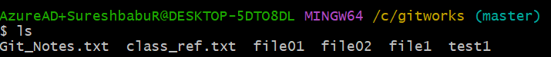

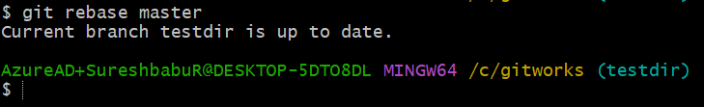

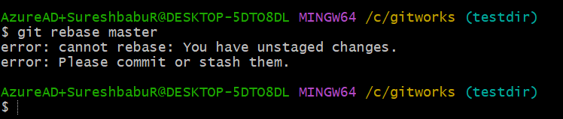

Below command (git add .) || added all files to staging and committed

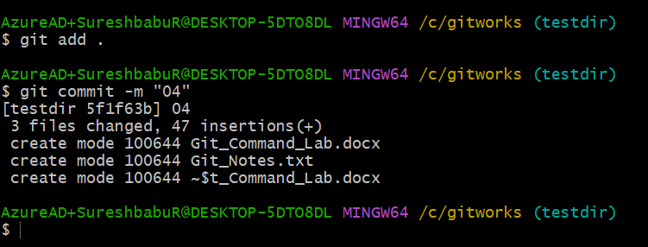

1. Rebase
2. How to push into the Git website

Push to on git web

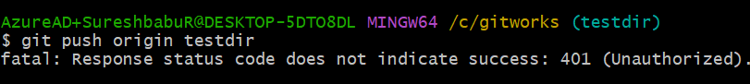

Create the new token in developer settings.

