#Notification

1. While student submit proposal notification should apper in admin projects, supervisor invitation .
2. While sending message
3. While supervisor assign task
4. While student submit task

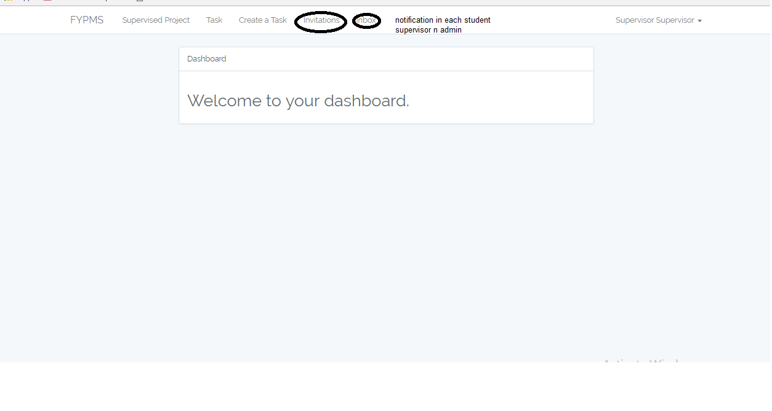

#Student assignment

Error vako yehi ho dai ?

1. While student receive task, along with deadline ? if student had submit task done or undone should be seen

http://localhost:8000/student/assignment

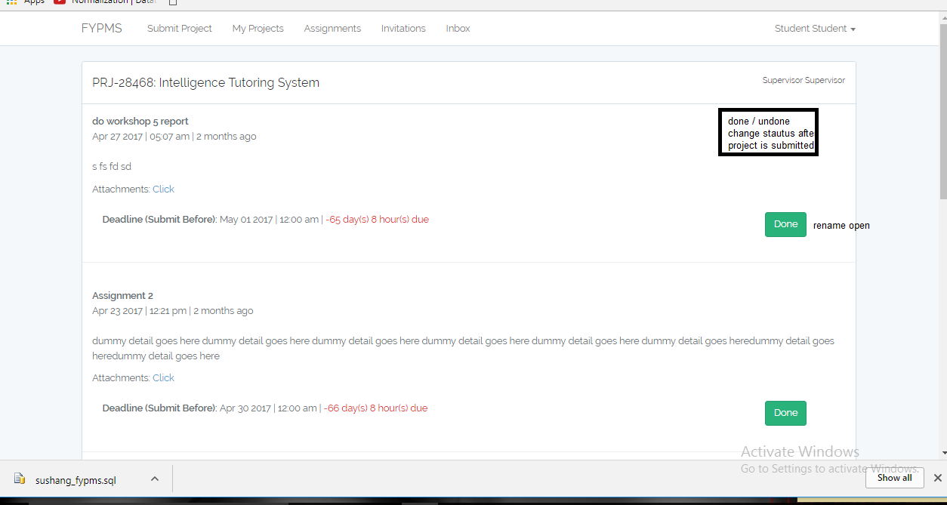

#supervisor

1 supervisor should able to view project proposal, along with accept and reject and hold project along with certain message.

http://localhost:8000/supervisor/project-invitation

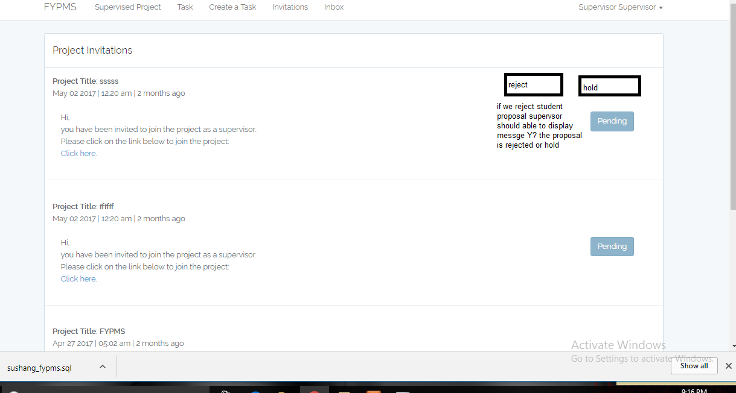

Dai main kam haru eti ho ? auru ta color change tapai ley afno hisab ley melai dnu, ani tehe edit haru kam gari rako xaina supervisor ko task and student ko myprojects ko edit teo ni herdnu la dai .