FounderLink- Platform
Domain: Investor & Startup Founder Collaboration Platform
This is structured like a real backend system design document, suitable for building with Spring Boot, Spring Security, Microservices, Spring Cloud, RabbitMQ.

1. System Overview
FounderLink is a multi-user platform connecting startup founders with investors and potential co-founders.
The platform enables:
- Founders to post startup ideas
- Investors to discover startups and invest
- Founders to build startup teams
- Communication between founders and investors
- Tracking investments and startup progress
The system will be implemented using microservices architecture to ensure scalability and maintainability.

2. Business Goals
The platform aims to:
- Enable founders to present startup ideas to investors.
- Help investors discover high-potential startups.
- Facilitate team building for startups.
- Provide secure communication between investors and founders.
- Maintain transparent investment tracking.

3. User Roles

3.1 Founder
A user who owns a startup idea.
Capabilities:
- Create startup profile
- Upload pitch details
- Raise funding
- Invite co-founders
- Communicate with investors

3.2 Investor
An individual or organization investing in startups.
Capabilities:
- Discover startups
- View startup profiles
- Invest in startups
- Track investments

3.3 Co-Founder
A professional interested in joining startups.
Capabilities:
- View startup opportunities
- Join startup teams
- Collaborate with founders

3.4 Admin
Platform administrator.
Capabilities:
- Approve startup listings
- Monitor platform activity
- Manage users
- Handle reports

4. Core Functional Requirements

4.1 Authentication & Authorization
Users must securely register and login.
Features:
- user registration
- login
- JWT authentication
- role-based authorization
Roles supported:
ROLE_FOUNDER
ROLE_INVESTOR
ROLE_COFUNDER
ROLE_ADMIN

4.2 User Profile Management
Users maintain professional profiles.
Profile fields include:
- name
- email
- skills
- experience
- bio
- portfolio links
Features:
- create profile
- update profile
- view profile

4.3 Startup Idea Management
Founders can publish startup ideas.
Startup details include:
- startup name
- description
- industry
- problem statement
- solution
- funding goal
- stage
Startup stages:
IDEA
MVP
EARLY_TRACTION
SCALING
Features:
- create startup
- update startup
- delete startup
- view startup listings

4.4 Investor Discovery
Investors should easily find startups.
Search filters:
- industry
- funding stage
- funding goal
- location
Features:
- search startups
- view startup details
- follow startups

4.5 Investment Management
Investors can invest in startups.
Features:
- create investment
- track investment
- view investment portfolio
Investment status:
PENDING
APPROVED
REJECTED
COMPLETED

4.6 Team Building
Founders can build teams.
Features:
- invite co-founders
- accept invitation
- join startup team
- manage team roles
Example roles:
CTO
CPO
MARKETING_HEAD
ENGINEERING_LEAD

4.7 Messaging System
Communication between:
- Founder ↔ Investor
- Founder ↔ Co-founder
Features:
- start conversation
- send messages
- fetch conversation history

4.8 Notifications
Users receive notifications for:
- new startup created
- investment requests
- team invitations
- investment approvals
Notification delivery handled asynchronously using RabbitMQ.

5. Non Functional Requirements

Scalability
Microservices allow independent scaling.

Security
Spring Security + JWT authentication.

Reliability
RabbitMQ ensures reliable event delivery.

Maintainability
Each service has independent codebase.

Performance
Async communication reduces latency.

6. High Level Architecture (HLD)
Client Applications
(Web / Mobile)
|
|
API Gateway (Spring Cloud Gateway)
|
Service Discovery (Eureka)
|
----------------------------------------------------
| Auth Service |
| User Service |
| Startup Service |
| Investment Service |
| Team Service |
| Messaging Service |
| Notification Service |
----------------------------------------------------
|
RabbitMQ
|
Database per microservice

7. Microservices Design

7.1 Auth Service
Handles authentication.
Responsibilities:
- register users
- login
- generate JWT
- validate tokens
APIs
POST /auth/register
POST /auth/login
POST /auth/refresh
Database tables:
users
roles
user_roles

7.2 User Service
Manages user profiles.
Responsibilities:
- create profile
- update profile
- fetch user details
APIs
GET /users/{id}
PUT /users/{id}
GET /users

7.3 Startup Service
Handles startup idea listings.
Responsibilities:
- create startup
- update startup
- list startups
- search startups
APIs
POST /startups
GET /startups
GET /startups/{id}
PUT /startups/{id}
DELETE /startups/{id}

7.4 Investment Service
Handles investment operations.
Responsibilities:
- create investment
- approve investment
- track investments
APIs
POST /investments
GET /investments/startup/{startupId}
GET /investments/investor/{investorId}

7.5 Team Service
Handles startup team management.
Responsibilities:
- invite cofounder
- join startup team
- list team members
APIs
POST /teams/invite
POST /teams/join
GET /teams/startup/{startupId}

7.6 Messaging Service
Handles communication.
Responsibilities:
- create conversations
- send messages
- retrieve chat history
APIs
POST /messages
GET /messages/conversation/{id}

7.7 Notification Service
Handles event-based notifications.
Responsibilities:
- send email
- send push notifications
- process events
Uses RabbitMQ to consume events.

8. Event Driven Communication (RabbitMQ)
Example event flow.

Event 1 – Startup Created
Startup Service publishes event.
STARTUP_CREATED
{
startupId
founderId
industry
fundingGoal
}
Notification Service sends alerts to investors.

Event 2 – Investment Created
Investment Service publishes event.
INVESTMENT_CREATED
{
startupId
investorId
amount
}
Founder receives notification.

Event 3 – Team Invitation
Team Service publishes event.
TEAM_INVITE_SENT
{
startupId
invitedUserId
role
}
User receives invitation notification.

9. Database Design (High Level)

User Table
User
-----
id
name
email
password
role
created_at

Startup Table
Startup
--------
id
name
description
industry
stage
funding_goal
founder_id
created_at

Investment Table
Investment
-----------
id
startup_id
investor_id
amount
status
created_at

Team Table
Team
-----
id
startup_id
user_id
role
joined_at

Message Table
Message
--------
id
sender_id
receiver_id
content
created_at

10. Security Architecture
Authentication Flow
Client login request
|
Auth Service validates credentials
|
JWT token generated
|
Client includes token in Authorization header
|
API Gateway validates token
|
Request routed to microservice
Authorization examples:
- Only founders can create startups.
- Only investors can invest.
- Only founders can invite team members.
- Only admins approve startups.

11. Deployment Architecture
System components:
API Gateway
Eureka Discovery Server
Config Server
Auth Service
User Service
Startup Service
Investment Service
Team Service
Messaging Service
Notification Service
RabbitMQ
MySQL/PostgreSQL
Each microservice maintains its own database.

12. Future Enhancements
Possible advanced features:
- AI startup-investor matching
- startup analytics dashboard
- document sharing (pitch decks)
- real-time chat using WebSockets
- investment escrow system
- startup performance tracking

- UI Screens

z
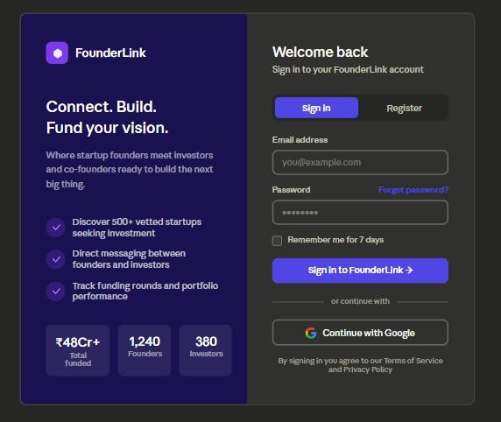

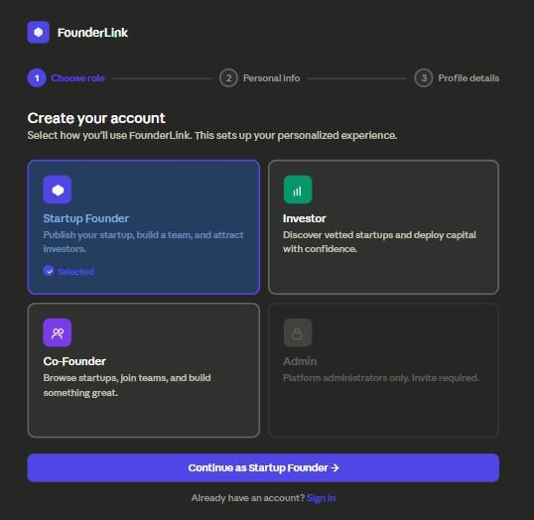

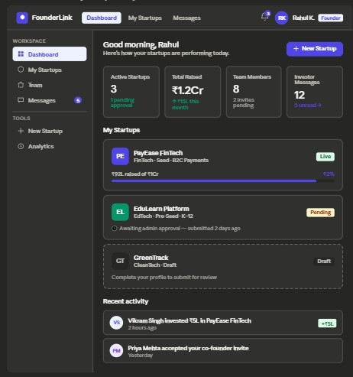

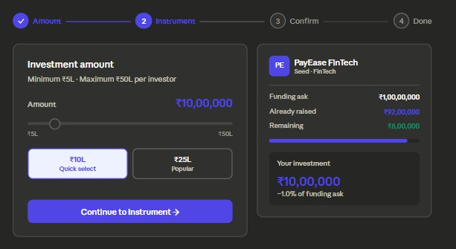

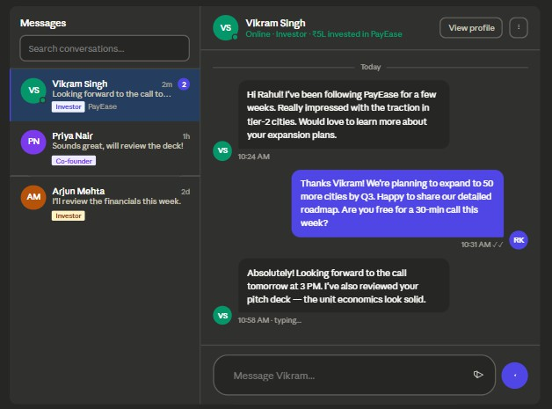

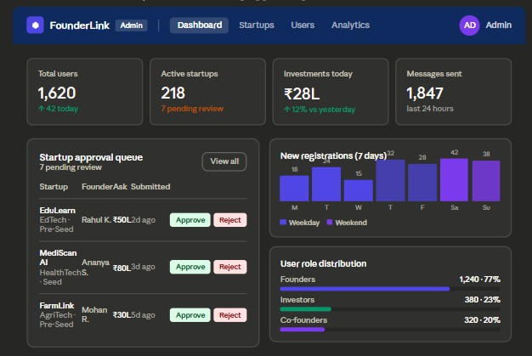

FounderLink – Investor & Startup Founder Collaboration Platform
Frontend System Design Document • React.js & Tailwind CSS • Production Grade • v1.0
Engineering & Architecture Review — Confidential

