What is an ESB?
An Enterprise Service Bus (ESB) is fundamentally an architecture. It is a set of rules and principles for integrating numerous applications together over a bus-like infrastructure. ESB products enable users to build this type of architecture, but vary in the way that they do it and the capabilities that they offer. The core concept of the ESB architecture is that you integrate different applications by putting a communication bus between them and then enable each application to talk to the bus. This decouples systems from each other, allowing them to communicate without dependency on or knowledge of other systems on the bus. The concept of ESB was born out of the need to move away from point-to-point integration, which becomes brittle and hard to manage over time. Point-to-point integration results in custom integration code being spread among applications with no central way to monitor or troubleshoot. This is often referred to as "spaghetti code" and does not scale because it creates tight dependencies between applications.

Why use an ESB?

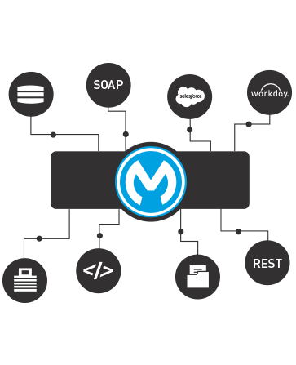

Increasing organizational agility by reducing time to market for new initiatives is one of the most common reasons that companies implement an ESB as the backbone of their IT infrastructure. An ESB architecture facilitates this by providing a simple, well defined, "pluggable" system that scales really well. Additionally, an ESB provides a way to leverage your existing systems and expose them to new applications using its communication and transformation capabilities.

Implementation
The ESB architecture has some key principles that allow for business agility and scale. The key focus is to decouple systems from each other while allowing them to communicate in a consistent and manageable way.
- The "bus" concept decouples applications from each other. This is usually achieved using a messaging server like JMS or AMQP.
- The data that travels on the bus is a canonical format and is almost always XML.
- There is an "adapter" between the application and the bus that marshals data between the two parties.
- The adapter is responsible for talking to the backend application and transforming data from the application format to the bus format. The adapter can also perform a host of other activities such as message routing transaction management, security, monitoring, error handling, etc.
- ESBs are generally stateless; the state is embedded in the messages passing through the bus.
- The canonical message format is the contract between systems. The canonical format means that there is one consistent message format traveling on the bus and that every application on the bus can communicate with each other

Integration core principles
Let's take a look at how an ESB architecture maps to our five core integration principles:
- Orchestration: Composing several existing fine-grained components into a single higher order composite service. This can be done to achieve appropriate "granularity" of services and promote reuse and manageability of the underlying components.
- Transformation: Data transformation between canonical data formats and specific data formats required by each ESB connector. An example of this would be transforming between CSV, Cobol copybook or EDI formats to either SOAP/XML or JSON. Canoncial data formats can greatly simplify the transformation requirements associated with a large ESB implementation where there are many consumers and providers, each with their own data formats and definitions.
- Transportation: Transport protocol negotiation between multiple formats (such as HTTP, JMS, JDBC). Note: Mule treats databases like another "service" by making JDBC just another transport (or endpoint) where data can be accessed.
- Mediation: Providing multiple interfaces for the purpose of a) supporting multiple versions of a service for backwards compatibility or alternatively, b) to allow for multiple channels to the same underlying component implementation. This second requirement may involve providing multiple interfaces to the same component, one legacy interface (flat file) and one standards compliant (SOAP/XML) interface.
- Non-functional consistency: For a typical ESB initiative, this can include consistency around the way security and monitoring policies are applied and implemented. Additionally, the goals of scalability and availability can be achieved by using multiple instances of an ESB to provide increased throughput (scalability) and eliminate single-points-of-failure (SPOFs), which is the key objective for highly available systems.

Choosing an ESB platform
There are many ESB platforms out there, from big proprietary vendors to niche and open source vendors. On paper, there are lots of similarities. Here are some points to consider when making an ESB selection.

Lightweight
Mule is the most lightweight integration platform available, with the fully loaded distribution weighing in at 40 MB. It is modular by design so you can strip out unwanted modules if you need to reduce the footprint. We don't see "lightweight" as just about size either; it is also the cost of making changes to existing integrations and the amount of heavy lifting you need to do to make changes. The Mule run-time offers modularization and super-fast hot deployment as well as a configuration model that makes it easy to re-order and add/change functionality.

Not just mediation
Most vendors think of an ESB as purely mediation between systems and have separate products for hosting business logic and publishing services. We see this as unnecessary complexity. Mule provides a light and scalable service container for publishing REST and SOAP services. Since Mule integrates tightly with Spring, it means developers can also leverage the capabilities of Spring to implement business logic.

Accessible - any developer can learn Mule
Mule uses common tools that all Java developers are familiar with, such as Maven, Eclipse, JUnit and Spring. Mule uses an XML configuration model (similar to Spring) to define logic, and custom code can be written in a variety of languages, including Java, Groovy, JavaScript, Ruby or Python. Also, Anypoint Studio helps new developers get up to speed quickly with a graphical development environment.

Scaling up, scaling down
Mule was designed for horizontal scale on commodity hardware - no need for big iron. Mule's runtime is easily embeddable into an application. It can also be embedded in your application server such as Tomcat, JBoss or WAS or directly in your application. More importantly, Mule provides JUnit support so that it can be embedded in a JUnit test case. This is powerful because it means you can create repeatable unit tests for integrations that will run on a developer laptop and can be incorporated into a continuous build.

Message agnostic
A powerful feature of Mule is that the container is message agnostic. This means it does not force XML messages on its users. While XML is common, there are many scenarios where you will want to use JSON, flat files, Cobol Copybooks, binary and file attachments, streams and Java objects. Our graphical Data Mapper is equally not fussy about the data that can be mapped. What's more, Mule streaming allows developers to process large messages efficiently.

Cloud ready
If you'd rather leave the application architecture, hosting and monitoring of your integration to the integration experts then CloudHub™ is for you. CloudHub is an integration Platform as a Service (iPaaS) that gets you up and running in minutes. CloudHub offers a multi-tenanted, elastic platform with connectivity to 150+ SaaS, Social Media and infrastructure services and the ability to connect to your on-premise applications. CloudHub applications run on Mule standalone and vice versa. This means that whether you are deploying on-premise or the cloud, there are no new concepts to learn and the developer experience is the same. No need to learn a new way of doing things.

Today, I’m going to unveil to you an ultimate lightweight enterprise service bus(ESB), Mule with its integration framework, provided by MuleSoft.
The first question that will rise in your head is, “On what platform does Mule run on or can connect to?”
It is the runtime engine of Anypoint Platform, and is a Java-based Enterprise Service Bus (ESB).
It’s integration program allows developers to compare applications quickly and easily, allowing them to exchange data.
This enables integration of existing systems, regardless of different technologies that the applications use, including JMS, Web Services, JDBC, HTTP, and more. The ESB can be used anywhere, can integrate and organize events in real time or in batch.
Are you thinking about the benefits of an ESB?
Well, I can tell you, it doesn’t get any handier than this. It allows various applications to communicate with each other, as a transit system for carrying data between applications, within your enterprise or across the Internet.
Mule has strong capabilities that include:
I. Service creation and hosting: Expose and host reusable services, using the ESB as a lightweight service container.
II. Service mediation: Shield aim from message formats and protocols, separate business logic from messaging, and allow location independent service calls.
III. Message routing: Route, filter, aggregate, and re-sequence information based on content and rules.
IV. Data transformation: Replacing data across various formats and transport protocols.

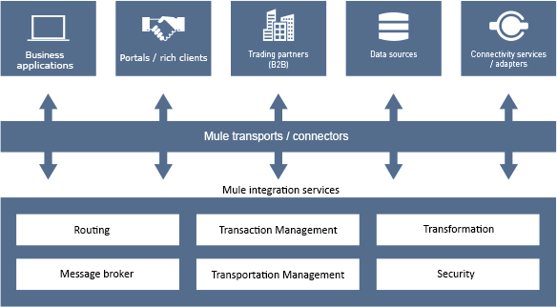

What is a Mule Application?
Mule applications are configured to run on Mule Runtime to process inbound information, and ingest this in a pre-defined manner.
An awaited request for a running Mule application usually triggers Mule to encode the event and data in a Mule message, passing it along with a single thread or multiple threads.
It modifies and routes the Mule message in steps, according to the processors configured to interact with the message at the various stages. Mule gets the message to its destination, passing the requisite data to the recipient.
The Mule application is defined in an XML document that specifies the necessary dependencies for the Mule application to run. You can configure your Mule application to process data in a variety of ways and can adjust the Mule runtime instance accordingly.
Mule is a package of components, connectors, and transformers that operate to get the data and metadata you need from your Mule application and serve it to any destination.
Mule Goals:
- Deploy or integrate applications or systems on premise or in the cloud
- Employ out-of-the-box connectors to create SaaS integration applications
- Build and expose APIs
- Consume APIs
- Create Web services which orchestrate calls to other services
- Create interfaces to expose applications for mobile consumption
- Integrate B2B with solutions that are secure, efficient, and quick to build and deploy
- Shift applications onto the cloud
- Connect B2B e-commerce activities
Do I need an ESB?
Mule and other ESBs give real value in situations where there are at least some integration points or 3 applications to unite. They are also quite suited to situations where loose coupling, scalability, and robustness are needed.
Here is a quick ESB selection checklist, to go through when to selecting an ESB. Read this article written by Mule Soft founder and VP of Product Strategy Ross Mason: To ESB or not to ESB.
1. Are you integrating 3 or more applications/services?
2. Will you need to plug in more applications in the future?
3. Do you need to use more than one type of communication protocol?
4. Do you require message routing abilities such as forking and aggregating message flows, or content-based routing?
5. Do you need to publish services for consumption by other applications?
Why Mule?
It’s a given that Mule is lightweight, but extremely scalable.
How though? It allows you to start and connect more applications. The ESB controls all the interactions between applications and components transparently, whether they exist in the same virtual machine or over the Internet.
There are several ESB implementations on the market. However, many of these provide limited functionality or are built on top of an existing application server or messaging server, locking you into that specific vendor. Mule is vendor-neutral, so, different implementations can be plugged in. You are never secured with a particular vendor when you use Mule.
Mule provides many advantages over competitors, including:
Mule components can be any type you want. You can easily integrate anything from a “plain old Java object” (POJO) to a component from another framework.
Mule and the ESB model enable significant component reuse. Mule allows using existing components without any changes. Components do not require any Mule-specific code to run in Mule, and there is no programmatic API required. The business logic is kept completely separate from the messaging logic.
Information about messages can be in any format from SOAP to binary image files. Mule does not force any constraints on the architect, such as XML messaging or WSDL service contracts.
You can deploy Mule in a variety of topologies, and not just ESB, since it’s lightweight and embeddable.
Mule’s stage event-driven architecture (SEDA) makes it extremely scalable.
Installation, Management and Deployment
To get started with a local installation of Mule runtime, I suggest you click on Download, and Start Mule Runtime.
You can deploy Mule applications to MuleSoft’s cloud platform via CloudHub and manage them via Runtime Manager. Runtime Manager can be used to manage local deployments, making it more accomplished than its forerunner Mule Management Console, used for local Mule deployments.

Why MuleSoft?

In the last 14 years, I have been working for some amazing companies with a focus on Application Lifecycle Management (ALM), Quality Management, Automated Testing, and DevOps. I worked with one of the best professionals in the market in the ALM space and I learned a lot of great approaches and powerful tools.

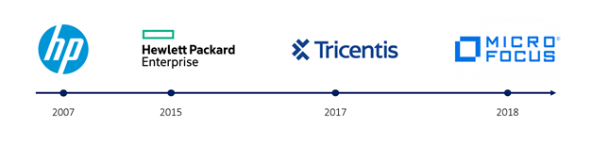
Now it is time for me to learn something new – something, which would put me out of my comfort zone.
IT culture and technology changed a lot since I started at HP in 2007. Back in 2007, integration between tools was nice to have an asset, but not mandatory. COM interfaces were on the daily agenda and already at that time, I enjoyed building integrations from system to system to enable users and businesses to gain higher visibility into the processes.
Over the years the organization's mindset changed from an isolated to a shared approach. Today, integrations have gained more importance, and that is why every software product is providing plugins and integration possibilities. Even products without an integration possibility are being modernized and equipped with an Application Programming Interface (API).
I knew APIs from my recent role at Micro Focus and have worked with the REST API Interface of several tools, but only as a consumer. I started to research jobs in the API market space and found the most innovative approach towards digital transformation called “API-led connectivity” for developing, managing, and orchestrating APIs with a unified platform. Before going deeper into that approach, let us discuss why APIs are needed.

Why are APIs needed?
APIs are needed to connect applications together in order to perform defined processes around sharing data. An API acts as the middleman, allowing developers/engineers to build interactions between applications people and businesses use daily.
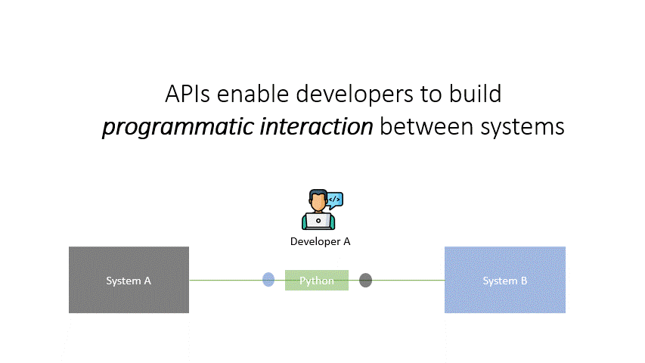

When I look back on recent projects in 2020-21, the usage of APIs was the key to success for the project delivery. Providing out-of-the-box plugins is great and helps customers to utilize the “standard” capabilities of a tool, but in many cases, custom integration between systems is higher in demand.
Imagine, we have a simple System A, which is being introduced into an organization’s business unit. This system requires integration to 3 other systems (System B, System C, and System D). Each system has a responsible architect/engineer who would build a programmatic interaction with System A.
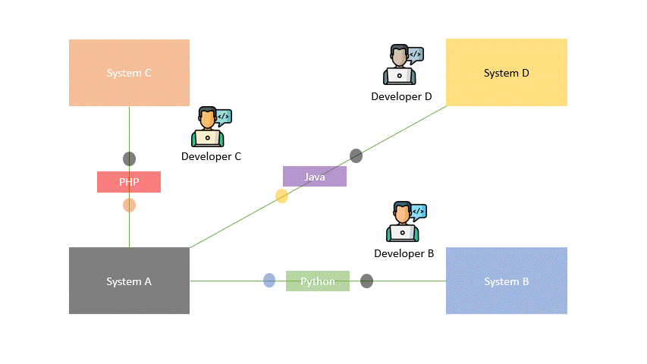

Each architect/engineer has a different level of expertise and choice of programming language to build the desired integration. With high initial effort, the integrations are built and put into operation.
Now imagine a change in the API of System A?
A major change in System A’s API would:
- cause failure in all integrated systems (B, C, and D),
- prevent users from working,
- require analysis and fix in all systems,
- cause downtime and business interruption,
- decrease the user experience of all involved parties (customers, partners, and employees).
Another downside of such an isolated approach is, that the knowledge on the integration is with the skilled engineer - If the engineer retires or leaves the company, the maintenance of that specific integration becomes difficult.
And in this simple example, we are talking about just 3 systems to integrate.
In a real-world example, if you are driving a transformation initiative to build a new e-commerce platform for your customers, there would be a minimum of up to 70 or more integrations required to allow an end-to-end experience for customers, partners, and employees. Think about a CRM migration project, a new mobile customer app, or a database switch from SQL to No-SQL.
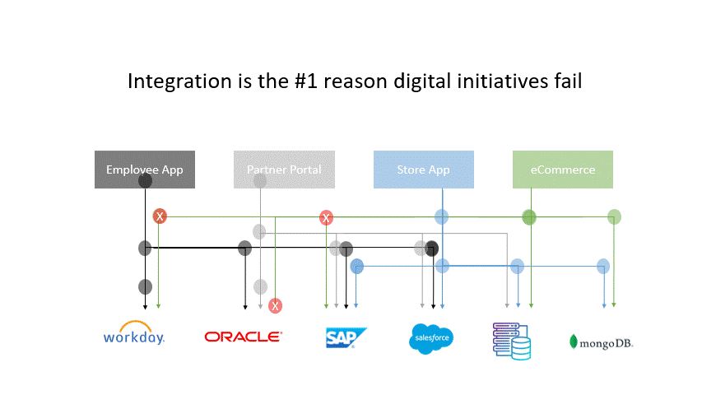

Leveraging APIs only as “technology that connects systems” will forcibly build a heterogeneous approach to drive digital transformation, which on one hand may be quick but on the other hand, it is fragile, not maintainable, and error-prone. This is due to the integrations between system-to-system, system-to-database, database-to-database, etc. as nothing between the teams is orchestrated, shared, or reused.

API-led connectivity
Applying a central and unified approach to API Management will solve these challenges and allow organizations to build an organized ecosystem towards digital transformation by enabling business and IT to share application assets across business units.
Let me introduce you to the API-led connectivity approach of MuleSoft. API-led connectivity is an approach that defines methods for connecting and exposing your assets. The approach shifts the way IT operates and promotes decentralized access to data and capabilities, while not compromising governance. And the outcome of API-led connectivity is an application network: a network of applications, data, and devices that are ‘pluggable’, providing the agility that the speed of today’s digital transformation demands.
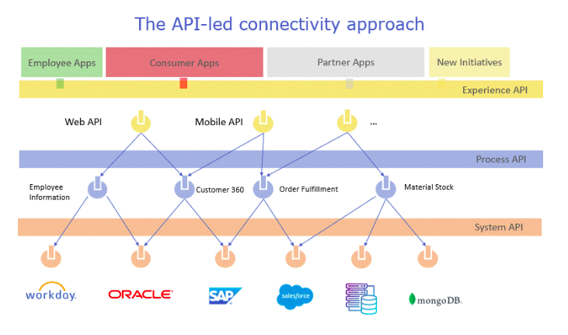
The beauty of the API-led connectivity approach is the flexibility and agility it provides through its three-layered architecture.
The first and lowest layer is for the System APIs, which provide a means of accessing underlying systems of record and exposing that data. These APIs will also change more infrequently and will be governed by central IT given the importance of the underlying systems.
The second layer is for the Process APIs, which represent all underlying business processes that interact and shape data should be strictly encapsulated independently of the source systems from which the data originates, as well as the target channels through which that data is to be delivered. For example, in a purchase order process, there is some logic that is common across products, geographies, and retail channels that can and should be distilled into a single service.
The third and top layer is for the Experience APIs, which are the means by which data can be reconfigured so that it is most easily consumed by its intended audience, all from a common data source, rather than setting up separate point-to-point integrations for each channel.

MuleSoft: The API-led connectivity platform
MuleSoft’s Anypoint Platform™ is a single, unified platform that allows organizations to easily build and rapidly scale application networks. Anypoint Platform is the world’s leading integration solution and is trusted by more than 1,600 enterprise customers across every major industry. Anypoint Platform enables end-to-end connectivity across APIs, service orchestration, and application integration. This allows developers to rapidly connect, orchestrate, and enable any internal or external endpoint. The result is a 2x to 5x faster time to launch new initiatives, connect systems, and unlock data across the enterprise and a 30% reduction in integration costs.
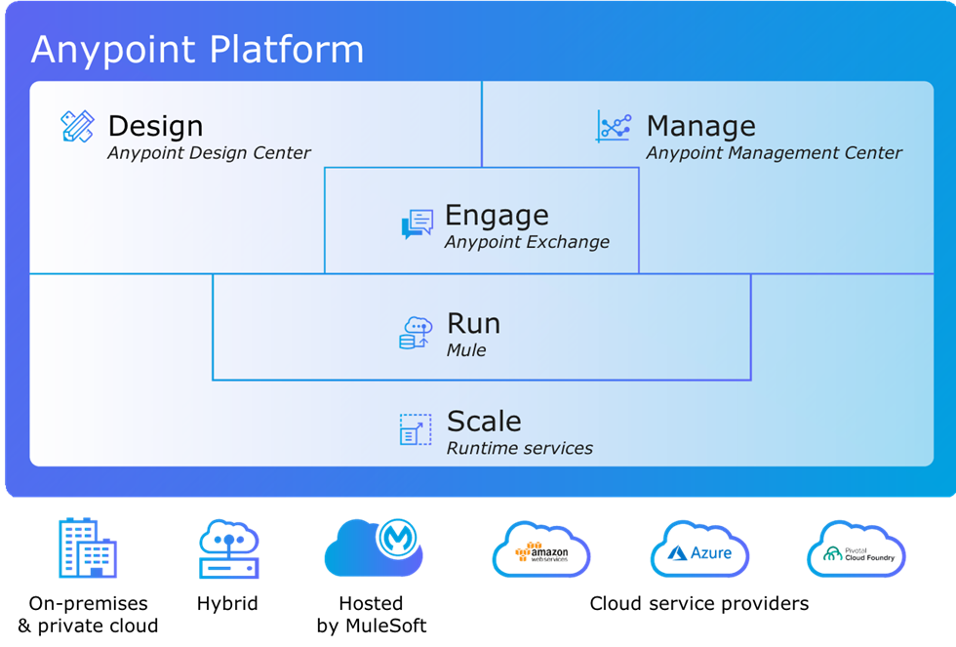

MuleSoft: Anypoint Studio
Build and test APIs and integrations quickly with Anypoint Platform’s desktop IDE.
Boost development productivity
Accelerate implementation with an IDE for integration and API development that has prebuilt modules for common integration requirements — including querying backend systems, routing events, business transformation logic, and error handling.
- Jumpstart your integrations with prebuilt connectors, templates, and examples
- Debug with design-time error handling
- Normalize, join, filter, or map any data format
- Integrate automated testing into your existing CI/CD pipeline with MUnit
- Deploy APIs and integrations to the cloud or on-premises

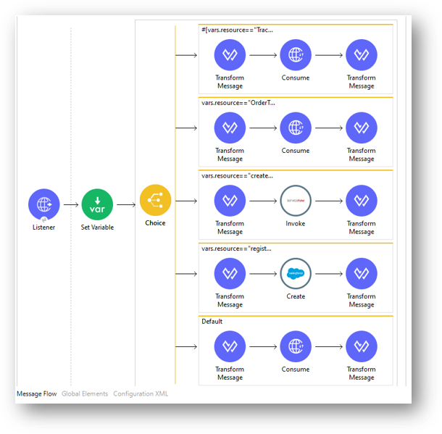
.

MuleSoft Connectors
MuleSoft Anypoint platform comes with many out-of-the-box and pre-built connectors. These Connectors are reusable extensions to Mule runtime engine (Mule) that enable you to integrate a Mule app with third-party APIs, databases, and standard integration protocols. Connectors abstract the technical details involved with connecting to a target system. All connectivity in Mule 4 is provided through connectors.
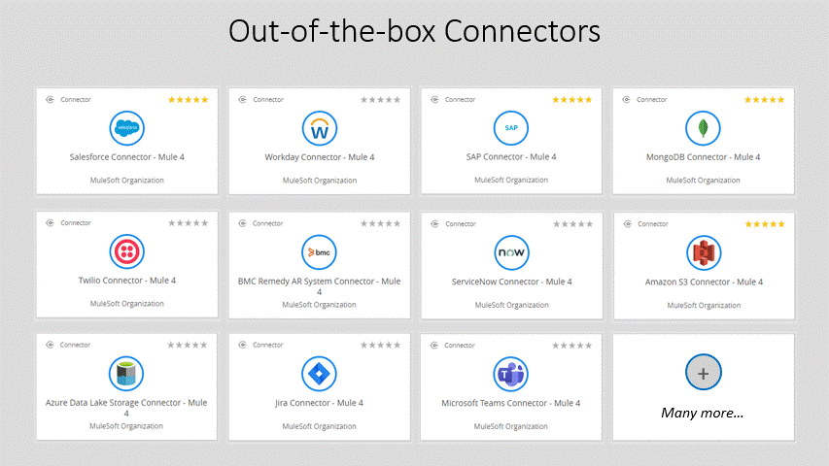

Connect to any endpoint
- Connect to SaaS applications such as SAP or Salesforce
- Integrate cloud infrastructure and services in AWS and Azure
- Use ODBC, JDBC, and other open protocols to connect databases
- Empower business teams to connect with clicks, not code
- Build and certify your connector to make it available in our public marketplace
Besides all out-of-the-box connectors, MuleSoft also provides a Connector SDK to build custom connectors for the Anypoint platform.

