Tennis Gets Smart:
Machine Learning Based Tennis Personal Coach
SS 2017

Wearables Computing Laboratory
Embedded Systems chair, University of Freiburg

Amir Kallel | Alexander Kozhinov | Suresh Dharani Parasuraman

Table of Contents

1 Introduction 3
2 Theory and Methods 3
2.1 Tennis swing modeling 3
2.2 Live Swing detection 4
3 Project Setup 4
3.1 Hardware 5
3.2 Software 6
4 Results 6
5 Conclusions 8
6 References: 8

- Introduction
Tennis is a fun game to play, however quite difficult to get better at: a Tennis club membership is usually the only option for ambitious players who want to level up their game. This comes with a big cost and time commitment.
Fortunately, a smart racket may replace the effort of a personal trainer at the club as well as the pricey bill that follows. This project serves as proof of concept as an alternative to a personal coach while training, where it guides the player via live feedback of his tennis moves in order to develop a proper technique.
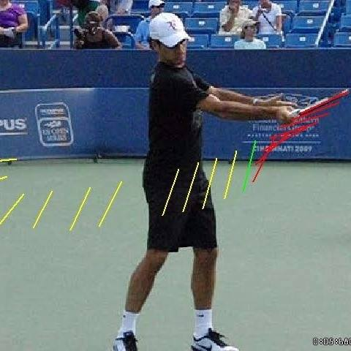
Figure 1 : Professional tennis player swing motion illustrated [1]
- Theory and Methods
  - Tennis swing modeling
A parametric model has to be defined to model the correct swing motion. 93 data set was recorded while performing correct swing motions. This data is then plotted and analyzed using Matlab and modeled using the curve fitting toolbox plugin with different fit types: Polynomial, gaussian etc. The most appropriate fit type determined is the gaussian fit (see equation 2.1) due to the close resemblance to the data recorded as seen in figure 5.
 | $y=Ae^{-\frac{{(x-μ)}^{2}}{{2σ}^{2}}}+b$ [2] | (2.1)
Where:
$A$ = $\frac{1}{σ\sqrt{2π}}$
$μ$ : Mean representing the amplitude of the data recorded.
$σ$ : Standard deviation representing the duration of the swing recorded.
$b$ : Bias

5 out of 9 sensor data channels were modeled using 1st and 2nd gaussian distributions as shown in the following table:
Table 1: Fit types and features of sensor channels models
Sensor channel | Fit type | Features | Number of features
X Acceleration axis | 2nd Gaussian | $$A_{1} ,μ_{1},σ_{1},A_{2} ,μ_{2},σ_{2},b$$ | 7
Y Acceleration axis | 1st Gaussian | $$A_{1} ,μ_{1},σ_{1},b$$ | 4
Y Rotation speed axis | 1st Gaussian | $$A_{1} ,μ_{1},σ_{1},b$$ | 4
Z Rotation speed axis | 2nd Gaussian | $$A_{1} ,μ_{1},σ_{1},A_{2} ,μ_{2},σ_{2},b$$ | 7
β Euler angle | 1st Gaussian | $$A_{1} ,μ_{1},σ_{1},b$$ | 4
Total features |  |  | 26

In total, 26 parameters define the model obtained. For dimensionality reduction purposes, Linear Discriminant Analysis (LDA) algorithm is used on the 93 recorded data set to obtain a linear classifier that is later used to predict goodness of swing motion..
2.2 Live Swing detection
Once the linear classifier is determined, it can be integrated in the program that collects, plots and fits live data coming from the racket as illustrated in figures 4 and 5.
A minimum Threshold value for the X acceleration axis (see figure 4) can be configured on the program’s interface to launch the fitting algorithm once a motion has exceeded that threshold. The goal is to enhance performance via fitting only when a suspected swing motion is detected.
Once the fitting algorithm is launched, it buils a window where the minimum value lies in the middle with half of the fit window length (141 datapoints as seen in figure X) on each side: 70 points on each side of the minimum value. This approach ensures correct modelling of the motion recorded. If the fit modeled is multiplied by a cross product with the linier classifier already created, if it is classified as a swing motion, the fit is plotted in green, otherwise the fit is plotted in red.
- Project Setup
The architecture model of the project is client-server as illustrated in the following figure:

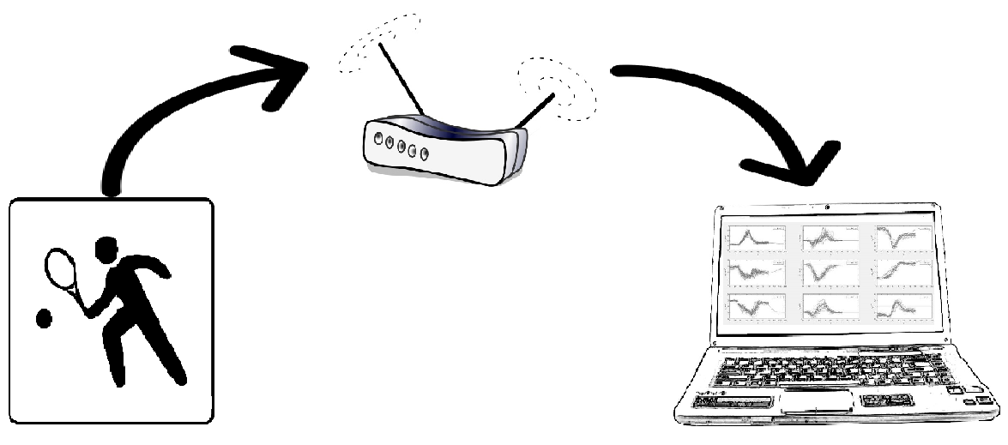
Figure 2: Client-server architecture model approach used in the project

Client Side | Server Side
- Broadcasting sensors data  - …. | - Live data plotting  - On-the-fly classification of data to detect swings  - Display game statistics

  - Hardware
An MPU-9150™ 9-axis motion tracking device from invensense® [Gyroscope / Compass / Accelerometer] is embedded in the racket on a 3D printed platform along with an Intel Edison serving as a sensor data broadcaster through a client application written in C++ as shown in the following figure:
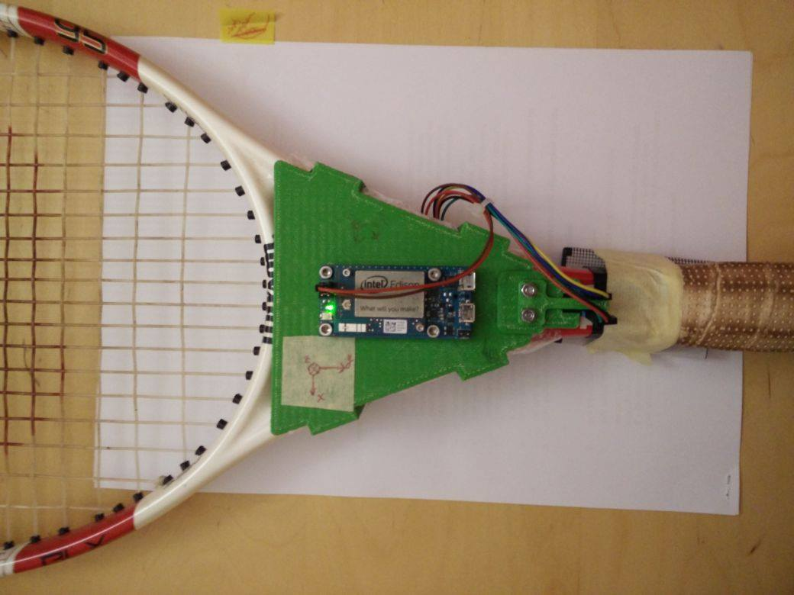
Figure 3: Racket hardware setup
The server side application is written in C++/Python running on QT. It may run on a Linux or Mac OS running machine with the following recommended requirements:
The script used to determine the swing model is written in C++/Python. It may run on a Linux or Mac OS running machine
  - Software
Flowchart to be inserted:Suresh input.
- Results
The following are screenshots of the server side application while running:
Figure 4: Data plotted and predicted correctly as a wrong swing move

Figure 5: Data plotted and predicted correctly as a wrong swing move
Control elements are explained in the following table:
Table 2 Control elements of the server user interface
Control Element | Description
Fit window length | The number of data points of the desired window to be fitted. The value is defined manually from correct swing motion data
Plot buffer size | Determines how many points are plotted on the x axis of the plot.
Local port | The port number to listen to
a_x min threshold | The minimum Acceleration X axis threshold that once exceeded, the fitting algorithm is launched. (Explained in section 2.2)
Fit window step % of window length | ….
Phone/Edissoon checkbutton | Determines whether the server is listening from a smartphone sensor broadcaster app or from the Intel Edisson

- Conclusions
The challenge addressed in this project revolves around reducing the dimensionality of swing model defined: LDA algorithm is used to easily classify 26 features of gaussian distribution models representing 5 sensor data channels by creating a linear classifier used to seperate good swing motions from other motions.
The system can be improved through the following:
- Record more data for the training set for better swing prediction accuracy.
- Train a classifier with nonlinear characteristics.
- Better signal filtering.
- Train the system automatically while playing.
- Qualitify swing motions by comparing it to the training set.
- Provide live feedback along with game statistics and estimated calories burned through a smartwatch
- References:
[1] Navsharan Singh. (2014, Juin 14). How do you put spin on a tennis ball? [Blog post]. Retrieved from http://www.quora.com/How-do-you-put-spin-on-a-tennis-ball
[2] Courtney Taylor. (2016, August 30). Formula for the Normal Distribution or Bell Curve. Retrieved from http://www.thoughtco.com/normal-distribution-bell-curve-formula-3126278

