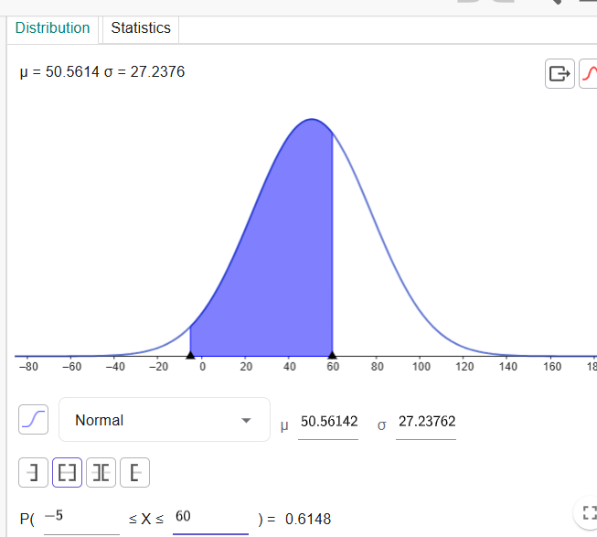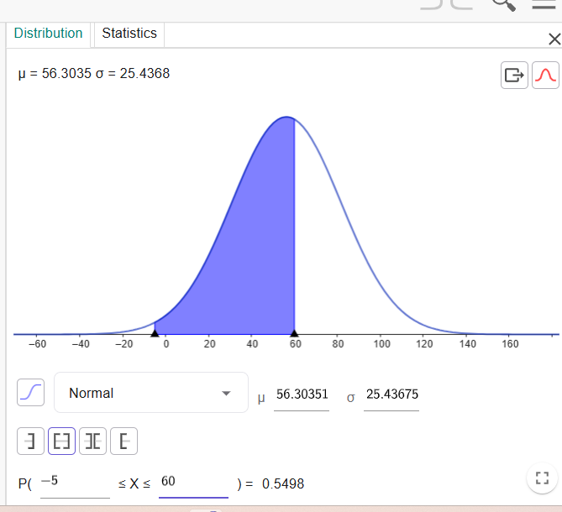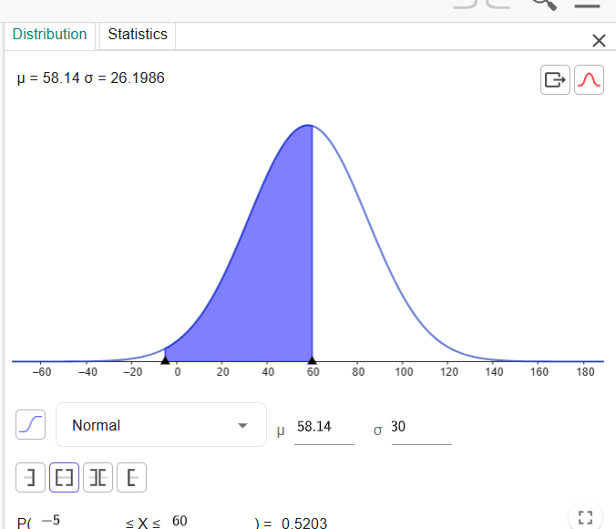

**Image 1 (mu = 58.14, sigma = 26.1986)**

In this first image, the mean (μ) is approximately 58.14, and the standard deviation (σ) is around 26.20.

* **Inference:** This platform has a higher average completion percentage and a larger standard deviation compared to the other two. The wide spread of the curve indicates that the completion percentages are highly variable. This could suggest that some campaigns on this platform are performing exceptionally well, while others are underperforming significantly. The high variability might indicate that this platform requires more careful campaign optimization and monitoring.

**Image 2 (mu = 50.56, sigma = 27.2376)**

Here, the mean (μ) is about 50.56, and the standard deviation (σ) is around 27.24.

* **Inference:** This platform has the lowest average completion percentage, and also a large standard deviation. The lower mean suggests that on average, campaigns on this platform are less effective at achieving high completion rates. The high standard deviation again points to high variability in campaign performance. This platform might be a less consistent choice for driving high completion rates.

**Image 3 (mu = 56.30, sigma = 25.4368)**

In this final image, the mean (μ) is approximately 56.30, and the standard deviation (σ) is around 25.44.

* **Inference:** This platform has the second-highest average completion percentage and the lowest standard deviation among the three. The slightly narrower curve indicates that the completion percentages are more consistently clustered around the mean. This suggests that this platform is a more stable and reliable option for achieving a higher average completion rate.

**Overall Conclusion**

Comparing all three plots:

* **Platform 1** seems to have the highest average performance, but it's also the most volatile.
* **Platform 2** is the least effective on average, with high variability.
* **Platform 3** appears to be the most consistent and reliable platform, offering a high average completion percentage with less variability than the other two.

Based on this analysis, the third platform (the one) would likely be the most dependable choice for future marketing efforts if your goal is to consistently achieve a good completion rate without significant fluctuations. However, the first platform might offer the highest potential if you can identify and replicate the strategies of its most successful campaigns.