DATA WAREHOUSING WITH IBM CLOUD DB2 WAREHOUSE

PHASE 2 : INNOVATION

OVERVIEW :

To Develop A Comprehensive Data Warehousing System Integrated With IBM Cloud Application Development, Enabling Our Organization To Efficiently Store, Manage, And Analyze Data While Empowering Application Developers To Create Data-Driven Applications. The Objective Is To Bring Together Data From Various Sources, Perform Advanced Data Integration And Transformation, And Provide Data Architects With The Tools To Explore, Analyze, And Deliver Actionable Data For Informed Decision-Making. This Project Encompasses Defining The Data Warehouse Structure, Integrating Data Sources, Performing ETL (Extract, Transform, Load) Processes, And Enabling Data Analysis

IMPLEMENTATION STEPS:

1. Requirements Gathering:

* Define the scope of the project.
* Identify stakeholders and their requirements.
* Determine data sources and types of data to be warehoused.
* Define key performance indicators (KPIs) and reporting requirements.

1. Architecture Design:

* Select IBM Cloud Db2 Warehouse as the data warehousing platform.
* Define the data model, including tables, schemas, and relationships.
* Plan data extraction, transformation, and loading (ETL) processes.
* Decide on data security and access control mechanisms.

1. Environment Setup:

* Create an IBM Cloud account and provision Db2 Warehouse services.
* Configure network access and security settings.
* Install and set up ETL tools (e.g., IBM DataStage) if needed.

1. Data Ingestion:

* Extract data from source systems (databases, applications, files).
* Transform data as per the defined data model and business rules.
* Load transformed data into Db2 Warehouse.

1. Data Quality and Governance:

* Implement data quality checks to ensure data accuracy.
* Establish data governance policies and metadata management.

1. Performance Optimization:

* Tune database parameters and query optimization.
* Implement indexing and partitioning strategies for efficient data retrieval.

1. Reporting and Analytics:

* Develop dashboards and reports using tools like IBM Cognos or Tableau.
* Enable users to query and analyze data for insights.

1. Monitoring and Maintenance:

* Set up monitoring for system performance and data quality.
* Implement regular backups and disaster recovery plans.
* Perform routine maintenance and updates.

1. User Training and Documentation:

* Provide training for end-users and administrators.
* Document the system architecture, data models, and ETL processes.

1. Project Testing and Validation:

* Perform extensive testing, including unit testing, integration testing, and user acceptance testing.

1. Deployment:

* Deploy the data warehousing solution into the production environment.

1. Project Evaluation and Optimization:

* Continuously monitor system performance and user feedback.
* Optimize the system based on feedback and changing requirements.

1. Project Documentation and Handover:

* Create comprehensive documentation for future reference.
* Handover the project to the operations team for ongoing management.

1. Project Closure:

* Evaluate the success of the project against the initial objectives.
* Conduct a project review to identify lessons learned.

1. Ongoing Support and Enhancement:

* Provide ongoing support and maintenance for the data warehousing solution.
* Implement enhancements and updates as needed.

KEY COMPONENTS:

* Unified Data Repository: Implement a data lake architecture on IBM Cloud, consolidating data from various sources and formats into a single, unified repository. Use IBM Cloud Object Storage to store raw and processed data.
* AI-Driven Data Quality and Governance: Utilize IBM Watson to implement AI-driven data quality and governance. This includes data profiling, classification, masking, and automated data lineage tracking to ensure data accuracy and compliance.
* Cloud-Native Application Development: Develop a cloud-native application development environment using IBM Cloud Kubernetes Service and IBM Cloud Foundry. This environment includes DevOps automation, continuous integration, and containerization for application deployment.
* Data Virtualization: Implement data virtualization using IBM Cloud Pak for Data, enabling real-time access to data across the organization without the need for complex data movement.

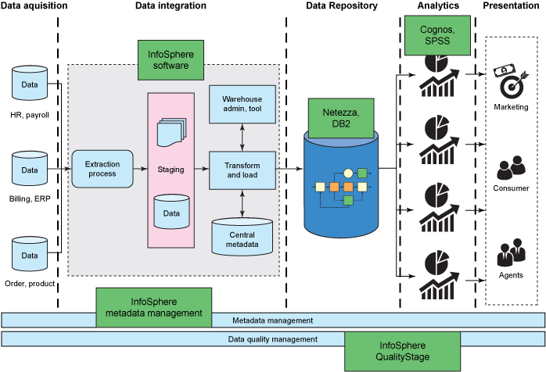

* AI-Powered Analytics: Incorporate IBM Watson Studio for AI and machine learning capabilities, allowing for predictive analytics, data-driven insights, and smart recommendations within applications.
* Real-Time Streaming and Event Processing: Utilize IBM Event Streams for real-time data ingestion and event processing. This is particularly useful for applications that require real-time data updates.

BENEFITS:

* Enhanced data management and analytics capabilities.
* Accelerated application development with access to real-time data.
* Improved decision-making through data-driven insights.
* Scalability to accommodate future data growth.
* Reduced operational costs through cloud-based solutions.
* This project plan outlines the steps to integrate data warehousing and application development on IBM Cloud, enabling your organization to harness the power of data for innovation and competitiveness.