ICT EXPO PROJECTS – HAND-MADE WORKING MODELS
Grade 1 (6 Projects) | Grade 2 (6 Projects)
Each project maps to one module from the textbook Contents. Images are reference illustrations of the hand-made model.
GRADE 1 : ICT EXPO PROJECTS
No. | Project Topic | Module (Contents) | Materials & How to Make | Reference Image
1 | Algorithms All Around Us — Step-by-Step Wall | Module 1: Computational thinking and programming · 1.1 Algorithms all around us | Chart board base (thick cardboard); Picture cards of daily-routine steps; Velcro or sticky tack; Colour markers, glue, scissors.  How to make: Draw and cut picture cards for 3–4 everyday activities. Shuffle the cards and fix a big 'algorithm wall' on the board. Invite a visitor: they arrange one activity's steps in the correct order. They read the algorithm aloud — first, next, then, last! | 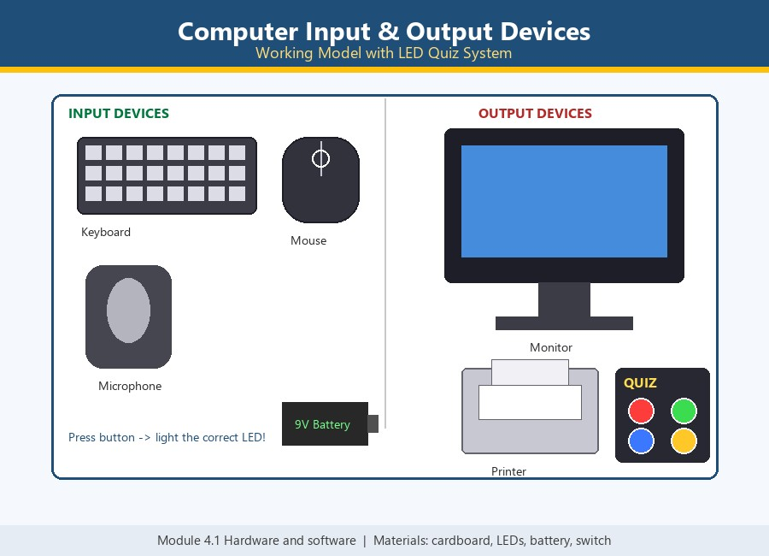
2 | Bee-Bot Beginnings — Cardboard Robot Grid | Module 1: Computational thinking and programming · 1.2 Bee-Bot beginnings | Cardboard Bee-Bot model with arrow buttons; Taped floor grid (or mat with squares); Flower / goal cut-out; Battery + buzzer (optional beep).  How to make: Tape the grid on the floor and place the flower goal square. Put the Bee-Bot on the start square. The child plans the route aloud, then presses the arrow buttons in order. Press GO — the Bee-Bot follows the sequence to the flower! | 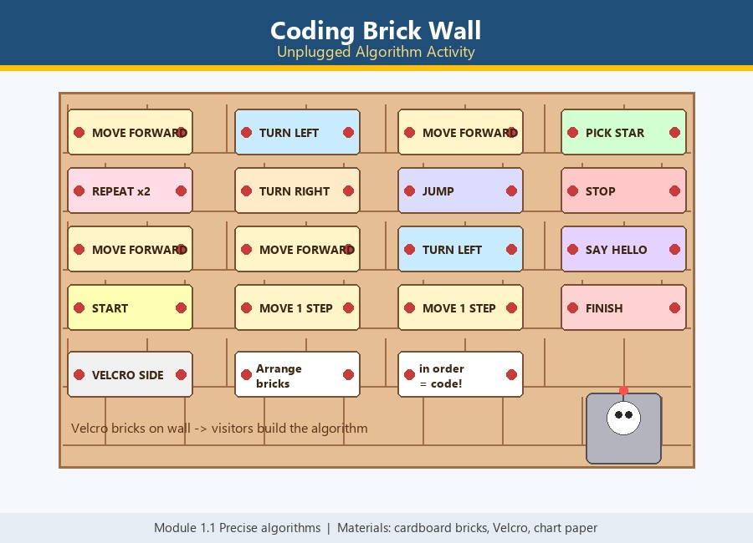
3 | What Happens Next? — Story Prediction Machine | Module 1: Computational thinking and programming · 1.3 What happens next? | Cardboard machine frame with a display window; Sequence cards (seed → sprout → plant → flower); 3 prediction-choice pockets; Slider or flip mechanism.  How to make: Build the machine frame with a display window and a card slot. Feed the sequence cards into the window one by one. The visitor studies the pattern and picks the next-step card from the choices. Correct prediction — the machine reveals the next card! Try all the sequences. | 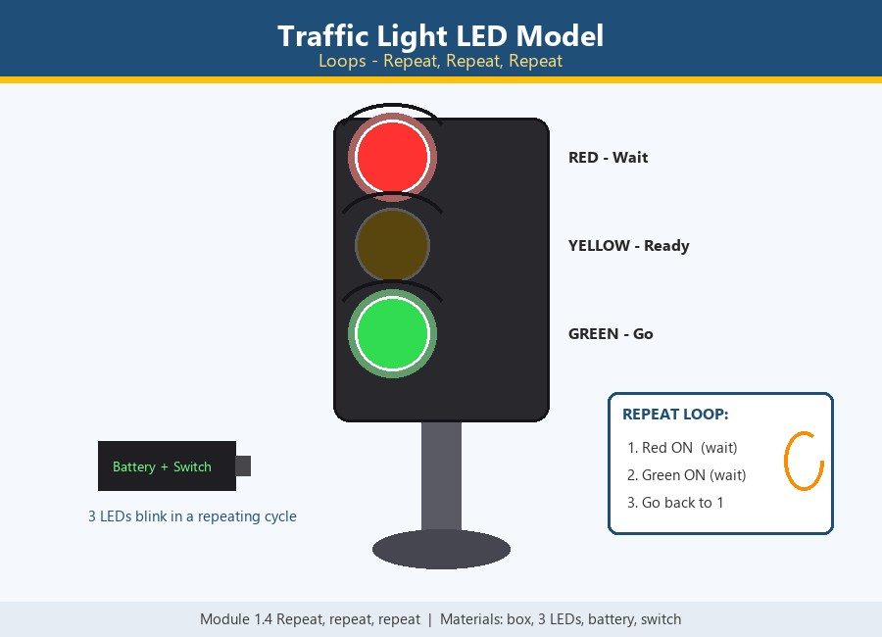
4 | Spot the Bug — Fix the Silly Robot | Module 1: Computational thinking and programming · 1.4 Spot the bug | Silly robot poster (drawn with deliberate mistakes); Correct fix cards (shoe, sock, hat…); Velcro / sticky tack; Detective magnifying glass prop.  How to make: Draw the silly robot with 4–5 deliberate bugs. Prepare a pile of correct fix cards. The visitor finds a bug and points with the magnifying glass. They paste the correct fix card over the bug — robot fixed! | 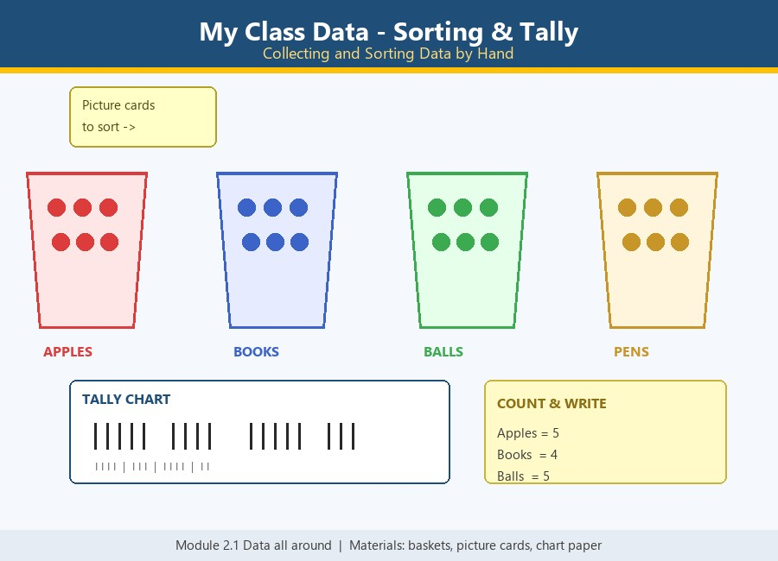
5 | Using Data — Class Favourite Tally Wall | Module 2: Managing data · 2.1 Using data | Chart paper wall with a big question; Picture choice columns; Sticky notes / marker for tally marks; Counting cards.  How to make: Write the big question and draw the choice columns. Each visitor adds a sticky note or tally mark under their favourite. Count the marks together — more or fewer? Read the answer from the data: the tallest column wins! | 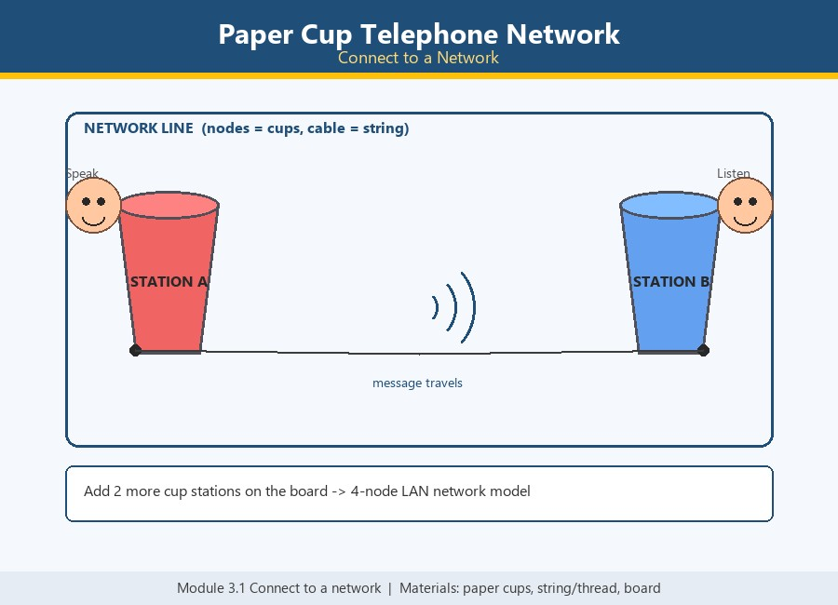
6 | My Computer Works — Input · Process · Output Box | Module 2: Managing data · 2.2 Classifying data (project week) | Big cardboard computer box; INPUT mouth + OUTPUT slot openings; Input/output task cards (2+3, A→a, sun→day); Blinking LED + battery for the 'thinking' light.  How to make: Build the computer box with IN and OUT openings. Wire the blinking thinking LED inside. Visitor picks an input card and feeds it into the INPUT mouth. Machine 'thinks', then the helper pulls out the matching output card! | 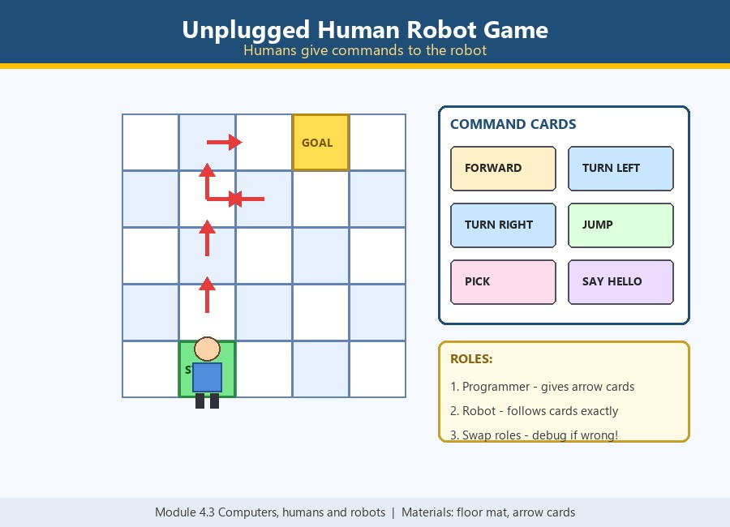

GRADE 2 : ICT EXPO PROJECTS
No. | Project Topic | Module (Contents) | Materials & How to Make | Reference Image
1 | Precise Algorithms — Sandwich Robot Challenge | Module 1: Computational thinking and programming · 1.1 Precise algorithms | Cardboard robot chef (moveable arms); Sandwich step cards; Paper bread, jam, knife props; Instruction wall strip.  How to make: Build the chef with a wall strip to order his steps. Mix precise and vague cards in the deck. The visitor orders the steps and the chef 'acts' each one. Vague steps fail funny; precise steps make the sandwich — precision wins! | 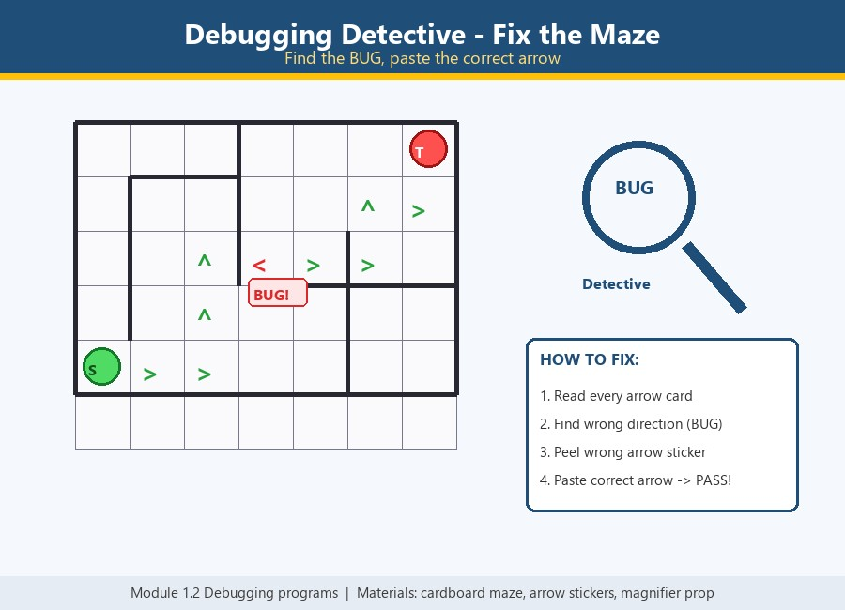
2 | Debugging Programs – Fix the Broken Maze | Module 1: Computational thinking and programming · 1.2 Debugging programs | Cardboard maze with grid path; Arrow-code path card with one wrong arrow; Correct arrow stickers; Magnifying-glass 'debugger' prop.  How to make: Build the maze and lay the arrow-code path with one deliberate bug. Give the visitor the detective magnifying glass. Visitor traces the code and finds the wrong arrow (the bug). They paste the correct sticker — the path now works and the robot reaches the treasure. | 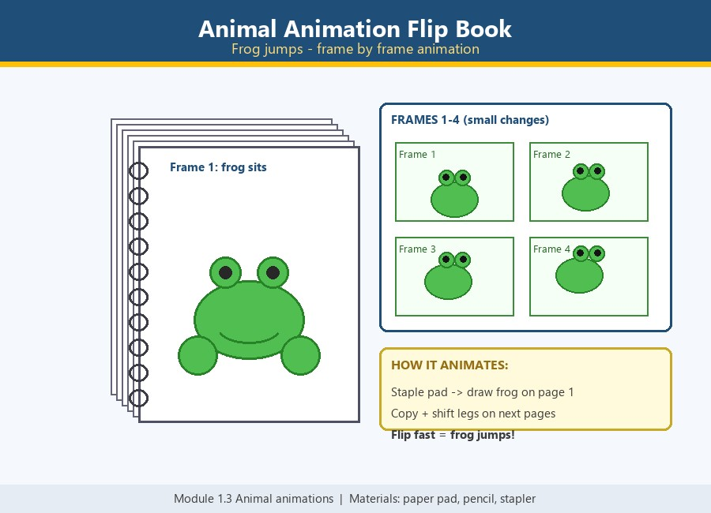
3 | Animal Animations in Scratch – Move That Frog! | Module 1: Computational thinking and programming · 1.3 Animal animations | Laptop with Scratch (scratch.mit.edu) or offline app; Frog sprite with 2–3 costumes; Expo poster of Scratch blocks interface; Green-flag button prop.  How to make: Open Scratch and choose the frog sprite with its costumes. Snap the blocks: when flag clicked → forever → move 10 steps → next costume → wait 0.2. Visitor presses the green flag — the frog animates! Let the visitor change numbers (steps, wait) and watch the animation change — live coding! | 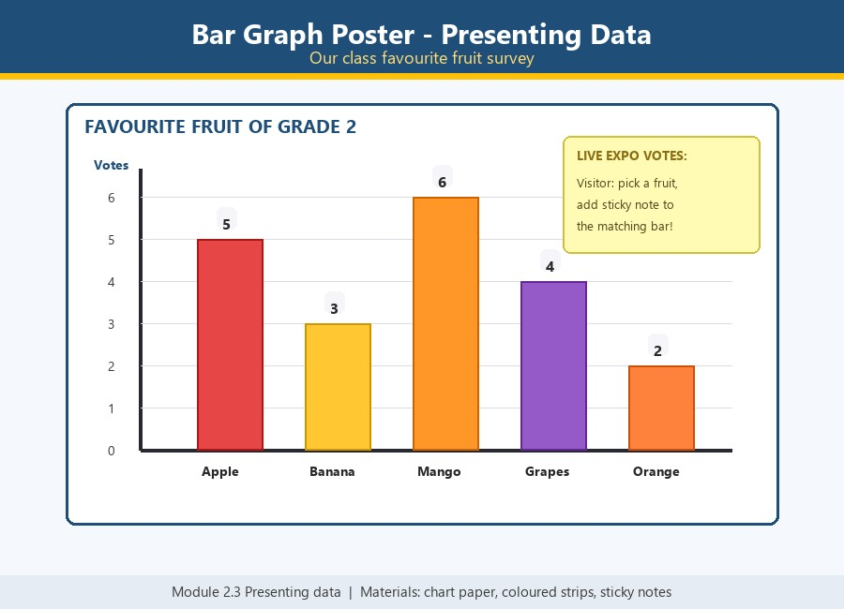
4 | Repeat, Repeat, Repeat — Traffic Light Loop Machine | Module 1: Computational thinking and programming · 1.4 Repeat, repeat, repeat | Cardboard box traffic-light frame; Red, yellow and green LEDs; Switch + battery pack; Loop instruction card.  How to make: Build the traffic-light frame from the cardboard box. Fix the three LEDs in order: red, yellow, green. Attach the loop card: RED wait – GREEN wait – repeat. Flip the switch and let visitors watch the loop and point out the 'repeat' block. | 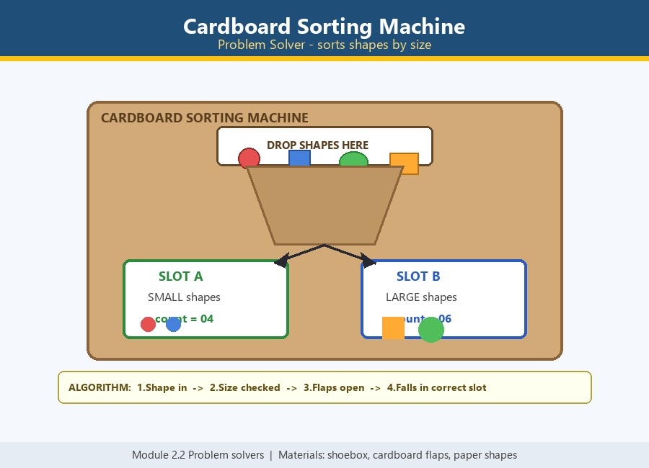
5 | Data All Around — Sorting & Counting Shop | Module 2: Managing data · 2.1 Data all around | 3–4 labelled shop baskets; Item cards (fruits, animals, shapes); Chart board + marker for tally marks; Play-money props (optional).  How to make: Label each basket with one category. Shuffle the item cards and spread them out. Visitors sort each item into the correct basket. Count every basket and add tally marks — the data is collected and used! | 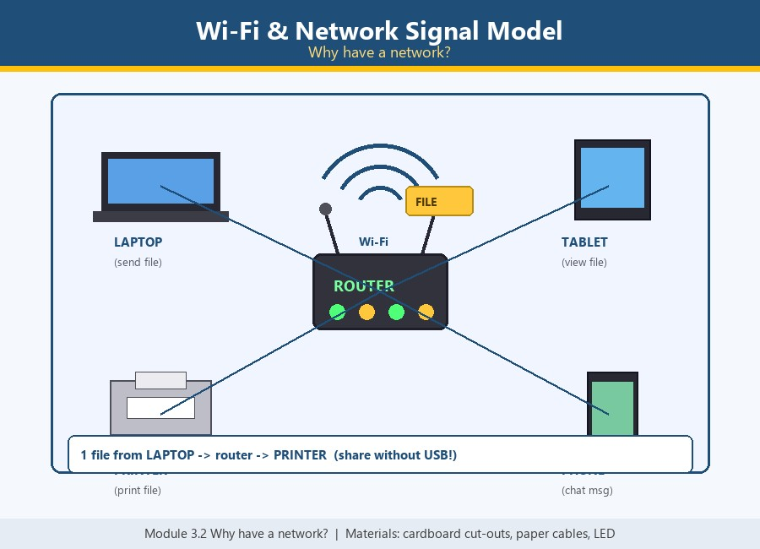
6 | Our Data Story – Presenting with a Live Bar Graph | Module 2: Managing data · 2.2 Presenting data (project week) | Chart paper bar graph; Coloured paper strips for bars; Sticky notes for votes; Marker for labels.  How to make: Draw the graph axes and label the choices. Build each bar with coloured paper strips. Visitors stick a note on their favourite — the bar grows live. Read the result: the tallest bar wins! | 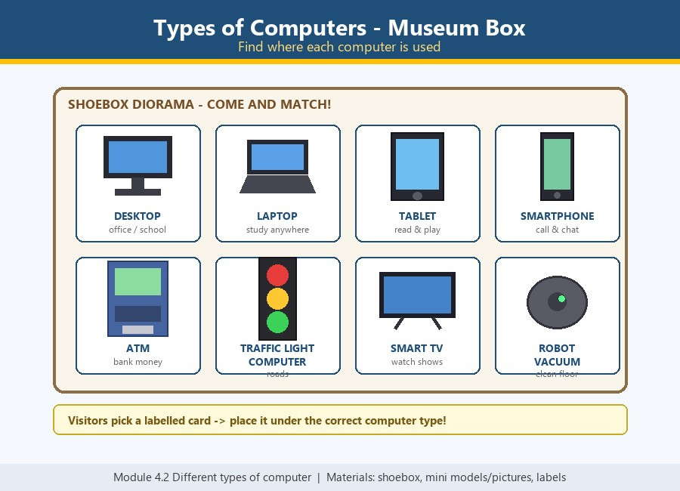

PROJECT DETAILS – FULL EXPLANATIONS

GRADE 1 · Project 1: Algorithms All Around Us — Step-by-Step Wall
Grade | Grade 1
Textbook Module | Module 1: Computational thinking and programming · 1.1 Algorithms all around us
Type | Hand-made working model
A chart-board wall of everyday algorithms — brushing teeth, making juice, getting ready for school. Pupils arrange picture steps in the right order and discover that algorithms are all around us.
Project Explanation
- An algorithm is a list of steps to finish a task — and they are all around us! Brushing teeth, making a sandwich, and getting dressed are all algorithms.
- The board shows everyday activities as picture cards. Each card is one step: first, next, then, last.
- Visitors pick an activity, arrange its steps in the right order on the wall, and read the algorithm out loud: 'First squeeze the toothpaste, next brush, then rinse, last wipe your mouth.'
- If the steps are in the wrong order, the task fails — just like a program. That is why order in an algorithm matters.
Materials
- Chart board base (thick cardboard)
- Picture cards of daily-routine steps
- Velcro or sticky tack
- Colour markers, glue, scissors
How the Expo Demo Runs
- Draw and cut picture cards for 3–4 everyday activities.
- Shuffle the cards and fix a big 'algorithm wall' on the board.
- Invite a visitor: they arrange one activity's steps in the correct order.
- They read the algorithm aloud — first, next, then, last!
Reference image of the hand-made model

GRADE 1 · Project 2: Bee-Bot Beginnings — Cardboard Robot Grid
Grade | Grade 1
Textbook Module | Module 1: Computational thinking and programming · 1.2 Bee-Bot beginnings
Type | Hand-made working model
A cardboard Bee-Bot floor robot on a taped grid. Children press arrow buttons to program it forward, left and right to reach the flower — beginning robotics with an unhurried friend.
Project Explanation
- A Bee-Bot is a friendly floor robot that remembers the buttons you press and then follows them in order — this is called a sequence.
- On the taped grid, the Bee-Bot starts on one square and must reach the flower on another square.
- A child plans the route first (thinking like a programmer), then presses the arrow buttons: FORWARD, FORWARD, TURN RIGHT, FORWARD…
- Press GO and the Bee-Bot follows the stored sequence exactly. If it goes the wrong way, the child re-programs — that is computational thinking!
Materials
- Cardboard Bee-Bot model with arrow buttons
- Taped floor grid (or mat with squares)
- Flower / goal cut-out
- Battery + buzzer (optional beep)
How the Expo Demo Runs
- Tape the grid on the floor and place the flower goal square.
- Put the Bee-Bot on the start square.
- The child plans the route aloud, then presses the arrow buttons in order.
- Press GO — the Bee-Bot follows the sequence to the flower!
Reference image of the hand-made model

GRADE 1 · Project 3: What Happens Next? — Story Prediction Machine
Grade | Grade 1
Textbook Module | Module 1: Computational thinking and programming · 1.3 What happens next?
Type | Hand-made working model
A story-machine board: a sequence is shown (seed → sprout → plant) and the visitor predicts the next step by choosing a card. Programs follow patterns — and we can predict what happens next!
Project Explanation
- Programs follow patterns. When we see the pattern, we can predict what happens next — a key thinking skill in programming.
- The machine shows a growing sequence on its window: seed → sprout → small plant → …
- The visitor studies the pattern and predicts the next card from three choices.
- When they predict right, the machine 'flips' the next card into place. Patterns make the future predictable — in stories and in code!
Materials
- Cardboard machine frame with a display window
- Sequence cards (seed → sprout → plant → flower)
- 3 prediction-choice pockets
- Slider or flip mechanism
How the Expo Demo Runs
- Build the machine frame with a display window and a card slot.
- Feed the sequence cards into the window one by one.
- The visitor studies the pattern and picks the next-step card from the choices.
- Correct prediction — the machine reveals the next card! Try all the sequences.
Reference image of the hand-made model

GRADE 1 · Project 4: Spot the Bug — Fix the Silly Robot
Grade | Grade 1
Textbook Module | Module 1: Computational thinking and programming · 1.4 Spot the bug
Type | Hand-made working model
A funny robot poster doing everyday tasks wrongly — sock on hand, shoes on wrong feet. Visitors spot the bug in each picture and paste the correct fix card. Debugging made silly and fun!
Project Explanation
- Sometimes programs (and people!) make mistakes. Finding the mistake is called spotting the bug.
- The poster shows a silly robot doing simple tasks wrongly: sock on his hand, shoes on the wrong feet, hat on his nose.
- The visitor plays detective: find what is wrong in each picture, then choose the correct fix card from the fix pile.
- Pasting the right fix makes the robot sensible again — debugging means find the bug, then fix it!
Materials
- Silly robot poster (drawn with deliberate mistakes)
- Correct fix cards (shoe, sock, hat…)
- Velcro / sticky tack
- Detective magnifying glass prop
How the Expo Demo Runs
- Draw the silly robot with 4–5 deliberate bugs.
- Prepare a pile of correct fix cards.
- The visitor finds a bug and points with the magnifying glass.
- They paste the correct fix card over the bug — robot fixed!
Reference image of the hand-made model

GRADE 1 · Project 5: Using Data — Class Favourite Tally Wall
Grade | Grade 1
Textbook Module | Module 2: Managing data · 2.1 Using data
Type | Hand-made working model
A big chart wall where visitors answer a real question with sticky notes and tally marks. The class collects, counts and uses data — first steps of managing data by hand.
Project Explanation
- Data is information we collect to answer questions: What is our class's favourite animal? How many like each one?
- The wall asks one big question with picture choices. Each visitor puts a sticky note or tally mark under their choice.
- As marks grow, children count them and compare: more or fewer? Which column has the most?
- The finished wall answers the question with data — we collected it, counted it, and used it!
Materials
- Chart paper wall with a big question
- Picture choice columns
- Sticky notes / marker for tally marks
- Counting cards
How the Expo Demo Runs
- Write the big question and draw the choice columns.
- Each visitor adds a sticky note or tally mark under their favourite.
- Count the marks together — more or fewer?
- Read the answer from the data: the tallest column wins!
Reference image of the hand-made model

GRADE 1 · Project 6: My Computer Works — Input · Process · Output Box
Grade | Grade 1
Textbook Module | Module 2: Managing data · 2.2 Classifying data (project week)
Type | Hand-made working model
A cardboard computer box with three openings: IN (keyboard/mouse), WORK (thinking light), OUT (monitor/printer). Visitors feed input cards and receive output cards — how a computer works, made touchable.
Project Explanation
- A computer works in three steps: INPUT (we give information), PROCESS (it thinks), OUTPUT (it gives the result).
- The giant cardboard computer has a mouth for input cards and a slot for output cards. A thinking LED blinks in the middle while it 'processes'.
- A visitor feeds an input card (e.g. 2 + 3) into the INPUT mouth.
- Blink… blink… and the machine outputs the answer card (5)! Input → Process → Output, touched and understood.
Materials
- Big cardboard computer box
- INPUT mouth + OUTPUT slot openings
- Input/output task cards (2+3, A→a, sun→day)
- Blinking LED + battery for the 'thinking' light
How the Expo Demo Runs
- Build the computer box with IN and OUT openings.
- Wire the blinking thinking LED inside.
- Visitor picks an input card and feeds it into the INPUT mouth.
- Machine 'thinks', then the helper pulls out the matching output card!
Reference image of the hand-made model

GRADE 2 · Project 1: Precise Algorithms — Sandwich Robot Challenge
Grade | Grade 2
Textbook Module | Module 1: Computational thinking and programming · 1.1 Precise algorithms
Type | Hand-made working model
A cardboard robot chef who takes every instruction literally! Visitors give exact step cards to make a sandwich — missing or vague steps cause hilarious (and instructive) results.
Project Explanation
- A computer does exactly what you say — nothing more, nothing less. Precise algorithms leave nothing to guess.
- The cardboard chef follows step cards literally: if you only say 'put the bread', he holds one slice and waits forever.
- Visitors arrange precise step cards: take 2 bread slices → open the jam jar → spread jam with the knife → cover with slice 2 → press gently → serve.
- Precise steps make a perfect sandwich. Vague steps make a mess — precision is the lesson!
Materials
- Cardboard robot chef (moveable arms)
- Sandwich step cards
- Paper bread, jam, knife props
- Instruction wall strip
How the Expo Demo Runs
- Build the chef with a wall strip to order his steps.
- Mix precise and vague cards in the deck.
- The visitor orders the steps and the chef 'acts' each one.
- Vague steps fail funny; precise steps make the sandwich — precision wins!
Reference image of the hand-made model

GRADE 2 · Project 2: Debugging Programs – Fix the Broken Maze
Grade | Grade 2
Textbook Module | Module 1: Computational thinking and programming · 1.2 Debugging programs
Type | Hand-made working model
A cardboard maze with a wrong arrow-code path. The visitor finds the mistake (the bug) and pastes the correct arrow sticker to fix the path — with a magnifying-glass 'debugger' prop included.
Project Explanation
- A bug is a mistake in a program. Debugging means finding the bug and fixing it — just like a detective solves a case.
- The cardboard maze has an arrow-code path stuck beside it: ↑ → ↑ ↓ … but one arrow is WRONG, so the path leads the robot into a wall.
- The visitor becomes the Debugging Detective with the magnifying glass: they trace the path step by step until they find the wrong arrow.
- They then paste the correct arrow sticker over the bug. When the fixed path guides the robot to the treasure, the case is solved!
Materials
- Cardboard maze with grid path
- Arrow-code path card with one wrong arrow
- Correct arrow stickers
- Magnifying-glass 'debugger' prop
How the Expo Demo Runs
- Build the maze and lay the arrow-code path with one deliberate bug.
- Give the visitor the detective magnifying glass.
- Visitor traces the code and finds the wrong arrow (the bug).
- They paste the correct sticker — the path now works and the robot reaches the treasure.
Reference image of the hand-made model

GRADE 2 · Project 3: Animal Animations in Scratch – Move That Frog!
Grade | Grade 2
Textbook Module | Module 1: Computational thinking and programming · 1.3 Animal animations
Type | Hand-made working model
A live Scratch-style stage where visitors snap code blocks — move, turn, change costume, repeat — to animate a frog sprite. Expo poster shows the same blocks, so visitors build the animation themselves.
Project Explanation
- In Scratch, a sprite (like our frog) is animated by snapping code blocks together: MOVE, TURN, NEXT COSTUME, REPEAT.
- Costumes are pictures of the same animal in slightly different poses. Switching costumes fast = animation, exactly like a flip book.
- At the stall, visitors snap blocks on the board: WHEN FLAG CLICKED → FOREVER → MOVE 10 STEPS → NEXT COSTUME → WAIT 0.2.
- Press the green flag and the frog hops across the stage! The poster shows the real Scratch interface so visitors connect the game to the app.
Materials
- Laptop with Scratch (scratch.mit.edu) or offline app
- Frog sprite with 2–3 costumes
- Expo poster of Scratch blocks interface
- Green-flag button prop
How the Expo Demo Runs
- Open Scratch and choose the frog sprite with its costumes.
- Snap the blocks: when flag clicked → forever → move 10 steps → next costume → wait 0.2.
- Visitor presses the green flag — the frog animates!
- Let the visitor change numbers (steps, wait) and watch the animation change — live coding!
Reference image of the hand-made model

GRADE 2 · Project 4: Repeat, Repeat, Repeat — Traffic Light Loop Machine
Grade | Grade 2
Textbook Module | Module 1: Computational thinking and programming · 1.4 Repeat, repeat, repeat
Type | Hand-made working model
A cardboard-box traffic light with red, yellow and green LEDs running a repeat loop. A loop card shows RED wait – GREEN wait – repeat, and visitors point to where the 'repeat' block is.
Project Explanation
- Real traffic lights run the same pattern again and again, all day long. In programming we call that a repeat loop.
- The model is a cardboard-box traffic light with three real LEDs: red, yellow and green. A switch turns the loop on.
- The loop card next to the light reads: RED wait → GREEN wait → REPEAT. Visitors are asked: 'Where is the repeat block?' — they must spot the part of the code that makes the pattern start over.
- This teaches that a computer can repeat instructions forever without getting tired — we only write the pattern once and loop it.
Materials
- Cardboard box traffic-light frame
- Red, yellow and green LEDs
- Switch + battery pack
- Loop instruction card
How the Expo Demo Runs
- Build the traffic-light frame from the cardboard box.
- Fix the three LEDs in order: red, yellow, green.
- Attach the loop card: RED wait – GREEN wait – repeat.
- Flip the switch and let visitors watch the loop and point out the 'repeat' block.
Reference image of the hand-made model

GRADE 2 · Project 5: Data All Around — Sorting & Counting Shop
Grade | Grade 2
Textbook Module | Module 2: Managing data · 2.1 Data all around
Type | Hand-made working model
A mini class shop with labelled baskets for fruits, animals and shapes. Visitors sort items, count with tally marks and read the answer from the data — collecting data all around us.
Project Explanation
- Data is all around us: ages, favourite fruits, eye colours. Before computers can use data, someone must collect and sort it.
- In the mini shop, items are mixed in a pile. Visitors sort each item into the correct labelled basket — that is collecting and classifying data.
- After sorting, each basket is counted and the counts are written as tally marks on the shop board. One line = 1, and every 5th tally crosses the four.
- The board becomes a tiny database of the shop — the same idea a computer does inside a spreadsheet, but done by hand so the idea is clear.
Materials
- 3–4 labelled shop baskets
- Item cards (fruits, animals, shapes)
- Chart board + marker for tally marks
- Play-money props (optional)
How the Expo Demo Runs
- Label each basket with one category.
- Shuffle the item cards and spread them out.
- Visitors sort each item into the correct basket.
- Count every basket and add tally marks — the data is collected and used!
Reference image of the hand-made model

GRADE 2 · Project 6: Our Data Story – Presenting with a Live Bar Graph
Grade | Grade 2
Textbook Module | Module 2: Managing data · 2.2 Presenting data (project week)
Type | Hand-made working model
A chart-paper bar graph made of coloured paper strips (e.g. favourite fruit). Sticky notes for visitor votes are added live onto the graph — data turned into a presented chart, telling our data story.
Project Explanation
- After we collect data, we must present it so everyone can understand it at one glance. A bar graph does this perfectly.
- The poster is a chart-paper bar graph. Each bar is a coloured paper strip — one strip per choice, e.g. favourite fruits: apple, banana, mango.
- Expo visitors vote by adding a sticky note onto their favourite bar. The bar grows live as more votes come in!
- The tallest bar shows the class's favourite — the whole crowd reads the result instantly. That is the power of presenting data.
Materials
- Chart paper bar graph
- Coloured paper strips for bars
- Sticky notes for votes
- Marker for labels
How the Expo Demo Runs
- Draw the graph axes and label the choices.
- Build each bar with coloured paper strips.
- Visitors stick a note on their favourite — the bar grows live.
- Read the result: the tallest bar wins!
Reference image of the hand-made model

