GRADE 1 : ICT EXPO PROJECTS
No. | Project Topic | Module (Contents) | Materials & How to Make | Reference Image
1 | Algorithms All Around Us  Step-by-Step Wall | Module 1: Computational thinking and programming  1.1 Algorithms all around us | • Chart board base (thick cardboard)  • Picture cards of daily-routine steps  • Velcro or sticky tack  • Colour markers, glue, scissors  How to make:  Step 1: Draw and cut picture cards for 3–4 everyday activities.  Step 2: Shuffle the cards and fix a big 'algorithm wall' on the board.  Step 3: Invite a visitor: they arrange one activity's steps in the correct order.  Step 4: They read the algorithm aloud — first, next, then, last! | 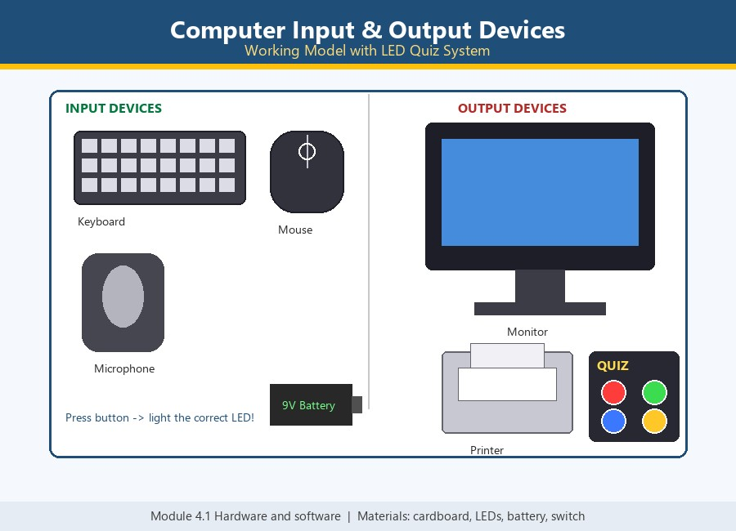
2 | Bee-Bot Beginnings  Cardboard Robot Grid | Module 1: Computational thinking and programming  1.2 Bee-Bot beginnings | • Cardboard Bee-Bot model with arrow buttons  • Taped floor grid (or mat with squares)  • Flower / goal cut-out  • Battery + buzzer (optional beep)  How to make:  Step 1: Tape the grid on the floor and place the flower goal square.  Step 2: Put the Bee-Bot on the start square.  Step 3: The child plans the route aloud, then presses the arrow buttons in order.  Step 4: Press GO — the Bee-Bot follows the sequence to the flower! | 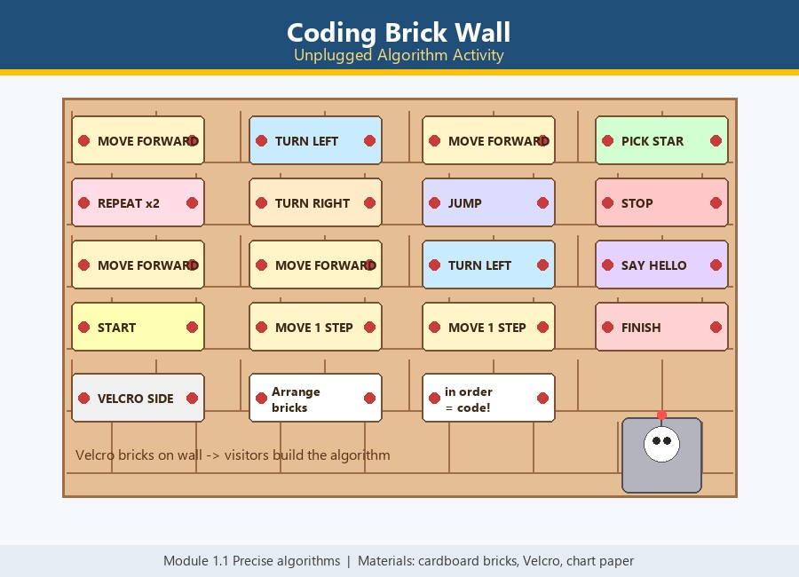
3 | What Happens Next?  Story Prediction Machine | Module 1: Computational thinking and programming  1.3 What happens next? | • Cardboard machine frame with a display window  • Sequence cards (seed → sprout → plant → flower)  • 3 prediction-choice pockets  • Slider or flip mechanism  How to make:  Step 1: Build the machine frame with a display window and a card slot.  Step 2: Feed the sequence cards into the window one by one.  Step 3: The visitor studies the pattern and picks the next-step card from the choices.  Step 4: Correct prediction — the machine reveals the next card! Try all the sequences. | 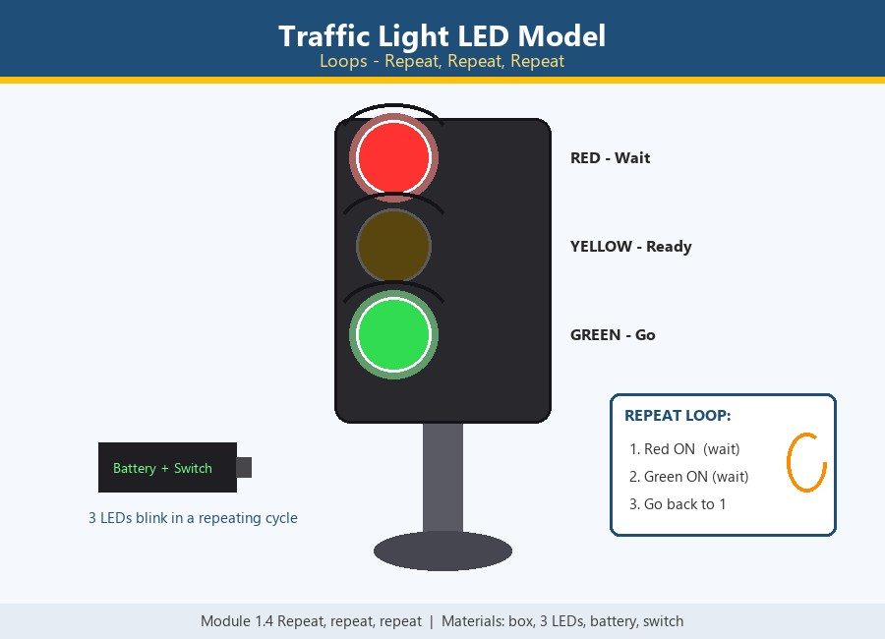
4 | Spot the Bug  Fix the Silly Robot | Module 1: Computational thinking and programming  1.4 Spot the bug | • Silly robot poster (drawn with deliberate mistakes)  • Correct fix cards (shoe, sock, hat…)  • Velcro / sticky tack  • Detective magnifying glass prop  How to make:  Step 1: Draw the silly robot with 4–5 deliberate bugs.  Step 2: Prepare a pile of correct fix cards.  Step 3: The visitor finds a bug and points with the magnifying glass.  Step 4: They paste the correct fix card over the bug — robot fixed! | 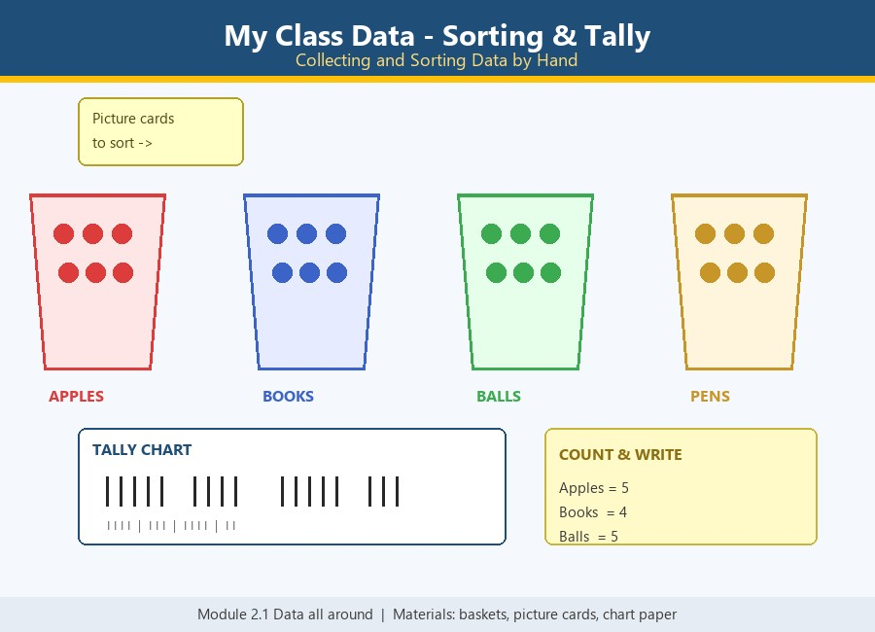
5 | Using Data  Data Detective Picture Chart | Module 2: Managing data  2.1 Using data | • Chart paper with one row for each creature  • Picture cards or stickers for the chart  • Question cards for the detective  • Pointer stick for reading the chart  How to make:  Step 1: Make the chart: one picture for each creature we counted.  Step 2: Count the pictures in every row.  Step 3: Compare the rows — which is most, which is least?  Step 4: Answer the detective questions using the chart. | 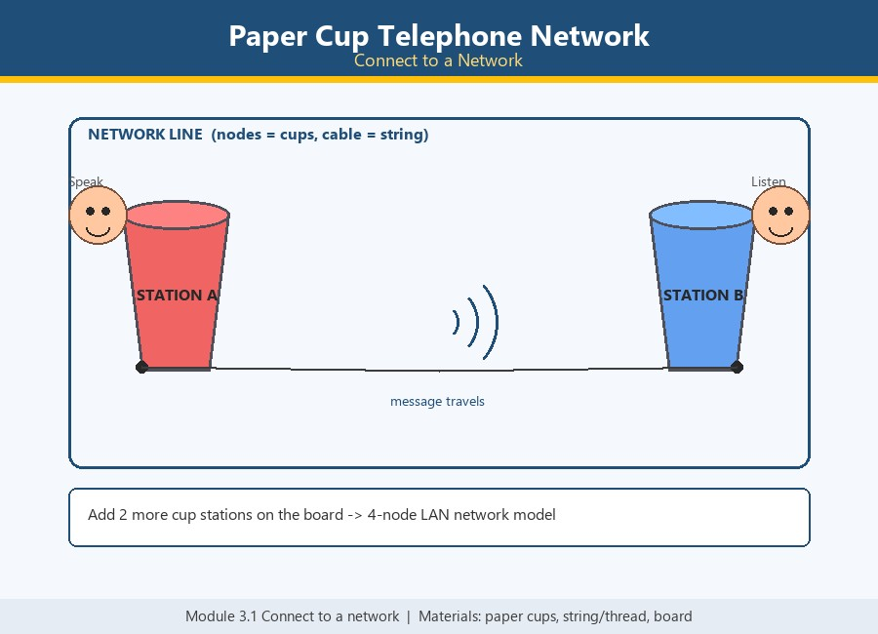
6 | My Computer Works  Input · Process · Output Box | Module 2: Managing data  2.2 Classifying data (project week) | • Big cardboard computer box  • INPUT mouth + OUTPUT slot openings  • Input/output task cards (2+3, A→a, sun→day)  • Blinking LED + battery for the 'thinking' light  How to make:  Step 1: Build the computer box with IN and OUT openings.  Step 2: Wire the blinking thinking LED inside.  Step 3: Visitor picks an input card and feeds it into the INPUT mouth.  Step 4: Machine 'thinks', then the helper pulls out the matching output card! | 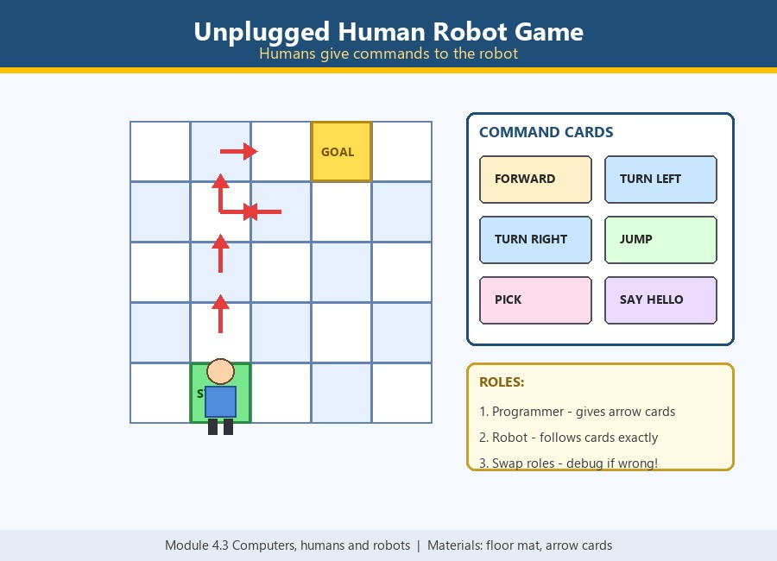
GRADE 2 : ICT EXPO PROJECTS
No. | Project Topic | Module (Contents) | Materials & How to Make | Reference Image
1 | Precise Algorithms  Sandwich Robot Challenge | Module 1: Computational thinking and programming  1.1 Precise algorithms | • Cardboard robot chef (moveable arms)  • Sandwich step cards  • Paper bread, jam, knife props  • Instruction wall strip  How to make:  Step 1: Build the chef with a wall strip to order his steps.  Step 2: Mix precise and vague cards in the deck.  Step 3: The visitor orders the steps and the chef 'acts' each one.  Step 4: Vague steps fail funny; precise steps make the sandwich — precision wins! | 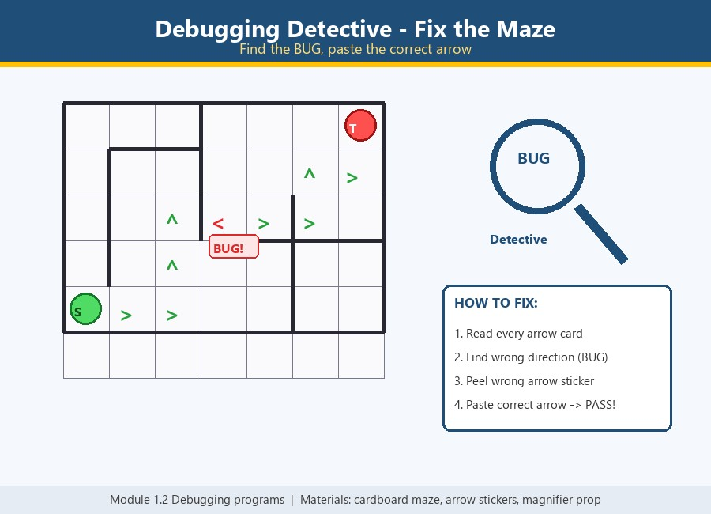
2 | Debugging Programs – Fix the Broken Maze | Module 1: Computational thinking and programming  1.2 Debugging programs | • Cardboard maze with grid path  • Arrow-code path card with one wrong arrow  • Correct arrow stickers  • Magnifying-glass 'debugger' prop  How to make:  Step 1: Build the maze and lay the arrow-code path with one deliberate bug.  Step 2: Give the visitor the detective magnifying glass.  Step 3: Visitor traces the code and finds the wrong arrow (the bug).  Step 4: They paste the correct sticker — the path now works and the robot reaches the treasure. | 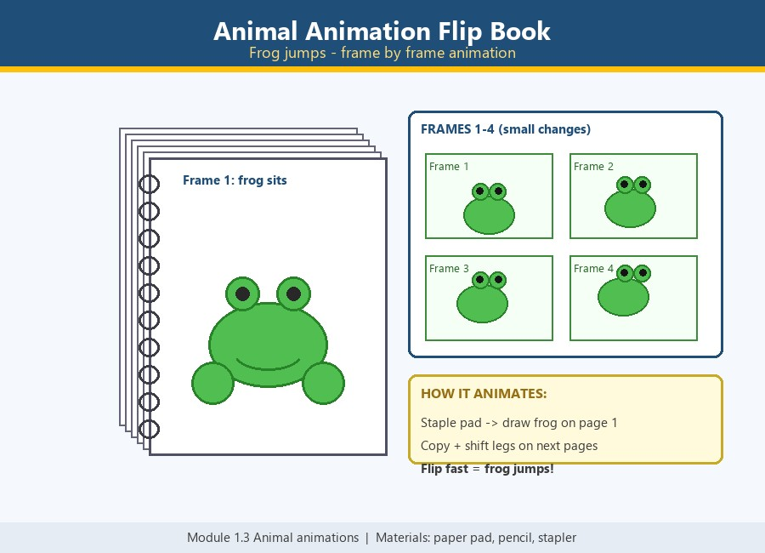
3 | Animal Animations in Scratch – Move That Frog! | Module 1: Computational thinking and programming  1.3 Animal animations | • Laptop with Scratch (scratch.mit.edu) or offline app  • Frog sprite with 2–3 costumes  • Expo poster of Scratch blocks interface  • Green-flag button prop  How to make:  Step 1: Open Scratch and choose the frog sprite with its costumes.  Step 2: Snap the blocks: when flag clicked → forever → move 10 steps → next costume → wait 0.2.  Step 3: Visitor presses the green flag — the frog animates!  Step 4: Let the visitor change numbers (steps, wait) and watch the animation change — live coding! | 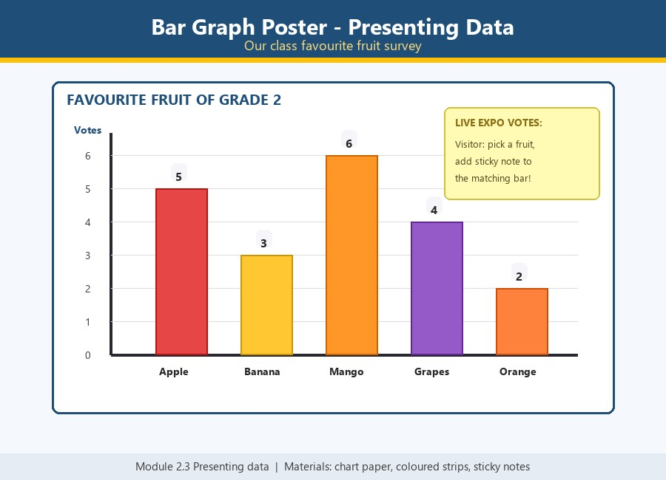
4 | Repeat, Repeat, Repeat  Traffic Light Loop Machine | Module 1: Computational thinking and programming  1.4 Repeat, repeat, repeat | • Cardboard box traffic-light frame  • Red, yellow and green LEDs  • Switch + battery pack  • Loop instruction card  How to make:  Step 1: Build the traffic-light frame from the cardboard box.  Step 2: Fix the three LEDs in order: red, yellow, green.  Step 3: Attach the loop card: RED wait – GREEN wait – repeat.  Step 4: Flip the switch and let visitors watch the loop and point out the 'repeat' block. | 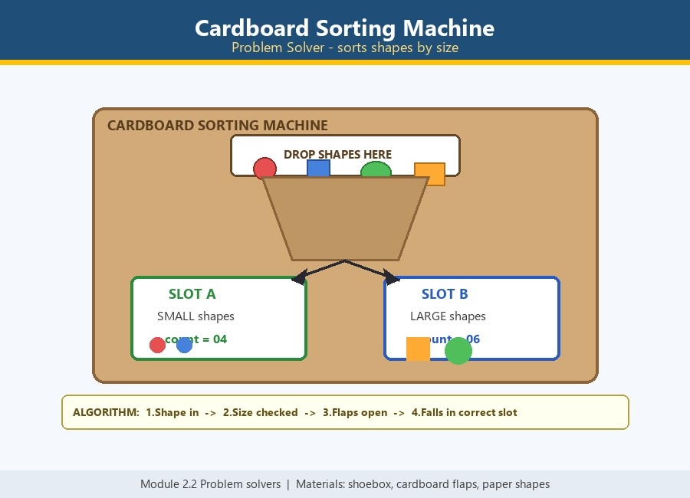
5 | Data All Around  Sorting & Counting Shop | Module 2: Managing data  2.1 Data all around | • 3–4 labelled shop baskets  • Item cards (fruits, animals, shapes)  • Chart board + marker for tally marks  • Play-money props (optional)  How to make:  Step 1: Label each basket with one category.  Step 2: Shuffle the item cards and spread them out.  Step 3: Visitors sort each item into the correct basket.  Step 4: Count every basket and add tally marks — the data is collected and used! | 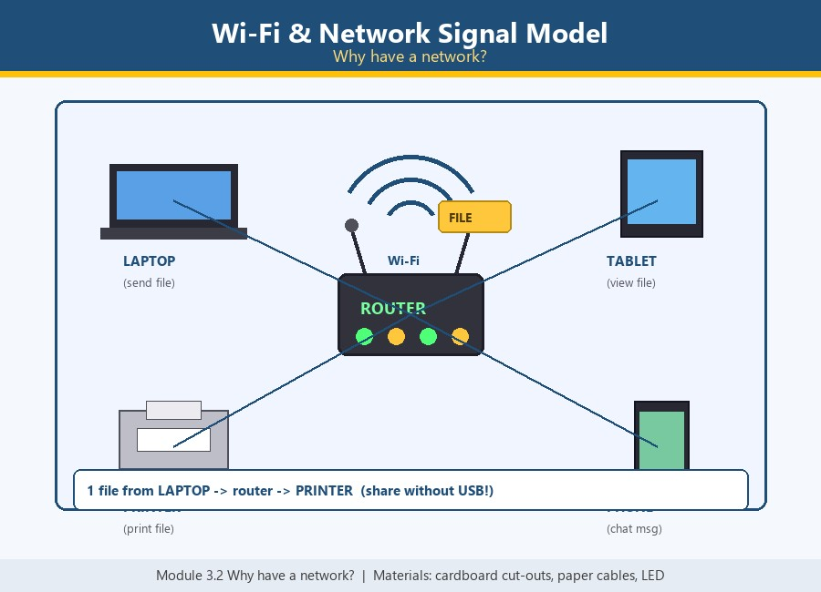
6 | Our Data Story – Presenting with a Live Bar Graph | Module 2: Managing data  2.2 Presenting data (project week) | • Chart paper bar graph  • Coloured paper strips for bars  • Sticky notes for votes  • Marker for labels  How to make:  Step 1: Draw the graph axes and label the choices.  Step 2: Build each bar with coloured paper strips.  Step 3: Visitors stick a note on their favourite — the bar grows live.  Step 4: Read the result: the tallest bar wins! | 