**Task1**

**Create a simple FreeStyle Job To Install Nginx on the server**

**Name : SURETHAN S**

**­­­­Roll No : 22ISR052**

**Steps to Create a Freestyle Job to Install Nginx:**

1. Open Jenkins Dashboard and click on "New Item"

2. Enter a job name and select Freestyle Project, then click OK

3. Navigate to the Build section and select "Execute shell"

4. Enter the following shell script to install Nginx:

sudo apt update

sudo apt install -y nginx

sudo systemctl start nginx

sudo systemctl enable nginx

5. Click Save and then Build Now to execute the job

1.installing nginx in ubuntu through Jenkins

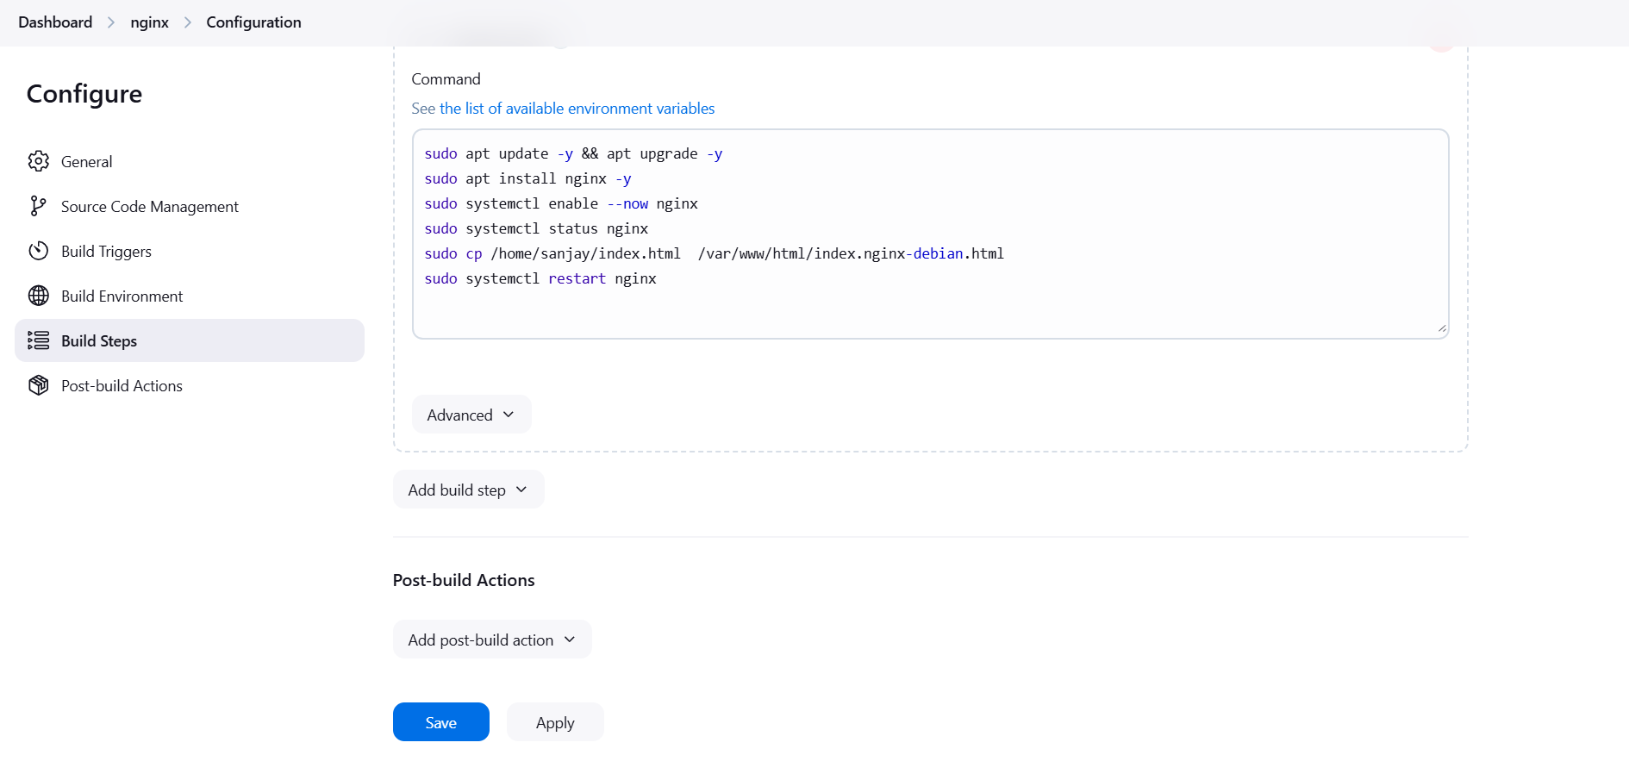

2.output in console:

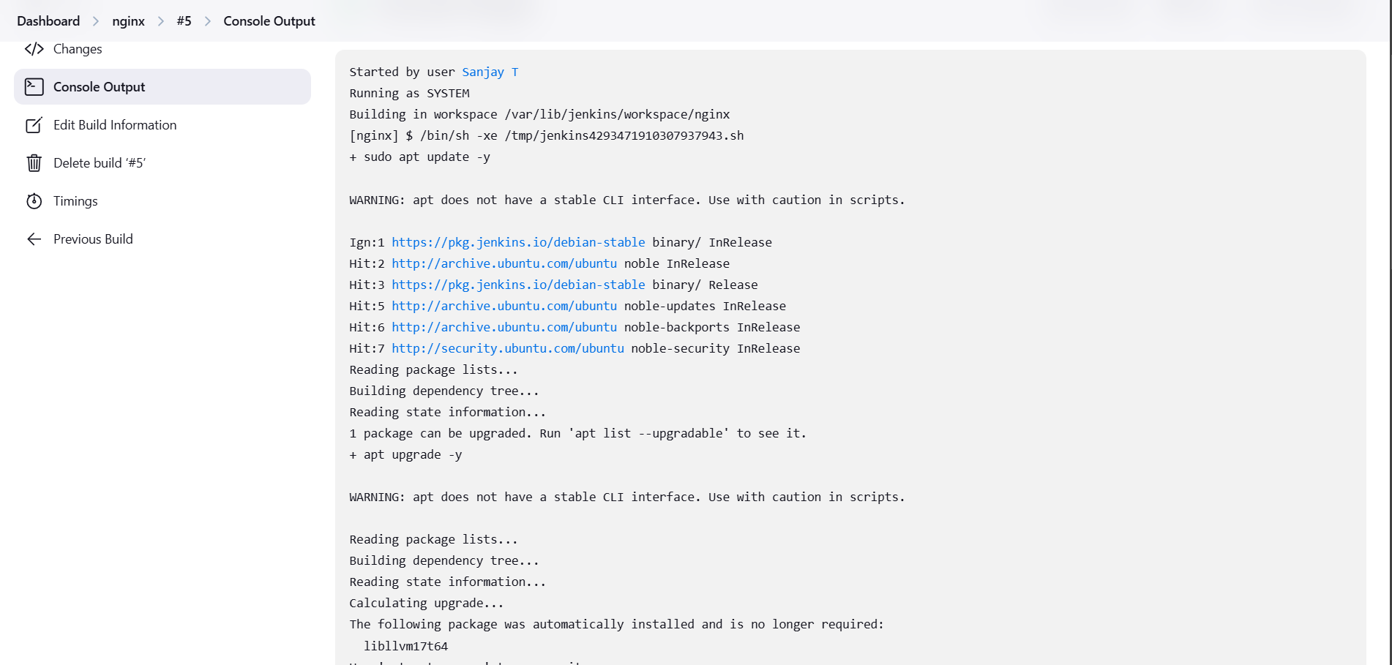

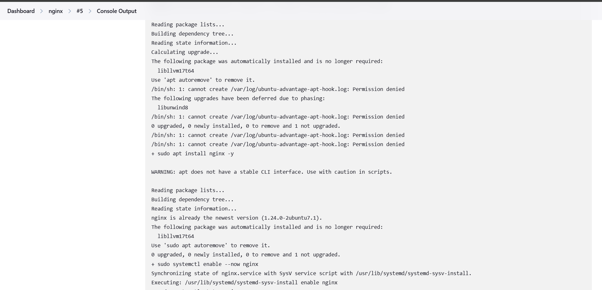

3.output in chrome

