**Umbrella Stand 1.0.0**

This umbrella stand was created by Rehan Ladiwala and Qihan Zhang. This umbrella stand is licensed under CC BY-SA 4.0. The images of blueprints were made in Autodesk Fusion Personal.

**Preface:**

When it rains in an area, people in the area often use an umbrella to prevent themselves from getting wet. However, the water from umbrellas can be used to water plants and letting them drip out ignores the fact that the water that drips out could be used for other purposes, conserving water. This umbrella stand is designed to solve this problem.

**Introduction:**

There are four parts of this umbrella stand. These parts are the hanging hook, the top part of the drip-through holder, the bottom part of the drip-through holder, and the drip container. The hanging hook and the top part of the drip-through holder should be fastened to a vertical surface using screws (this will be explained in further detail their respective subsections of the Installation section). Also, in the Installation section, it will explain how to connect the bottom part of the drip-through holder to the top part of the drip-through holder.

**3D Printing the Umbrella Stand:**

All parts should be printed in Polyethylene Terephthalate Glycol (PETG). Also, all parts besides the drip container should be printed with supports. The hanging hook and the top section of the drip-through holder should be printed with at least 50% infill (60% is the ideal infill). The bottom part of the drip-through holder should be printed with at least 40% infill (50% is the ideal infill). The drip container should be printed with at least 30% infill (40% is the ideal infill) The drip container and the bottom part of the drip-through holder should use Rectilinear infill or Gyroid infill. All other parts of the umbrella stand should be printed with Gyroid infill.

**Installation:**

The following tools are required to install the umbrella stand:

* Wood Screws
* A Drill

The person(s) installing the umbrella stand should not begin the process of installing the umbrella stand until they have read the entirety of this section.

**Installation of the Hanging Hook:**

The hanging hook is the topmost part of the umbrella stand. In the image above, the face shown in blue is the face that the person(s) installing the hanging hook should insert their screws into. The cylindrical face shown in green is the face that the umbrella should be hooked onto. The hanging hook should be hung high enough above the top section of the drip-through holder so that the umbrella sits in the top section of the drip-through holder but does not touch the surface that is colored black in the image of the umbrella stand in the next subsection.

**Installation of the Top Section of the Drip-Through Holder:**

The top section of the drip-through holder is the part of the umbrella stand that the umbrella will rest in. In the image above, the face shown in blue is the face that the person(s) installing the hanging hook should insert their screws into. The screws should be placed closer to the top of the blue parts as shown in the picture. The part of the top section of the drip-through holder shown below that is colored red is the part that the bottom section of the drip-through holder will attach to.

**Installation of the Bottom Section of the Drip-Through Holder:**

The bottom section of the drip-through holder merges the four drain holes of the top section into one drain hole. The part of the bottom section of the drip-through holder colored red in the image below should be attached to part of the picture of the top section of the drip-through holder of the umbrella stand colored red in the previous subsection. The part of the bottom section of the drip-through holder colored green in the image below may touch the vertical surface that the umbrella stand is installed onto.

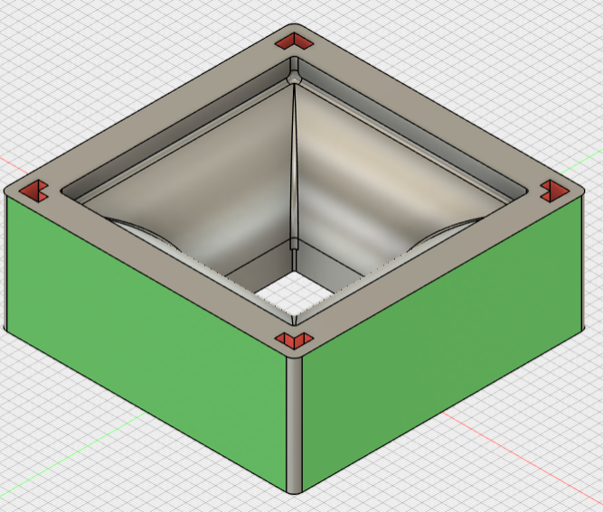

**Placement of the Drip Container:**

The drip container should be placed on a flat ground and should not be fastened so that the drip container can be emptied once it is full. The drip container should be placed such that its opening is directly under the hole at the bottom of the bottom section of the drip-through holder. Water will drip into the surface colored black in the image below.

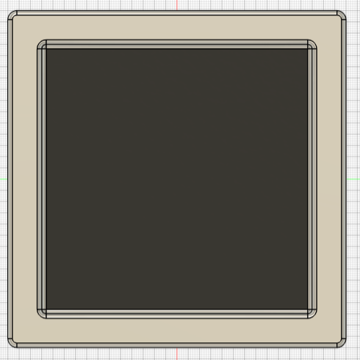

**The Workings of the Drip-Through Holder:**

Refer to the image below the next paragraph when reading the next paragraph.

The line in the image that is boxed in red is the divider between the top and the bottom section of the drip-through holder. Water that drips from the umbrella will drip through four holes in the top section of the drip-through holder. The bottom section of the drip-through holder will merge this into one hole. The water will then drip out the bottom hole of the bottom section of the drip-through holder and will then fall into the drip container.

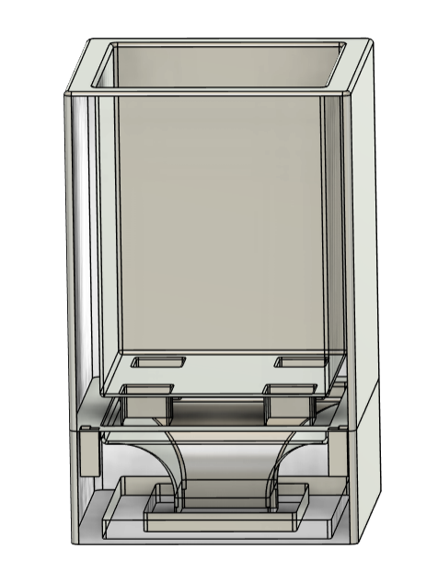

**Summarization:**

This 3D-printable umbrella stand (licensed under CC BY-SA 4.0) collects the water that drips out from umbrellas allowing the water to be used for purposes such as watering plants, which results in the conservation of water.