EdgeDebounceLite

TUTORIAL

SWITCHES ARE ON OR OFF RIGHT?

Yes and no. Switches are analog devices. They are designed to let current flow thru them. Usually, you have two conductive materials that come into contact after the user has done something to bring them together or to take them apart. When the conductors are apart, there is no current flowing and the switch is off (the switch is open). When the conductors are in contact, the current flows and the switch is on (the switch is closed). So most of the time, the switch is off or on.

OPEN CLOSED

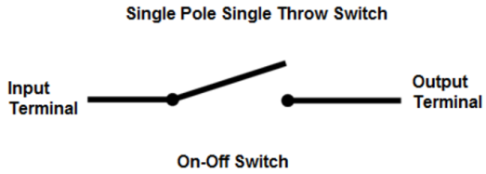 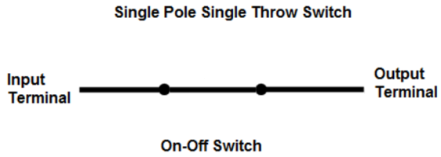

But many things can happen when there is a transition between off and on. You have seen thunderstorms right? This phenomenon can happen in a switch. Given sufficient humidity, sufficient particles in suspension, there can be “lightning” happening inside your switch when it is pressed or released. The contact has not been made (or released) yet, but there is current flowing. Rest assured nothing there to send a DeLorean into the future. None the less, if you ask your Arduino to report the switches’ status at the exact time a “lightning” occurs in your switch, you will get a false reading. All that your Arduino can tell you when you only ask once what is the state of my switch right now is… that’s how it looks right now.

Here is an example of a thunderstorm[1]:

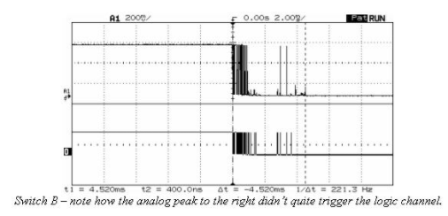On the top, you can see the real voltages that went thru the switch. On the bottom, you see what an analog to digital converter does to this signal. When the switch was released and the contacts where still really close, current went thru erratic states. The time between a full on to a full off state, without spikes is around 2ms for that switch. That is 2 thousands of a second. Your Arduino can read a pin around 560 times during this period. During that brief period, what digitalRead() reports is likely wrong.

Some switches are smoother than others when going from low to high or vice-versa. Here is an example:

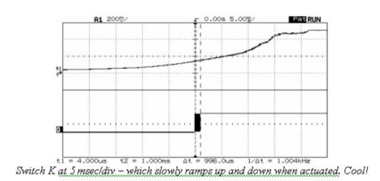That could be cool, but the problem here, is how Arduino decides if a signal is high or is low. The specs are clear: A TTL input signal is defined as "low" when between 0 V and 0.8 V with respect to the ground terminal, and "high" when between 2.2 V and 5 V. In between, Arduino will report low or high in a random manner, and will not let you know that it is doing so. Looking at the diagram, you can see that during the period that the analog to digital is uncertain, (between 0.8 and 2.2 V) anything goes.

HOW CAN I BE SURE THAT A SWITCH IS ON OR OFF

As we saw earlier, bouncing only happens when going from high to low or vice-versa. Our approach will be to be patient. We can read successively many times the switch and decide if it is on or off. Let’s say that instead of reading the switch once, we read it 16 times in a row, as fast as Arduino can (around 90μS). If the switch is off, the 16 reads will return the same value. The same goes when the switch is on. The problem only happens when there is a transition from off to on and vice-versa. The obvious way to detect this is to make sure that there is no discrepancy between successive reads of the pin. If all consecutive reads report high, we can be reasonably certain that the pin is high. The same goes with lows. Otherwise, if some digitalRead() report high and some report low, we are certain that we are in a transition phase. As said before, we need to be patient. We will read another batch of 16 digitalRead() again and again until the signal is stable (16 high or 16 low).

THE ALGORITHM[2]

1. 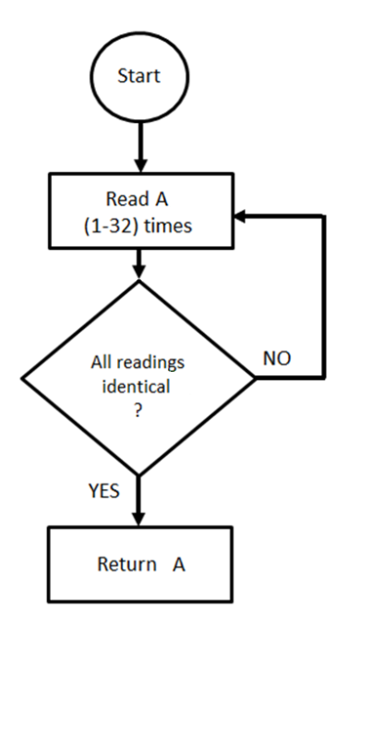Read the pins consecutively a certain amount of times (the Library can be set to read between 1 (no debouncing) and 32 times for maximum debouncing).
2. If all the reads are the same (all low or all high), return that value.
3. If not, return to step 1

By default, the number of reads is set to 16. You can use the “TestSensitivity.ino” sketch to play around with this value and see what is the best choice for your particular switch or application.

When I first posted the EdgeDebounce Library in the Arduino Forum, **larryd** sent me images of what happens using an oscilloscope. <https://forum.arduino.cc/index.php?topic=489925.0> on page 2

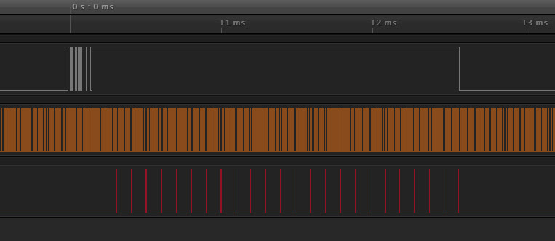

The top signal (grey) is what a normal switch would send. The transition from LOW to HIGH is bouncy.

The middle signal (orange) shows all the digitalReads() that EdgeDebounceLite makes.

The bottom signal (red) is what debouncePin() reports. It is going high only when the top signal is high and is not bouncing.

To see how the algorithm is working, let’s take a zoom where the switch was actually pressed.

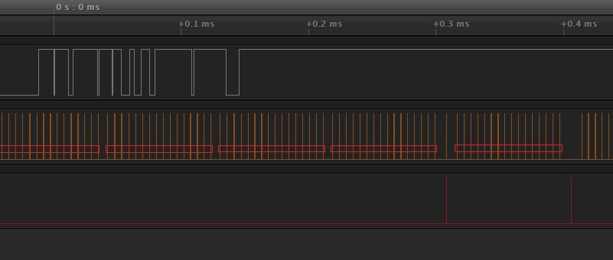

debounce.pin() returns true:

16 reads

Pass 5

16 reads

Pass 4

16 reads

Pass 3

16 reads

Pass 2

16 reads

Pass 1

Bouncing stops here

Switch pressed here

The call to debounce.pin() is made to the very left of the image.

In the first pass of 16 reads there some bouncing. We need another pass.

In the second pass of 16 reads there is still some bouncing. We need another pass.

In the third pass of 16 reads there is still some bouncing. We need another pass.

In the fourth pass, there is no more bouncing. debounce.pin() returns true.

A second call is made to debounce.pin() is made just after that.

In the fifth pass, there is no bouncing. debounce.pin() returns immediately true.

THE LIBRARY

To use the Library, you have to install it in Arduino’s IDE. You will find a good tutorial to do it at this address: <https://www.arduino.cc/en/Guide/Libraries>

In your sketch, you have to mention that you want to use the library. This is done with this line of code which has to be near the top of your sketch, before the setup() section.

#include <EdgeDebounceLite.h>

Right after that, you will instantiate the debouncer:

EdgeDebounceLite debounce;

Right after that, you can give a name to the pin that is attached to your switch (You don’t have to, but it is good practice to do so).

#define BUTTON_PIN 2

In the setup() part of your sketch don’t forget to indicate the pinMode() as you would normally do:

pinMode(BUTTON_PIN, INPUT_PULLUP);

From now on, you just use the .pin() method instead of digitalRead() :

byte aVariable = debounce.pin(BUTTON_PIN);

instead of

byte aVariable = digitalRead(BUTTON_PIN);

One last thing that the Debounce object can do is to set its sensitivity between 1 and 32 (defaults to 16).

In the setup() section of your sketch, you can write :

debounce.setSensitivity(8);

EXAMPLE

#include <EdgeDebounceLite.h>

#define BUTTON_PIN 2

#define LED_PIN 13

EdgeDebounceLite debounce;

void setup() {

pinMode(BUTTON_PIN, INPUT_PULLUP);

pinMode(LED_PIN, OUTPUT);

}

void loop() {

if (!debounce.pin(BUTTON_PIN)) digitalWrite(LED_PIN, HIGH);

else digitalWrite(LED_PIN, LOW);

}

**I sincerely hope that this EdgeDebounceLite Library will help you in your projects.**

Jacques Bellavance

1. All examples are taken from : <http://www.ganssle.com/debouncing.htm>
2. This algorithm is based on the recommendations on this page: <http://www.ganssle.com/debouncing-pt2.htm>