PHOSP clustering

PHOSP-COVID collaborative

Table of Contents

### Tier 2 cohort before 30 Nov 2020 with < 240 days follow-up

## Number of patients in clustering

| label | var_type | n | missing_n | missing_percent |
| --- | --- | --- | --- | --- |
| GAD7 total score | <dbl> | 1031 | 46 | 4.3 |
| PHQ9 total score | <dbl> | 1029 | 48 | 4.5 |
| PCL-5 Total Severity Score | <dbl> | 1030 | 47 | 4.4 |
| Dyspnoea-12 score | <dbl> | 1017 | 60 | 5.6 |
| FACIT fatigue subscale score | <dbl> | 1036 | 41 | 3.8 |
| SPPB total score (0-12) | <dbl> | 970 | 107 | 9.9 |
| MOCA total score | <dbl> | 888 | 189 | 17.5 |

## # A tibble: 1 x 1  
## `Complete cases`  
## <int>  
## 1 767

## Call: clara(x = ., k = 4, metric = "euclidean", samples = 50, pamLike = TRUE)   
## Medoids:  
## gad7_summary phq9_summary pcl5_summary dyspnoea12_summary facit_item_total  
## [1,] 1.5921223 1.64955480 1.1880387 1.2262824 1.3974373  
## [2,] 0.5270043 -0.06651103 0.5344896 0.3746578 0.7784612  
## [3,] -0.3605941 -0.22251701 -0.3567137 -0.1119849 -0.4594909  
## [4,] -0.7156334 -0.84654095 -0.7131950 -0.7202882 -0.8463509  
## sppb_score mocal_total  
## [1,] 0.44058087 -0.07143863  
## [2,] 0.01010249 -0.60862910  
## [3,] 0.01010249 1.27153755  
## [4,] -0.42037588 -0.34003386  
## Objective function: 1.627008  
## Clustering vector: int [1:767] 1 2 2 3 2 2 4 4 4 1 4 4 2 4 2 1 4 2 ...  
## Cluster sizes: 131 159 127 350   
## Best sample:  
## [1] 7 15 24 32 55 91 95 96 107 117 148 166 174 188 197 213 230 263 278  
## [20] 303 358 379 382 398 405 409 413 441 442 485 529 559 580 583 585 591 602 614  
## [39] 640 641 662 668 715 726 730 749 760 761  
##   
## Available components:  
## [1] "sample" "medoids" "i.med" "clustering" "objective"   
## [6] "clusinfo" "diss" "call" "silinfo" "data"

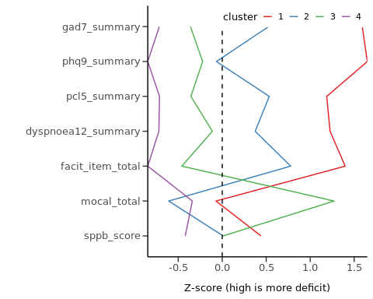

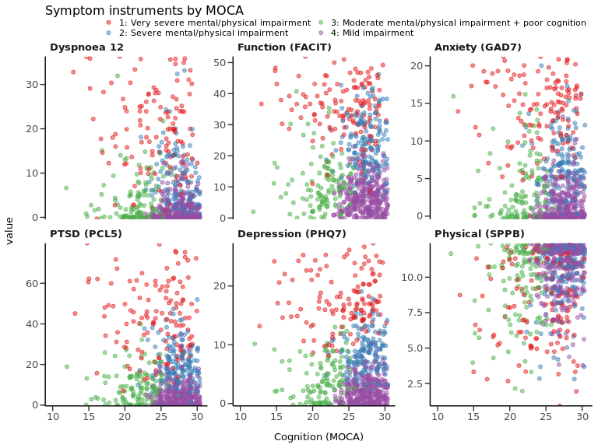

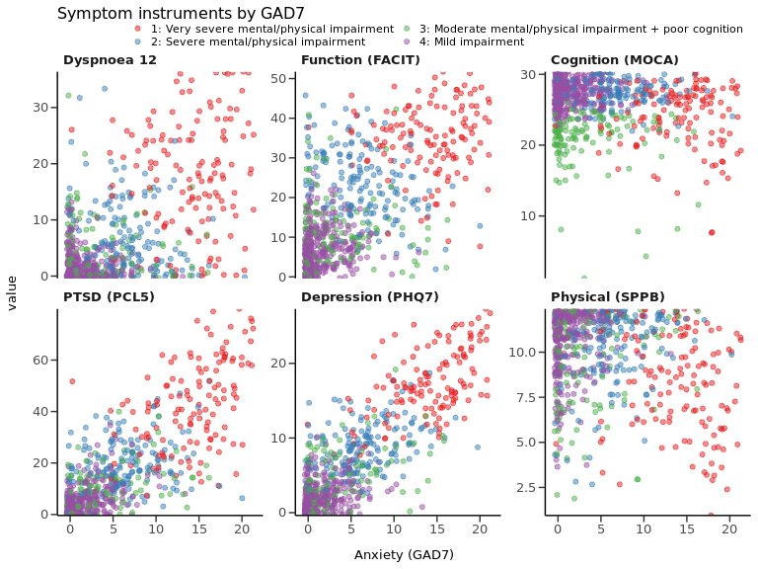

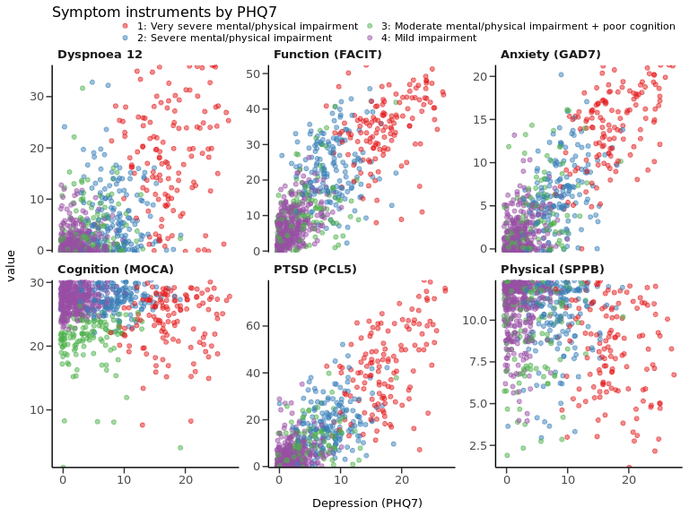

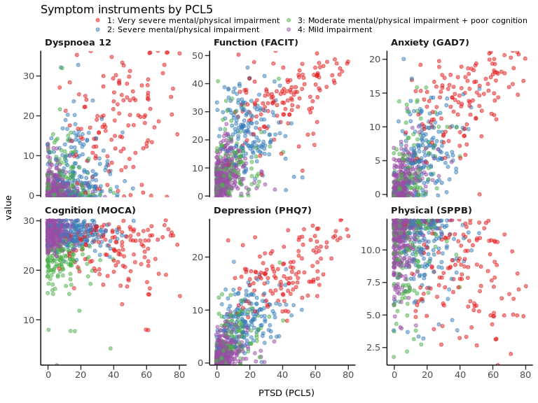

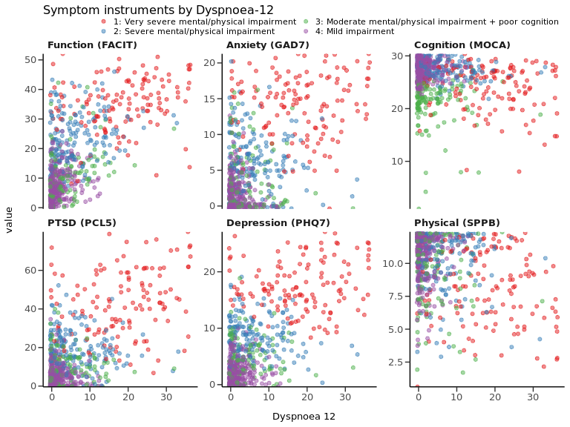

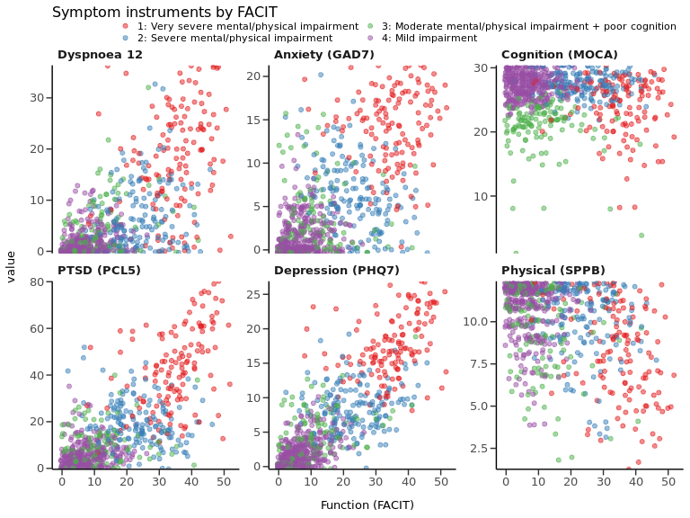

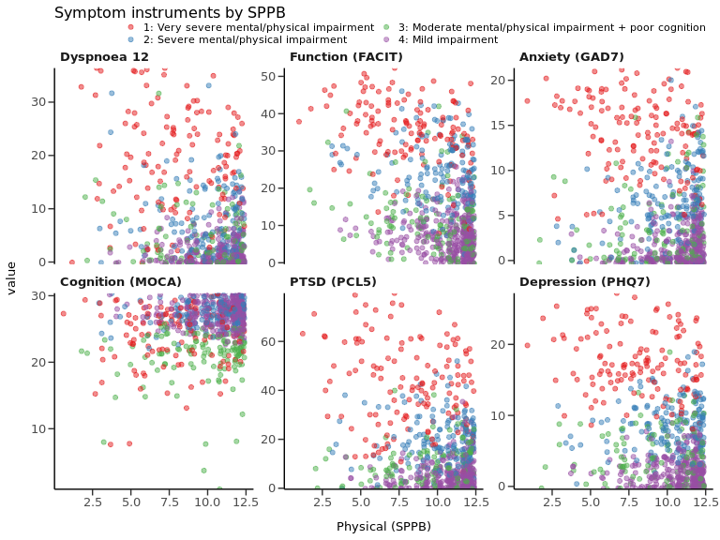

## Table 1: Clusters by patient characteristics

### Row proportions

| label | levels | 1: Very severe mental/physical impairment | 2: Severe mental/physical impairment | 3: Moderate mental/physical impairment + poor cognition | 4: Mild impairment | Total | p |
| --- | --- | --- | --- | --- | --- | --- | --- |
| Total N (%) |  | 131 (17.1) | 159 (20.7) | 127 (16.6) | 350 (45.6) | 767 |  |
| swab_pcr_result | Negative | 13 (16.9) | 20 (26.0) | 13 (16.9) | 31 (40.3) | 77 (100) | 0.785 |
|  | Positive | 108 (17.0) | 127 (20.0) | 107 (16.9) | 292 (46.1) | 634 (100) |  |
|  | Indeterminate |  | 1 (50.0) |  | 1 (50.0) | 2 (100) |  |
| Discharge to review time (days) | Median (IQR) | 150.0 (104.0 to 191.5) | 155.0 (127.5 to 184.0) | 168.5 (118.8 to 190.2) | 164.0 (124.5 to 189.0) | 159.0 (120.0 to 189.0) | 0.400 |
| Age at admission (y) | Median (IQR) | 56.5 (50.0 to 63.0) | 56.0 (47.8 to 62.0) | 65.0 (55.5 to 73.0) | 59.0 (49.0 to 67.0) | 58.0 (49.0 to 66.0) | <0.001 |
| Sex at birth | Male | 71 (14.5) | 86 (17.6) | 81 (16.6) | 251 (51.3) | 489 (100) | <0.001 |
|  | Female | 60 (21.6) | 73 (26.3) | 46 (16.5) | 99 (35.6) | 278 (100) |  |
| Ethnicity | White | 94 (17.7) | 118 (22.2) | 77 (14.5) | 242 (45.6) | 531 (100) | 0.083 |
|  | South Asian | 12 (10.3) | 20 (17.1) | 25 (21.4) | 60 (51.3) | 117 (100) |  |
|  | Black | 11 (22.4) | 6 (12.2) | 15 (30.6) | 17 (34.7) | 49 (100) |  |
|  | Mixed | 2 (15.4) | 2 (15.4) | 3 (23.1) | 6 (46.2) | 13 (100) |  |
|  | Other | 7 (21.2) | 5 (15.2) | 6 (18.2) | 15 (45.5) | 33 (100) |  |
|  | (Missing) | 5 (20.8) | 8 (33.3) | 1 (4.2) | 10 (41.7) | 24 (100) |  |
| Index of multiple deprivation | 1 - most deprived | 37 (25.5) | 24 (16.6) | 31 (21.4) | 53 (36.6) | 145 (100) | 0.001 |
|  | 2 | 32 (18.4) | 36 (20.7) | 39 (22.4) | 67 (38.5) | 174 (100) |  |
|  | 3 | 19 (12.9) | 29 (19.7) | 19 (12.9) | 80 (54.4) | 147 (100) |  |
|  | 4 | 20 (13.7) | 32 (21.9) | 22 (15.1) | 72 (49.3) | 146 (100) |  |
|  | 5 - least deprived | 18 (12.5) | 37 (25.7) | 13 (9.0) | 76 (52.8) | 144 (100) |  |
|  | (Missing) | 5 (45.5) | 1 (9.1) | 3 (27.3) | 2 (18.2) | 11 (100) |  |
| BMI | Median (IQR) | 33.5 (29.0 to 38.5) | 31.4 (28.0 to 35.7) | 29.2 (25.9 to 32.3) | 29.6 (26.5 to 33.5) | 30.3 (27.1 to 34.9) | <0.001 |
| Smoking | Never | 61 (16.2) | 70 (18.6) | 65 (17.2) | 181 (48.0) | 377 (100) | 0.018 |
|  | Ex-smoker | 50 (19.0) | 61 (23.2) | 43 (16.3) | 109 (41.4) | 263 (100) |  |
|  | Current smoker | 4 (40.0) | 5 (50.0) | 0 (0.0) | 1 (10.0) | 10 (100) |  |
|  | (Missing) | 16 (13.7) | 23 (19.7) | 19 (16.2) | 59 (50.4) | 117 (100) |  |
| Number of comorbidities | Median (IQR) | 2.0 (1.0 to 4.0) | 2.0 (1.0 to 3.0) | 1.0 (0.0 to 3.0) | 1.0 (0.0 to 2.0) | 1.0 (0.0 to 3.0) | <0.001 |
| Cardiovascular | No | 66 (14.5) | 91 (20.0) | 76 (16.7) | 222 (48.8) | 455 (100) | 0.069 |
|  | Yes | 65 (20.8) | 68 (21.8) | 51 (16.3) | 128 (41.0) | 312 (100) |  |
| Neurological and psychiatric | No | 78 (12.1) | 122 (19.0) | 115 (17.9) | 327 (50.9) | 642 (100) | <0.001 |
|  | Yes | 53 (42.4) | 37 (29.6) | 12 (9.6) | 23 (18.4) | 125 (100) |  |
| Respiratory | No | 75 (13.4) | 112 (20.0) | 104 (18.5) | 270 (48.1) | 561 (100) | <0.001 |
|  | Yes | 56 (27.2) | 47 (22.8) | 23 (11.2) | 80 (38.8) | 206 (100) |  |
| Rheumatological | No | 106 (15.5) | 143 (20.9) | 112 (16.4) | 323 (47.2) | 684 (100) | 0.005 |
|  | Yes | 25 (30.1) | 16 (19.3) | 15 (18.1) | 27 (32.5) | 83 (100) |  |
| Gastrointestinal | No | 112 (16.6) | 132 (19.6) | 113 (16.7) | 318 (47.1) | 675 (100) | 0.062 |
|  | Yes | 19 (20.7) | 27 (29.3) | 14 (15.2) | 32 (34.8) | 92 (100) |  |
| Metabolic/endocrine/renal | No | 115 (16.6) | 141 (20.4) | 112 (16.2) | 324 (46.8) | 692 (100) | 0.251 |
|  | Yes | 16 (21.3) | 18 (24.0) | 15 (20.0) | 26 (34.7) | 75 (100) |  |
| Malignancy | No | 122 (16.9) | 153 (21.2) | 115 (15.9) | 332 (46.0) | 722 (100) | 0.188 |
|  | Yes | 9 (20.0) | 6 (13.3) | 12 (26.7) | 18 (40.0) | 45 (100) |  |
| Diabetes | No | 105 (16.7) | 127 (20.2) | 103 (16.4) | 293 (46.7) | 628 (100) | 0.673 |
|  | Type 2 | 26 (18.7) | 32 (23.0) | 24 (17.3) | 57 (41.0) | 139 (100) |  |
| Infectious disease | No | 129 (16.9) | 159 (20.8) | 127 (16.6) | 350 (45.8) | 765 (100) | 0.021 |
|  | Yes | 2 (100.0) | 0 (0.0) | 0 (0.0) | 0 (0.0) | 2 (100) |  |
| Admission duration (days) | Median (IQR) | 12.0 (4.5 to 27.0) | 7.0 (3.0 to 25.5) | 10.0 (5.0 to 17.0) | 8.0 (4.0 to 18.0) | 9.0 (4.0 to 20.0) | 0.064 |
| Maximal organ support | No respiratory support | 27 (17.5) | 38 (24.7) | 22 (14.3) | 67 (43.5) | 154 (100) | 0.063 |
|  | O2 | 33 (12.0) | 53 (19.3) | 56 (20.4) | 132 (48.2) | 274 (100) |  |
|  | CPAP/BIPAP/HFN | 21 (16.7) | 24 (19.0) | 20 (15.9) | 61 (48.4) | 126 (100) |  |
|  | IMV/RRT/ECMO | 50 (23.5) | 44 (20.7) | 29 (13.6) | 90 (42.3) | 213 (100) |  |
| Systemic (oral or IV) steroids | No | 67 (13.7) | 111 (22.7) | 87 (17.8) | 223 (45.7) | 488 (100) | 0.024 |
|  | Yes | 47 (21.9) | 35 (16.3) | 34 (15.8) | 99 (46.0) | 215 (100) |  |
|  | (Missing) | 17 (26.6) | 13 (20.3) | 6 (9.4) | 28 (43.8) | 64 (100) |  |
| Antibiotic therapy | No | 25 (17.5) | 34 (23.8) | 21 (14.7) | 63 (44.1) | 143 (100) | 0.756 |
|  | Yes | 103 (17.1) | 123 (20.4) | 105 (17.4) | 273 (45.2) | 604 (100) |  |
|  | (Missing) | 3 (15.0) | 2 (10.0) | 1 (5.0) | 14 (70.0) | 20 (100) |  |
| Therapeutic dose anti-coagulation | No | 82 (16.8) | 113 (23.2) | 86 (17.6) | 207 (42.4) | 488 (100) | 0.058 |
|  | Yes | 39 (17.1) | 35 (15.4) | 37 (16.2) | 117 (51.3) | 228 (100) |  |
|  | (Missing) | 10 (19.6) | 11 (21.6) | 4 (7.8) | 26 (51.0) | 51 (100) |  |

### Column proportions

| label | levels | 1: Very severe mental/physical impairment | 2: Severe mental/physical impairment | 3: Moderate mental/physical impairment + poor cognition | 4: Mild impairment | Total | p |
| --- | --- | --- | --- | --- | --- | --- | --- |
| Total N (%) |  | 131 (17.1) | 159 (20.7) | 127 (16.6) | 350 (45.6) | 767 |  |
| swab_pcr_result | Negative | 13 (10.7) | 20 (13.5) | 13 (10.8) | 31 (9.6) | 77 (10.8) | 0.785 |
|  | Positive | 108 (89.3) | 127 (85.8) | 107 (89.2) | 292 (90.1) | 634 (88.9) |  |
|  | Indeterminate |  | 1 (0.7) |  | 1 (0.3) | 2 (0.3) |  |
| Discharge to review time (days) | Median (IQR) | 150.0 (104.0 to 191.5) | 155.0 (127.5 to 184.0) | 168.5 (118.8 to 190.2) | 164.0 (124.5 to 189.0) | 159.0 (120.0 to 189.0) | 0.400 |
| Age at admission (y) | Median (IQR) | 56.5 (50.0 to 63.0) | 56.0 (47.8 to 62.0) | 65.0 (55.5 to 73.0) | 59.0 (49.0 to 67.0) | 58.0 (49.0 to 66.0) | <0.001 |
| Sex at birth | Male | 71 (54.2) | 86 (54.1) | 81 (63.8) | 251 (71.7) | 489 (63.8) | <0.001 |
|  | Female | 60 (45.8) | 73 (45.9) | 46 (36.2) | 99 (28.3) | 278 (36.2) |  |
| Ethnicity | White | 94 (74.6) | 118 (78.1) | 77 (61.1) | 242 (71.2) | 531 (71.5) | 0.083 |
|  | South Asian | 12 (9.5) | 20 (13.2) | 25 (19.8) | 60 (17.6) | 117 (15.7) |  |
|  | Black | 11 (8.7) | 6 (4.0) | 15 (11.9) | 17 (5.0) | 49 (6.6) |  |
|  | Mixed | 2 (1.6) | 2 (1.3) | 3 (2.4) | 6 (1.8) | 13 (1.7) |  |
|  | Other | 7 (5.6) | 5 (3.3) | 6 (4.8) | 15 (4.4) | 33 (4.4) |  |
|  | (Missing) | 5 | 8 | 1 | 10 | 24 |  |
| Index of multiple deprivation | 1 - most deprived | 37 (29.4) | 24 (15.2) | 31 (25.0) | 53 (15.2) | 145 (19.2) | 0.001 |
|  | 2 | 32 (25.4) | 36 (22.8) | 39 (31.5) | 67 (19.3) | 174 (23.0) |  |
|  | 3 | 19 (15.1) | 29 (18.4) | 19 (15.3) | 80 (23.0) | 147 (19.4) |  |
|  | 4 | 20 (15.9) | 32 (20.3) | 22 (17.7) | 72 (20.7) | 146 (19.3) |  |
|  | 5 - least deprived | 18 (14.3) | 37 (23.4) | 13 (10.5) | 76 (21.8) | 144 (19.0) |  |
|  | (Missing) | 5 | 1 | 3 | 2 | 11 |  |
| BMI | Median (IQR) | 33.5 (29.0 to 38.5) | 31.4 (28.0 to 35.7) | 29.2 (25.9 to 32.3) | 29.6 (26.5 to 33.5) | 30.3 (27.1 to 34.9) | <0.001 |
| Smoking | Never | 61 (53.0) | 70 (51.5) | 65 (60.2) | 181 (62.2) | 377 (58.0) | 0.018 |
|  | Ex-smoker | 50 (43.5) | 61 (44.9) | 43 (39.8) | 109 (37.5) | 263 (40.5) |  |
|  | Current smoker | 4 (3.5) | 5 (3.7) | 0 (0.0) | 1 (0.3) | 10 (1.5) |  |
|  | (Missing) | 16 | 23 | 19 | 59 | 117 |  |
| Number of comorbidities | Median (IQR) | 2.0 (1.0 to 4.0) | 2.0 (1.0 to 3.0) | 1.0 (0.0 to 3.0) | 1.0 (0.0 to 2.0) | 1.0 (0.0 to 3.0) | <0.001 |
| Cardiovascular | No | 66 (50.4) | 91 (57.2) | 76 (59.8) | 222 (63.4) | 455 (59.3) | 0.069 |
|  | Yes | 65 (49.6) | 68 (42.8) | 51 (40.2) | 128 (36.6) | 312 (40.7) |  |
| Neurological and psychiatric | No | 78 (59.5) | 122 (76.7) | 115 (90.6) | 327 (93.4) | 642 (83.7) | <0.001 |
|  | Yes | 53 (40.5) | 37 (23.3) | 12 (9.4) | 23 (6.6) | 125 (16.3) |  |
| Respiratory | No | 75 (57.3) | 112 (70.4) | 104 (81.9) | 270 (77.1) | 561 (73.1) | <0.001 |
|  | Yes | 56 (42.7) | 47 (29.6) | 23 (18.1) | 80 (22.9) | 206 (26.9) |  |
| Rheumatological | No | 106 (80.9) | 143 (89.9) | 112 (88.2) | 323 (92.3) | 684 (89.2) | 0.005 |
|  | Yes | 25 (19.1) | 16 (10.1) | 15 (11.8) | 27 (7.7) | 83 (10.8) |  |
| Gastrointestinal | No | 112 (85.5) | 132 (83.0) | 113 (89.0) | 318 (90.9) | 675 (88.0) | 0.062 |
|  | Yes | 19 (14.5) | 27 (17.0) | 14 (11.0) | 32 (9.1) | 92 (12.0) |  |
| Metabolic/endocrine/renal | No | 115 (87.8) | 141 (88.7) | 112 (88.2) | 324 (92.6) | 692 (90.2) | 0.251 |
|  | Yes | 16 (12.2) | 18 (11.3) | 15 (11.8) | 26 (7.4) | 75 (9.8) |  |
| Malignancy | No | 122 (93.1) | 153 (96.2) | 115 (90.6) | 332 (94.9) | 722 (94.1) | 0.188 |
|  | Yes | 9 (6.9) | 6 (3.8) | 12 (9.4) | 18 (5.1) | 45 (5.9) |  |
| Diabetes | No | 105 (80.2) | 127 (79.9) | 103 (81.1) | 293 (83.7) | 628 (81.9) | 0.673 |
|  | Type 2 | 26 (19.8) | 32 (20.1) | 24 (18.9) | 57 (16.3) | 139 (18.1) |  |
| Infectious disease | No | 129 (98.5) | 159 (100.0) | 127 (100.0) | 350 (100.0) | 765 (99.7) | 0.021 |
|  | Yes | 2 (1.5) | 0 (0.0) | 0 (0.0) | 0 (0.0) | 2 (0.3) |  |
| Admission duration (days) | Median (IQR) | 12.0 (4.5 to 27.0) | 7.0 (3.0 to 25.5) | 10.0 (5.0 to 17.0) | 8.0 (4.0 to 18.0) | 9.0 (4.0 to 20.0) | 0.064 |
| Maximal organ support | No respiratory support | 27 (20.6) | 38 (23.9) | 22 (17.3) | 67 (19.1) | 154 (20.1) | 0.063 |
|  | O2 | 33 (25.2) | 53 (33.3) | 56 (44.1) | 132 (37.7) | 274 (35.7) |  |
|  | CPAP/BIPAP/HFN | 21 (16.0) | 24 (15.1) | 20 (15.7) | 61 (17.4) | 126 (16.4) |  |
|  | IMV/RRT/ECMO | 50 (38.2) | 44 (27.7) | 29 (22.8) | 90 (25.7) | 213 (27.8) |  |
| Systemic (oral or IV) steroids | No | 67 (58.8) | 111 (76.0) | 87 (71.9) | 223 (69.3) | 488 (69.4) | 0.024 |
|  | Yes | 47 (41.2) | 35 (24.0) | 34 (28.1) | 99 (30.7) | 215 (30.6) |  |
|  | (Missing) | 17 | 13 | 6 | 28 | 64 |  |
| Antibiotic therapy | No | 25 (19.5) | 34 (21.7) | 21 (16.7) | 63 (18.8) | 143 (19.1) | 0.756 |
|  | Yes | 103 (80.5) | 123 (78.3) | 105 (83.3) | 273 (81.2) | 604 (80.9) |  |
|  | (Missing) | 3 | 2 | 1 | 14 | 20 |  |
| Therapeutic dose anti-coagulation | No | 82 (67.8) | 113 (76.4) | 86 (69.9) | 207 (63.9) | 488 (68.2) | 0.058 |
|  | Yes | 39 (32.2) | 35 (23.6) | 37 (30.1) | 117 (36.1) | 228 (31.8) |  |
|  | (Missing) | 10 | 11 | 4 | 26 | 51 |  |

## Table 2: Clusters by HRQoL

### Row proportions

| label | levels | 1: Very severe mental/physical impairment | 2: Severe mental/physical impairment | 3: Moderate mental/physical impairment + poor cognition | 4: Mild impairment | Total | p |
| --- | --- | --- | --- | --- | --- | --- | --- |
| Total N (%) |  | 131 (17.1) | 159 (20.7) | 127 (16.6) | 350 (45.6) | 767 |  |
| Do you feel fully recovered from COVID-19? | Yes | 3 (1.9) | 9 (5.6) | 36 (22.2) | 114 (70.4) | 162 (100) | <0.001 |
|  | No | 95 (29.1) | 86 (26.4) | 47 (14.4) | 98 (30.1) | 326 (100) |  |
|  | Not sure | 15 (12.5) | 34 (28.3) | 16 (13.3) | 55 (45.8) | 120 (100) |  |
|  | (Missing) | 18 (11.3) | 30 (18.9) | 28 (17.6) | 83 (52.2) | 159 (100) |  |
| How good or bad is your health overall? Pre-COVID | Mean (SD) | 74.45 (17.82) | 80.19 (14.85) | 84.11 (15.24) | 85.62 (12.67) | 82.46 (15.01) | <0.001 |
| How good or bad is your health overall? Current visit | Mean (SD) | 54.06 (19.77) | 68.56 (16.17) | 75.90 (16.72) | 81.17 (15.09) | 73.14 (19.13) | <0.001 |
| eq5d5l_q1_delta_change | No change | 32 (9.7) | 49 (14.8) | 54 (16.4) | 195 (59.1) | 330 (100) | <0.001 |
|  | Improvement | 5 (15.6) | 3 (9.4) | 9 (28.1) | 15 (46.9) | 32 (100) |  |
|  | Worse | 43 (28.1) | 51 (33.3) | 19 (12.4) | 40 (26.1) | 153 (100) |  |
|  | (Missing) | 51 (20.2) | 56 (22.2) | 45 (17.9) | 100 (39.7) | 252 (100) |  |
| eq5d5l_q2_delta_change | No change | 20 (6.5) | 41 (13.4) | 54 (17.6) | 192 (62.5) | 307 (100) | <0.001 |
|  | Improvement | 3 (42.9) | 1 (14.3) | 1 (14.3) | 2 (28.6) | 7 (100) |  |
|  | Worse | 57 (28.4) | 62 (30.8) | 27 (13.4) | 55 (27.4) | 201 (100) |  |
|  | (Missing) | 51 (20.2) | 55 (21.8) | 45 (17.9) | 101 (40.1) | 252 (100) |  |
| eq5d5l_q3_delta_change | No change | 22 (7.0) | 47 (15.0) | 54 (17.3) | 190 (60.7) | 313 (100) | <0.001 |
|  | Improvement | 8 (29.6) | 3 (11.1) | 4 (14.8) | 12 (44.4) | 27 (100) |  |
|  | Worse | 50 (28.6) | 54 (30.9) | 24 (13.7) | 47 (26.9) | 175 (100) |  |
|  | (Missing) | 51 (20.2) | 55 (21.8) | 45 (17.9) | 101 (40.1) | 252 (100) |  |
| eq5d5l_q4_delta_change | No change | 33 (11.6) | 45 (15.8) | 40 (14.1) | 166 (58.5) | 284 (100) | <0.001 |
|  | Improvement | 14 (13.0) | 23 (21.3) | 23 (21.3) | 48 (44.4) | 108 (100) |  |
|  | Worse | 33 (27.0) | 36 (29.5) | 18 (14.8) | 35 (28.7) | 122 (100) |  |
|  | (Missing) | 51 (20.2) | 55 (21.7) | 46 (18.2) | 101 (39.9) | 253 (100) |  |
| eq5d5l_q5_delta_change | No change | 9 (3.4) | 37 (14.0) | 44 (16.6) | 175 (66.0) | 265 (100) | <0.001 |
|  | Improvement | 20 (29.0) | 13 (18.8) | 11 (15.9) | 25 (36.2) | 69 (100) |  |
|  | Worse | 51 (28.2) | 53 (29.3) | 27 (14.9) | 50 (27.6) | 181 (100) |  |
|  | (Missing) | 51 (20.2) | 56 (22.2) | 45 (17.9) | 100 (39.7) | 252 (100) |  |
| eq5d5l_utility_index_pre | Mean (SD) | 0.67 (0.30) | 0.83 (0.19) | 0.87 (0.17) | 0.92 (0.13) | 0.85 (0.21) | <0.001 |
| eq5d5l_utility_index | Mean (SD) | 0.43 (0.27) | 0.68 (0.17) | 0.76 (0.18) | 0.87 (0.14) | 0.74 (0.24) | <0.001 |
| EQ5D utility index (difference) | Mean (SD) | -0.25 (0.36) | -0.17 (0.20) | -0.10 (0.18) | -0.05 (0.15) | -0.11 (0.22) | <0.001 |
| WG-SS: any 'Yes - lot of difficulty' | No | 50 (10.5) | 93 (19.6) | 85 (17.9) | 246 (51.9) | 474 (100) | <0.001 |
|  | Yes | 63 (48.8) | 33 (25.6) | 15 (11.6) | 18 (14.0) | 129 (100) |  |
|  | (Missing) | 18 (11.0) | 33 (20.1) | 27 (16.5) | 86 (52.4) | 164 (100) |  |
| WG-SS: new disability | No | 53 (10.9) | 100 (20.5) | 85 (17.4) | 250 (51.2) | 488 (100) | <0.001 |
|  | Yes | 57 (54.3) | 25 (23.8) | 11 (10.5) | 12 (11.4) | 105 (100) |  |

### Column proportions

| label | levels | 1: Very severe mental/physical impairment | 2: Severe mental/physical impairment | 3: Moderate mental/physical impairment + poor cognition | 4: Mild impairment | Total | p |
| --- | --- | --- | --- | --- | --- | --- | --- |
| Total N (%) |  | 131 (17.1) | 159 (20.7) | 127 (16.6) | 350 (45.6) | 767 |  |
| Do you feel fully recovered from COVID-19? | Yes | 3 (2.7) | 9 (7.0) | 36 (36.4) | 114 (42.7) | 162 (26.6) | <0.001 |
|  | No | 95 (84.1) | 86 (66.7) | 47 (47.5) | 98 (36.7) | 326 (53.6) |  |
|  | Not sure | 15 (13.3) | 34 (26.4) | 16 (16.2) | 55 (20.6) | 120 (19.7) |  |
|  | (Missing) | 18 | 30 | 28 | 83 | 159 |  |
| How good or bad is your health overall? Pre-COVID | Mean (SD) | 74.45 (17.82) | 80.19 (14.85) | 84.11 (15.24) | 85.62 (12.67) | 82.46 (15.01) | <0.001 |
| How good or bad is your health overall? Current visit | Mean (SD) | 54.06 (19.77) | 68.56 (16.17) | 75.90 (16.72) | 81.17 (15.09) | 73.14 (19.13) | <0.001 |
| eq5d5l_q1_delta_change | No change | 32 (40.0) | 49 (47.6) | 54 (65.9) | 195 (78.0) | 330 (64.1) | <0.001 |
|  | Improvement | 5 (6.2) | 3 (2.9) | 9 (11.0) | 15 (6.0) | 32 (6.2) |  |
|  | Worse | 43 (53.8) | 51 (49.5) | 19 (23.2) | 40 (16.0) | 153 (29.7) |  |
|  | (Missing) | 51 | 56 | 45 | 100 | 252 |  |
| eq5d5l_q2_delta_change | No change | 20 (25.0) | 41 (39.4) | 54 (65.9) | 192 (77.1) | 307 (59.6) | <0.001 |
|  | Improvement | 3 (3.8) | 1 (1.0) | 1 (1.2) | 2 (0.8) | 7 (1.4) |  |
|  | Worse | 57 (71.2) | 62 (59.6) | 27 (32.9) | 55 (22.1) | 201 (39.0) |  |
|  | (Missing) | 51 | 55 | 45 | 101 | 252 |  |
| eq5d5l_q3_delta_change | No change | 22 (27.5) | 47 (45.2) | 54 (65.9) | 190 (76.3) | 313 (60.8) | <0.001 |
|  | Improvement | 8 (10.0) | 3 (2.9) | 4 (4.9) | 12 (4.8) | 27 (5.2) |  |
|  | Worse | 50 (62.5) | 54 (51.9) | 24 (29.3) | 47 (18.9) | 175 (34.0) |  |
|  | (Missing) | 51 | 55 | 45 | 101 | 252 |  |
| eq5d5l_q4_delta_change | No change | 33 (41.2) | 45 (43.3) | 40 (49.4) | 166 (66.7) | 284 (55.3) | <0.001 |
|  | Improvement | 14 (17.5) | 23 (22.1) | 23 (28.4) | 48 (19.3) | 108 (21.0) |  |
|  | Worse | 33 (41.2) | 36 (34.6) | 18 (22.2) | 35 (14.1) | 122 (23.7) |  |
|  | (Missing) | 51 | 55 | 46 | 101 | 253 |  |
| eq5d5l_q5_delta_change | No change | 9 (11.2) | 37 (35.9) | 44 (53.7) | 175 (70.0) | 265 (51.5) | <0.001 |
|  | Improvement | 20 (25.0) | 13 (12.6) | 11 (13.4) | 25 (10.0) | 69 (13.4) |  |
|  | Worse | 51 (63.8) | 53 (51.5) | 27 (32.9) | 50 (20.0) | 181 (35.1) |  |
|  | (Missing) | 51 | 56 | 45 | 100 | 252 |  |
| eq5d5l_utility_index_pre | Mean (SD) | 0.67 (0.30) | 0.83 (0.19) | 0.87 (0.17) | 0.92 (0.13) | 0.85 (0.21) | <0.001 |
| eq5d5l_utility_index | Mean (SD) | 0.43 (0.27) | 0.68 (0.17) | 0.76 (0.18) | 0.87 (0.14) | 0.74 (0.24) | <0.001 |
| EQ5D utility index (difference) | Mean (SD) | -0.25 (0.36) | -0.17 (0.20) | -0.10 (0.18) | -0.05 (0.15) | -0.11 (0.22) | <0.001 |
| WG-SS: any 'Yes - lot of difficulty' | No | 50 (44.2) | 93 (73.8) | 85 (85.0) | 246 (93.2) | 474 (78.6) | <0.001 |
|  | Yes | 63 (55.8) | 33 (26.2) | 15 (15.0) | 18 (6.8) | 129 (21.4) |  |
|  | (Missing) | 18 | 33 | 27 | 86 | 164 |  |
| WG-SS: new disability | No | 53 (48.2) | 100 (80.0) | 85 (88.5) | 250 (95.4) | 488 (82.3) | <0.001 |
|  | Yes | 57 (51.8) | 25 (20.0) | 11 (11.5) | 12 (4.6) | 105 (17.7) |  |

## Table 3

### Row proportions

| label | Total N | levels | 1: Very severe mental/physical impairment | 2: Severe mental/physical impairment | 3: Moderate mental/physical impairment + poor cognition | 4: Mild impairment | Total | p |
| --- | --- | --- | --- | --- | --- | --- | --- | --- |
| Total N (%) |  |  | 131 (17.1) | 159 (20.7) | 127 (16.6) | 350 (45.6) | 767 |  |
| Any symptom at 3 months (%) | 767 (100.0) | No | 17 (8.7) | 28 (14.4) | 30 (15.4) | 120 (61.5) | 195 (100) | <0.001 |
|  |  | Yes | 114 (19.9) | 131 (22.9) | 97 (17.0) | 230 (40.2) | 572 (100) |  |
| Symptom count | 767 (100.0) | Median (IQR) | 18.0 (11.5 to 23.0) | 11.0 (4.5 to 17.0) | 6.0 (1.0 to 11.0) | 3.0 (0.0 to 7.0) | 6.0 (0.0 to 14.0) | <0.001 |
| Anxiety (GAD7 >8) | 767 (100.0) | No | 13 (2.2) | 115 (19.7) | 111 (19.0) | 346 (59.1) | 585 (100) | <0.001 |
|  |  | Yes | 118 (64.8) | 44 (24.2) | 16 (8.8) | 4 (2.2) | 182 (100) |  |
|  |  | (Missing) | 0 (NaN) | 0 (NaN) | 0 (NaN) | 0 (NaN) | 0 (100) |  |
| GAD7 total score | 767 (100.0) | Mean (SD) | 14.2 (4.3) | 6.4 (4.0) | 3.5 (4.1) | 1.6 (2.1) | 5.0 (5.6) | <0.001 |
| Depression (PHQ-9 >= 10) | 767 (100.0) | No | 3 (0.5) | 99 (17.4) | 118 (20.7) | 349 (61.3) | 569 (100) | <0.001 |
|  |  | Yes | 128 (64.6) | 60 (30.3) | 9 (4.5) | 1 (0.5) | 198 (100) |  |
|  |  | (Missing) | 0 (NaN) | 0 (NaN) | 0 (NaN) | 0 (NaN) | 0 (100) |  |
| PHQ9 total score | 767 (100.0) | Mean (SD) | 17.5 (4.4) | 8.7 (3.4) | 4.3 (3.6) | 2.1 (2.0) | 6.4 (6.4) | <0.001 |
| PTSD (PCL-5 >= 38) | 767 (100.0) | No | 52 (7.7) | 150 (22.2) | 125 (18.5) | 350 (51.7) | 677 (100) | <0.001 |
|  |  | Yes | 79 (87.8) | 9 (10.0) | 2 (2.2) | 0 (0.0) | 90 (100) |  |
|  |  | (Missing) | 0 (NaN) | 0 (NaN) | 0 (NaN) | 0 (NaN) | 0 (100) |  |
| PCL-5 Total Severity Score | 767 (100.0) | Mean (SD) | 42.7 (17.2) | 19.5 (9.9) | 9.3 (8.2) | 4.7 (5.3) | 15.0 (16.8) | <0.001 |
| Dyspnoea-12 score | 767 (100.0) | Mean (SD) | 18.2 (9.9) | 6.7 (6.4) | 4.2 (5.3) | 1.6 (2.5) | 5.9 (8.2) | <0.001 |
| FACIT fatigue subscale score | 767 (100.0) | Mean (SD) | 34.9 (8.9) | 23.8 (8.6) | 11.2 (8.4) | 7.0 (5.2) | 15.9 (12.9) | <0.001 |
| BPI severity | 587 (76.5) | Mean (SD) | 21.5 (8.4) | 13.9 (8.6) | 11.7 (10.1) | 7.3 (7.6) | 12.1 (9.9) | <0.001 |
| BPI interference | 574 (74.8) | Mean (SD) | 39.9 (17.1) | 21.2 (14.9) | 14.1 (15.8) | 6.7 (9.7) | 17.5 (18.3) | <0.001 |
| SPPB total score (0-12) | 767 (100.0) | Mean (SD) | 8.2 (2.8) | 10.2 (2.1) | 9.6 (2.5) | 10.8 (1.6) | 10.0 (2.3) | <0.001 |
| SPPB (mobility disability | 767 (100.0) | No | 37 (8.5) | 87 (20.1) | 60 (13.9) | 249 (57.5) | 433 (100) | <0.001 |
|  |  | Yes | 94 (28.1) | 72 (21.6) | 67 (20.1) | 101 (30.2) | 334 (100) |  |
| Distance (m) | 463 (60.4) | Mean (SD) | 277.8 (189.8) | 431.7 (258.0) | 415.3 (225.8) | 536.2 (261.9) | 452.0 (260.8) | <0.001 |
| ISWT % predicted | 463 (60.4) | Mean (SD) | 28.2 (23.4) | 49.6 (33.0) | 52.4 (35.3) | 52.8 (40.8) | 48.1 (37.0) | <0.001 |
| Rockwood clinical frailty score >=5 | 702 (91.5) | No | 88 (13.2) | 147 (22.1) | 111 (16.7) | 320 (48.0) | 666 (100) | <0.001 |
|  |  | Yes | 26 (72.2) | 2 (5.6) | 4 (11.1) | 4 (11.1) | 36 (100) |  |
| RCF score (factor) | 702 (91.5) | 1 = Very Fit | 4 (3.7) | 10 (9.3) | 13 (12.0) | 81 (75.0) | 108 (100) | <0.001 |
|  |  | 2 = Well | 10 (4.3) | 51 (21.8) | 39 (16.7) | 134 (57.3) | 234 (100) |  |
|  |  | 3 = Managing Well | 46 (19.8) | 57 (24.6) | 36 (15.5) | 93 (40.1) | 232 (100) |  |
|  |  | 4 = Vulnerable | 28 (30.4) | 29 (31.5) | 23 (25.0) | 12 (13.0) | 92 (100) |  |
|  |  | 5 = Mildly Frail | 15 (62.5) | 2 (8.3) | 4 (16.7) | 3 (12.5) | 24 (100) |  |
|  |  | 6 = Moderately Frail | 11 (91.7) | 0 (0.0) | 0 (0.0) | 1 (8.3) | 12 (100) |  |
|  |  | 7 = Severely Frail | 0 (NaN) | 0 (NaN) | 0 (NaN) | 0 (NaN) | 0 (100) |  |
|  |  | 8 = Very Severely Frail | 0 (NaN) | 0 (NaN) | 0 (NaN) | 0 (NaN) | 0 (100) |  |
|  |  | 9 = Terminally Ill | 0 (NaN) | 0 (NaN) | 0 (NaN) | 0 (NaN) | 0 (100) |  |
|  |  | (Missing) | 17 (26.2) | 10 (15.4) | 12 (18.5) | 26 (40.0) | 65 (100) |  |
| MOCA <23 | 767 (100.0) | No | 91 (14.2) | 157 (24.4) | 45 (7.0) | 350 (54.4) | 643 (100) | <0.001 |
|  |  | Yes | 40 (32.3) | 2 (1.6) | 82 (66.1) |  | 124 (100) |  |
| MOCA total score | 767 (100.0) | Mean (SD) | 24.1 (4.3) | 27.4 (1.8) | 21.0 (4.0) | 27.3 (1.8) | 25.7 (3.7) | <0.001 |
| mocal_total_corrected | 767 (100.0) | Mean (SD) | 24.1 (4.3) | 27.4 (1.8) | 21.0 (4.0) | 27.3 (1.8) | 25.7 (3.7) | <0.001 |
| MOCA (corrected) <23 | 767 (100.0) | No | 91 (14.2) | 157 (24.4) | 45 (7.0) | 350 (54.4) | 643 (100) | <0.001 |
|  |  | Yes | 40 (32.3) | 2 (1.6) | 82 (66.1) |  | 124 (100) |  |
| FEV1 % predicted | 359 (46.8) | Mean (SD) | 79.8 (20.9) | 91.2 (35.5) | 89.5 (20.8) | 91.6 (17.5) | 89.3 (24.2) | 0.014 |
| FEV1 % pred <80% | 359 (46.8) | No | 28 (10.9) | 60 (23.3) | 51 (19.8) | 118 (45.9) | 257 (100) | 0.002 |
|  |  | Yes | 27 (26.5) | 23 (22.5) | 18 (17.6) | 34 (33.3) | 102 (100) |  |
| FVC % pred <80% | 358 (46.7) | No | 24 (9.9) | 58 (23.9) | 49 (20.2) | 112 (46.1) | 243 (100) | 0.001 |
|  |  | Yes | 30 (26.1) | 25 (21.7) | 20 (17.4) | 40 (34.8) | 115 (100) |  |
| FEV1/FVC <0.7 | 421 (54.9) | No | 62 (16.1) | 86 (22.4) | 66 (17.2) | 170 (44.3) | 384 (100) | 0.552 |
|  |  | Yes | 4 (10.8) | 11 (29.7) | 8 (21.6) | 14 (37.8) | 37 (100) |  |
| pft_tlco | 164 (21.4) | Mean (SD) | 7.0 (1.9) | 6.8 (2.4) | 6.7 (1.6) | 7.5 (1.7) | 7.1 (1.9) | 0.233 |
| TLCO % predicted | 141 (18.4) | Mean (SD) | 86.7 (20.4) | 91.0 (44.8) | 90.0 (18.5) | 91.4 (21.8) | 90.4 (28.1) | 0.933 |
| TLCO predicted <80% | 141 (18.4) | No | 12 (12.5) | 21 (21.9) | 16 (16.7) | 47 (49.0) | 96 (100) | 0.692 |
|  |  | Yes | 8 (17.8) | 12 (26.7) | 7 (15.6) | 18 (40.0) | 45 (100) |  |
| pft_kco | 169 (22.0) | Mean (SD) | 1.5 (0.3) | 1.4 (0.4) | 1.4 (0.3) | 1.4 (0.2) | 1.4 (0.3) | 0.633 |
| KCO % predicted | 144 (18.8) | Mean (SD) | 103.6 (19.7) | 93.6 (25.1) | 100.7 (20.2) | 98.1 (10.6) | 98.3 (18.0) | 0.215 |
| KCO predicted <80% | 144 (18.8) | No | 19 (14.6) | 26 (20.0) | 21 (16.2) | 64 (49.2) | 130 (100) | 0.036 |
|  |  | Yes | 2 (14.3) | 7 (50.0) | 3 (21.4) | 2 (14.3) | 14 (100) |  |
| BNP/NT-Pro-BNP above threshold | 439 (57.2) | No | 64 (15.5) | 97 (23.5) | 70 (17.0) | 181 (43.9) | 412 (100) | 0.772 |
|  |  | Yes | 5 (18.5) | 4 (14.8) | 5 (18.5) | 13 (48.1) | 27 (100) |  |
| HbA1C above threshold (>=6.0%) | 433 (56.5) | No | 38 (13.3) | 69 (24.1) | 47 (16.4) | 132 (46.2) | 286 (100) | 0.242 |
|  |  | Yes | 27 (18.4) | 26 (17.7) | 29 (19.7) | 65 (44.2) | 147 (100) |  |
| eGFR < 60 ml/min/1.73 m2 | 615 (80.2) | No | 87 (16.1) | 127 (23.6) | 88 (16.3) | 237 (44.0) | 539 (100) | 0.301 |
|  |  | Yes | 16 (21.1) | 11 (14.5) | 14 (18.4) | 35 (46.1) | 76 (100) |  |
| D-Dimer Result (mg/L) | 546 (71.2) | Mean (SD) | 276.0 (348.9) | 240.1 (200.9) | 274.1 (269.2) | 290.2 (346.5) | 273.9 (306.6) | 0.536 |
| D-dimer (>= 500 ng/ml) | 546 (71.2) | No | 76 (15.7) | 109 (22.6) | 84 (17.4) | 214 (44.3) | 483 (100) | 0.925 |
|  |  | Yes | 8 (12.7) | 14 (22.2) | 11 (17.5) | 30 (47.6) | 63 (100) |  |
| CRP (>10 mg/L) | 578 (75.4) | No | 84 (16.1) | 109 (20.9) | 90 (17.3) | 238 (45.7) | 521 (100) | 0.003 |
|  |  | Yes | 15 (26.3) | 20 (35.1) | 9 (15.8) | 13 (22.8) | 57 (100) |  |

### Column proportions

| label | Total N | levels | 1: Very severe mental/physical impairment | 2: Severe mental/physical impairment | 3: Moderate mental/physical impairment + poor cognition | 4: Mild impairment | Total | p |
| --- | --- | --- | --- | --- | --- | --- | --- | --- |
| Total N (%) |  |  | 131 (17.1) | 159 (20.7) | 127 (16.6) | 350 (45.6) | 767 |  |
| Any symptom at 3 months (%) | 767 (100.0) | No | 17 (13.0) | 28 (17.6) | 30 (23.6) | 120 (34.3) | 195 (25.4) | <0.001 |
|  |  | Yes | 114 (87.0) | 131 (82.4) | 97 (76.4) | 230 (65.7) | 572 (74.6) |  |
| Symptom count | 767 (100.0) | Median (IQR) | 18.0 (11.5 to 23.0) | 11.0 (4.5 to 17.0) | 6.0 (1.0 to 11.0) | 3.0 (0.0 to 7.0) | 6.0 (0.0 to 14.0) | <0.001 |
| Anxiety (GAD7 >8) | 767 (100.0) | No | 13 (9.9) | 115 (72.3) | 111 (87.4) | 346 (98.9) | 585 (76.3) | <0.001 |
|  |  | Yes | 118 (90.1) | 44 (27.7) | 16 (12.6) | 4 (1.1) | 182 (23.7) |  |
|  |  | (Missing) | 0 | 0 | 0 | 0 | 0 |  |
| GAD7 total score | 767 (100.0) | Mean (SD) | 14.2 (4.3) | 6.4 (4.0) | 3.5 (4.1) | 1.6 (2.1) | 5.0 (5.6) | <0.001 |
| Depression (PHQ-9 >= 10) | 767 (100.0) | No | 3 (2.3) | 99 (62.3) | 118 (92.9) | 349 (99.7) | 569 (74.2) | <0.001 |
|  |  | Yes | 128 (97.7) | 60 (37.7) | 9 (7.1) | 1 (0.3) | 198 (25.8) |  |
|  |  | (Missing) | 0 | 0 | 0 | 0 | 0 |  |
| PHQ9 total score | 767 (100.0) | Mean (SD) | 17.5 (4.4) | 8.7 (3.4) | 4.3 (3.6) | 2.1 (2.0) | 6.4 (6.4) | <0.001 |
| PTSD (PCL-5 >= 38) | 767 (100.0) | No | 52 (39.7) | 150 (94.3) | 125 (98.4) | 350 (100.0) | 677 (88.3) | <0.001 |
|  |  | Yes | 79 (60.3) | 9 (5.7) | 2 (1.6) | 0 (0.0) | 90 (11.7) |  |
|  |  | (Missing) | 0 | 0 | 0 | 0 | 0 |  |
| PCL-5 Total Severity Score | 767 (100.0) | Mean (SD) | 42.7 (17.2) | 19.5 (9.9) | 9.3 (8.2) | 4.7 (5.3) | 15.0 (16.8) | <0.001 |
| Dyspnoea-12 score | 767 (100.0) | Mean (SD) | 18.2 (9.9) | 6.7 (6.4) | 4.2 (5.3) | 1.6 (2.5) | 5.9 (8.2) | <0.001 |
| FACIT fatigue subscale score | 767 (100.0) | Mean (SD) | 34.9 (8.9) | 23.8 (8.6) | 11.2 (8.4) | 7.0 (5.2) | 15.9 (12.9) | <0.001 |
| BPI severity | 587 (76.5) | Mean (SD) | 21.5 (8.4) | 13.9 (8.6) | 11.7 (10.1) | 7.3 (7.6) | 12.1 (9.9) | <0.001 |
| BPI interference | 574 (74.8) | Mean (SD) | 39.9 (17.1) | 21.2 (14.9) | 14.1 (15.8) | 6.7 (9.7) | 17.5 (18.3) | <0.001 |
| SPPB total score (0-12) | 767 (100.0) | Mean (SD) | 8.2 (2.8) | 10.2 (2.1) | 9.6 (2.5) | 10.8 (1.6) | 10.0 (2.3) | <0.001 |
| SPPB (mobility disability | 767 (100.0) | No | 37 (28.2) | 87 (54.7) | 60 (47.2) | 249 (71.1) | 433 (56.5) | <0.001 |
|  |  | Yes | 94 (71.8) | 72 (45.3) | 67 (52.8) | 101 (28.9) | 334 (43.5) |  |
| Distance (m) | 463 (60.4) | Mean (SD) | 277.8 (189.8) | 431.7 (258.0) | 415.3 (225.8) | 536.2 (261.9) | 452.0 (260.8) | <0.001 |
| ISWT % predicted | 463 (60.4) | Mean (SD) | 28.2 (23.4) | 49.6 (33.0) | 52.4 (35.3) | 52.8 (40.8) | 48.1 (37.0) | <0.001 |
| Rockwood clinical frailty score >=5 | 702 (91.5) | No | 88 (77.2) | 147 (98.7) | 111 (96.5) | 320 (98.8) | 666 (94.9) | <0.001 |
|  |  | Yes | 26 (22.8) | 2 (1.3) | 4 (3.5) | 4 (1.2) | 36 (5.1) |  |
| RCF score (factor) | 702 (91.5) | 1 = Very Fit | 4 (3.5) | 10 (6.7) | 13 (11.3) | 81 (25.0) | 108 (15.4) | <0.001 |
|  |  | 2 = Well | 10 (8.8) | 51 (34.2) | 39 (33.9) | 134 (41.4) | 234 (33.3) |  |
|  |  | 3 = Managing Well | 46 (40.4) | 57 (38.3) | 36 (31.3) | 93 (28.7) | 232 (33.0) |  |
|  |  | 4 = Vulnerable | 28 (24.6) | 29 (19.5) | 23 (20.0) | 12 (3.7) | 92 (13.1) |  |
|  |  | 5 = Mildly Frail | 15 (13.2) | 2 (1.3) | 4 (3.5) | 3 (0.9) | 24 (3.4) |  |
|  |  | 6 = Moderately Frail | 11 (9.6) | 0 (0.0) | 0 (0.0) | 1 (0.3) | 12 (1.7) |  |
|  |  | 7 = Severely Frail | 0 (0.0) | 0 (0.0) | 0 (0.0) | 0 (0.0) | 0 (0.0) |  |
|  |  | 8 = Very Severely Frail | 0 (0.0) | 0 (0.0) | 0 (0.0) | 0 (0.0) | 0 (0.0) |  |
|  |  | 9 = Terminally Ill | 0 (0.0) | 0 (0.0) | 0 (0.0) | 0 (0.0) | 0 (0.0) |  |
|  |  | (Missing) | 17 | 10 | 12 | 26 | 65 |  |
| MOCA <23 | 767 (100.0) | No | 91 (69.5) | 157 (98.7) | 45 (35.4) | 350 (100.0) | 643 (83.8) | <0.001 |
|  |  | Yes | 40 (30.5) | 2 (1.3) | 82 (64.6) |  | 124 (16.2) |  |
| MOCA total score | 767 (100.0) | Mean (SD) | 24.1 (4.3) | 27.4 (1.8) | 21.0 (4.0) | 27.3 (1.8) | 25.7 (3.7) | <0.001 |
| mocal_total_corrected | 767 (100.0) | Mean (SD) | 24.1 (4.3) | 27.4 (1.8) | 21.0 (4.0) | 27.3 (1.8) | 25.7 (3.7) | <0.001 |
| MOCA (corrected) <23 | 767 (100.0) | No | 91 (69.5) | 157 (98.7) | 45 (35.4) | 350 (100.0) | 643 (83.8) | <0.001 |
|  |  | Yes | 40 (30.5) | 2 (1.3) | 82 (64.6) |  | 124 (16.2) |  |
| FEV1 % predicted | 359 (46.8) | Mean (SD) | 79.8 (20.9) | 91.2 (35.5) | 89.5 (20.8) | 91.6 (17.5) | 89.3 (24.2) | 0.014 |
| FEV1 % pred <80% | 359 (46.8) | No | 28 (50.9) | 60 (72.3) | 51 (73.9) | 118 (77.6) | 257 (71.6) | 0.002 |
|  |  | Yes | 27 (49.1) | 23 (27.7) | 18 (26.1) | 34 (22.4) | 102 (28.4) |  |
| FVC % pred <80% | 358 (46.7) | No | 24 (44.4) | 58 (69.9) | 49 (71.0) | 112 (73.7) | 243 (67.9) | 0.001 |
|  |  | Yes | 30 (55.6) | 25 (30.1) | 20 (29.0) | 40 (26.3) | 115 (32.1) |  |
| FEV1/FVC <0.7 | 421 (54.9) | No | 62 (93.9) | 86 (88.7) | 66 (89.2) | 170 (92.4) | 384 (91.2) | 0.552 |
|  |  | Yes | 4 (6.1) | 11 (11.3) | 8 (10.8) | 14 (7.6) | 37 (8.8) |  |
| pft_tlco | 164 (21.4) | Mean (SD) | 7.0 (1.9) | 6.8 (2.4) | 6.7 (1.6) | 7.5 (1.7) | 7.1 (1.9) | 0.233 |
| TLCO % predicted | 141 (18.4) | Mean (SD) | 86.7 (20.4) | 91.0 (44.8) | 90.0 (18.5) | 91.4 (21.8) | 90.4 (28.1) | 0.933 |
| TLCO predicted <80% | 141 (18.4) | No | 12 (60.0) | 21 (63.6) | 16 (69.6) | 47 (72.3) | 96 (68.1) | 0.692 |
|  |  | Yes | 8 (40.0) | 12 (36.4) | 7 (30.4) | 18 (27.7) | 45 (31.9) |  |
| pft_kco | 169 (22.0) | Mean (SD) | 1.5 (0.3) | 1.4 (0.4) | 1.4 (0.3) | 1.4 (0.2) | 1.4 (0.3) | 0.633 |
| KCO % predicted | 144 (18.8) | Mean (SD) | 103.6 (19.7) | 93.6 (25.1) | 100.7 (20.2) | 98.1 (10.6) | 98.3 (18.0) | 0.215 |
| KCO predicted <80% | 144 (18.8) | No | 19 (90.5) | 26 (78.8) | 21 (87.5) | 64 (97.0) | 130 (90.3) | 0.036 |
|  |  | Yes | 2 (9.5) | 7 (21.2) | 3 (12.5) | 2 (3.0) | 14 (9.7) |  |
| BNP/NT-Pro-BNP above threshold | 439 (57.2) | No | 64 (92.8) | 97 (96.0) | 70 (93.3) | 181 (93.3) | 412 (93.8) | 0.772 |
|  |  | Yes | 5 (7.2) | 4 (4.0) | 5 (6.7) | 13 (6.7) | 27 (6.2) |  |
| HbA1C above threshold (>=6.0%) | 433 (56.5) | No | 38 (58.5) | 69 (72.6) | 47 (61.8) | 132 (67.0) | 286 (66.1) | 0.242 |
|  |  | Yes | 27 (41.5) | 26 (27.4) | 29 (38.2) | 65 (33.0) | 147 (33.9) |  |
| eGFR < 60 ml/min/1.73 m2 | 615 (80.2) | No | 87 (84.5) | 127 (92.0) | 88 (86.3) | 237 (87.1) | 539 (87.6) | 0.301 |
|  |  | Yes | 16 (15.5) | 11 (8.0) | 14 (13.7) | 35 (12.9) | 76 (12.4) |  |
| D-Dimer Result (mg/L) | 546 (71.2) | Mean (SD) | 276.0 (348.9) | 240.1 (200.9) | 274.1 (269.2) | 290.2 (346.5) | 273.9 (306.6) | 0.536 |
| D-dimer (>= 500 ng/ml) | 546 (71.2) | No | 76 (90.5) | 109 (88.6) | 84 (88.4) | 214 (87.7) | 483 (88.5) | 0.925 |
|  |  | Yes | 8 (9.5) | 14 (11.4) | 11 (11.6) | 30 (12.3) | 63 (11.5) |  |
| CRP (>10 mg/L) | 578 (75.4) | No | 84 (84.8) | 109 (84.5) | 90 (90.9) | 238 (94.8) | 521 (90.1) | 0.003 |
|  |  | Yes | 15 (15.2) | 20 (15.5) | 9 (9.1) | 13 (5.2) | 57 (9.9) |  |

## Table 4

### Row proportions

| label | Total N | levels | 1: Very severe mental/physical impairment | 2: Severe mental/physical impairment | 3: Moderate mental/physical impairment + poor cognition | 4: Mild impairment | (Missing) | Total | p |
| --- | --- | --- | --- | --- | --- | --- | --- | --- | --- |
| Total N (%) |  |  | 131 (12.2) | 159 (14.8) | 127 (11.8) | 350 (32.5) | 310 (28.8) | 1077 |  |
| Before you got COVID-19 what was your occupation/working status (paid or unpaid work)? | 675 (88.0) | Working full-time | 59 (10.8) | 94 (17.2) | 45 (8.2) | 211 (38.6) | 138 (25.2) | 547 (100) | <0.001 |
|  |  | Working part-time | 11 (11.7) | 14 (14.9) | 17 (18.1) | 20 (21.3) | 32 (34.0) | 94 (100) |  |
|  |  | Full time carer (children or other) | 4 (36.4) | 1 (9.1) | 0 (0.0) | 2 (18.2) | 4 (36.4) | 11 (100) |  |
|  |  | Unemployed | 9 (32.1) | 2 (7.1) | 1 (3.6) | 4 (14.3) | 12 (42.9) | 28 (100) |  |
|  |  | Unable to work due to chronic illness | 8 (40.0) | 3 (15.0) | 0 (0.0) | 2 (10.0) | 7 (35.0) | 20 (100) |  |
|  |  | Student | 1 (10.0) | 1 (10.0) | 1 (10.0) | 3 (30.0) | 4 (40.0) | 10 (100) |  |
|  |  | Retired | 16 (7.1) | 22 (9.8) | 38 (17.0) | 74 (33.0) | 74 (33.0) | 224 (100) |  |
|  |  | Medically retired | 5 (38.5) | 3 (23.1) | 1 (7.7) | 0 (0.0) | 4 (30.8) | 13 (100) |  |
|  |  | Prefer not to say | 0 (0.0) | 0 (0.0) | 2 (66.7) | 1 (33.3) | 0 (0.0) | 3 (100) |  |
|  |  | (Missing) | 18 (14.2) | 19 (15.0) | 22 (17.3) | 33 (26.0) | 35 (27.6) | 127 (100) |  |
| working_status_change | 592 (77.2) | No | 60 (10.0) | 90 (15.0) | 74 (12.3) | 220 (36.6) | 157 (26.1) | 601 (100) | <0.001 |
|  |  | Yes | 49 (23.7) | 31 (15.0) | 25 (12.1) | 43 (20.8) | 59 (28.5) | 207 (100) |  |
| working_less | 592 (77.2) | No | 108 (13.7) | 116 (14.7) | 97 (12.3) | 257 (32.5) | 212 (26.8) | 790 (100) | 0.443 |
|  |  | Yes | 1 (5.6) | 5 (27.8) | 2 (11.1) | 6 (33.3) | 4 (22.2) | 18 (100) |  |
| no_longer_working | 592 (77.2) | No | 74 (10.6) | 109 (15.7) | 89 (12.8) | 240 (34.5) | 183 (26.3) | 695 (100) | <0.001 |
|  |  | Yes | 35 (31.0) | 12 (10.6) | 10 (8.8) | 23 (20.4) | 33 (29.2) | 113 (100) |  |
| health_reasons | 137 (17.9) | No | 6 (8.7) | 8 (11.6) | 9 (13.0) | 21 (30.4) | 25 (36.2) | 69 (100) | 0.001 |
|  |  | Yes | 42 (33.9) | 21 (16.9) | 10 (8.1) | 20 (16.1) | 31 (25.0) | 124 (100) |  |
| employer_reasons | 137 (17.9) | No | 47 (27.0) | 27 (15.5) | 16 (9.2) | 33 (19.0) | 51 (29.3) | 174 (100) | 0.040 |
|  |  | Yes | 1 (5.3) | 2 (10.5) | 3 (15.8) | 8 (42.1) | 5 (26.3) | 19 (100) |  |
| other_reasons | 137 (17.9) | No | 43 (30.1) | 23 (16.1) | 13 (9.1) | 28 (19.6) | 36 (25.2) | 143 (100) | 0.070 |
|  |  | Yes | 5 (10.0) | 6 (12.0) | 6 (12.0) | 13 (26.0) | 20 (40.0) | 50 (100) |  |

### Column proportions

| label | Total N | levels | 1: Very severe mental/physical impairment | 2: Severe mental/physical impairment | 3: Moderate mental/physical impairment + poor cognition | 4: Mild impairment | (Missing) | Total | p |
| --- | --- | --- | --- | --- | --- | --- | --- | --- | --- |
| Total N (%) |  |  | 131 (12.2) | 159 (14.8) | 127 (11.8) | 350 (32.5) | 310 (28.8) | 1077 |  |
| Before you got COVID-19 what was your occupation/working status (paid or unpaid work)? | 675 (88.0) | Working full-time | 59 (52.2) | 94 (67.1) | 45 (42.9) | 211 (66.6) | 138 (50.2) | 547 (57.6) | <0.001 |
|  |  | Working part-time | 11 (9.7) | 14 (10.0) | 17 (16.2) | 20 (6.3) | 32 (11.6) | 94 (9.9) |  |
|  |  | Full time carer (children or other) | 4 (3.5) | 1 (0.7) | 0 (0.0) | 2 (0.6) | 4 (1.5) | 11 (1.2) |  |
|  |  | Unemployed | 9 (8.0) | 2 (1.4) | 1 (1.0) | 4 (1.3) | 12 (4.4) | 28 (2.9) |  |
|  |  | Unable to work due to chronic illness | 8 (7.1) | 3 (2.1) | 0 (0.0) | 2 (0.6) | 7 (2.5) | 20 (2.1) |  |
|  |  | Student | 1 (0.9) | 1 (0.7) | 1 (1.0) | 3 (0.9) | 4 (1.5) | 10 (1.1) |  |
|  |  | Retired | 16 (14.2) | 22 (15.7) | 38 (36.2) | 74 (23.3) | 74 (26.9) | 224 (23.6) |  |
|  |  | Medically retired | 5 (4.4) | 3 (2.1) | 1 (1.0) | 0 (0.0) | 4 (1.5) | 13 (1.4) |  |
|  |  | Prefer not to say | 0 (0.0) | 0 (0.0) | 2 (1.9) | 1 (0.3) | 0 (0.0) | 3 (0.3) |  |
|  |  | (Missing) | 18 | 19 | 22 | 33 | 35 | 127 |  |
| working_status_change | 592 (77.2) | No | 60 (55.0) | 90 (74.4) | 74 (74.7) | 220 (83.7) | 157 (72.7) | 601 (74.4) | <0.001 |
|  |  | Yes | 49 (45.0) | 31 (25.6) | 25 (25.3) | 43 (16.3) | 59 (27.3) | 207 (25.6) |  |
| working_less | 592 (77.2) | No | 108 (99.1) | 116 (95.9) | 97 (98.0) | 257 (97.7) | 212 (98.1) | 790 (97.8) | 0.443 |
|  |  | Yes | 1 (0.9) | 5 (4.1) | 2 (2.0) | 6 (2.3) | 4 (1.9) | 18 (2.2) |  |
| no_longer_working | 592 (77.2) | No | 74 (67.9) | 109 (90.1) | 89 (89.9) | 240 (91.3) | 183 (84.7) | 695 (86.0) | <0.001 |
|  |  | Yes | 35 (32.1) | 12 (9.9) | 10 (10.1) | 23 (8.7) | 33 (15.3) | 113 (14.0) |  |
| health_reasons | 137 (17.9) | No | 6 (12.5) | 8 (27.6) | 9 (47.4) | 21 (51.2) | 25 (44.6) | 69 (35.8) | 0.001 |
|  |  | Yes | 42 (87.5) | 21 (72.4) | 10 (52.6) | 20 (48.8) | 31 (55.4) | 124 (64.2) |  |
| employer_reasons | 137 (17.9) | No | 47 (97.9) | 27 (93.1) | 16 (84.2) | 33 (80.5) | 51 (91.1) | 174 (90.2) | 0.040 |
|  |  | Yes | 1 (2.1) | 2 (6.9) | 3 (15.8) | 8 (19.5) | 5 (8.9) | 19 (9.8) |  |
| other_reasons | 137 (17.9) | No | 43 (89.6) | 23 (79.3) | 13 (68.4) | 28 (68.3) | 36 (64.3) | 143 (74.1) | 0.070 |
|  |  | Yes | 5 (10.4) | 6 (20.7) | 6 (31.6) | 13 (31.7) | 20 (35.7) | 50 (25.9) |  |