**FEASABLITY ANALYSIS**

**An Analysis of the problem:**

The students or members of any particular institution use a lot of things in common when staying inside the same campus. But, everytime new students join or the existing students move to a higher batch, most of them are compelled to buy new goods and books due to the lack of availibilty of secondhand products. What we intend to implement through the idea of CollegeMart is a web application where the members of that particular institution will uplaod all the reusable products and books they have and they no longer need it. In this manner, students will have knowledge of and access to every available reusable secondhand product in that institution. Easing the process of trade between campus-mates. Also, giving them an opportunity to earn some money through perfectly legal and correct means.

**Limitations and Constraints:**

Their are a very few amount of limitations to this service like:

1. Quality of the product may or may not be reusable.

2. Information about the product given by the uploader can be very confusing or unclear.

3. Non-availibility of all kinds of products all the time.

**Economic Feasablity:** This is a free to use web based system, so creation of account on the web portal or uploading items will not be charged at all. Our means to earn money will be a small commission as a percentage of amount earned on each purchase. Also, we will earn through several advertisements that will be there on our web site.

**Survey done on College Students of NIIT University:**

In order to confrim the acceptance of our products by our ntarget customers, we conducted a survey among more than 200 students. We have detail about the responses provided in the images below:

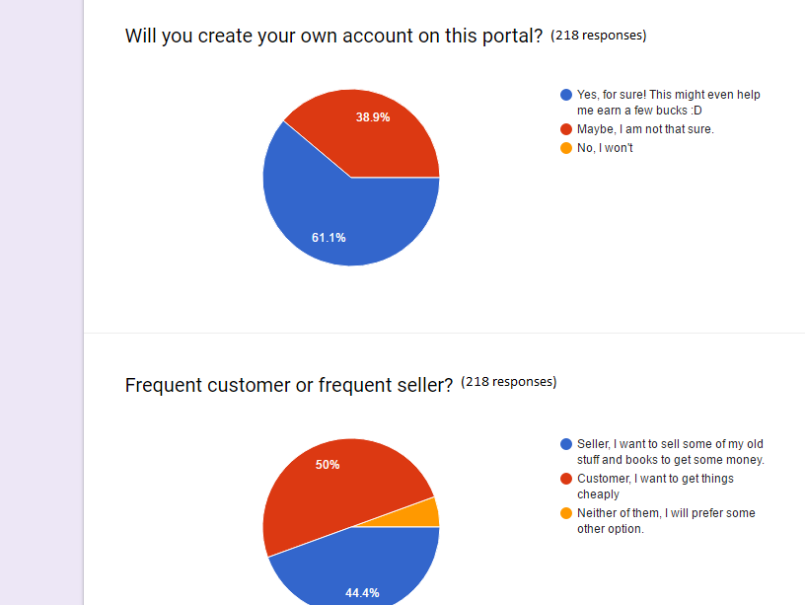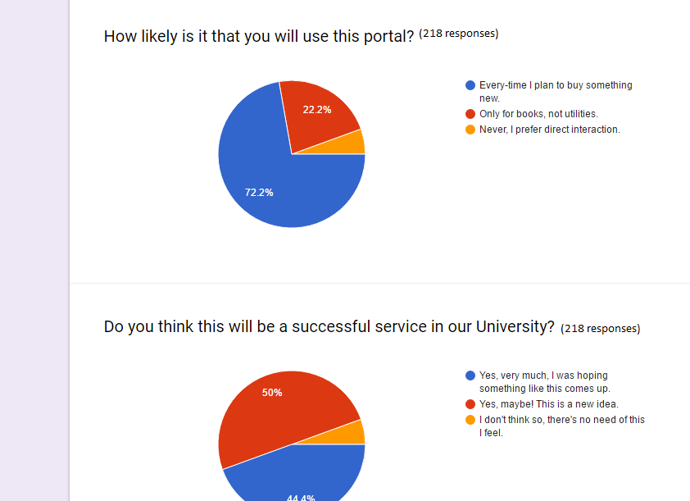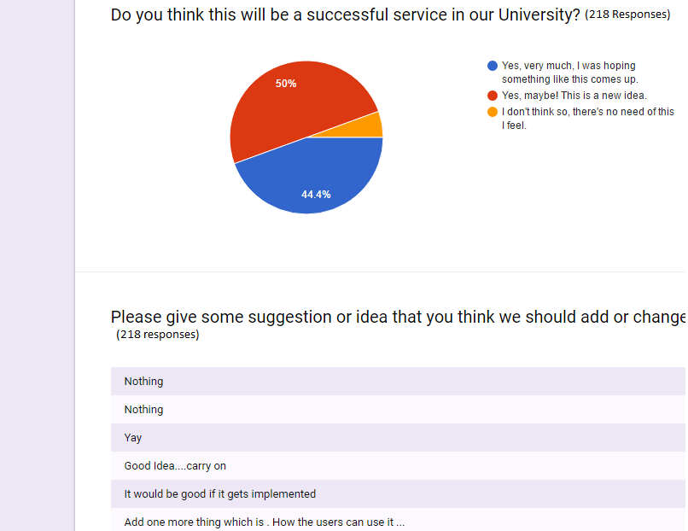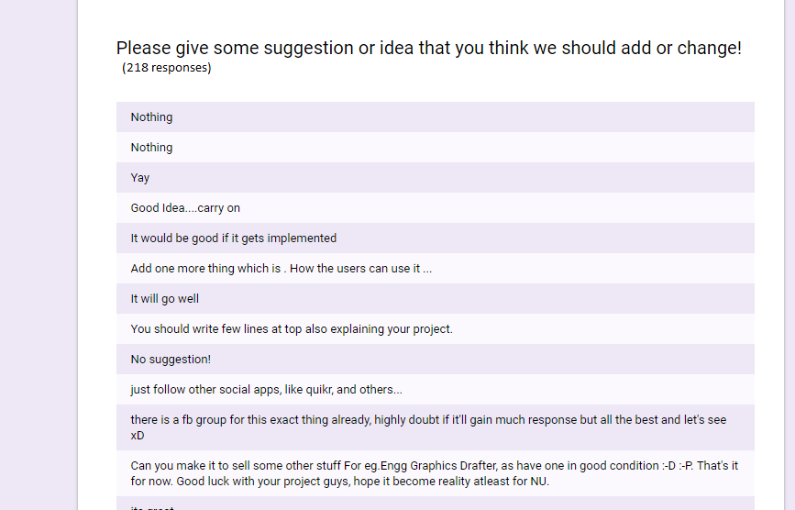

As can be seen from the responses given by the students of NIIT University, one can infer that our target customers are very much interested in this type of a service if provided.