**Exercise 5: Triggers**

**Scenario 1:** Automatically update the last modified date when a customer's record is updated.

**Question:** Write a trigger **UpdateCustomerLastModified** that updates the LastModified column of the Customers table to the current date whenever a customer's record is updated.  
  
CREATE TABLE customers (

customer_id NUMBER PRIMARY KEY,

name VARCHAR2(100),

age NUMBER,

balance NUMBER,

IsVIP VARCHAR2(5),

LastModified DATE

);

INSERT INTO customers VALUES (1, 'Koushika', 25, 12000, 'FALSE', SYSDATE);

COMMIT;

CREATE OR REPLACE TRIGGER UpdateCustomerLastModified

BEFORE UPDATE ON customers

FOR EACH ROW

BEGIN

:NEW.LastModified := SYSDATE;

END;

/

--example usage

UPDATE customers SET balance = balance + 1000 WHERE customer_id = 1;

SELECT * FROM customers WHERE customer_id = 1;

OUTPUT:

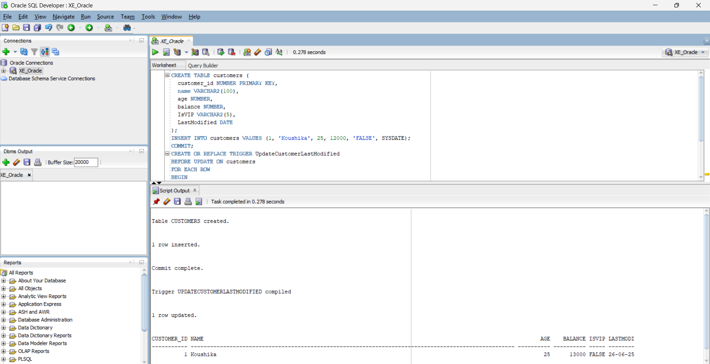

**Scenario 2:** Maintain an audit log for all transactions.

**Question:** Write a trigger **LogTransaction** that inserts a record into an AuditLog table whenever a transaction is inserted into the Transactions table.

CREATE TABLE transactions (

txn_id NUMBER PRIMARY KEY,

acc_no NUMBER,

txn_type VARCHAR2(20),

amount NUMBER,

txn_date DATE

);

CREATE TABLE audit_log (

log_id NUMBER GENERATED ALWAYS AS IDENTITY PRIMARY KEY,

txn_id NUMBER,

log_time DATE,

action VARCHAR2(50)

);

CREATE OR REPLACE TRIGGER LogTransaction

AFTER INSERT ON transactions

FOR EACH ROW

BEGIN

INSERT INTO audit_log (txn_id, log_time, action)

VALUES (:NEW.txn_id, SYSDATE, 'Transaction Inserted');

END;

/

--example usage

INSERT INTO transactions VALUES (1001, 401, 'deposit', 2000, SYSDATE);

SELECT * FROM audit_log;

OUTPUT:  
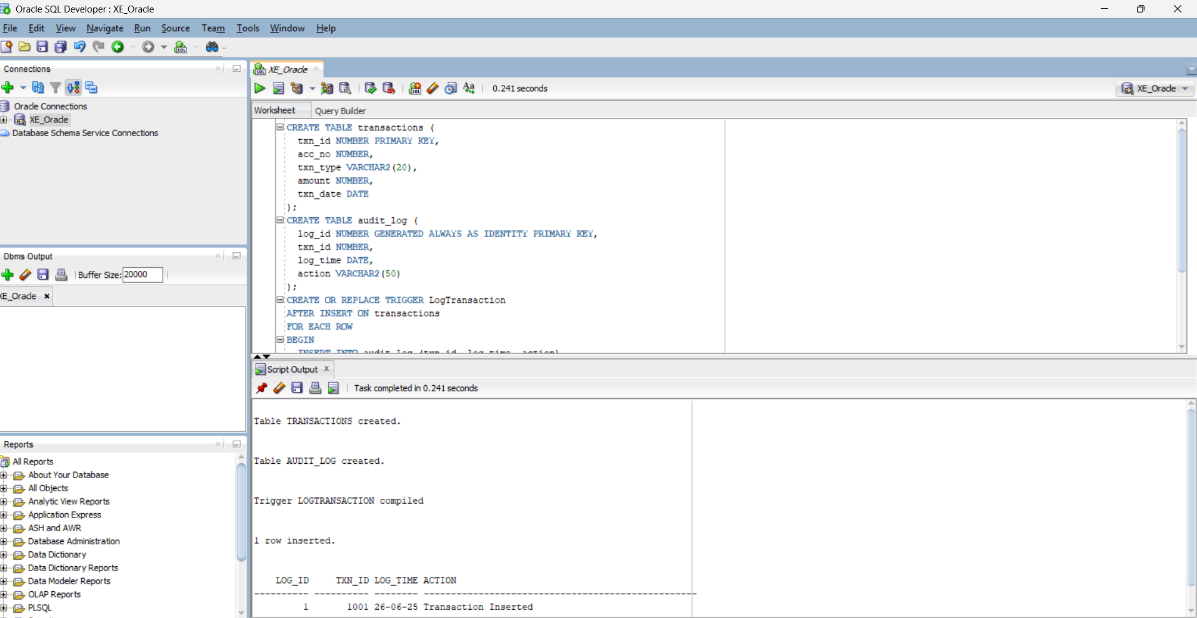

**Scenario 3:** Enforce business rules on deposits and withdrawals.

**Question:** Write a trigger **CheckTransactionRules** that ensures withdrawals do not exceed the balance and deposits are positive before inserting a record into the Transactions table.  
  
CREATE TABLE accounts (

acc_no NUMBER PRIMARY KEY,

holder_name VARCHAR2(100),

balance NUMBER

);

CREATE TABLE transactions (

txn_id NUMBER PRIMARY KEY,

acc_no NUMBER,

txn_type VARCHAR2(20),

amount NUMBER,

txn_date DATE

);

INSERT INTO accounts VALUES (401, 'Koushika', 8000);

COMMIT;

CREATE OR REPLACE TRIGGER CheckTransactionRules

BEFORE INSERT ON transactions

FOR EACH ROW

DECLARE

acc_balance NUMBER;

BEGIN

SELECT balance INTO acc_balance

FROM accounts

WHERE acc_no = :NEW.acc_no;

IF :NEW.txn_type = 'withdraw' AND :NEW.amount > acc_balance THEN

RAISE_APPLICATION_ERROR(-20001, 'Withdrawal exceeds current balance.');

END IF;

IF :NEW.txn_type = 'deposit' AND :NEW.amount <= 0 THEN

RAISE_APPLICATION_ERROR(-20002, 'Deposit amount must be positive.');

END IF;

EXCEPTION

WHEN NO_DATA_FOUND THEN

RAISE_APPLICATION_ERROR(-20003, 'Account not found.');

END;

/

--example usage

INSERT INTO transactions VALUES (1001, 401, 'deposit', 1000, SYSDATE);

OUTPUT:

