**Exercise 6: Cursors**

**Scenario 1:** Generate monthly statements for all customers.

**Question:** Write a PL/SQL block using an explicit cursor **GenerateMonthlyStatements** that retrieves all transactions for the current month and prints a statement for each customer.

CREATE TABLE transactions (

txn_id NUMBER PRIMARY KEY,

acc_no NUMBER,

txn_type VARCHAR2(20),

amount NUMBER,

txn_date DATE

);

INSERT INTO transactions VALUES (2001, 401, 'deposit', 1000, SYSDATE);

INSERT INTO transactions VALUES (2002, 401, 'withdraw', 500, SYSDATE - 2);

INSERT INTO transactions VALUES (2003, 402, 'deposit', 2000, SYSDATE - 40);

COMMIT;

DECLARE

CURSOR txn_cursor IS

SELECT acc_no, txn_type, amount, txn_date

FROM transactions

WHERE TO_CHAR(txn_date, 'MMYYYY') = TO_CHAR(SYSDATE, 'MMYYYY');

v_acc_no transactions.acc_no%TYPE;

v_type transactions.txn_type%TYPE;

v_amt transactions.amount%TYPE;

v_date transactions.txn_date%TYPE;

BEGIN

OPEN txn_cursor;

LOOP

FETCH txn_cursor INTO v_acc_no, v_type, v_amt, v_date;

EXIT WHEN txn_cursor%NOTFOUND;

DBMS_OUTPUT.PUT_LINE('Account: ' || v_acc_no || ' | Type: ' || v_type || ' | Amount: ' || v_amt || ' | Date: ' || TO_CHAR(v_date, 'DD-Mon-YYYY'));

END LOOP;

CLOSE txn_cursor;

END;

/

--example usage

SELECT * FROM transactions

WHERE TO_CHAR(txn_date, 'MMYYYY') = TO_CHAR(SYSDATE, 'MMYYYY');

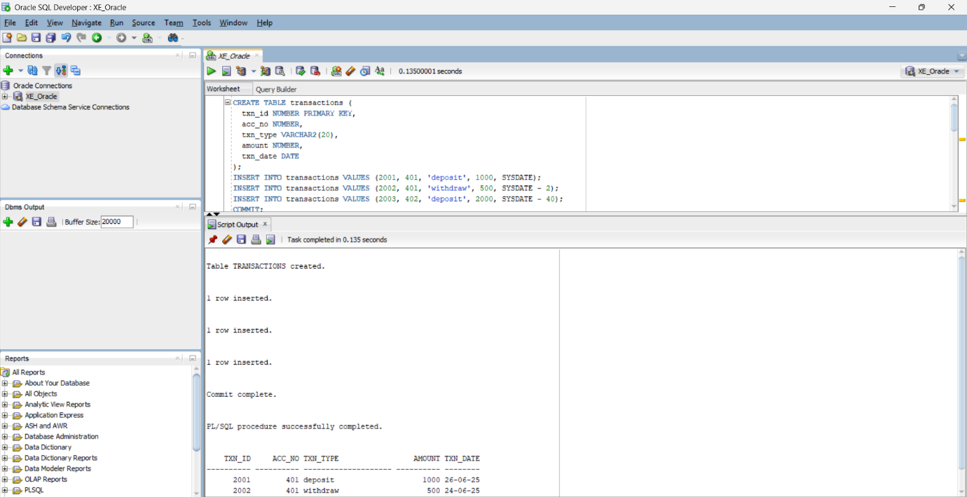 OUTPUT:

**Scenario 2:** Apply annual fee to all accounts.

**Question:** Write a PL/SQL block using an explicit cursor **ApplyAnnualFee** that deducts an annual maintenance fee from the balance of all accounts.

DECLARE

CURSOR acc_cursor IS

SELECT acc_no, balance FROM accounts;

v_acc_no accounts.acc_no%TYPE;

v_balance accounts.balance%TYPE;

annual_fee CONSTANT NUMBER := 500;

BEGIN

OPEN acc_cursor;

LOOP

FETCH acc_cursor INTO v_acc_no, v_balance;

EXIT WHEN acc_cursor%NOTFOUND;

UPDATE accounts

SET balance = balance - annual_fee

WHERE acc_no = v_acc_no;

DBMS_OUTPUT.PUT_LINE('Annual fee applied to Account: ' || v_acc_no);

END LOOP;

CLOSE acc_cursor;

COMMIT;

END;

/

--view

SELECT * FROM accounts;

OUTPUT:

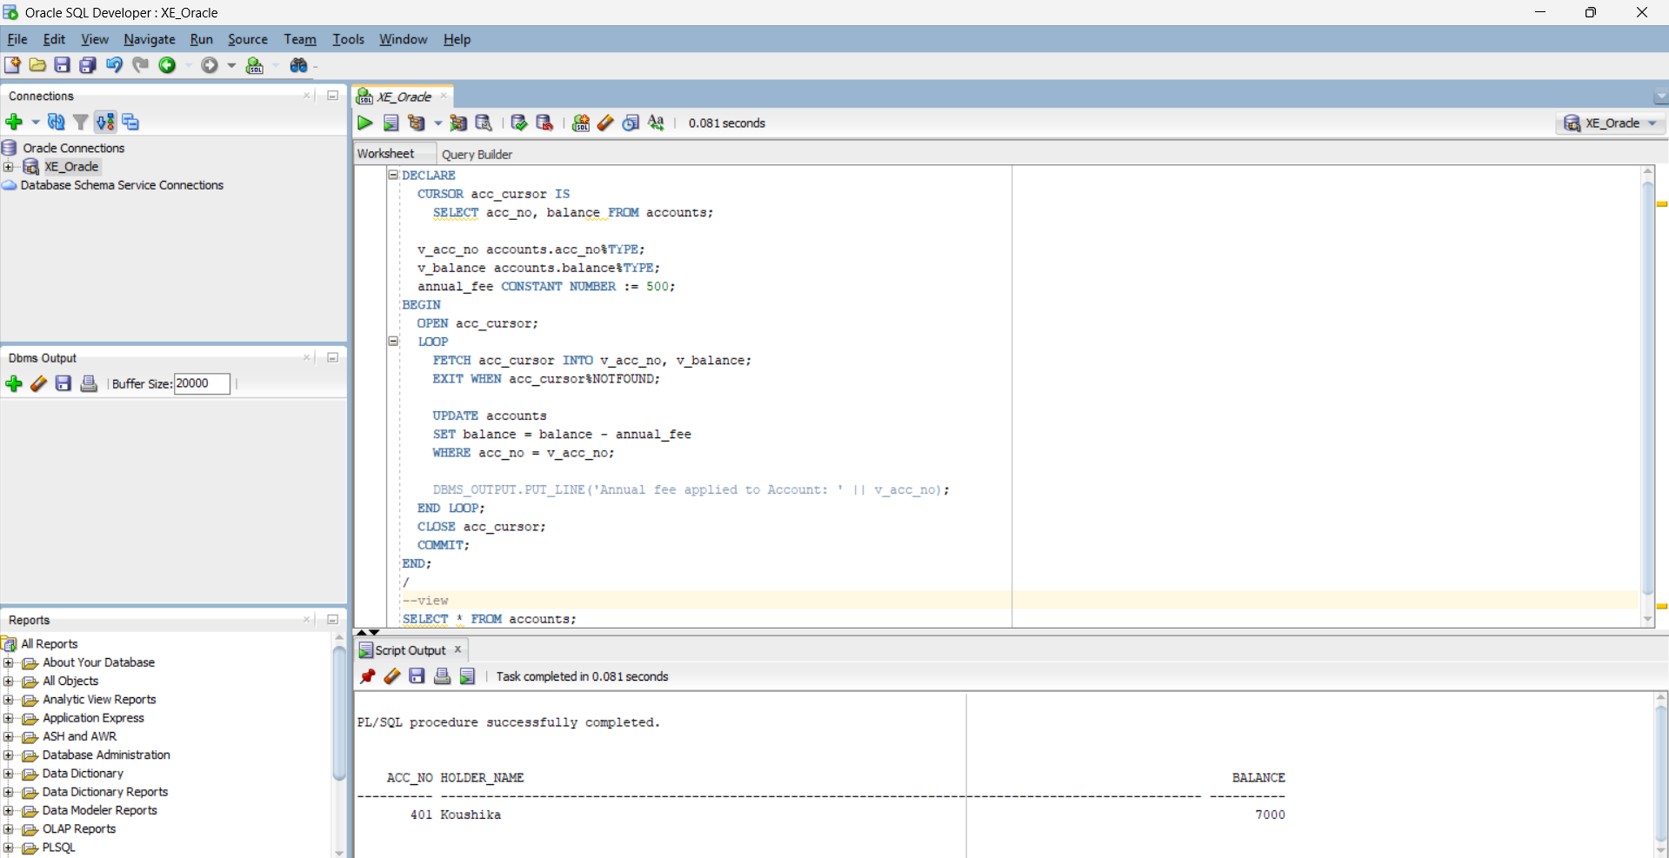

**Scenario 3:** Update the interest rate for all loans based on a new policy.

**Question:** Write a PL/SQL block using an explicit cursor **UpdateLoanInterestRates** that fetches all loans and updates their interest rates based on the new policy.

CREATE TABLE loans (

loan_id NUMBER PRIMARY KEY,

customer_id NUMBER,

interest_rate NUMBER,

due_date DATE

);

INSERT INTO loans VALUES (301, 1, 9.5, SYSDATE + 180);

INSERT INTO loans VALUES (302, 2, 8.0, SYSDATE + 90);

COMMIT;

DECLARE

CURSOR loan_cursor IS

SELECT loan_id, interest_rate FROM loans;

v_loan_id loans.loan_id%TYPE;

v_rate loans.interest_rate%TYPE;

BEGIN

OPEN loan_cursor;

LOOP

FETCH loan_cursor INTO v_loan_id, v_rate;

EXIT WHEN loan_cursor%NOTFOUND;

UPDATE loans

SET interest_rate = v_rate + 0.5

WHERE loan_id = v_loan_id;

DBMS_OUTPUT.PUT_LINE('Updated interest for Loan ID: ' || v_loan_id);

END LOOP;

CLOSE loan_cursor;

COMMIT;

END;

/

--view

SELECT * FROM loans;

OUTPUT:  
