CardioSense: A Machine Learning Pipeline for Early-Stage Cardiovascular Disease Risk Prediction
Random Forest Feature Selection with a Threshold-Tuned, Calibrated Support Vector Machine
Abstract
Cardiovascular disease (CVD) remains one of the leading causes of death worldwide, and early identification of at-risk individuals can meaningfully improve outcomes through timely lifestyle intervention and clinical follow-up. This project, CardioSense, presents a complete machine learning pipeline for early-stage cardiovascular disease risk screening using self-reported health survey data. A Random Forest classifier is first used to rank and select the ten most predictive features from a large, real-world health survey dataset, after which a Support Vector Machine (SVM) with an RBF kernel is trained on the reduced feature set and optimized through randomized hyperparameter search. Because the target class is heavily imbalanced (approximately 91% negative to 9% positive), the project applies class-weighting, decision-threshold tuning via the precision-recall curve, and isotonic probability calibration to produce a classifier whose predicted probabilities meaningfully reflect real-world risk rather than an arbitrary or miscalibrated score. The final model achieves a test-set ROC-AUC of 0.76 and a minority-class recall of 41%, a substantial improvement over the near-zero recall obtained from an uncalibrated, default-threshold baseline. The trained pipeline is deployed as an interactive Streamlit web application that allows a user to enter basic health and lifestyle information and receive an instant, color-coded cardiovascular risk assessment.
Problem Statement
Cardiovascular disease is often asymptomatic in its early stages, and many at-risk individuals are unaware of their risk level until a clinical event occurs. Traditional diagnostic pathways rely on clinical tests, physician visits, and laboratory panels, which are not always accessible, affordable, or top-of-mind for the general population. There is a clear need for lightweight, accessible screening tools that can flag elevated risk from information a person already knows about themselves — age, weight, general health perception, diagnosed conditions, and lifestyle habits — without requiring a clinical visit.
Building such a tool from real-world survey data introduces several non-trivial challenges that this project directly addresses: (1) severe class imbalance in diagnosed-disease data, which biases naive classifiers toward always predicting the majority (healthy) class; (2) reverse-causality confounding in self-reported behavioral data, where a diagnosed condition can itself change a person's subsequent reported behavior; and (3) the tendency of imbalance-correction techniques such as class-weighting to distort predicted probabilities even after classification accuracy is fixed. Addressing all three was essential to producing a model that is not just statistically accurate, but genuinely trustworthy to a person interpreting a risk percentage.
Objectives
- Build an end-to-end machine learning pipeline for cardiovascular disease risk prediction from a real-world, large-scale health survey dataset.
- Use Random Forest feature importance to identify the most predictive health and lifestyle indicators, reducing dimensionality for a computationally lighter final model.
- Train and optimize a Support Vector Machine classifier via randomized hyperparameter search, appropriately handling the practical challenge of SVM training complexity on a large dataset.
- Correct for class imbalance through class-weighting and data-driven decision-threshold selection rather than the default 0.5 cutoff.
- Identify and correct feature-level confounding introduced by reverse causality in self-reported survey data.
- Calibrate the classifier's output probabilities so that displayed risk percentages reflect true population-level risk rather than a distorted, class-balanced score.
- Deploy the final pipeline as an interactive, user-facing web application for real-time risk screening.
About the Dataset
The project uses the BRFSS-derived “Cardiovascular Diseases Risk Prediction” dataset, sourced from Kaggle and originally derived from the CDC's Behavioral Risk Factor Surveillance System (BRFSS), a large-scale annual U.S. health survey. The dataset contains 308,854 records and 19 columns, with no missing values in any field.
Features include demographic information (Sex, Age_Category), self-reported general health and diagnosed conditions (General_Health, Diabetes, Arthritis, Skin_Cancer, Other_Cancer, Depression), physical measurements (Height_(cm), Weight_(kg), BMI), and lifestyle/behavioral indicators (Exercise, Smoking_History, Alcohol_Consumption, Fruit_Consumption, Green_Vegetables_Consumption, FriedPotato_Consumption, Checkup). The binary target variable, Heart_Disease, indicates whether the respondent has ever been diagnosed with heart disease. The target is heavily imbalanced, with approximately 91% “No” and 9% “Yes” responses — a realistic reflection of disease prevalence in the general population, but one that required deliberate handling throughout the modeling pipeline.
Data Preprocessing
Preprocessing began with removing exact duplicate rows to avoid inflating the effective sample size of any particular respondent profile. The Checkup column (time since last medical checkup) was dropped, as it was judged not to reflect an underlying health or lifestyle risk factor and added noise without predictive value for this task.
Categorical variables were encoded using two distinct strategies depending on their nature. Purely binary Yes/No columns (Exercise, Skin_Cancer, Other_Cancer, Depression, Arthritis, Sex, Smoking_History, and the target Heart_Disease) were transformed using scikit-learn's LabelEncoder. Ordinal categorical variables, where category order carries meaning, were instead mapped explicitly to preserve that order: General_Health was mapped Poor=0 through Excellent=4; Age_Category was mapped by sorting each age-range label according to its numeric lower bound; and Diabetes was collapsed from four raw text categories into three ordinal levels, treating “borderline/pre-diabetes” and “told only during pregnancy” as intermediate states between “No” and a full “Yes” diagnosis.
The cleaned, encoded dataset was split into training and test sets using an 80/20 stratified split, ensuring both sets preserved the same 91:9 class balance as the full dataset. All numeric features were standardized using StandardScaler, fit only on the training set and then applied to the test set, to avoid data leakage.
Methodology Used (Algorithms)
Two algorithms were used in a complementary, two-stage design: Random Forest for feature selection, and Support Vector Machine for final classification.
Random Forest: A RandomForestClassifier with 300 trees and class_weight='balanced' was trained on the full encoded feature set. Random Forest was chosen for this stage because its feature_importances_ output provides a robust, non-linear ranking of predictive power across mixed categorical and numeric features, without requiring manual feature engineering or assumptions about linearity.
Support Vector Machine: An SVM with an RBF (radial basis function) kernel was selected as the final classifier for its strong performance on non-linearly separable data. Because SVM training complexity scales roughly quadratically to cubically with sample size, hyperparameter tuning was performed using RandomizedSearchCV on a stratified 8,000-row subsample rather than the full ~247,000-row training set — a necessary practical tradeoff to keep training times feasible, justified further in the discussion of feature selection below. The final model was fit on a larger 40,000-row stratified subsample using the best hyperparameters found (kernel='rbf', C=0.1, gamma=0.01) with class_weight='balanced' to address class imbalance.
Threshold tuning and calibration: Two distinct corrections were required beyond standard model fitting. First, because class-weighting shifts the decision boundary, the default 0.5 classification threshold caused the model to over-predict the positive class; the optimal threshold was instead selected by maximizing F1-score across the precision-recall curve. Second, the raw predicted probabilities from the class-weighted SVM were found to be poorly calibrated — compressed into an uninformative 17%–54% range regardless of a person's actual risk. This was corrected using CalibratedClassifierCV with isotonic regression, fit on a held-out calibration split, which remapped the raw scores so that the average predicted probability (≈08%) closely matches the true population prevalence of heart disease in the test data, without harming the model's underlying ranking ability (ROC-AUC unchanged).
Feature Selection
Feature selection was performed using Random Forest feature importances rather than manual selection, ensuring the choice of predictive features was data-driven. An important discovery during exploratory analysis directly informed this stage: Alcohol_Consumption and FriedPotato_Consumption were found to exhibit reverse-causality confounding — respondents already diagnosed with heart disease reported lower alcohol and fried-food consumption than undiagnosed respondents, almost certainly reflecting post-diagnosis lifestyle changes (e.g. doctor-advised dietary restriction) rather than these habits being protective. Including these two features caused the trained model to associate unhealthy habits with lower predicted risk in some cases — a clearly undesirable and misleading behavior for a risk-screening tool.
These two features were therefore excluded prior to running feature selection. Random Forest was then trained on the remaining feature set, and the top 10 features by importance were retained for the final SVM: Age_Category, BMI, Weight_(kg), General_Health, Green_Vegetables_Consumption, Fruit_Consumption, Height_(cm), Diabetes, Arthritis, and Smoking_History. Per-feature sanity checks were performed post-selection — holding all other inputs constant and varying one feature at a time — confirming that predicted risk moves in the clinically expected direction for each selected feature (e.g., risk increases with age, poorer self-rated health, higher weight, smoking history, and arthritis, and decreases with higher fruit and vegetable consumption).
Feature Engineering
- Ordinal-aware encoding: General_Health, Age_Category, and Diabetes were mapped to integers that preserve their real-world ordering, rather than relying on arbitrary alphabetical label encoding, so that models sensitive to feature ordering could exploit the natural progression of risk.
- Derived BMI: Body Mass Index was used directly as a feature (Weight_(kg) / Height_(m)²), consolidating two physical measurements into a single, clinically meaningful risk indicator; height and weight were also retained individually since Random Forest found independent predictive value in each.
- Standardization: All numeric features were scaled to zero mean and unit variance prior to SVM training, which is essential for margin-based classifiers like SVM that are sensitive to feature scale.
- Feature exclusion as engineering: deliberately removing Alcohol_Consumption and FriedPotato_Consumption is itself a feature-engineering decision — recognizing that not all statistically correlated features are causally valid inputs for a predictive model intended to reflect true risk direction.
Results and Conclusion
The final calibrated SVM was evaluated on a held-out test set of 61,755 records. At the F1-optimal decision threshold of approximately 0.17–0.23 (depending on model iteration), the model achieved the performance summarized below, alongside a comparison against the Random Forest classifier evaluated at its default threshold on the same test set.
Metric | Random Forest | Optimized SVM
Accuracy | 0.917 | 0.849
Precision (Yes) | 0.396 | 0.243
Recall (Yes) | 0.040 | 0.407
F1-score (Yes) | 0.072 | 0.304
ROC-AUC | 0.814 | 0.764
Table 1: Random Forest vs. Optimized SVM performance on the held-out test set.
Random Forest achieves higher raw accuracy and ROC-AUC, but its recall on the positive (“Yes”) class is only 4% — it is barely detecting true heart-disease cases at the default threshold, a direct consequence of class imbalance. The threshold-tuned SVM trades a small amount of accuracy and AUC for a substantially better recall of 41%, which is the more clinically meaningful outcome for a screening tool, where failing to flag a true at-risk individual is costlier than an occasional false alarm.
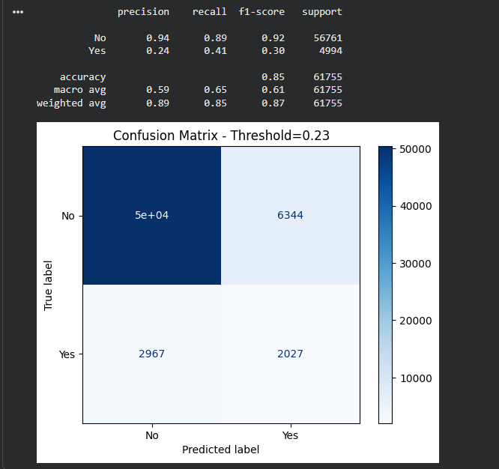
Figure 1: Classification report and confusion matrix at the tuned decision threshold (0.23).
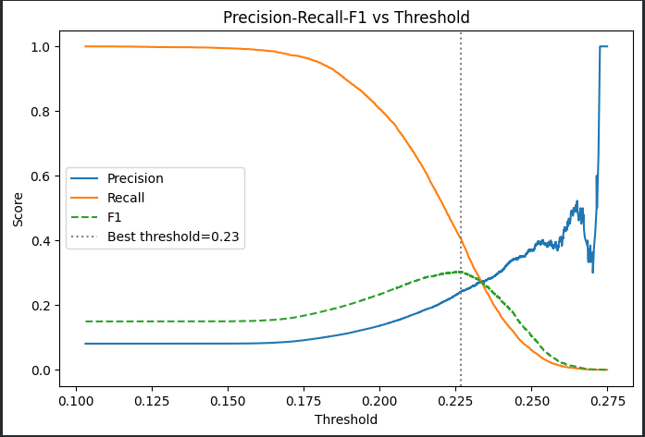
Figure 2: Precision, recall, and F1-score across candidate decision thresholds, with the F1-optimal threshold marked.
Beyond raw classification performance, this project's most instructive results were methodological. The identification of reverse-causality confounding in the Alcohol_Consumption and FriedPotato_Consumption features demonstrates that statistically important features are not automatically causally meaningful — a critical distinction in health survey data where behavior can be a consequence of diagnosis rather than a cause of it. Separately, the discovery that class_weight='balanced' fixes decision boundaries but simultaneously distorts predicted probabilities highlights that classification accuracy and probability calibration are two distinct problems requiring two distinct solutions — addressing only the former, as is common practice, would have left the deployed application displaying misleading risk percentages to every user.
The completed pipeline was deployed as CardioSense, an interactive Streamlit web application allowing a user to enter their age, general health, height, weight, diabetes status, fruit and vegetable intake, arthritis status, and smoking history, and receive an instant, calibrated cardiovascular risk percentage alongside a color-coded risk tier (Healthy, Borderline, Elevated, or High Risk).
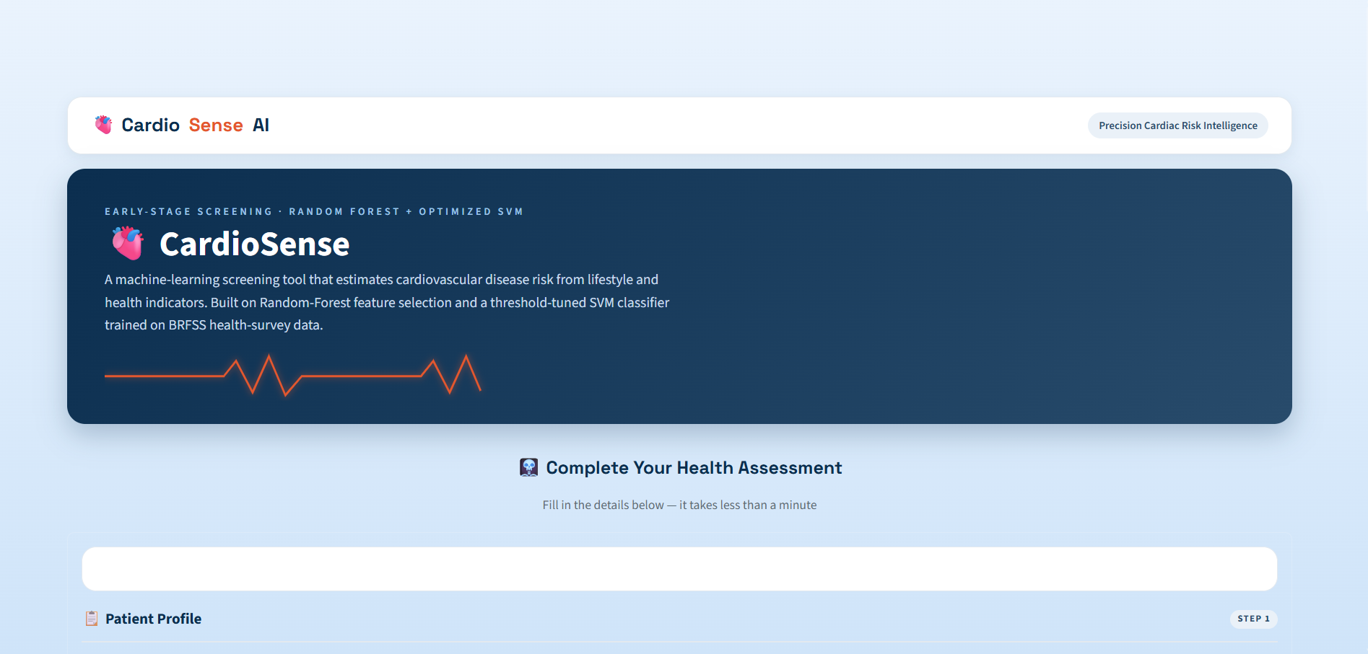
Figure 3: CardioSense application landing page.
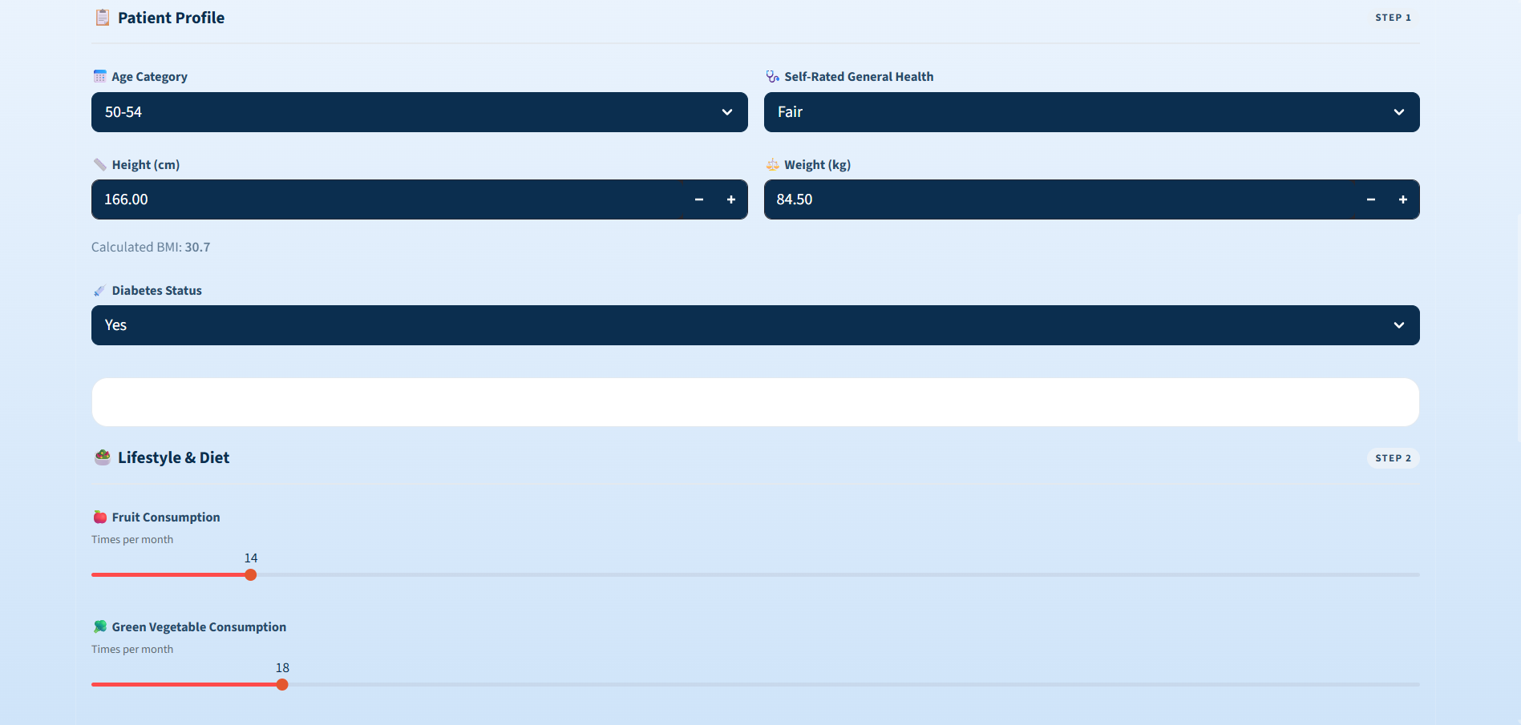
Figure 4: Patient health assessment input form.
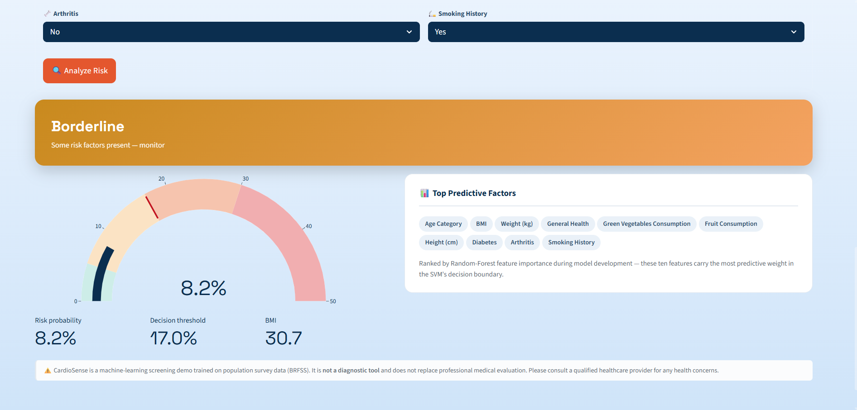
Figure 5: Calibrated risk output with gauge visualization and top predictive factors.
In conclusion, this project demonstrates that a carefully engineered classical machine learning pipeline — combining Random Forest feature selection, threshold-tuned SVM classification, and isotonic probability calibration — can produce a genuinely usable cardiovascular risk screening tool from imperfect, imbalanced, real-world survey data. The project's value lies not only in its final performance metrics, but in the systematic diagnosis and correction of multiple distinct failure modes (class imbalance, reverse-causality confounding, and probability miscalibration) that commonly go unaddressed in similar student and portfolio projects.
Future Work
- Incorporate longitudinal (rather than cross-sectional) health data where available, to better distinguish causal risk factors from post-diagnosis behavioral changes, directly addressing the reverse-causality limitation identified in this project.
- Experiment with additional algorithms, such as gradient-boosted trees (XGBoost, LightGBM) or shallow neural networks, and compare their calibrated performance and recall against the current SVM baseline.
- Apply explainability techniques such as SHAP or LIME to provide per-prediction, per-feature explanations to end users, increasing the transparency and trustworthiness of individual risk assessments.
- Explore resampling techniques such as SMOTE or ADASYN as an alternative or complement to class-weighting, and compare their effect on both classification metrics and probability calibration.
- Extend the model to a multi-class or continuous risk-scoring framework rather than a binary classification, potentially capturing finer-grained risk gradation than the current four-tier system.
- Conduct clinical validation in partnership with healthcare professionals before considering any real-world deployment beyond an educational or portfolio context, given that the current model is explicitly not a diagnostic tool.
- Add automated model monitoring to detect data or performance drift if the application were to be used on an ongoing basis with new user data.

