**Experiment No. 9**

**Title: Case study: Big data platform / analytics as business need)**

**Batch:B1 Roll No.:1714126 Experiment No.:9**

# Title: Case study: Machine Studio on Azure

**Resources needed: Microsoft Azure Machine Learning Studio**

**___________________________________________________________________________**

**Describe the following points with respect to the business under consideration,**

1. **Problem faced by the business**
2. **Approach/ Methodology followed by the business**
3. **Skillsets , infrastructure and other impact on the business during implementation**
4. **Similar approaches followed by other businesses**

**Results:**

**Activate the student pack and login with Somaiya ID.**

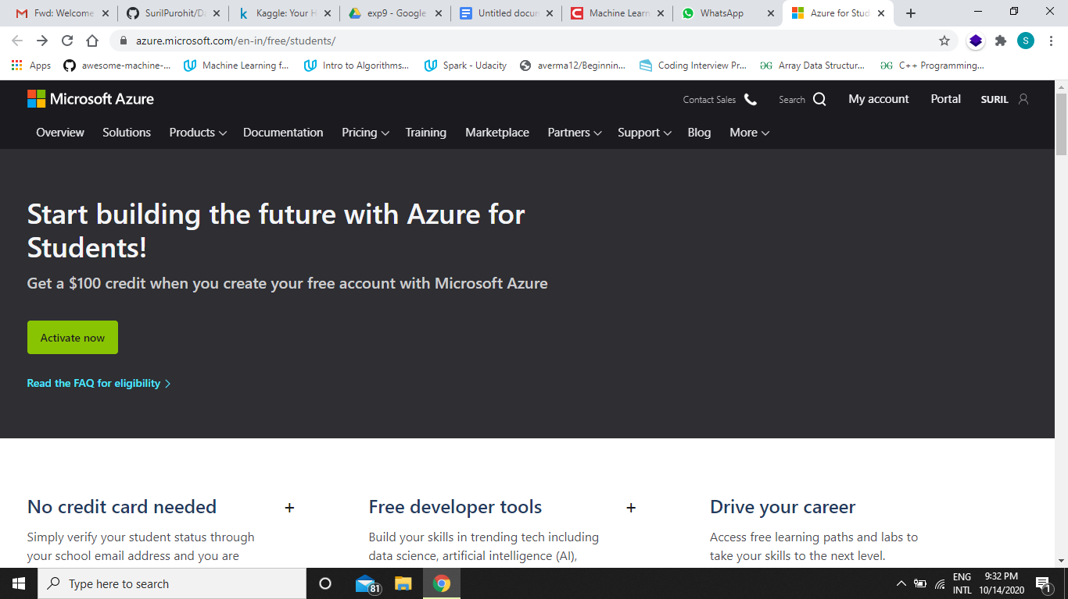

**You will be rewarded 100$ initially.**

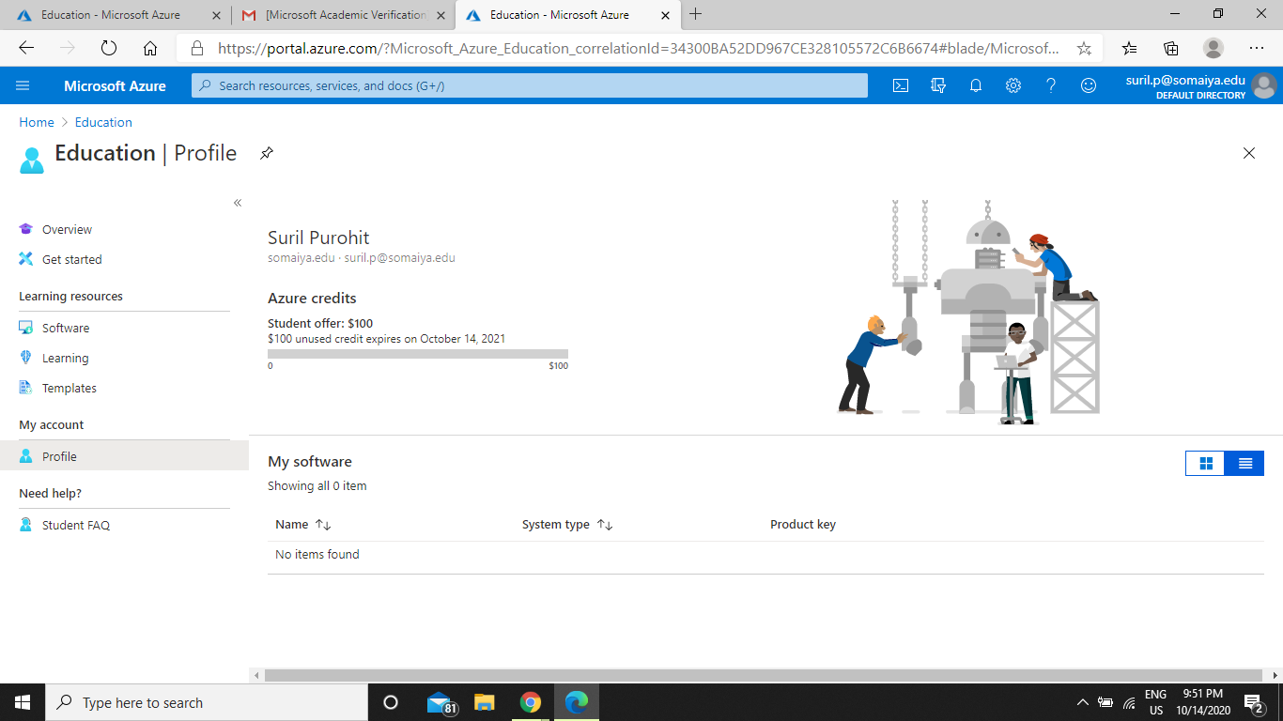

We have used the Microsoft Azure Machine Learning studio to execute a machine learning algorithm.

Following are the steps for the same:

* 1. Add dataset

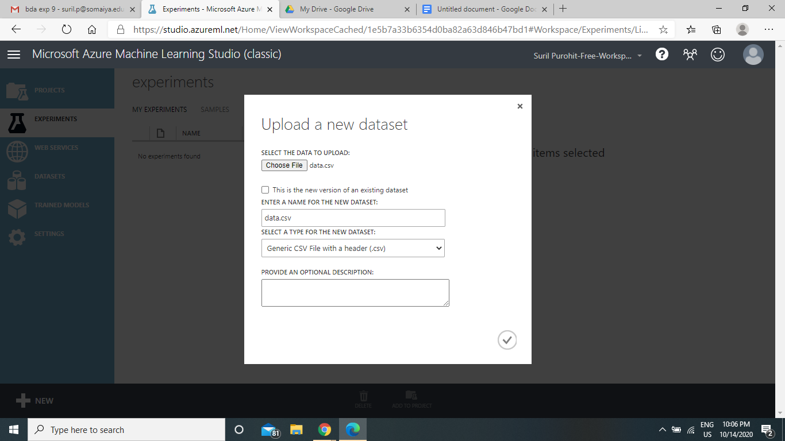

* 1. Create new experiment

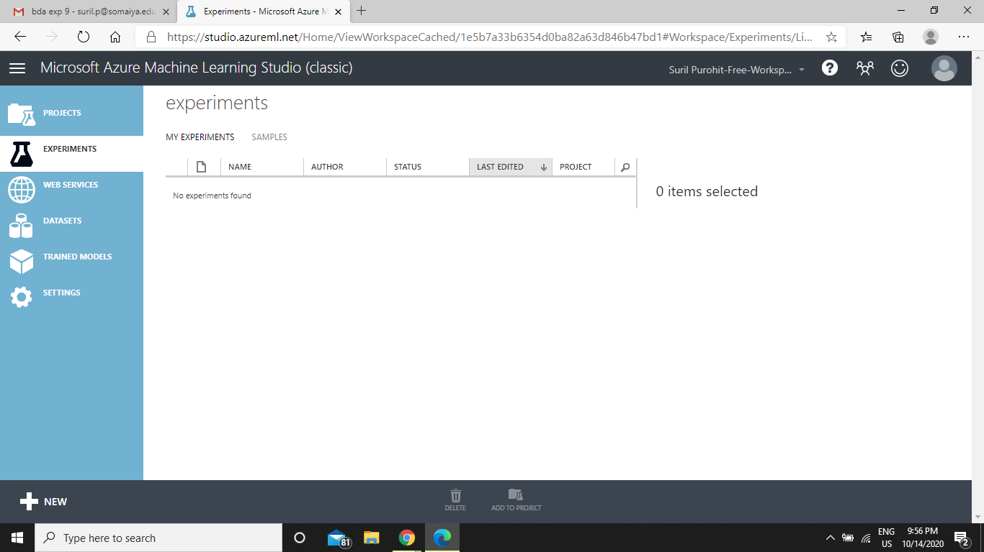

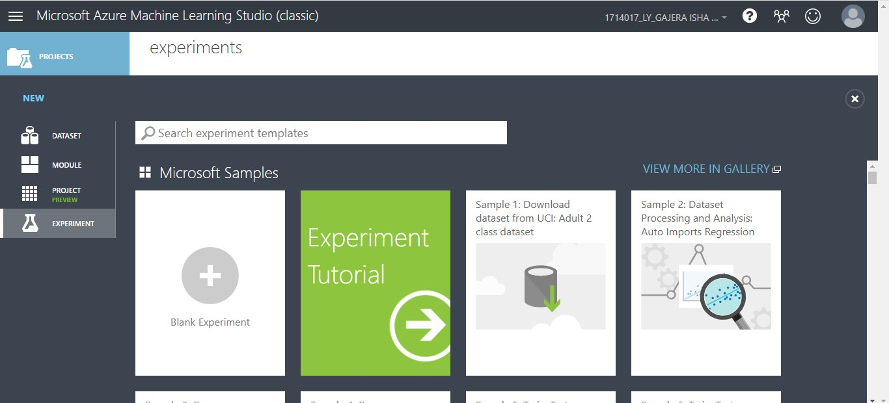

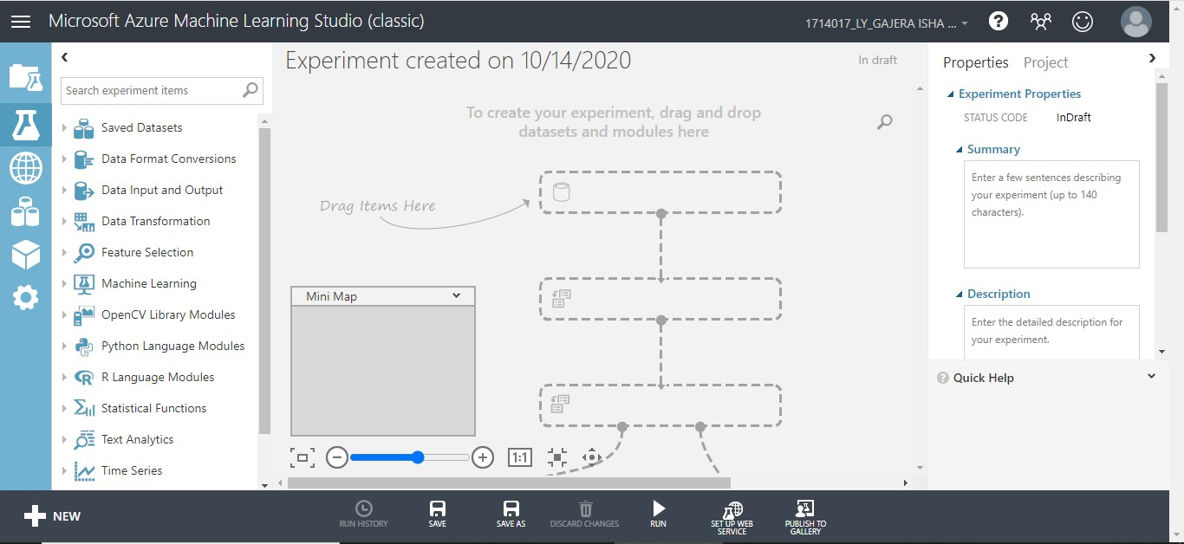

* 1. Adding dataset from saved datasets of Azure to experiment

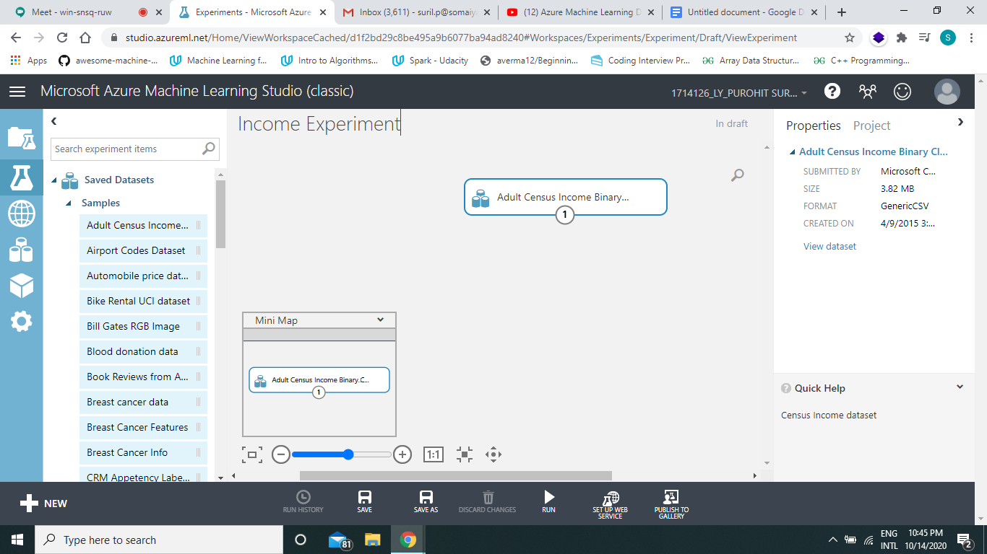

Visualizing the dataset

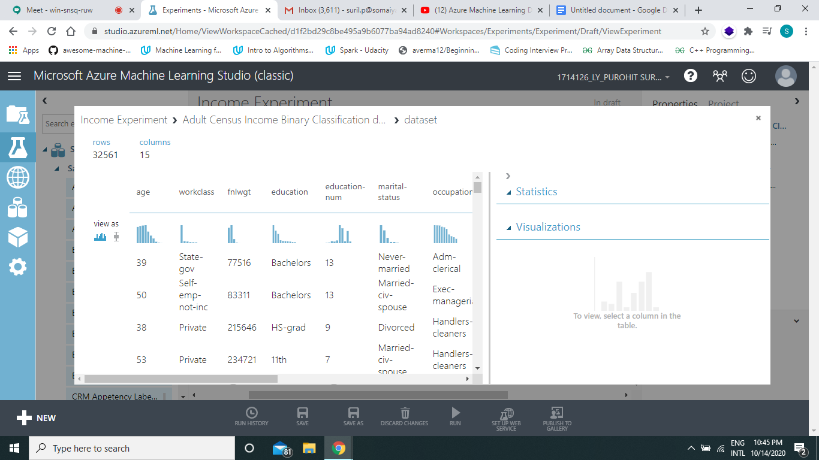

Two category of income column

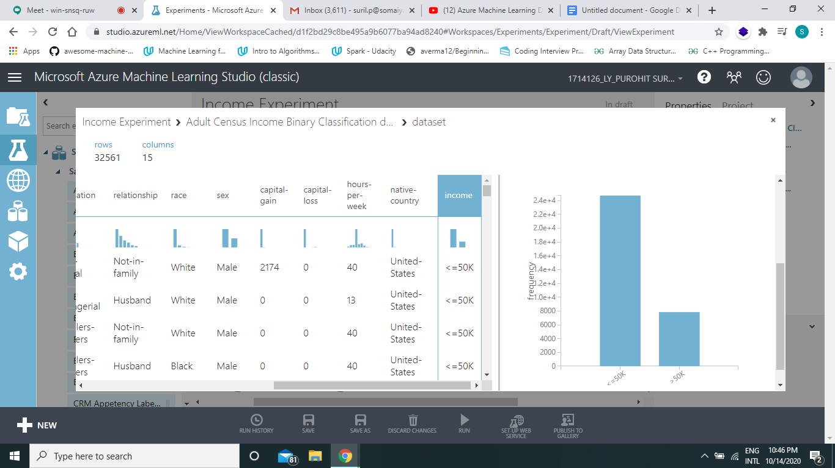

* 1. Select from age, education, marital status, relationship, sex, race and income

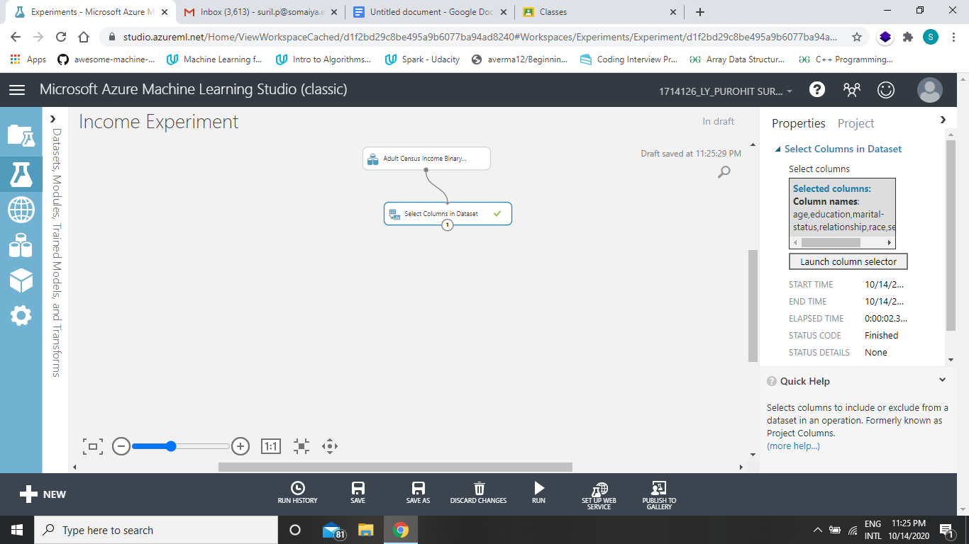

1. Added Two Class Boosted Decision Tree for better performance

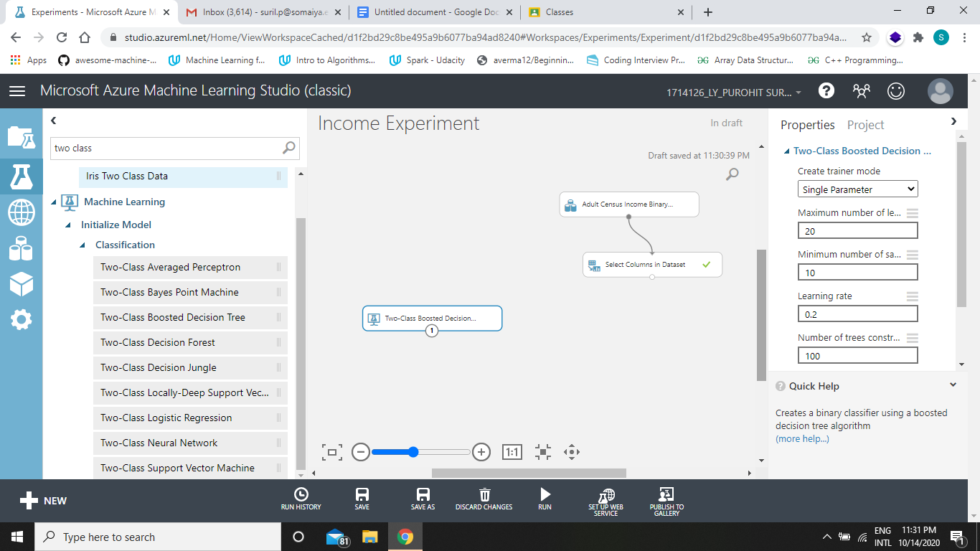

1. Split data 0.8 i.e. 80% train and 20% test

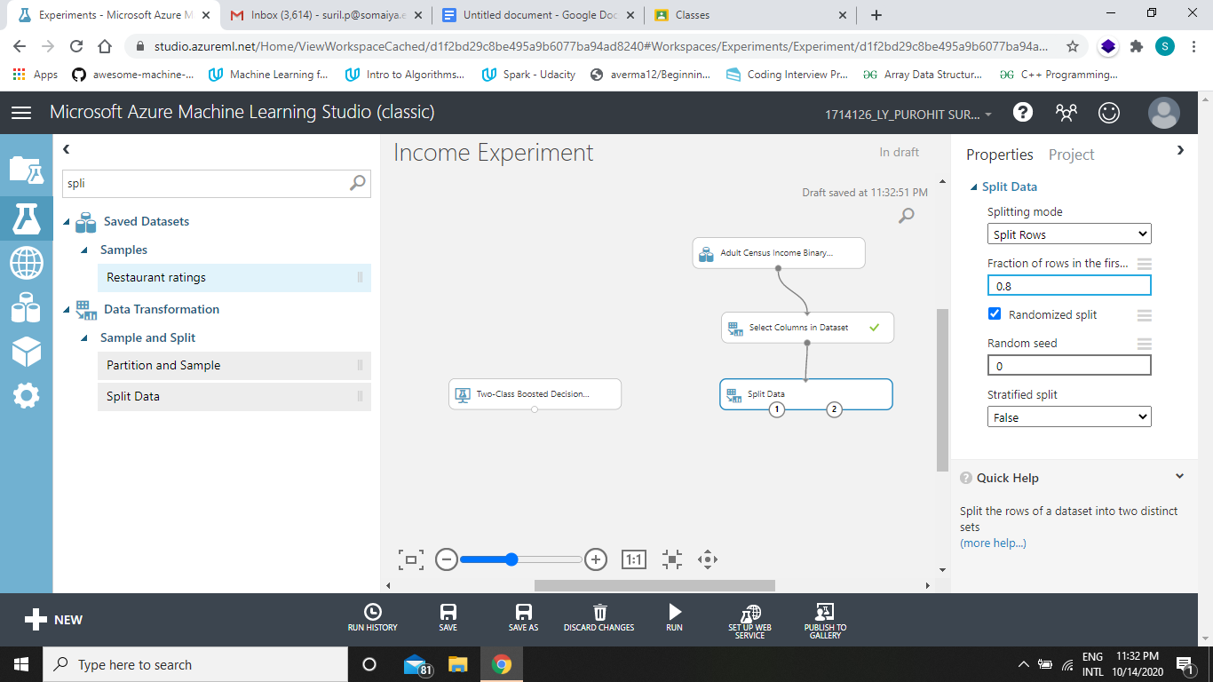

1. Train Model and select a attribute to train and test on. In this case we have chosen Income column.

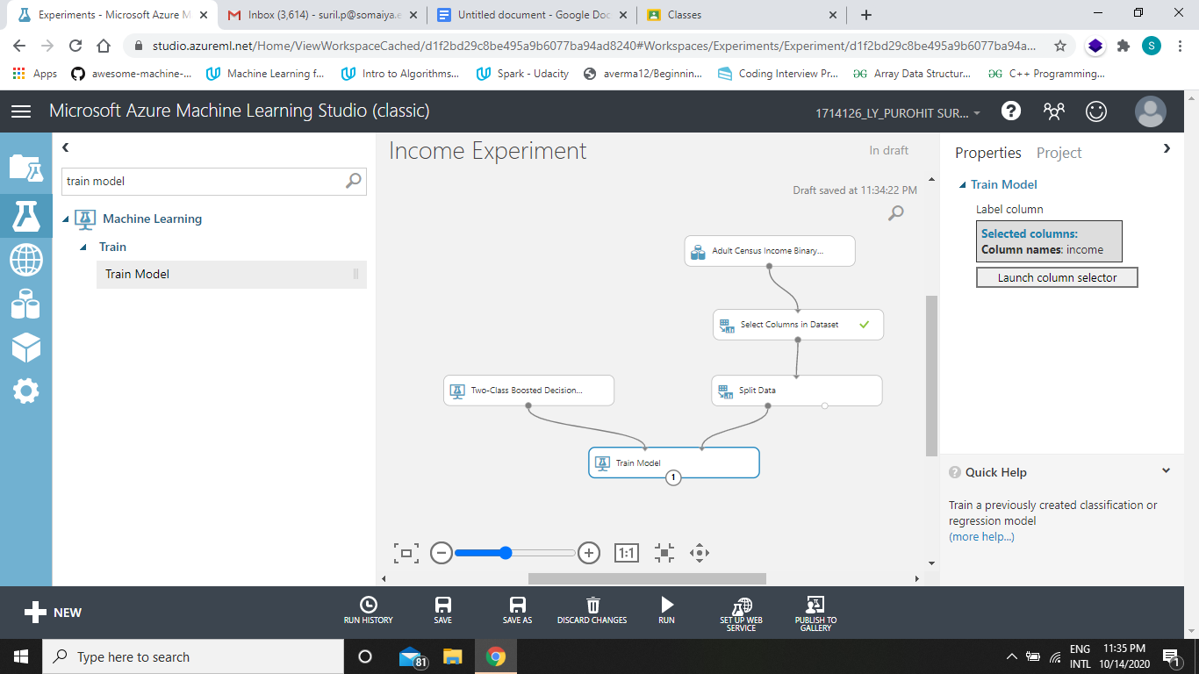

1. Add the score model in order to see the effectiveness of the trained model.

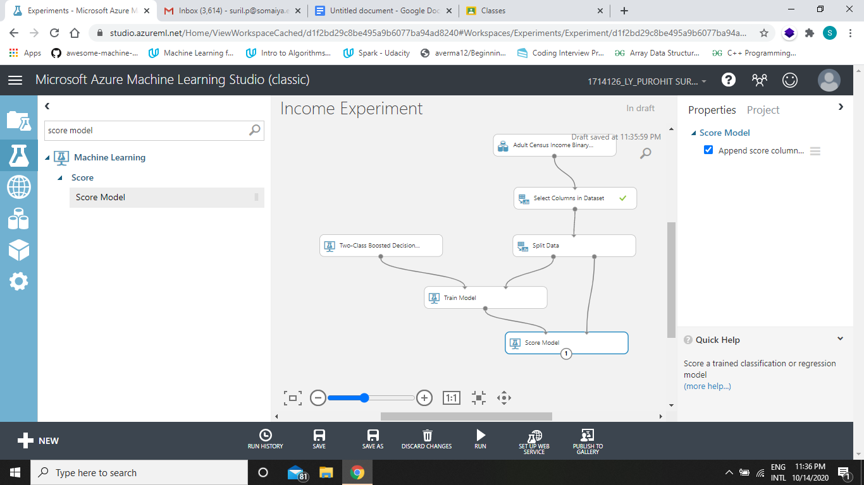

1. Evaluating the model and viewing the results.

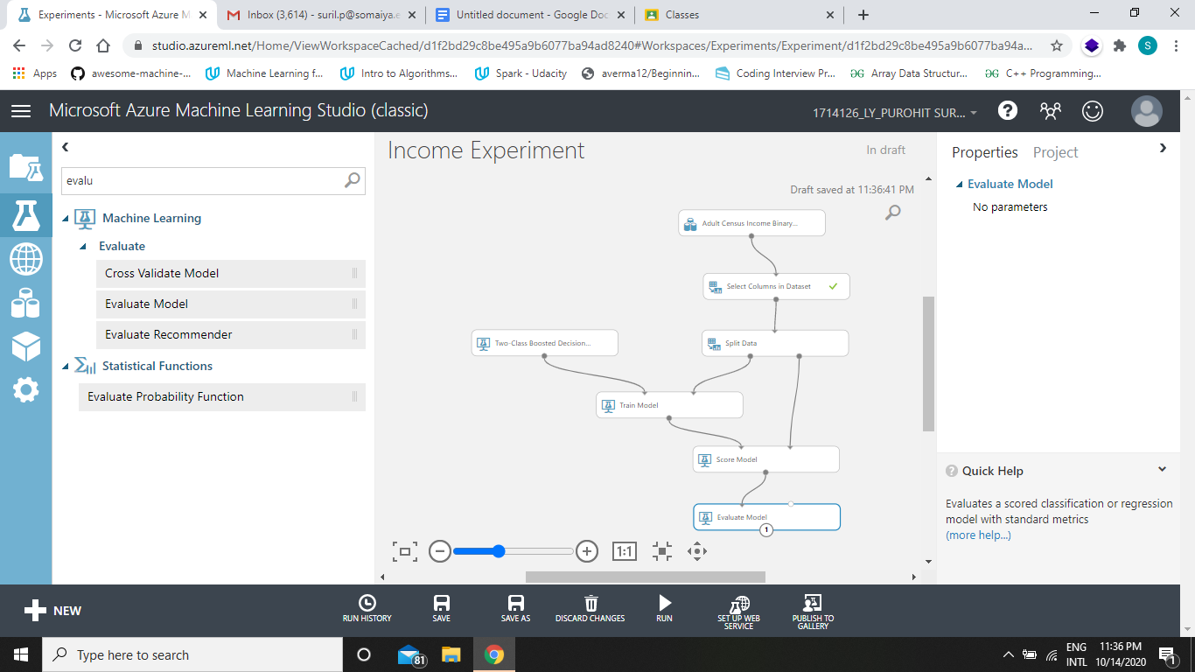

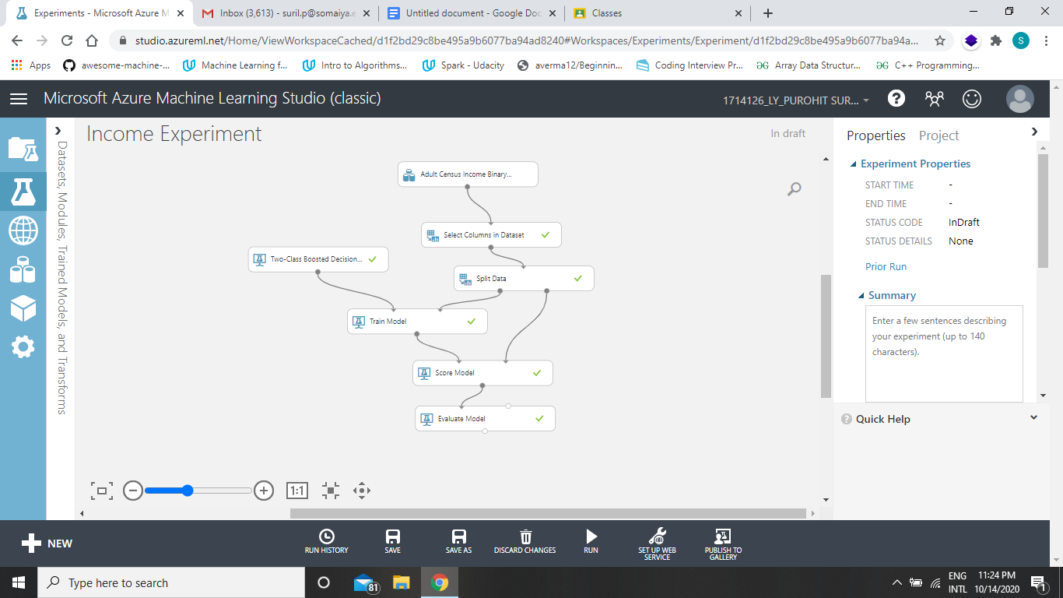

1. Visualization and Stats of result obtained.

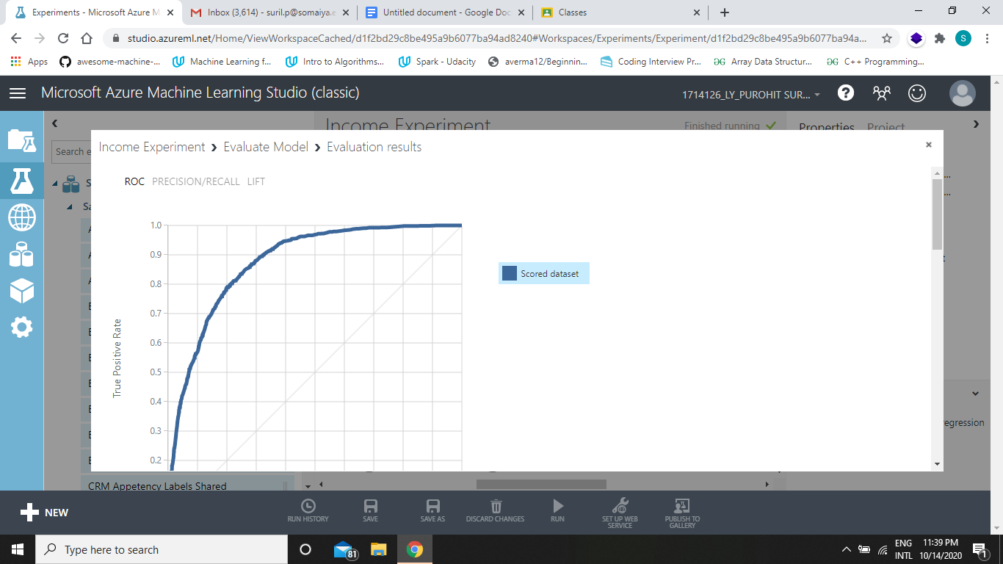

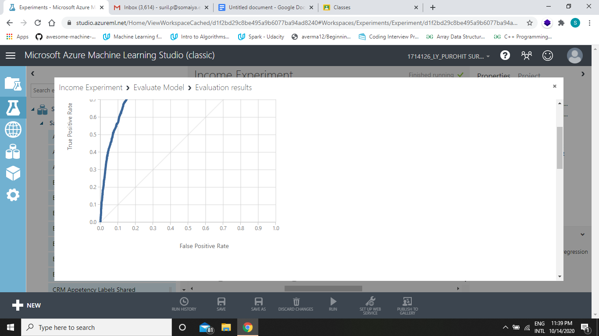

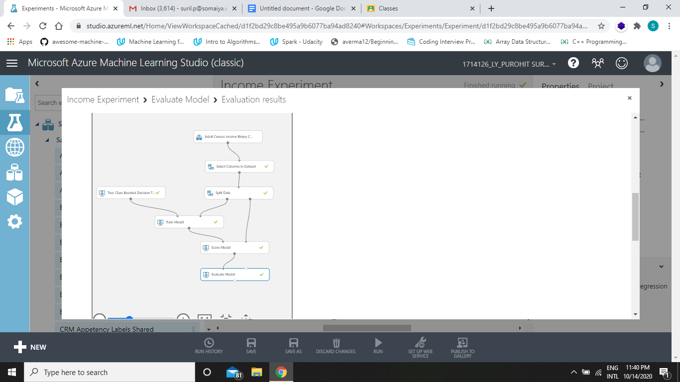

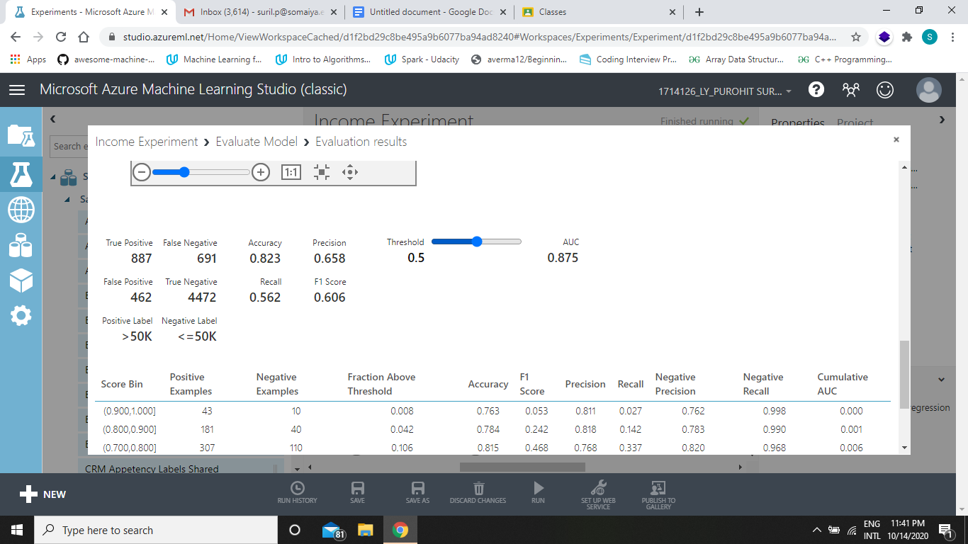

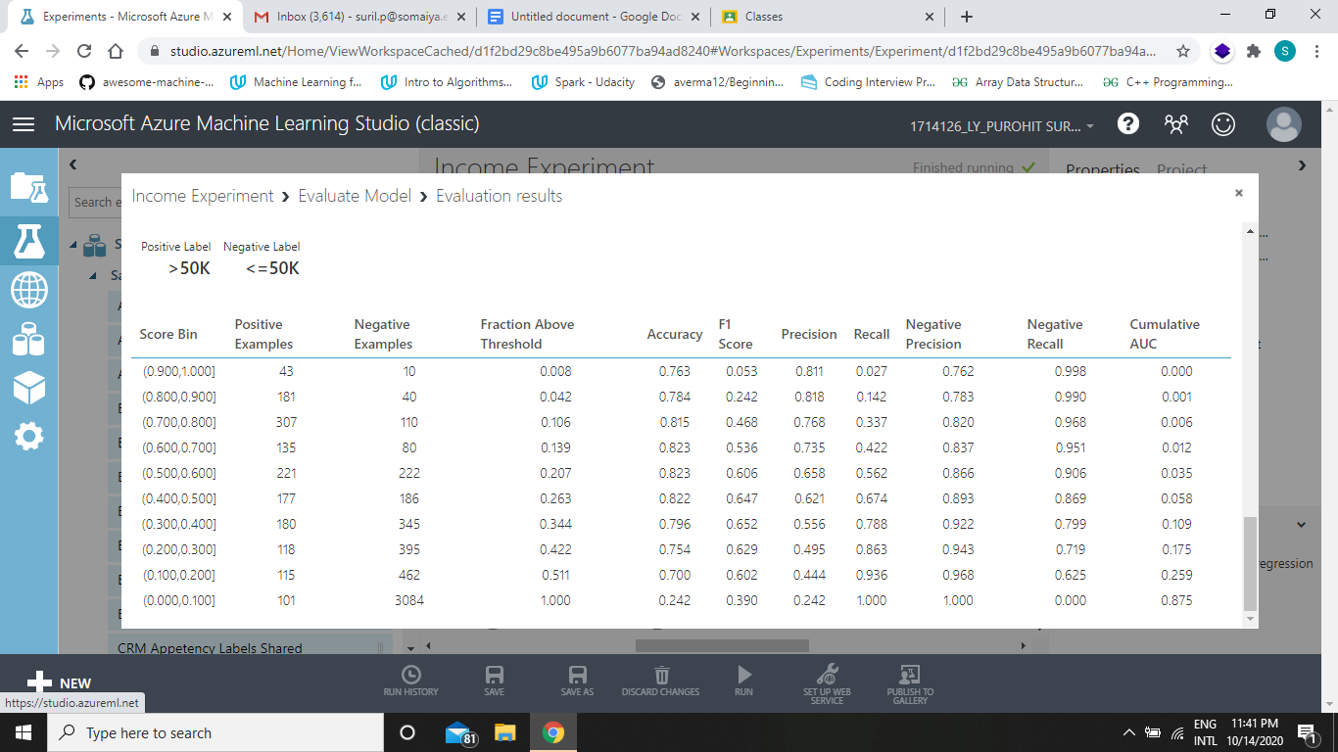

1. Pushing to Gallery

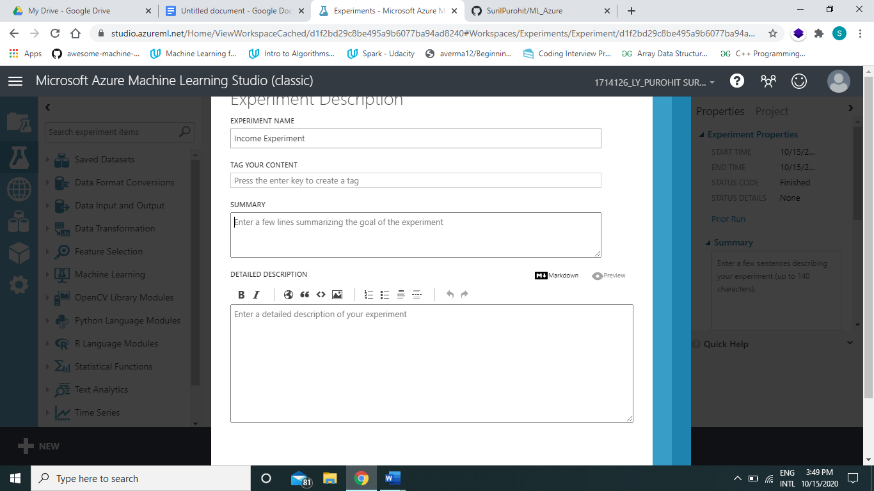

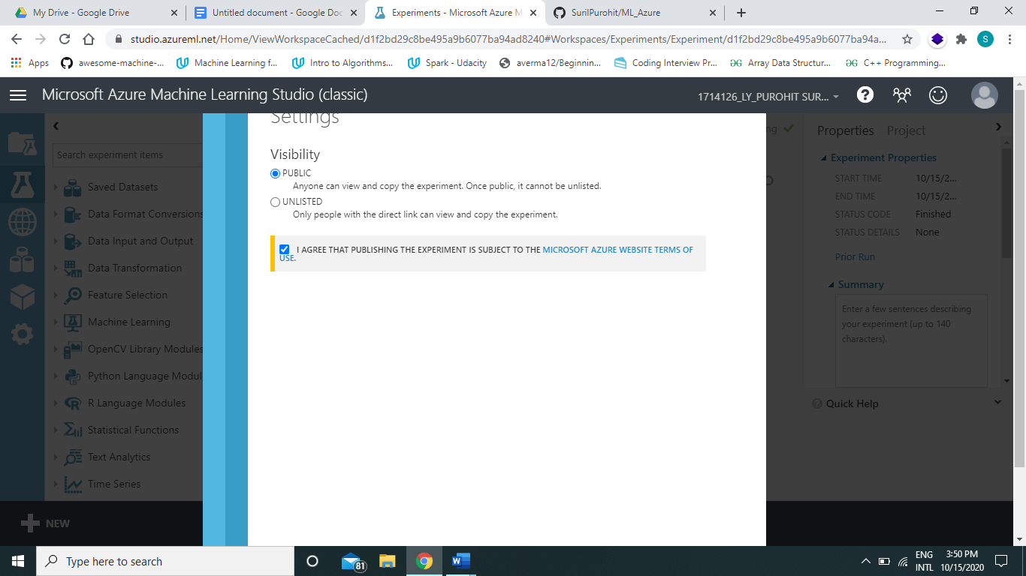

Azure Gallery Link: https://gallery.cortanaintelligence.com/Experiment/Income-Experiment-12

# Outcomes: Realize adequate perspectives of big data analytics in various applications.

# Conclusion: Therefore, I was able to explore Microsoft Azure ML Studio and Implement regression algorithm on the same.

# Grade: AA / AB / BB / BC / CC / CD /DD Signature of faculty in-charge with date

**Reference Books/ Journals/ Websites:**