**Bug Report**

Bug ID: BUG-01

Description:

When attempting to proceed to checkout on the Sauce Demo website, the application allows the checkout process to be completed even when the cart is empty. After successfully proceeding to checkout, an "Order Successful" message is displayed along with a valid order ID, despite no items being in the cart.

Steps to Reproduce:

1. Navigate to “<https://www.saucedemo.com/>”.

2. Login using valid username and password.

3. After the successful login click on the "Cart" icon.

4. Ensure the cart is empty.

5. Click on the "Checkout" button.

6. Fill in the checkout information and submit the form.

7. Observe the resulting page displaying "Order Successful" and an order ID.

Expected Result:

The system should prevent checkout and display an error message indicating that the cart is empty. The user should not be able to proceed to checkout without adding items to the cart.

Actual Result:

The system allows the checkout process to complete successfully and generates an order ID even when the cart is empty.

Screenshot: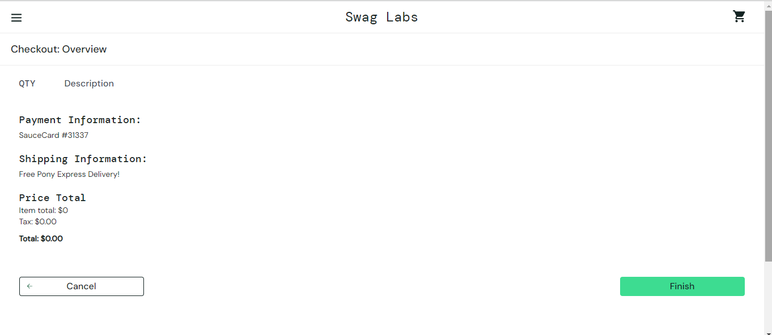

Suggested Fix:

Implement a validation check to ensure the cart is not empty before allowing the user to proceed to checkout. Display an appropriate message if the cart is empty, preventing further checkout actions.