IOT BASED EARLY FLOOD MONITORING, DETECTION AND ALARMING SYSTEM

# ABSTRACT

*Nowadays natural calamities like flooding turn up drastically, and it severely affects standard of living. In this paper the development of flood monitoring system using IOT to keep track of the conditions nearby the reservoir with the help of Arduino, the prototyping platform and the compactible sensors such as level, temperature, humidity and flow distinctly presented. Firstly the hardware unit is placed in the flood prone areas, the Wi-Fi module (ESP8266) act as the transmitting unit and the sensors associated with the system measures the corresponding parameters. Then the accurately measured parameters are displayed through the LCD display and passed to the IOT web application. Here the thingspeak web application is used to store data in private channel and the web application then alerts the authority and people while flood occurs.*

**Key words:-***Internet of things(IOT),Arduino Uno R3,ESP8266 Wi-Fi module, sensors*

# INTRODUCTION

Natural calamities happens everywhere in the world, and which affects the human life and economy of the country. Economy and growth of any country depends upon the agriculture, hence the proper alert makes the farmers vigilant to protect the crop from flooding.

In order to detect and avoid flood like disastrous calamities in a timely manner, current world technology plays a vital role. We can prevent natural disaster caused by flood, with the aid of an IOT based early flood related parameter monitoring and detection system and its avoidance using the Arduino project, is proposed as a solution to the mentioned problem.

The proposed model is very much utilized for monitoring of the water level, flow variations, humidity and temperature variation in the river and the same can be used at dam or reservoirs. The measured values are regularly updated on the web server which is very much useful to send flood alerts to authority and people for faster action.

The entire system consist of five different Arduino compactible sensors which are temperature, humidity, water level, flow and ultrasonic sensors. Also it consist of an Arduino controller, a Wi-Fi module, an LCD display an alarm and an IOT remote server based platform.

In this advanced system the initial stage indicates the level of water and the other parameters like flow rate temperature and humidity. Then these information is passed to the web server or the IOT via a Wi-Fi module, here the ESP8266 is used as Wi-Fi module. Which transmit and DHT11 is the temperature and humidity sensor, it is a basic low cost digital temperature and humidity sensor. And HC-SR04 ultrasonic sensor used as the water level sensor, which works on the SONAR principle. In this paper the main objective are implement a system which covers

both the IOT based system and the sensor network interfaced with both ESP8266 and the Arduino Uno R3 board for detecting floods and for sending alert to organizations and the society. The LED and buzzer act as alerting system when there is rise in the water level and the associating parameters.

Nowadays at most of the times the ordinary system notifies only the respective governed registered organizations, result in the slowdown of the process in rescuing citizens and also most of their belongings cannot be stored. In present condition it is necessary to develop the design of accurate smart flood monitoring system using sensors and IOT thus the system efficiency can be increased and can be imposed as the real time monitoring system. In this paper the main objectives are to implement a system which covers both the ESP8266- based technology, sensor network components, IOT and web applications for detecting the floods for sending an alert to the organization.

# LITERATURE REVIEW

## INTERNET OF THINGS BASED REAL TIME FLOOD MONITORING AND ALERT

**MANAGEMENT SYSTEM -** The system is much advantaged for protecting the lives of people and animals. This system is very much utilized for monitoring of the water level, flow variations in rivers and the same can be used for measuring of the water level at Dam/ Reservoirs. The measured values are regularly updated on the web server which is very much useful to send flood alerts to consistent authority and people for faster action. This constitute a wireless sensor nodes which called as a mote and the motes are placed along the river beds to monitor water condition. Each Node is connected with a GSM module. The measured parameters are processed by the Raspberry pi3 which contains 64-bit ARM Cortex A53 processor. The processed information transmitted from corresponding node to alert management system using GPRS. Google spread sheet Application program interface (API) created and this API is used as a data logger

## AN INTELLIGENT FLOOD MONITORING SYSTEM FOR BANGLADESH USING WIRELESS

**SENSOR NETWORK -** A neuro-fuzzy based flood alert system using WSN has been proposed. The distributed sensor nodes use low rate wireless personal area network to collect water level data from the river, rainfall data, wind speed data and air pressure data from the selected site. The sensors information are sent to the distributed alert center via Arduino micro controller and the XBee Transceivers. At the distributed alert center, XBee Transceiver and a Raspberry Pi microcomputer are used to generate flood alert based on sensor information. Two decades flood monitoring data have been used to estimate the duration of the flood and these data are stored in a database. An intelligent NFC is created in Raspberry Pi microcomputer which uses sensor data to announce broadcast the flood alerts.

## DEVOLEPMENT OF A LOW COST COMMUNITY BASED REAL TIME FLOOD MONITORING

**AND EARLY WARNING SYSTEM -** The proposed system employs the use of low cost Arduino Uno micro controllers and other low cost devices to detect potential flood and alert the community in real time. Results obtained from the system prototype/field test demonstrated its capability in mitigating the devastating impacts of floods especially for the poorest and most vulnerable communities in developing countries.

* 1. **SMS BASED FLOOD MONITORING AND EARLY WARNING -** This monitoring system is fast, cheaper and reliable hence it helps prevent the loss of lives damage to properties. One problem in the system may develop if the network provider makes changes to the network. The GSM module cannot upgrade itself. The system is further improved by make it independent by incorporating a solar battery charging system. This can be supported by the GSM module. GSM module has a feature that enables it to check the battery level at any time. Since the setup will be in a remote area, the solar charging system will allow for the battery to be constantly charged. The user can also check the battery status through the GSM module. The module should be able to feedback the battery level to the user via SMS. Further remote top-up, adding resident numbers are also incorporated to make the system fully efficient.

# PROPOSED MODEL

## BLOCK DIAGRAM

To detect a flood the system observes various natural factors, which includes humidity, temperature, water level and flow level. To collect data of mentioned natural factors the system consist of different sensors which collects data for individual parameters. For detecting changes in humidity and temperature the system has a DHT11 Digital Temperature Humidity Sensor. It is a advanced sensor module with consists of resistive humidity and temperature detection components. The water level is always under observation by a float sensor, which work by opening and closing circuits (dry contacts) as water levels rise and fall. It normally rest in the closed position, meaning the circuit is incomplete and no electricity is passing through the wires yet. Once the water level drops below a predetermined point, the circuit completes itself and sends electricity through the completed circuit to trigger an alarm. The flow sensor on the system keeps eye on the flow of water.

The water flow sensor consists of a plastic valve body, a water rotor, and a hall-effect sensor. When water flows through the rotor, rotor rolls. Its speed changes with different rate of flow. The system also consist of a HC-SR04 Ultrasonic Range Finder Distance Sensor. The Ultrasonic sensor works on the principle of SONAR and is designed to measure the distance using ultrasonic wave to determine the distance of an object from the sensor. All the sensors are connected to Arduino UNO, which processes and saves data. The system has wifi feature, which is useful to access the system and its data over IOT.

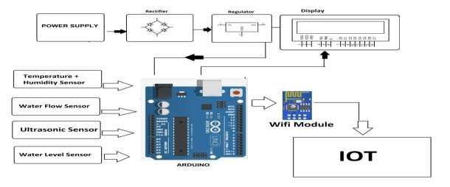

**Fig -1: Basic Model of the System**

# HARDWARE SPECIFICATION

## Arduino Uno R3

Arduino is an open-source electronic platform that is based on connection between hardware and software and it is easy to use and implement. They are designed in such a way that it read the input – water reaches a certain threshold and turn it into an output – sending the alert . The Arduino Uno is a microcontroller board based on the ATmega328. It has 20 digital input/output pins (of which 6 can be used as PWM outputs and 6 can be used as analog inputs), a 16 MHz resonator, a USB connection, a power jack, an in-circuit system programming (ICSP) header, and a reset button. It contains everything needed to support the microcontroller; simply connect it to a computer with a USB cable or power it with a AC-to-DC adapter or battery to get started.

The Uno differs from all preceding boards in that it does not use the FTDI USB-to-serial driver chip. Instead, it features an ATmega16U2 programmed as a USB-to-serial converter. This auxiliary microcontroller has its own USB boot loader, which allows advanced users to reprogram it. The Arduino has a large support community and an

extensive set of support libraries and hardware add-on [shields](https://www.pololu.com/category/113/arduino-shields)making it a great introductory platform for embedded electronics

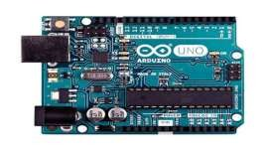

**Fig -2: Top view of Arduino board**

## Wi-Fi MODULE – ESP8266

The ESP8266 Wi-Fi Module is a self contained SOC with integrated TCP/IP protocol stack that can give any microcontroller access to your Wi-Fi network. The ESP8266 is capable of either hosting an application or offloading all Wi-Fi networking functions from another application processor. Each ESP8266 module comes pre-programmed with an AT command set firmware, meaning, you can simply hook this up to your Arduino device and get about as much Wi-Fi-ability as a Wi-Fi Shield offers (and that's just out of the box) The ESP8266 module is an extremely cost effective board with a huge, and ever growing, community.

The ESP8266 Module is not capable of 5-3V logic shifting and will require an external Logic Level Converter. Please do not power it directly from your 5V dev board. This new version of the ESP8266 Wi-Fi Module has increased the flash disk size from 512k to 1MB

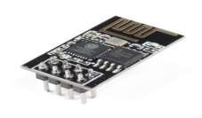

**Fig-3: ESP8266 Wi-Fi module**

## Temperature Humidity Sensor

The DHT11 is a basic, ultra low-cost digital temperature and humidity sensor. It uses a capacitive humidity sensor and a thermostat to measure the surrounding air, and spits out a digital signal on the data pin (no analog input pins needed). It’s fairly simple to use, but requires careful timing to grab data. The only real downside of this sensor is you can only get new data from it once every 2 seconds, so when using our library, sensor readings can be up to 2 seconds old.

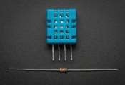

## Fig-4: DHT11 temperature .humidity sensor

* 1. **Ultrasonic sensor**

At its core, the HC-SR04 Ultrasonic distance sensor consists of two ultrasonic transducers. The one acts as a transmitter which converts electrical signal into 40 KHz ultrasonic sound pulses. The receiver listens for the transmitted pulses. If it receives them it produces an output pulse whose width can be used to determine the distance the pulse travelled. As simple as pie. The sensor is small, easy to use in any robotics project and offers excellent non-contact range detection between 2 cm to 400 cm (that’s about an inch to 13 feet) with an accuracy of 3mm. Since it operates on 5 volts, it can be hooked directly to an Arduino or any other 5V logic microcontrollers.

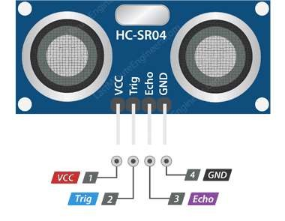

## Fig-5: HC-SR04 Ultrasonic Sensor

* 1. **Water flow sensor**

Water flow sensor consists of a plastic valve from which water can pass. A water rotor along with a hall effect sensor is present the sense and measure the water flow. When water flows through the valve it rotates the rotor. By this, the change can be observed in the speed of the motor. This change is calculated as output as a pulse signal by the Hall Effect sensor. Thus, the rate of flow of water can be measured.

The main working principle behind the working of this sensor is the Hall Effect. According to this principle, in this sensor, a voltage difference is induced in the conductor due to the rotation of the rotor. This induced voltage difference is transverse to the electric current. When the moving fan is rotated due to the flow of water, it rotates the rotor which induces the voltage. This induced voltage is measured by the Hall Effect sensor and displayed on the LCD display. The water flow sensor can be used with hot waters, cold waters, warm waters, clean water, and dirty water also. These sensors are available in different diameters, with different flow rate ranges. These sensors can be easily interfaced with microcontrollers like Arduino.

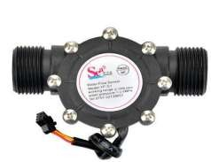

## Fig-6: Water flow sensor

* 1. **Water level senor**

The working of the water level sensor is pretty straightforward. The series of exposed parallel conductors, together acts as a variable resistor **(**just like a potentiometer) whose resistance varies according to the water level. The change in resistance corresponds to the distance from the top of the sensor to the surface of the water. The resistance is inversely proportional to the height of the water. The resistance is inversely proportional to the height of the water. The more water the sensor is immersed in, results in better conductivity and will result in a lower resistance. The less water the sensor is immersed in, results in poor conductivity and will result in a higher resistance. The sensor produces an output voltage according to the resistance, which by measuring we can determine the water level.

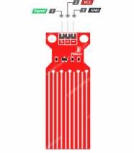

## Fig-7: Water level sensor

* 1. **LCD Display**

A liquid-crystal display (LCD) is a flat-panel display or other electronically modulated optical device that uses the light-modulating properties of liquid crystals combined with [polarizes.](https://en.wikipedia.org/wiki/Polarizer) Liquid crystals do not emit light directly, instead using a backlight or reflector to produce images in color or monochrome. LCDs are available to display arbitrary images (as in a general-purpose computer display) or fixed images with low information content, which can be displayed or hidden, such as preset words, digits, and seven-segment displays, as in a digital clock. They use the same basic technology, except that arbitrary images are made from a matrix of small pixels, while other displays have larger elements. LCDs can either be normally on (positive) or off (negative), depending on the polarizer arrangement.LCDs are used in a wide range of applications, including LCD televisions, computer monitors, instrument panels, aircraft cockpit displays, and indoor and outdoor signage. Small LCD screens are common in portable consumer devices such as digital cameras, watches, calculators, and mobile telephones, including smart phones.

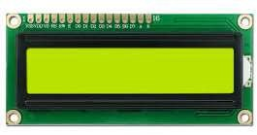

**Fig-8:LCD display**

# SOFTWARE SPECIFICATION

## Internet of things (IOT)

The Internet of things (IOT) is a system of interrelated computing devices, mechanical and digital machines provided with unique identifiers (UIDs) and the ability to transfer data over a network without requiring human-to- human or human-to-computer interaction. The definition of the Internet of things has evolved due to the convergence of multiple technologies, real-time analytics, machine learning, commodity sensors, and embedded systems. Traditional fields of embedded systems, wireless sensor networks, control systems, automation (including home and building automation), and others all contribute to enabling the Internet of things.

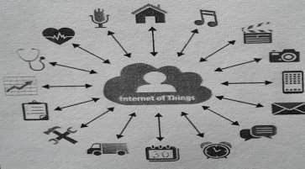

# Thingspeak web server

## Fig -8: Internet of things(IOT)

According to its developers, Thingspeak is an open-source Internet of Things (IOT) application and API to store and retrieve data from things using the HTTP and MQTT protocol over the Internet or via a Local Area Network. Thingspeak enables the creation of sensor logging applications, location tracking applications, and a social network of things with status updates. ThingSpeak has integrated support from the numerical computing software MATLAB from Math Works, allowing ThingSpeak users to analyze and visualize uploaded data using Matlab without requiring the purchase of a Matlab license from Math works.

## Arduino IDE

The Arduino Integrated Development Environment - or Arduino Software (IDE) - contains a text editor for writing code, a message area, a text console, a toolbar with buttons for common functions and a series of menus. It connects to the Arduino and Genuino hardware to upload programs and communicate with them.

# CONCLUSION AND FUTURE SCOPE

This project highlights the possibility to provide an alert system that will overcome the risk of flood. As the project is enabled with IOT technology and hence the sensor data can be monitored from anywhere in the world. More sensors can be integrated into the system in order to create more accurate and efficient flood detection system. It can also contribute to multiple government agencies or authority that ultimately help the society and mankind about the flood like hazardous natural disaster. It will monitor each and every aspect that can lead to flood. If the water level rises along with the speed, it will send an alert immediately. It also ensures increased accessibility in

dealing and reverting to this catastrophic incident. In summary, it will help the community in taking quick decisions and planning against this disaster mankind about the flood like hazardous natural disaster.

The Future scope of the project is , flood can also be related to the intensity of rainfall, which is the height of the water layer covering the ground in a period of time. Hence the development of a rainfall forecasting sensor eventually turn up to the early flood monitoring and detection, Scholarly studies are ongoing and can be implemented to our existing system in future.

# REFERENCE

[1].Early Flood Monitoring System using IoT Applications S Vara Kumari, O Sailaja, N V S Rama Krishna, Ch Thrinisha

[2].Flood Monitoring and Detection System using Wireless Sensor Network, Edward N. Udo1, Etebong B. Isong2

[3].Sms based flood monitoring and early warning system , Sheikh Azid, Bibhya Sharma, Krishna Raghuwaiya,

Abinendra Chand, Sumeet Prasad, A Jacquier

[4].Development of low cost community based real time flood monitoring and early warning system by Abimbola Atijosan, Ayodeji Olalekan Salau, Rahmon Ariyo Badru, Taofeek Alaga

[5].IOT based real time flood monitoring and alert management system by Jagadeesh Babu Mallisetty1 and Chandrasekhar V

[6].Automatic monitoring & Reporting of water quality by using WSN Technology and different routing methods.A.C.Khetre1, Prof.S.G.Hate2

[7][.https://lastminuteengineers.com/water-level-sensor-arduino-tutorial/](https://lastminuteengineers.com/water-level-sensor-arduino-tutorial/) [8].https://store.arduino.cc/usa/arduino-uno-rev3 [9].https://[www.maxbotix.com/articles/how-ultrasonic-sensors-work.htm](http://www.maxbotix.com/articles/how-ultrasonic-sensors-work.htm) [10].https://[www.elprocus.com/a-memoir-on-water-flow-sensor/](http://www.elprocus.com/a-memoir-on-water-flow-sensor/) [11].https://en.wikipedia.org/wiki/Internet_of_things [12].https://[www.adafruit.com/product/386](http://www.adafruit.com/product/386) [13].https://en.wikipedia.org/wiki/ESP8266

[14] https://thingspeak.com/