**Cost-effective Solution for Inventory-Management**

Abstract

The world today is competitive and always tries to maximise its gains and cut down its losses. We as engineers have the responsibility to innovate and provide cost-efficient technology so that no one is left behind in the race towards excellence. This paper focusses on how to create inventory systems that are cost-effective and easily adoptable to many small industries.

Introduction

Inventory management is one of the most crucial tasks in all industries. A slight miscalculation will cause the company to miss deadline which in turn will create a huge loss to the company. Many sophisticated solutions are available in the market for inventory management. But mostly they are too costly to be maintained for small industries. This paper deals with how to improve inventory management using sensors at appropriate places and storing the data in a database for the supervisor to manage and also send email to the prospective sellers when the materials in inventory are running low.

Methodology

The top-down approach

This method works in the case of a dedicated assembly line where we know that the final product coming out of the assembly line is same and will not change in the long run. In this method we attach a cubical structure at the end of the assembly line and place an infra-red proximity sensor in it. Once the final product comes out of the assembly line and passes through our cube, the sensor will detect it. We will have a separate local data-base having the details of the final product and the components used in it will be given by the industry person. So when a particular final product moves out we can send the information to a database in cloud and make changes to the quantity available for each component and the quantity of final products produced. In this way, the local database gets updated and if the number of components in the inventory has reached the re-order point an alert is generated and sent to the supervisor for resupplying. In the same way, the buyer can be alerted that their order is on the way by the supervisor.

Technology used

The products and software which is used in creating this system are the Arduino board, IR sensor, a nodemcu, PHP to create and update databases and the PHP codes are hosted in Heroku and the databases are hosted in Bitcloud. These are the databases hosted in the cloud.

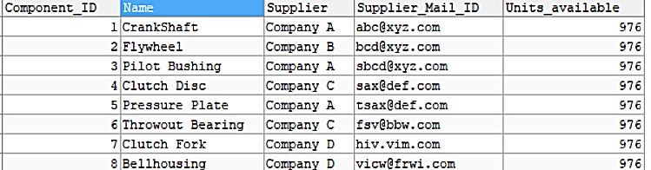

Component_Database



Product_Database

The component database has the number of components available and the product database has the number of units produced. Here in the above databases I have taken the example of clutch-plate assembly. Earlier all the components were 1000 in number but as we can see in the Product_Database 37 products were produced and due to that there has been a reduction of 37 units in each component available in the inventory. Thus we can see that there is only 976 units in each of the components. Note that this is just a small demonstration. In reality there can be various final-products produced from various dedicated assembly lines in the same industry. But there will be only a single IR sensor for each of those assembly lines.

Results

We have successfully created a database containing information about the number of components available and the quantity of finished products produced by the industry which is stored in the cloud and can be accessed from anywhere by anyone with the necessary credentials. We have also successfully automated the process of sending alerts to the sellers to send e-mails to replenish the inventory and inform buyers once their order is ready to be delivered to them.

Conclusion

In conclusion, we have created a cost-effective system with just a couple of sensors and free hosting resources provided. Based on all the papers we have studied, this approach is a new way to solve the problem of costly inventory management techniques. Further scope of improvement includes employing machine learning to predict the re-ordering quantity based on previous data. For example, often festivals can be an incentive to improve production in many industries. We can also bring humans in the loop by sending an alert before sending an e-mail to buy more components so that they can verify the re-order quantity.