**Project: *Measure Energy Consumption***

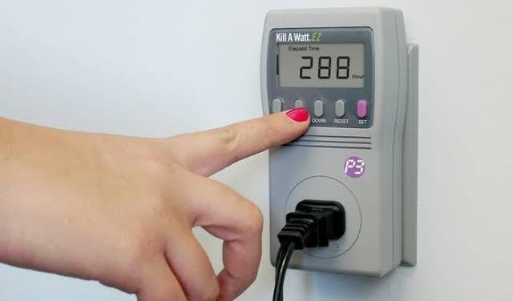

# Introduction:

* Energy consumption in the body is a product of the basal metabolic rate and the physical activity level.
* The physical activity level are defined for a non-pregnant, non- lactating adult as that person's total energy expenditure (TEE) in a 24-hour period, divided by his or her basal metabolic rate (BMR).
* We will focus on analyzing energy consumption data and creating visualizations based on the findings.

# Objective:

* Initiate the development process by selecting a suitable dataset and preparing it for analysis.
* In PHASE 1 we discussed about the problem definition and their application used in artificial intelligence.
* In phase 2 we discussed about the explore innovative technologies used in artificial intelligence.
* In phase 3 we discussed the development process for energy consumption >

***PHASE 4*:**

* To continue the development by analyzing the energy consumption data and creating visualization
* In this part you will continue building your project.
* Continue the development by:
  1. Analyzing the energy consumption data
  2. Creating visualizations.

**Dataset Link:**[**https://www.kaggle.com/datasets/robikscube/hourly-**](https://www.kaggle.com/datasets/robikscube/hourly-energy-consumption)[**energy-consumption**](https://www.kaggle.com/datasets/robikscube/hourly-energy-consumption)

# Analyzing Energy Consumption Data

you'll need to follow these steps such as,

# Data Cleaning and Preparation:

* + Load the energy consumption data into a suitable data structure (e.g., Data Frame if using Python).
  + Check for missing values, outliers, and any anomalies in the data.
  + Handle any data quality issues by imputing missing values or removing outliers.

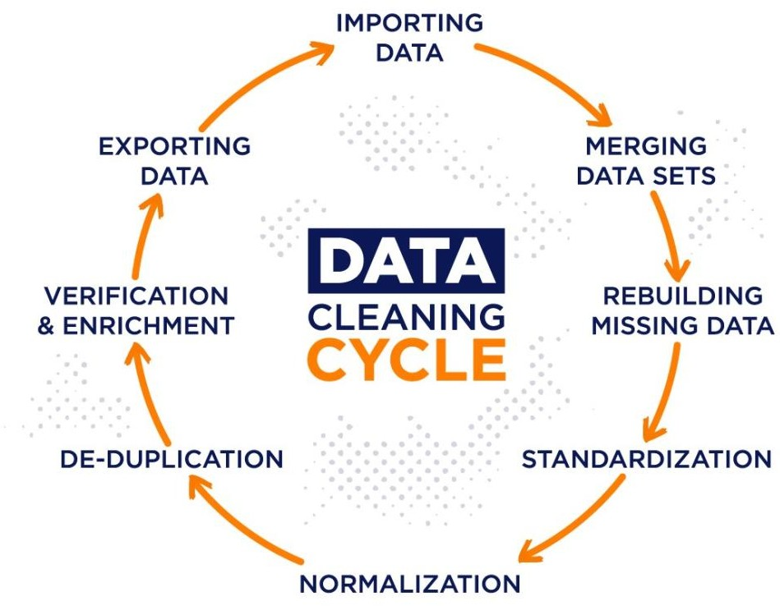

Fig.1.1 data cleaning cycle

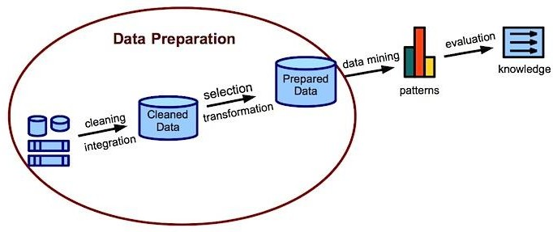

Fig.1.2 Data preparation

# Exploratory Data Analysis (EDA):

* + Calculate basic statistics (mean, median, standard deviation, etc.) to understand the central tendency and variability of energy consumption.
  + Visualize the distribution of energy consumption using histograms, box plots, or violin plots.
  + Identify any trends or patterns in the data over time.

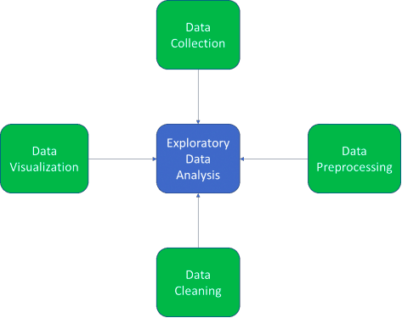

Fig.1.3 Exploratory data analysis

# Time Series Analysis :

* + If the data is time-stamped, perform time series analysis to uncover seasonality, trends, and cyclic patterns.
  + Apply techniques like decomposition, autocorrelation, and rolling statistics to gain insights.

**Components :**

1. Trend
2. Cyclical variation
3. Random or Irregular movements
4. Seasonal variations

**Types:**

1. **Classification:** It picks out and assigns categories or segments to the data**.**
2. **Descriptive Analysis:** It involves identifying the patterns in the time series data.
3. **Curve Fitting:** It plots the data on a curve for investigating the relationships among variables within the data.
4. **Segmentation:** It splits the data into different categories to disclose the source data’s underlying properties.

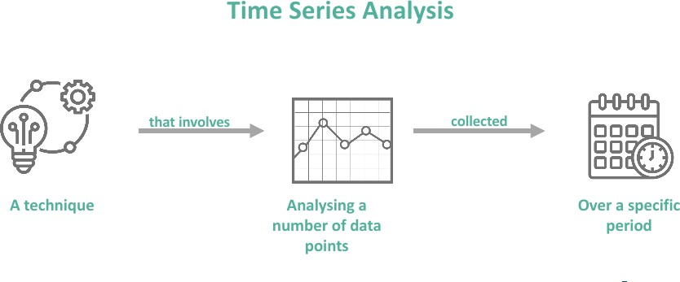

Fig.1.4 Time series analysis

# Creating Visualizations

1. **Energy Consumption Trends Over Time:**
   * Generate a line chart to visualize how energy consumption has evolved over the specified time period.
   * Add annotations or markers to highlight significant events or changes.

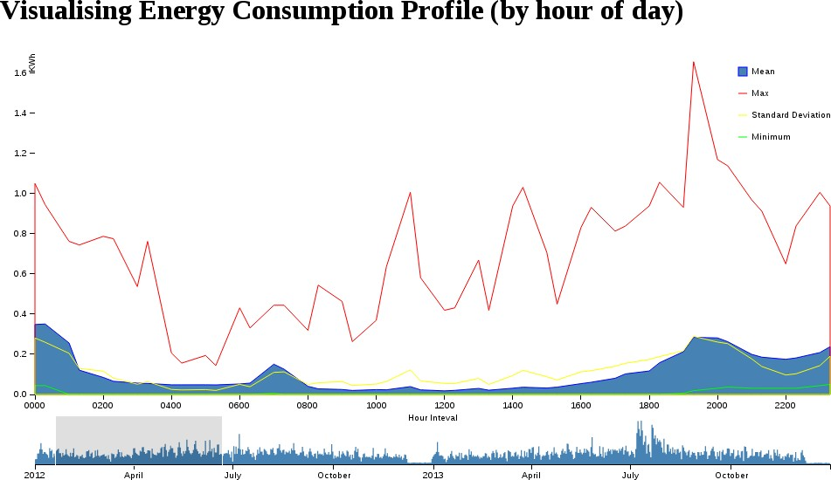

# Comparative Analysis:

* + Create bar charts or stacked area charts to compare energy consumption across different categories, regions, or units (if applicable).

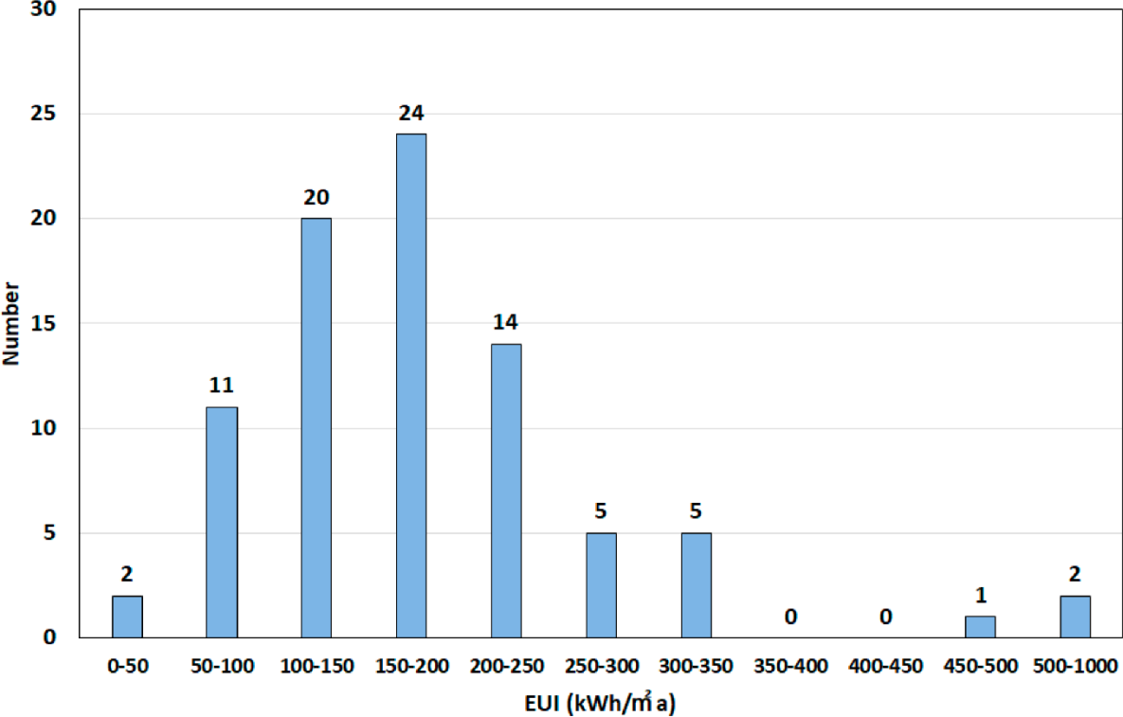

# Correlation Analysis:

* + Generate scatter plots or heatmaps to visualize the relationships between energy consumption and other relevant variables (e.g., temperature, occupancy, etc.).

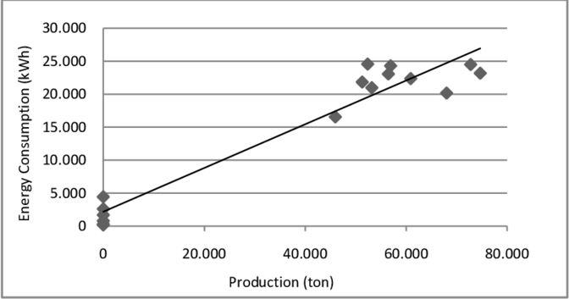

# Forecasting :

* + If forecasting is a goal, create visualizations that display actual vs. predicted energy consumption.

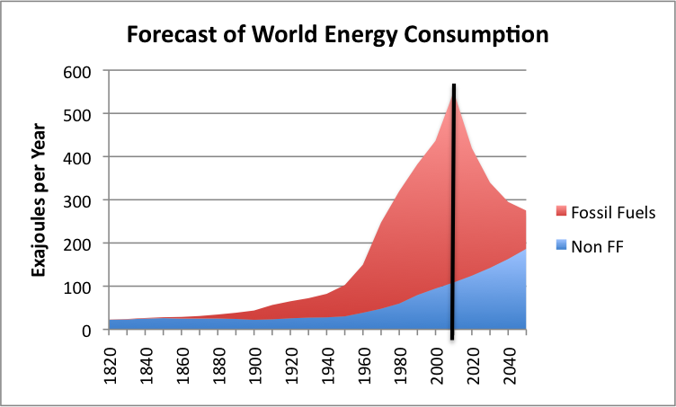

# Geospatial Visualization :

* + If the data contains location information, create maps to visualize energy consumption distribution across different regions.

Remember to label your visualizations appropriately, provide legends or color keys, and add titles and captions to convey the insights effectively.

# Documentation and Reporting

Lastly, document your analysis and visualization process. This should include:

* A summary of the key findings and insights.
* Any assumptions or data preprocessing steps taken.
* Interpretation of the visualizations and what they reveal about energy consumption patterns.
* Recommendations or actions based on the insights gained.

By following these steps, you'll be able to effectively analyze the energy consumption data and create meaningful visualizations to communicate your findings.

**Source code:**

**Int[1]:**

**Import numpy as np Import pandas as pd**

**Import matplotlib.pyplot as plt Import matplotlib.dates as mdates**

**%matplotlib inline Import seaborn as sns Import warnings**

**Warnings.filterwarnings(“ignore”)**

**From pandas.plotting import lag_plot From pylab import rcParams**

**From statsmodels.tsa.seasonal import seasonal_decompose**

**From pandas import DataFrame From pandas import concat**

**Int[2]:**

**Df=pd.read_csv(“../input/hourly-energy- consumption/AEP_hourly.csv”,index_col=’Datetime ’,parse_dates=True)**

**Df.head()**

**Out[2]:**

|  |  |
| --- | --- |
|  | **AEP_MW** |
| **Datetime** |  |
| **2004-12-31 01:00:00** | **13478.0** |
| **2004-12-31 02:00:00** | **12865.0** |
| **2004-12-31 03:00:00** | **12577.0** |
| **2004-12-31 04:00:00** | **12517.0** |
| **2004-12-31 05:00:00** | **12670.0** |

**Int[3]:**

**df.sort_values(by='Datetime', inplace=True) print(df)**

**Int[4]:**

**df.shape Out[4]:**

**(121273, 1)**

**Int[5]:**

**df.info()**

**Out[5]:**

**<class 'pandas.core.frame.DataFrame'> DatetimeIndex: 121273 entries, 2004-10-01 01:00:00**

**to 2018-08-03 00:00:00**

**Data columns (total 1 columns):**

**# Column Non-Null Count Dtype**

**---**

**------**

**--------------**

**-----**

**0 AEP_MW 121273 non-null float64 dtypes: float64(1)**

**memory usage: 1.9 MB**

**Int[6]:**

**df.describe() Out[6]:**

|  |  |
| --- | --- |
|  | **AEP_MW** |
| **count** | **121273.000000** |
| **mean** | **15499.513717** |
| **std** | **2591.399065** |
| **min** | **9581.000000** |
| **25%** | **13630.000000** |
| **50%** | **15310.000000** |
| **75%** | **17200.000000** |
| **100%** | **25695.000000** |

**Int[7]:**

**df.index = pd.to_datetime(df.index)**

**Int[8]:**

**# Extract all Data Like Year MOnth Day Time etc df["Month"] = df.index.month**

**df["Year"] = df.index.year df["Date"] = df.index.date df["Hour"] = df.index.hour df["Week"] = df.index.week df["Day"] = df.index.day_name() df.head()**

**Out[8]:**

|  |  |  |  |  |  |  |  |
| --- | --- | --- | --- | --- | --- | --- | --- |
|  | **AEP**  **_M W** | **Mon th** | **Year** | **Date** | **Hour** | **Wee k** | **Day** |
| **Date time** |  |  |  |  |  |  |  |
| **2004** | **1237** | **10** | **2004** | **2004** | **1** | **4** | **Frid** |
| **-10-** | **9.0** |  |  | **-10-** |  |  | **ay** |
| **01** |  |  |  | **01 1** |  |  |  |
| **01:0** |  |  |  |  |  |  |  |
| **0:00** |  |  |  |  |  |  |  |
| **2004** | **1193** | **10** | **2004** | **2004** | **2** | **4** | **Frid** |
| **-10-** | **5.0** |  |  | **-10-** |  |  | **ay** |
| **01** |  |  |  | **01 1** |  |  |  |
| **02:0** |  |  |  |  |  |  |  |

|  |  |  |  |  |  |  |  |
| --- | --- | --- | --- | --- | --- | --- | --- |
| **0:00** |  |  |  |  |  |  |  |
| **2004** | **1169** | **10** | **2004** | **2004** | **3** | **4** | **Frid** |
| **-10-** | **2.0** |  |  | **-10-** |  |  | **ay** |
| **01** |  |  |  | **01 1** |  |  |  |
| **03:0** |  |  |  |  |  |  |  |
| **0:00** |  |  |  |  |  |  |  |
| **2004** | **1159** | **10** | **2004** | **2004** | **4** | **4** | **Frid** |
| **-10-** | **7.0** |  |  | **-10-** |  |  | **ay** |
| **01** |  |  |  | **01 1** |  |  |  |
| **04:0** |  |  |  |  |  |  |  |
| **0:00** |  |  |  |  |  |  |  |
| **2004** | **05:0** | **10** | **2004** | **2004** | **5** | **4** | **Frid** |
| **-10-** | **0:00** |  |  | **-10-** |  |  | **ay** |
| **01** |  |  |  | **01 1** |  |  |  |
| **05:0** |  |  |  |  |  |  |  |
| **0:00** |  |  |  |  |  |  |  |

**Int[9]:**

**df.plot(title="PJME Energy use in MegaWatts", figsize=(20, 8),**

**style=".", color=sns.color_palette()[0])**

**plt.show()**

**Out[9]:**

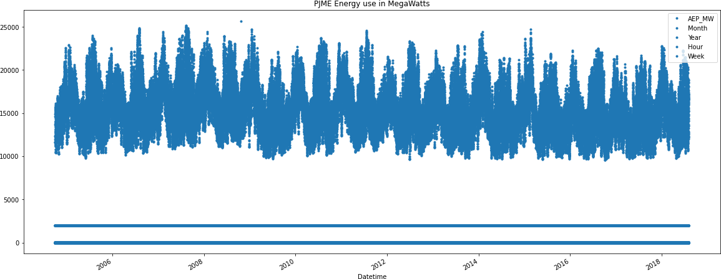

**Int[10]:**

**from pandas.plotting import autocorrelation_plot autocorrelation_plot(df['AEP_MW'])**

**plt.show() Out[10]:**

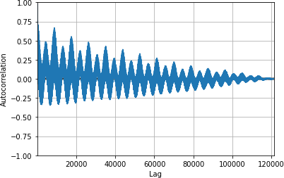

**Int[11]:**

**#Train Arima Model**

**train_arima = train_data['AEP_MW'] test_arima = test_data['AEP_MW']**

**history = [x for x in train_arima] y = test_arima**

**# make first prediction predictions = list()**

**model = sm.tsa.arima.ARIMA(history, order=(5,1,0))**

**model_fit = model.fit()**

**yhat = model_fit.forecast()[0] predictions.append(yhat) history.append(y[0])**

**# rolling forecasts**

**for i in range(1, len(y)): # predict**

**model = sm.tsa.arima.ARIMA(history, order=(5,1,0))**

**model_fit = model.fit()**

**yhat = model_fit.forecast()[0]**

**# invert transformed prediction predictions.append(yhat)**

**# observation obs = y[i]**

**history.append(obs)**

**plt.figure(figsize=(14,8))**

**plt.plot(df.index, df['AEP_MW'], color='green', label = 'Train Energy AEP_MW')**

**plt.plot(test_data.index, y, color = 'red', label = 'Real Energy AEP_MW')**

**plt.plot(test_data.index, predictions, color = 'blue', label = 'Predicted Energy AEP_MW')**

**plt.legend() plt.grid(True) plt.show()**

**plt.figure(figsize=(14,8))**

**plt.plot(df.index[-600:], df['AEP_MW'].tail(600), color='green', label = 'Train Energy AEP_MW')**

**plt.plot(test_data.index, y, color = 'red', label = 'Real Energy AEP_MW')**

**plt.plot(test_data.index, predictions, color = 'blue', label = 'Predicted Energy AEP_MW')**

**plt.legend() plt.grid(True) plt.show()**

**print('MSE: '+str(mean_squared_error(y, predictions)))**

**print('MAE: '+str(mean_absolute_error(y, predictions)))**

**print('RMSE: '+str(sqrt(mean_squared_error(y, predictions))))**

**Out[11]:**

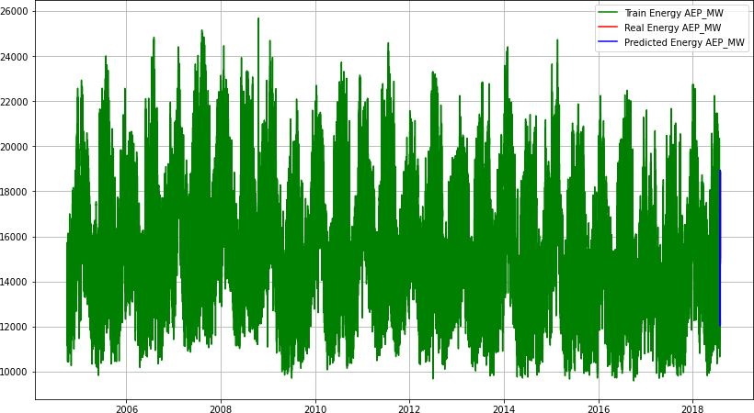

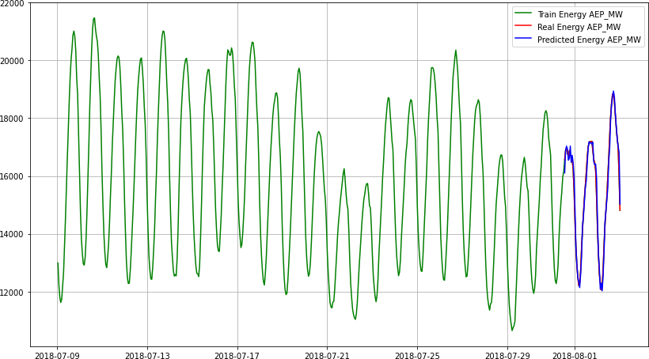

# Conclusion:

* Remember to iterate through these steps as necessary, and always validate your findings with domain experts if possible.
* Regularly updating the model with new data is crucial to ensure it remains accurate as consumption patterns evolve.