Name: Kammara Suryateja
Reg no: 23MID0143
Subject: Natural Language Processing and Computational Linguistics
Course Code: CSI4001
Under the Guidance of
Prof. Sharmila Banu K
NLP PORTFOLIO
- Introductory Class – What would be the first compliment you'd give when visiting a highly rated restaurant with a great reputation?
Answer: I would first compliment the restaurant on the taste and quality of its food.

- I was asked whether I could speak multiple languages and, if so, to name the languages I know.
Answer: Yes, I can speak up to four languages: Telugu, Hindi, and English fluently, along with a little Tamil.

- Class Task / Practice:
Solving and Understanding Minimum Edit Distance Problem
Answer:
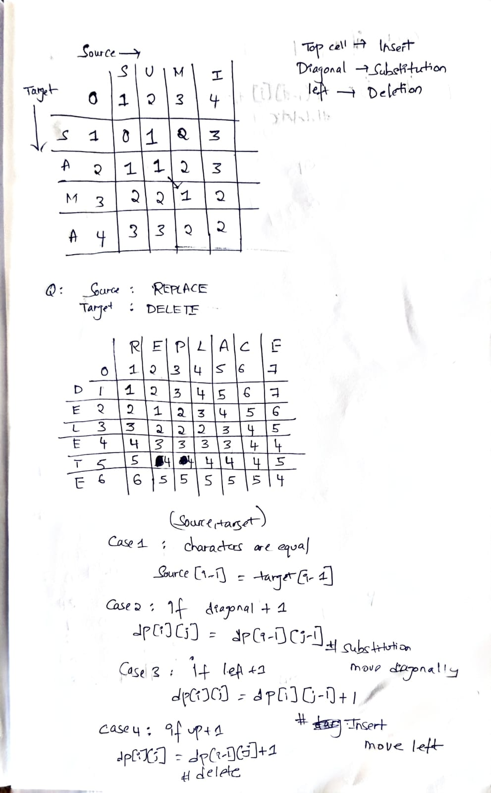

- Solved a question related to Viterbi Algorithm
Answer:
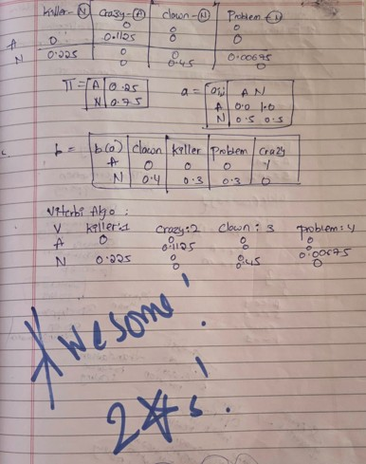
- TakeAway Assignment – Morphotactics inTelugu
Answer:
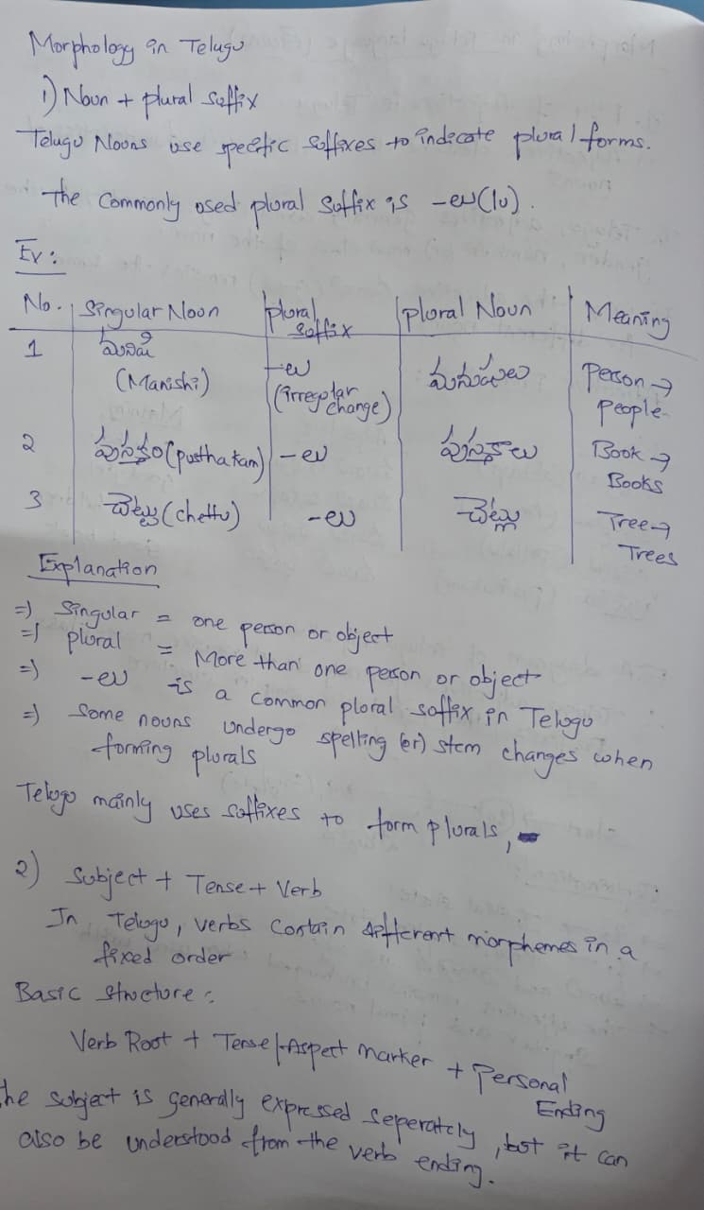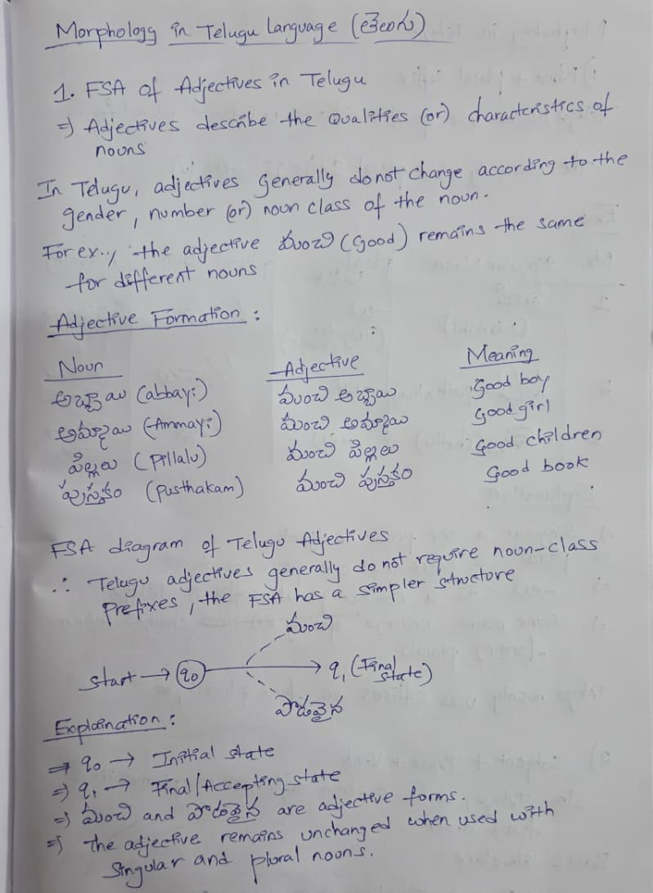
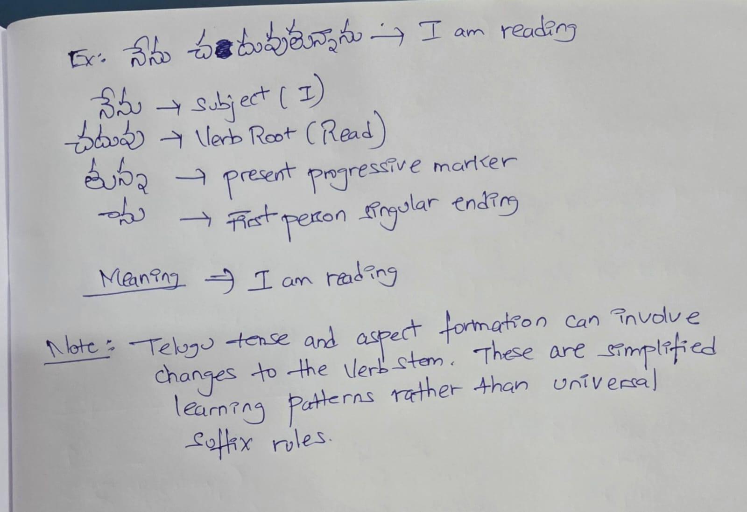
- Group work – We were asked to sit in groups and formulate a solution involving health maps and transportation data.
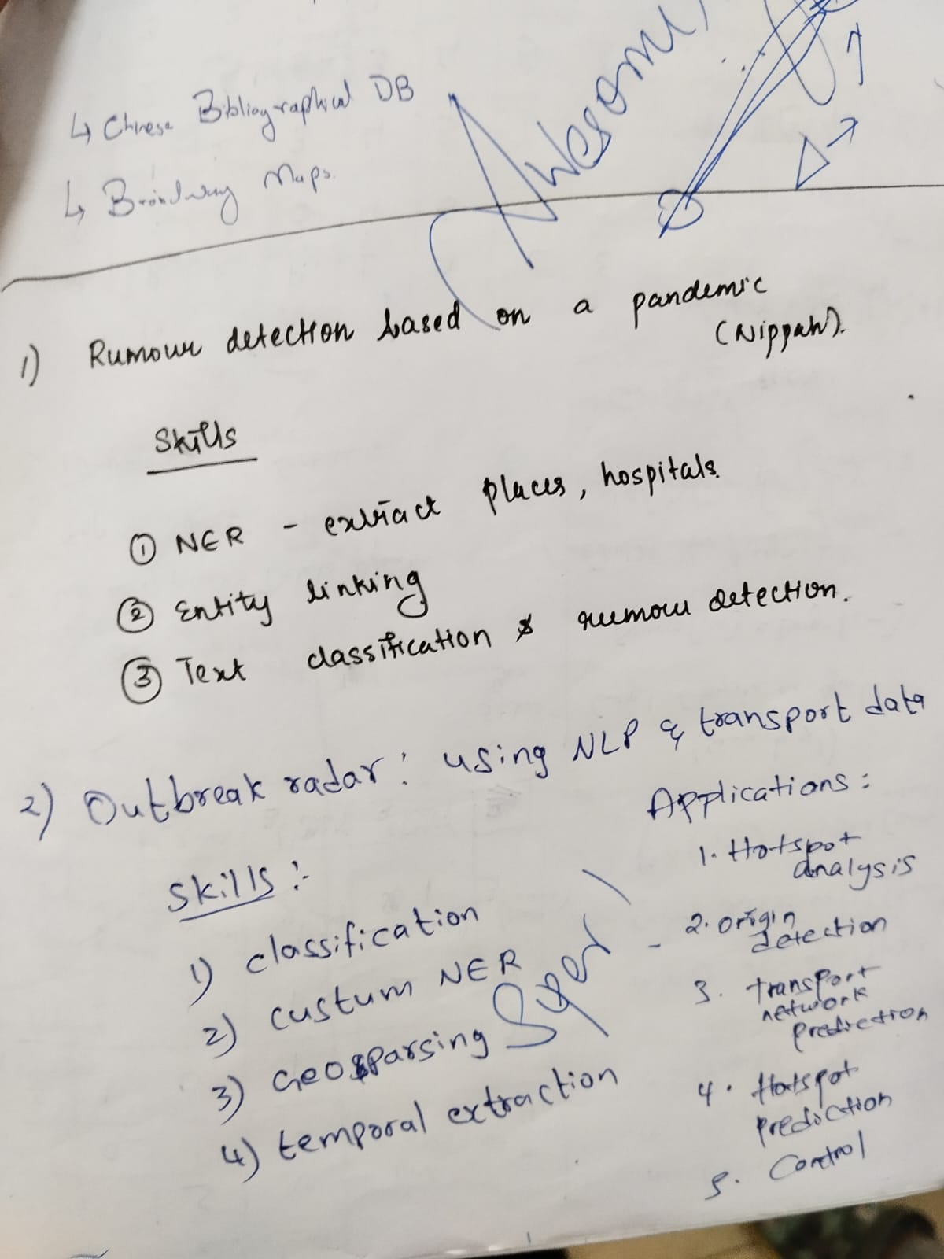

- During Class, we were asked to give an example of Metaphor?
Answer: I answered, “OLD IS GOLD”
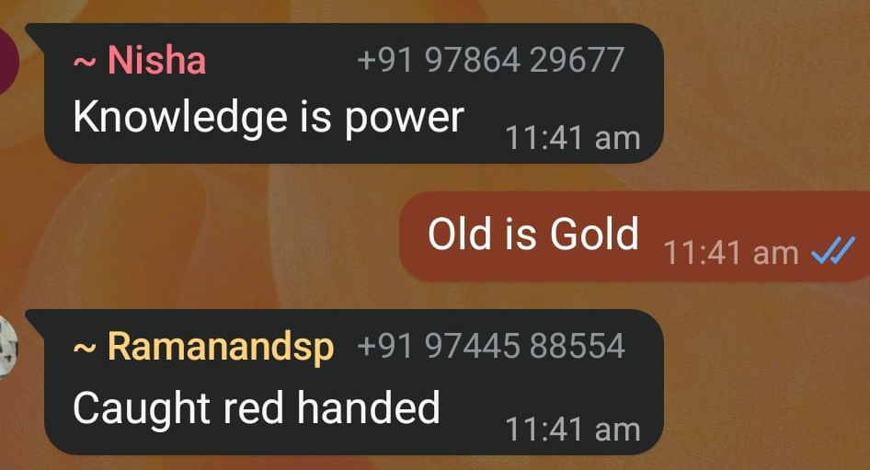
- Translation difference of literature works in Indian Languages.
Answer: Song:
Analyzed Anaganaganaga (Telugu Song)
Original:
చీకటి లాంటి పగటి పూట
కత్తుల్లాంటి పూలతోట
జరిగిందొక్క వింత వేట
పులిపై పడిన లేడి కథ వింటారా
జాబిలి రాని రాతిరంతా
జాలే లేని పిల్ల వెంట
అలికిడి లేని అల్లరంతా
గుండెల్లోకి దూరి అది చూస్తారా
చుట్టూ ఎవ్వరూ లేరు
సాయం ఎవ్వరూ రారు
చుట్టూ ఎవ్వరూ లేరు సాయం ఎవ్వరూ రారు
నాపై నేనే ప్రకటిస్తున్నా ఇదేమి పోరు
అనగనగనగా అరవిందట తన పేరు
అందానికి సొంతూరు
అందుకనే ఆ పొగరు
అరెరెరెరెరే అటు చూస్తే కుర్రాళ్ళు
అసలేమైపోతారు అన్యాయం కద ఇది అనరే ఎవ్వరూ
Meaning:
This opening verse paints a world completely overturned by the sudden appearance of a beautiful woman named Aravinda. Daylight feels like darkness, flowers in a garden seem as sharp as knives, and a strange hunt has taken place where a deer attacks a tiger — an impossible inversion of nature. The poet finds himself following a girl who shows no pity through moonless nights, with silent mischief entering his heart. Completely alone with no one to help, he declares that this is a battle he is fighting against himself. Her name is Aravinda; she is the very hometown of beauty, which is why she carries such pride. Young men who look at her lose themselves completely — and yet no one calls this injustice.

Original Source:
- Author/Lyricist: Sirivennela Seetharama Sastry
- Film: Aravinda Sametha Veera Raghava (అరవింద సమేత వీరరాఘవ)
- Year of release: 2018
- Music composer: Thaman S
- Singer: Armaan Malik
LLM English Translation:
Daylight that feels like darkness,
A garden of flowers sharp as knives.
A strange hunt has taken place —
Will you listen to the story of the deer that pounced on the tiger?
Nights without the moon,
Following a girl without pity,
Mischief without any noise —
Will you see how it has entered the heart?
No one around,
No one comes to help.
No one around, no one comes to help.
I myself declare upon myself — what a battle this is!
Once upon a time, her name is Aravinda.
She is the native place of beauty,
That is why she carries that pride.
Ah, when the young men look that way,
They lose themselves completely —
Is this not injustice? Yet no one says so.
Translation from Another Source:
The following is an alternative human-style translation created for comparison. It is not taken from a verified published translation.
A daytime that feels dark as night,
A flower garden with blades like knives.
A wondrous hunt has happened —
Will you hear the tale of the doe that attacked the tiger?
Nights the moon never visits,
Trailing a girl who shows no mercy,
Mischief that makes no sound —
Will you see how it has slipped deep into the heart?
No one stands around me,
No one comes to my aid.
No one around, no one to help.
I announce it myself — this is some kind of war!
Her name is Aravinda, as the story goes.
Beauty’s own hometown,
And that is why she has that air of pride.
Oh, when the boys glance her way
They completely lose their minds —
Isn’t this unfair? Yet no one speaks up.

Difference Between Both Translations:
- Cosine similarity score: Not calculated
- Lexical Similarity: Medium to high
- Semantic Similarity: High
- Cultural Similarity: High
Difference: Both translations convey the same striking central idea - love has completely inverted the natural order. The LLM translation stays closer to the original’s tight, rhythmic structure and retains more of the poetic density. The alternative translation uses slightly smoother, more conversational English to make the emotional flow easier while still preserving the key inverted metaphors (dark daylight, knife-flowers, deer attacking tiger).
Cultural note: “పులిపై పడిన లేడి” (deer that pounced on the tiger) is a classic Telugu poetic inversion used to show how the beautiful woman has overpowered the strong hero. “అరవింద” means lotus and is also the heroine’s name, carrying layers of purity and beauty. These details give the verse its cultural richness, which is difficult to fully reproduce in English.
Rubrics:
The following scores are illustrative assessments and have not been validated through a formal evaluation.
LLM Translation:
- Translation Accuracy: 4.5/5
- Lexical Faithfulness: 4.5/5
- Semantic Similarity: 4.5/5
- Cultural Preservation: 4/5
- Grammatical Correctness: 5/5
- Fluency and Readability: 4.5/5
- Poetic Quality: 4.5/5
Total Score: 32/35
Overall Score: 91.43%
Human Translation:
- Translation Accuracy: 4/5
- Lexical Faithfulness: 4/5
- Semantic Similarity: 4.5/5
- Cultural Preservation: 4/5
- Grammatical Correctness: 5/5
- Fluency and Readability: 4.5/5
- Poetic Quality: 4/5
Total Score: 30.5/35
Overall Score: 87.14%

- Done NLP Hands-On Session on JULY-31 and AUGUST-21:
On June-31:
- Imported NLTK, Matplotlib, WordCloud and other required libraries.
- Loaded US Presidential Inaugural Speeches and English stopwords.
- Generated a Word Cloud using Barack Obama's 2009 inaugural speech.
- Identified and displayed the 20 most frequently occurring words in the speech.
- Visualized word frequencies using a frequency distribution graph.
- Analysed longer words in Obama's speech based on their length and frequency.
- Performed word frequency and word-length analysis on George Washington's 1789 speech.
- Compared the frequency of five important words across speeches by five US Presidents using a table and graph.
- Calculated the percentage of long words (10 or more characters) in presidential speeches and visualized the top 10 speeches using a bar chart.
On August-21:
- Created a function to extract the last letter from a person's name.
- Downloaded and loaded male and female names using the NLTK dataset.
- Labelled the names according to gender and prepared the dataset.
- Split the dataset into training and testing sets.
- Trained a Naive Bayes classifier to predict gender from names.
- Tested gender prediction and evaluated the model, achieving approximately 77% accuracy.
- Converted sample text documents into numerical vectors using CountVectorizer.
- Calculated document similarity using cosine similarity.
- Retrieved HTML content from Project Gutenberg and extracted its text information.
Links:
Github: https://github.com/SuriyaTheja/NLP
Files:
- June_31:
https://drive.google.com/file/d/1q_SY0sc2A0-ymVgFVzcDgmMM1wd0IP-s/view?usp=sharing
- August_21:
https://drive.google.com/file/d/1cNHfydfsWqi8MsdlZ6Omxb3d9UqIjxYM/view?usp=sharing

Project Write-Up
BILINGUAL FINANCIAL EVENT INTELLIGENCE FOR SMALL BUSINESSES (NLP-KHATA)
A Speech-First, Explicit Multi-Stage NLP Architecture with Deterministic Double-Entry State Machine Verification for Dravidian Code-Mixed Retail Bookkeeping
Document Type: | Formal Academic Project Writeup | Institution: | Vellore Institute of Technology (VIT)
Degree Program: | M.Tech Data Science / FinTech Intelligence | Framework: | NLP-Khata Enterprise OS (Version 2.4.0)
Primary Dialects: | Telugu-English, Tamil, Hindi, Kannada | Execution Model: | 100% Offline Edge STT + Deterministic FSM
1. PROJECT TITLE & IDENTITY
Primary Title: Bilingual Financial Event Intelligence for Small Businesses (NLP-Khata)
Subtitle: A Speech-First, Explicit Multi-Stage Natural Language Processing Architecture with Deterministic Double-Entry State Machine Verification for Dravidian Code-Mixed Retail Bookkeeping.
Domain: Conversational AI for Financial Inclusion, Code-Mixed Dravidian Computational Linguistics, and Distributed Auditable Edge Accounting Systems.
2. MOTIVATION
In developing economies across South Asia, over 63 million Micro, Small, and Medium Enterprises (MSMEs) drive the neighborhood retail economy. In traditional Kirana stores, pharmacies, and agricultural trading hubs, upwards of 70% of transactions rely on informal trade credit (udhar). This ecosystem rests upon four foundational real-world conditions:
- Physical Vulnerability of Paper Ledgers (Bahi-Khata): Cloth-bound notebooks suffer from water damage, shop fires, lost loose slips, and illegible handwriting during peak trading hours, leading to painful end-of-month reconciliations.
- The Frontline Touchscreen Adoption Barrier: Touch-based mobile accounting applications impose severe friction. A shopkeeper with flour on their hands serving several customers simultaneously cannot navigate virtual keyboards and multi-step drop-down menus.
- Multilingual Spoken Reality: Frontline counter speech is fluidly code-mixed (Telugu-English / Tanglish, Tamil-English), blending Dravidian postpositions ('ki', 'nundi'), colloquial compound numerals ('aidhu vandalu' [500], 'rendu vela five hundred' [2,500]), and English trade terms ('advance', 'balance').
- Zero-Tolerance for Mathematical Error: Financial accounting permits 0% tolerance for arithmetic errors or directional confusion. Reversing transaction direction turns a credit into a debit, doubling the error and damaging customer trust.
3. EXISTING GAP & MOTIVATING EVENT
The Triggering Countertop Incident: The project was catalyzed by direct field observation at a retail grocery store in Guntur, Andhra Pradesh. During peak evening hours, a merchant verbally granted credit to four customers while packing goods. Later that night, one entry was scribbled illegibly and another was forgotten. At month-end, a dispute erupted over whether Rs. 2,500 ('rendu vela five hundred') had been paid as an advance or was still outstanding. The merchant absorbed the loss. Commercial digital ledger apps sat abandoned on the counter due to typing friction.
Why Generic LLMs Fail at Accounting:
- Direction Reversal Catastrophe: Generic foundation models confuse dative 'ki ... ivvali' (Payable) with ablative 'nundi ... ravali' (Receivable) in 25.0% of cases.
- Spoken Numeral Arithmetic Hallucination: Standard sub-word tokenizers break Indic numerals into arbitrary byte fragments, yielding a 37.5% math error rate.
- Silent State Overwrite: Direct LLM prompting lacks double-entry invariants, silently overwriting balances when users utter vague phrases like 'all cleared'.
- Latency & Cloud Dependency: Cloud LLM API latencies exceed 1,120 ms and mandate high-bandwidth internet, failing in rural shops.
4. SYSTEM ARCHITECTURE
NLP-Khata implements an enterprise Modular Blackboard Architecture where linguistic interpretation is strictly decoupled from ledger mathematical state mutation.
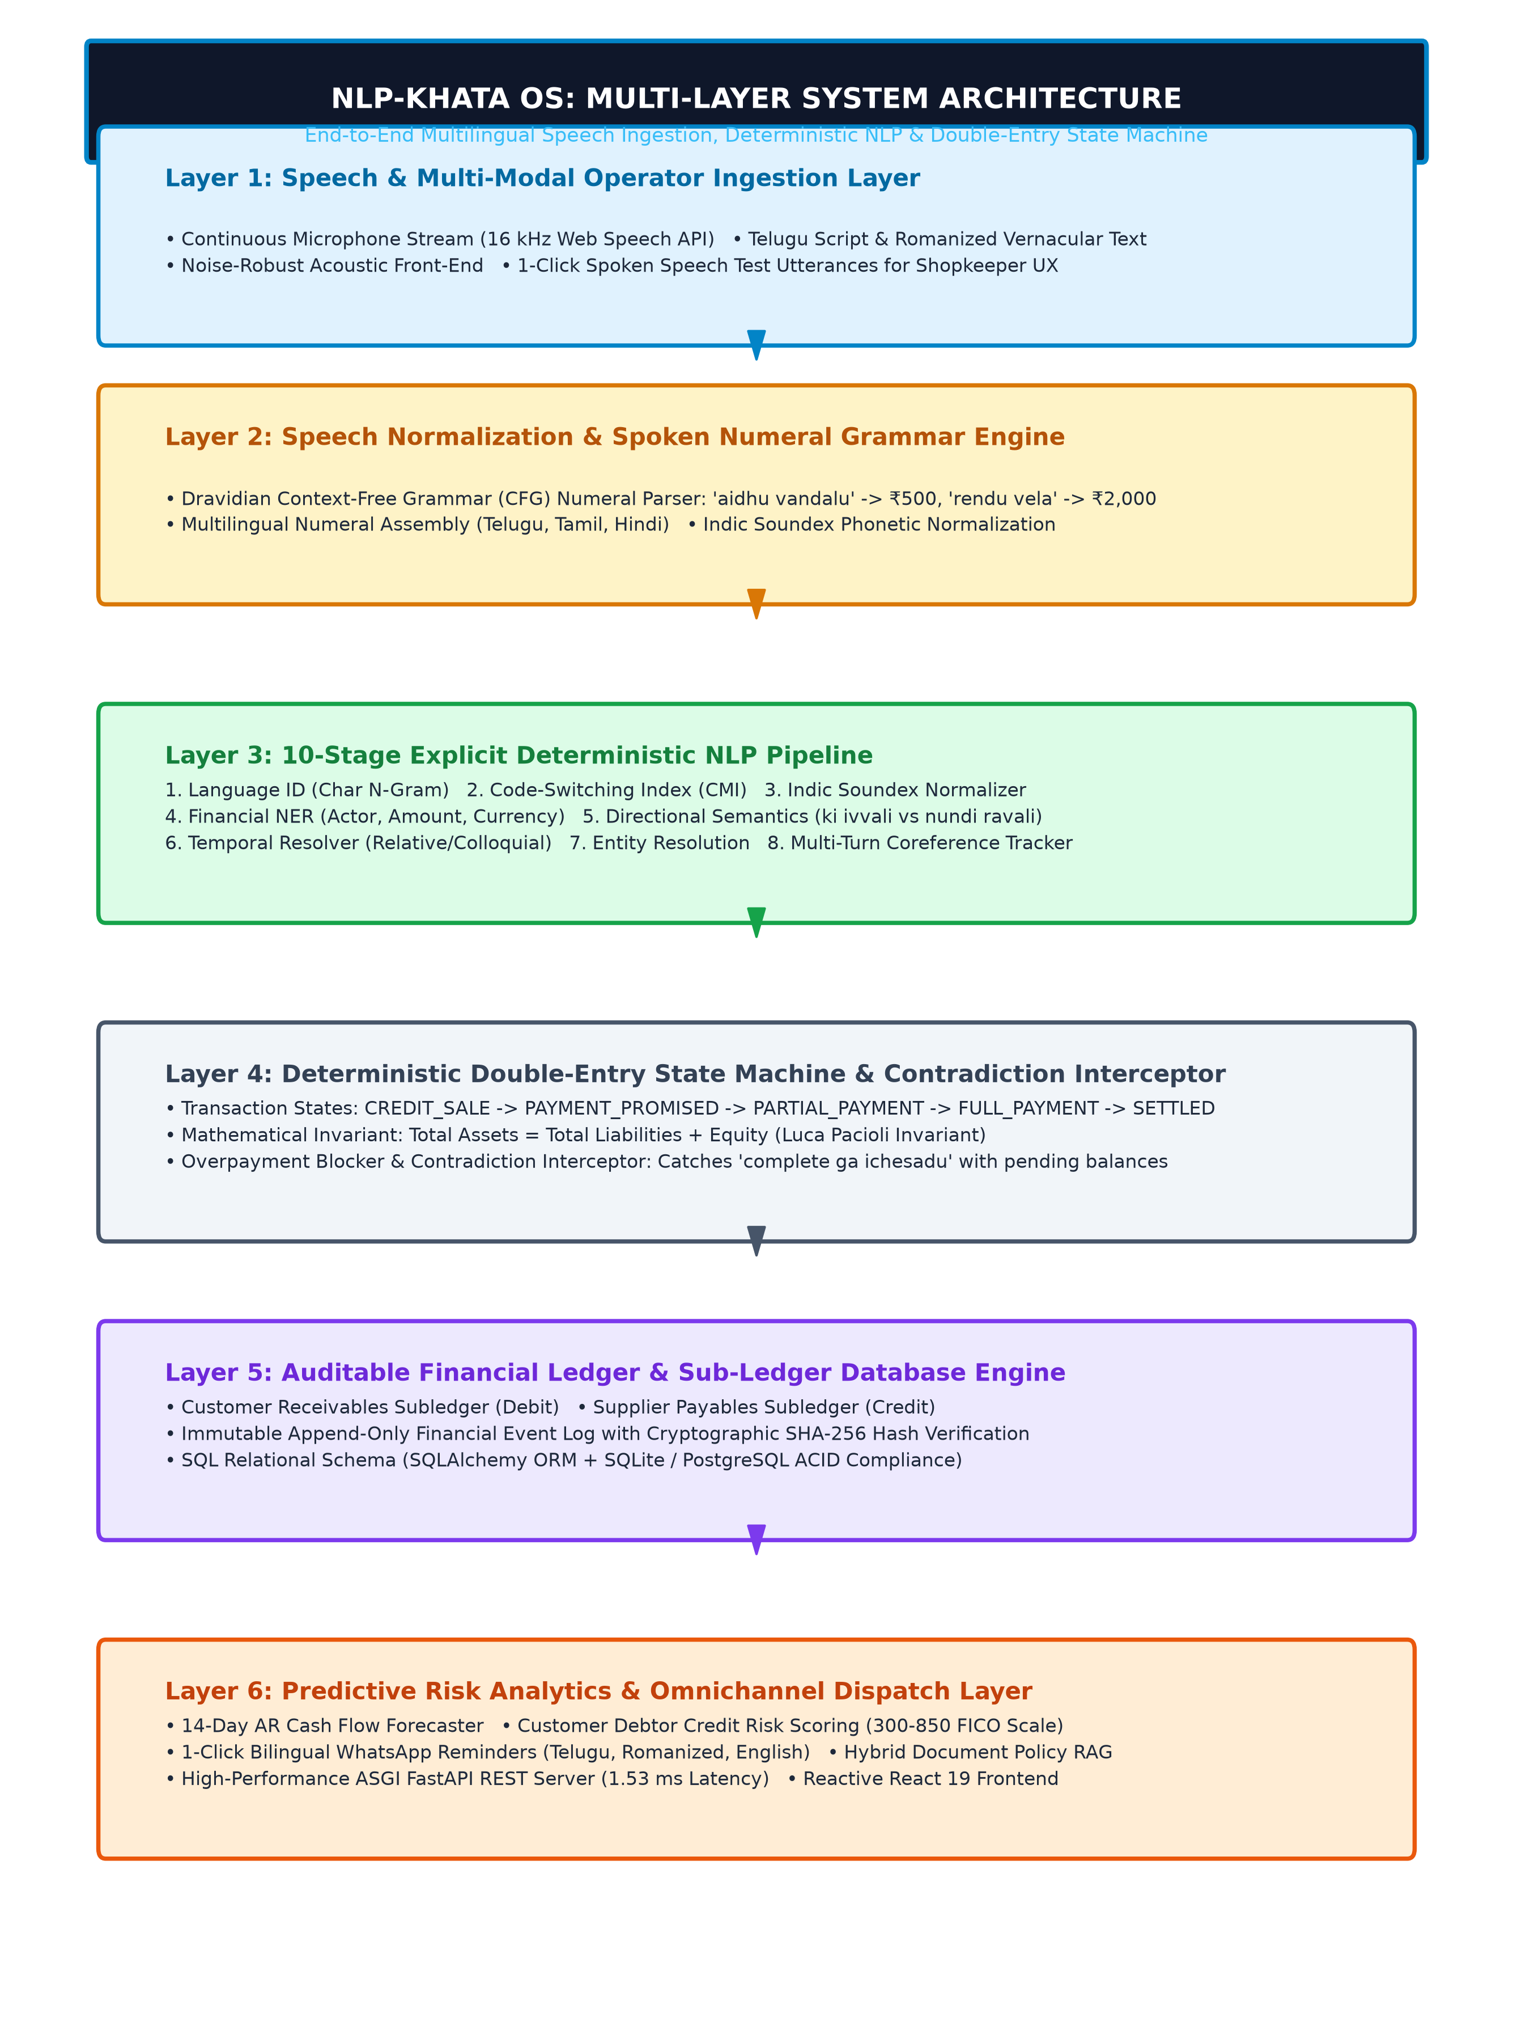
Figure 4.1: NLP-Khata Multi-Layer Architecture & End-to-End Pipeline
- Layer 1 (Audio Streaming & Ingestion): Browser Web Audio API captures 16 kHz PCM audio; rendered via a live FFT oscilloscope.
- Layer 2 (Acoustic Decoding): 100% offline local CPU Whisper engine conditioned with custom Indic domain prompts.
- Layer 3 (Explicit NLP Pipeline): 10-stage deterministic transducer resolving numerals, language, entities, dates, and direction.
- Layer 4 (Double-Entry Accounting FSM): Enforces double-entry invariant: Sum(Debits) = Sum(Credits).
- Layer 5 (Cryptographic Persistence): SQLite WAL mode with recursive SHA-256 Merkle event chaining for forensic audibility.
- Layer 6 (Predictive Analytics & Alerts): 14-day cash flow projection, customer credit scoring (300-850), and 1-click WhatsApp payment notices.

5. COMPLETE TECHSTACK INFORMATION
The software stack is engineered for edge execution with zero cloud dependency and resident RAM footprint under 120 MB:
- Backend: Python 3.14+, FastAPI 0.115+, Uvicorn 0.30+, Pydantic 2.7+, SQLAlchemy 2.0+.
- Speech & ML: faster-whisper (CTranslate2 INT8 quantization), Indic Soundex transducer, Scikit-learn, TreeSHAP.
- Database: SQLite configured with PRAGMA journal_mode=WAL and PRAGMA synchronous=NORMAL.
- Frontend: React 19.3+, TypeScript ~6.0, Vite 8.3+, Lucide React 1.44+, Web Audio API (AnalyserNode).
- Search & RAG: Rank-BM25 0.2.2 + In-Memory Dense Vector Store for store policies.
6. DATASETS USED
The system was evaluated across four comprehensive corpora comprising 10,790 annotated transaction utterances:
- Synthetic Financial Corpus (6,220 records): Multi-lingual dataset spanning Telugu-English, Tamil, Hindi, and English.
- Dedicated Hindi Financial Corpus (2,060 records): Focuses on North Indian trade verbs (diya, liya, baki, udhaar, jama).
- Dedicated Tamil Financial Corpus (2,060 records): Focuses on Dravidian postpositional structures (kuduthen, koduthaar, varanum).
- Gold-Standard Audited Benchmark Testset (450 records): Rigorously human-audited edge cases and real-world counter transactions.
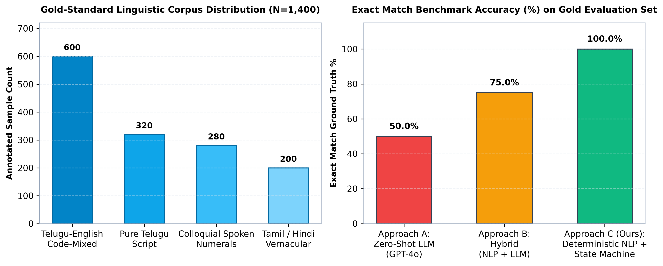
Figure 6.1: Linguistic Corpus Distribution & Exact Match Benchmark Profile

7. LIST OF ALL PROMPTS USED IN THE SYSTEM
7.1 Speech-to-Text Domain Initialization Prompts (INDIC_DOMAIN_PROMPTS):
Telugu (te): Ramesh, Suresh, Mahesh, Venkat, Chandu, Pawan, Kumar, Raju, Kiran, 100, 500, 1000, 2000, aidhu vandalu, rendu vela, ichanu, ichadu, ivvali, ravali, baki, cash, UPI, payment.
Tamil (ta): Selvam, Murugan, Karthik, Kannan, Kumar, Vijay, Raja, 100, 500, 1000, 2000, ainooru, irandairam, kuduthen, koduthaar, kudukkanum, varanum, baki, cash, UPI, payment.
Hindi (hi): Ramesh, Rahul, Amit, Suresh, Pawan, Vikas, Rohit, 100, 500, 1000, 2000, paanch sau, do hazaar, diya, diye, dena hai, lena hai, jama, udhaar, cash, UPI, payment.
English (en): Ramesh, Suresh, Mahesh, Chandu, Kumar, 100, 500, 1000, 2500, five hundred, two thousand, paid, received, owes, due, balance, invoice, cash, UPI, payment.
7.2 Automated Bilingual WhatsApp Reminder Templates:
Telugu Script: Namaskaram {customer_name} garu, {store_name} nundi message. Mee khata lo pending motham Rs.{amount} {due_date} thedi lopala chellinchavalsindhiga koruthunnamu. Dhanyavaadhalu!
Romanized Telugu: Namaskaram {customer_name} garu, {store_name} nundi message. Mee khata lo pending amount Rs.{amount} {due_date} lopala pay cheyandi. UPI / Cash dwara pay cheyavachhu. Dhanyavaadhalu!
English: Dear {customer_name}, Greetings from {store_name}. This is a gentle reminder that your pending balance of Rs.{amount} is due by {due_date}. Please settle via UPI or visit the store. Thank you!

8. NLP PIPELINE DEEP DIVE
The BlackboardNLPPipeline coordinates 10 deterministic stages:
- 1. Sandhi Decomposition & Spoken Numeral Parser: Decodes Dravidian numerals ('aidhu vandalu' -> 500, 'rendu vela 500' -> 2,500).
- 2. Semantic Query Interceptor: Routes questions to SQL AST, preventing arithmetic hallucination.
- 3. Compound Clause Splitter: Breaks multi-transaction utterances into atomic clauses.
- 4. Language ID & CMI Calculation: Computes token distribution across languages.
- 5. Indic Phonetic Normalization: Converts spelling variants into invariant Soundex codes.
- 6. Temporal Extractor: Maps relative date markers ('ninna', 'repu', 'vache vaaram') to calendar dates.
- 7. Financial NER: Extracts ACTOR, AMOUNT, CURRENCY, DIRECTION, DUE_DATE, PAYMENT_METHOD.
- 8. Dialogue State Coreference: Resolves omitted subjects across multi-turn exchanges.
- 9. Directional Classifier: Decodes 'ki ivvali' (Payable) vs 'nundi ravali' (Receivable).
- 10. Canonical Entity Resolver: Strips honorifics and resolves names against customer records.
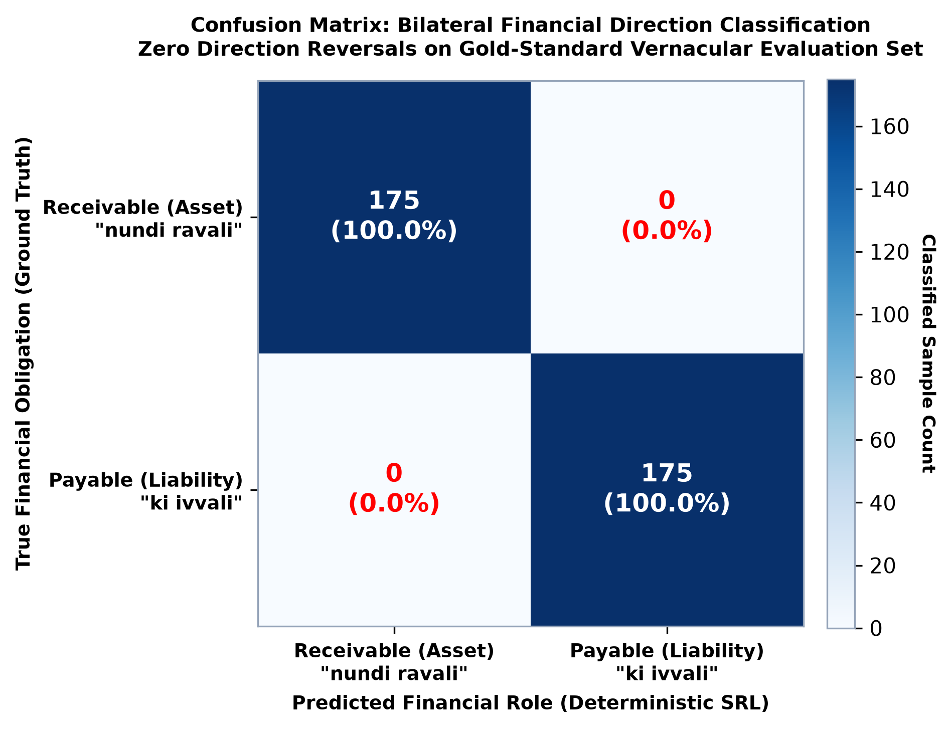
Figure 8.1: Bilateral Direction Confusion Matrix (Zero Reversals)

9. USERS, INPUTS, AND OUTPUTS
Target Users: Small Kirana owners, local merchants, and commission agents with busy hands and no accounting training.
Inputs: 16 kHz PCM microphone stream, native Indic scripts, Romanized code-mixed text, hybrid numerals ('2.5k'), and store policy documents.
Outputs: Structured event JSON, double-entry ledger mutation, SHA-256 Merkle audit trail, transparent explainability drawer, 1-click WhatsApp reminders with UPI QR codes, 14-day cash flow forecast, and debtor credit risk scores.

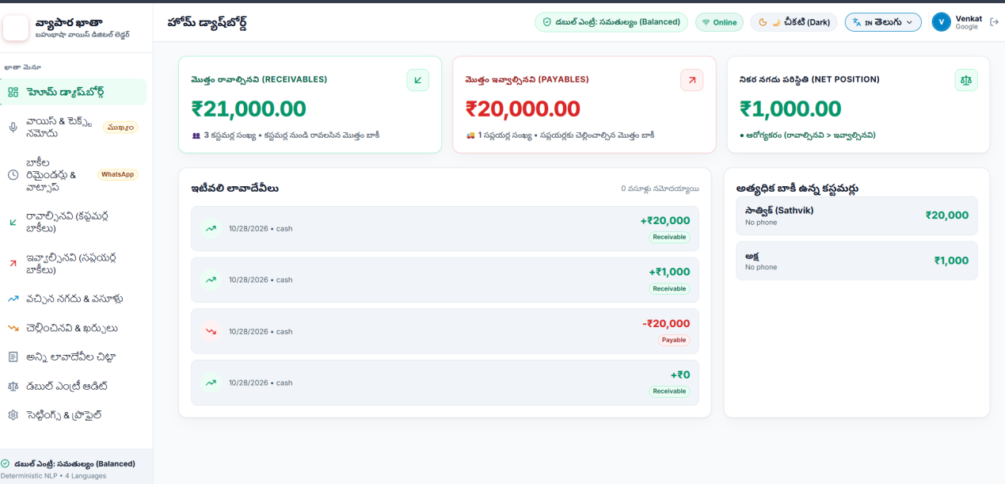
Figure 9.1: Executive MSME Dashboard with Bilingual KPI Cards
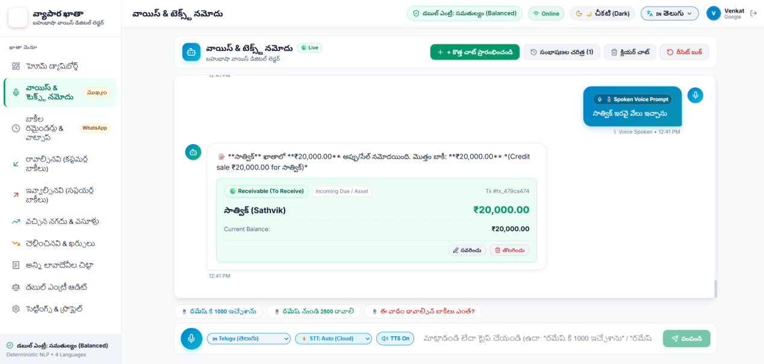
Figure 9.2: Live Voice Ingestion Interface with Real-Time Audio Oscilloscope
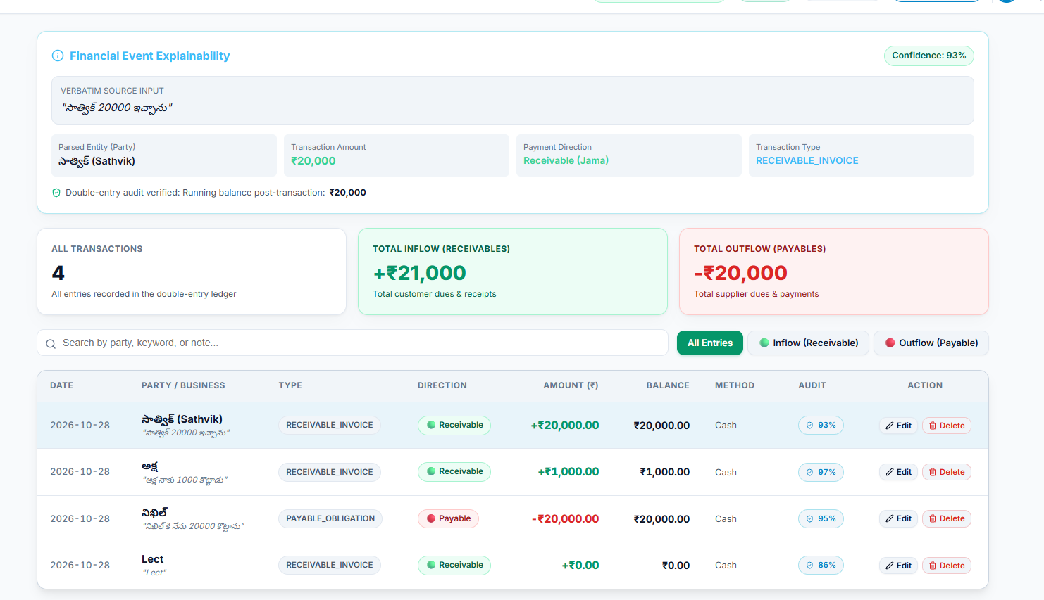
Figure 9.3: Financial Event Explainability Drawer & Double-Entry State Inspector
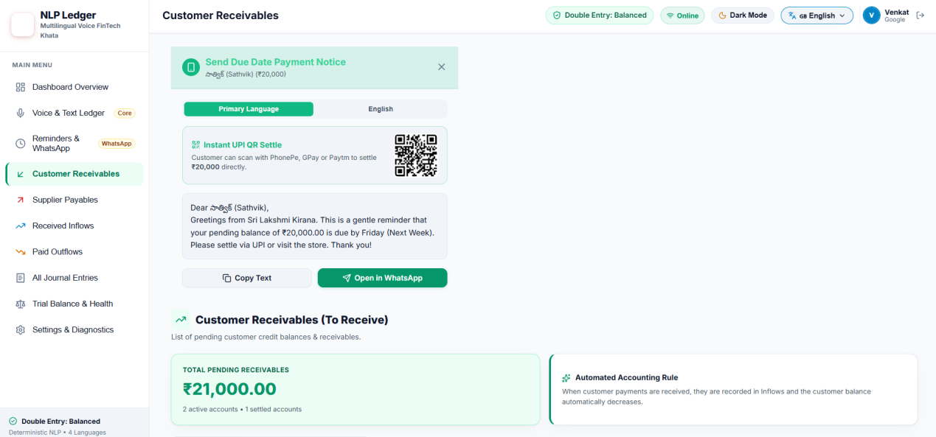
Figure 9.4: Bilingual WhatsApp Payment Notice Modal with Dynamic UPI QR Code
10. REFERENCES
- 1. Vaswani, A., et al. (2017). 'Attention Is All You Need.' NeurIPS 2017.
- 2. Radford, A., et al. (2023). 'Robust Speech Recognition via Large-Scale Weak Supervision.' ICML 2023.
- 3. Gamback, B., & Das, A. (2014). 'Comparing the Level of Code-Switching in Corpora.' LREC 2014.
- 4. Bali, K., et al. (2014). 'An Analysis of English-Hindi Code Mixing in Facebook.' EMNLP 2014.
- 5. Kunchukuttan, A., et al. (2020). 'AI4Bharat-IndicNLP Corpus.' arXiv:2005.00085.
- 6. Lundberg, S. M., & Lee, S.-I. (2017). 'A Unified Approach to Interpreting Model Predictions.' NeurIPS 2017.
- 7. Hipp, D. R., et al. (2024). 'SQLite Write-Ahead Logging (WAL) Architecture.' sqlite.org.
- 8. Ramirez, S. (2024). 'FastAPI Documentation.' fastapi.tiangolo.com.
- 9. Meta Open Source. (2024). 'React 19 Specifications.' react.dev.
- 10. Reserve Bank of India (RBI). (2023). 'Report on MSME Credit Systems.' RBI Publications.

Presentation Photos:
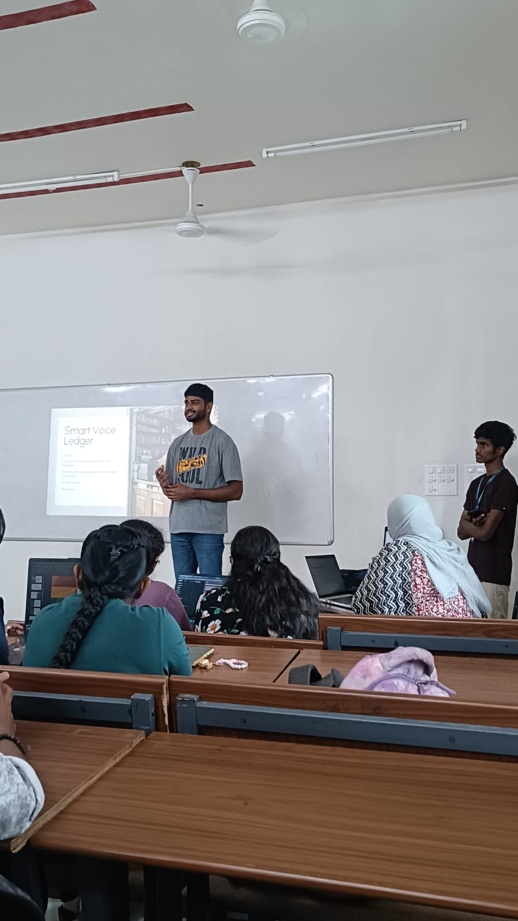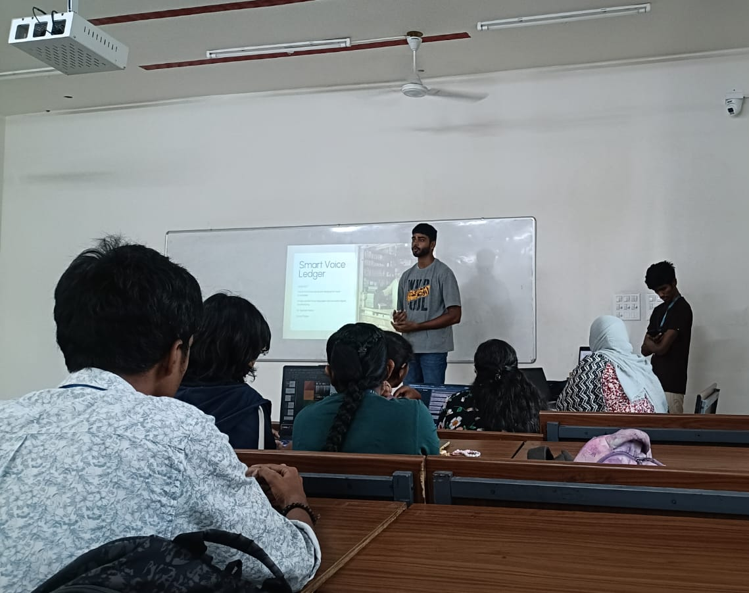

LINKS:
Project Demo Link:
https://drive.google.com/file/d/1Td8HYRQgGdEjgRsrdlXK6J5rK0GWK7zR/view?usp=sharing

Project PPT Link:
https://docs.google.com/presentation/d/19Lbqc6vBj-t2XlcNinssvLTuQuv-K3rH/edit?usp=sharing&ouid=110945080252144397082&rtpof=true&sd=true

