MediaWiki Application Setup – Guide

Created on April 24

Author – Suriyaadevan Balu



Contents

Introduction 2

Problem Statement 2

Solutions 2

Solution 1 2

Solution 2 3

Demo URL 3

Services Overview 3

Instance Template Overview: 3

Instance Groups 3

Scripts Execution 4

Conclusion 14

# Introduction

MediaWiki is the free open-source wiki software used to power Wikipedia and thousands of other wikis. The contributions of hundreds of individual developers have helped make it a feature-rich, secure and scalable platform capable of powering some of the largest collaboratively edited reference projects in the world.

# Problem Statement

We need to setup the MediaWiki application in red hat Linux on top of cloud providers.

# Solutions

Following are the two solutions I have worked on.

1. Google Cloud Infrastructure as service
2. Google Cloud Container as service (GKE)

## Solution 1

I used google cloud provider (Infrastructure as service) to host the mediawiki application. GCP Services I used are Instance template (startup script configuration for application setup), Managed resource group, gcloud commands for environment setup and resource creation. Then also we can integrate the Instance group with Load balancing service (HTTP content service), so that we can distribute the load among the cluster.

## Solution 2

Second solution I have hosted mediawiki application in GKE- Google kubernetes engine with auto scaling and rolling updates.

# Demo URL

<https://storage.googleapis.com/mediawiki-demo/Load_Balancer_configuration.mp4>

<https://storage.googleapis.com/mediawiki-demo/Mediawiki-IAAS-Setup-Demo.mp4>

# Services Overview

# Instance Template Overview:

An instance template is a resource that you can use to create virtual machine (VM) instances and managed instance groups (MIGs).

Instance templates define the machine type, boot disk image or container image, labels, and other instance properties. You can then use an instance template to create a MIG or to create individual VMs. Instance templates are a convenient way to save a VM instance's configuration so you can use it later to create VMs or groups of VMs.

# Instance Groups

An instance group is a collection of virtual machine (VM) instances that you can manage as a single entity.

Compute Engine offers two kinds of VM instance groups, managed and unmanaged:

* **Managed instance groups** (MIGs) let you operate apps on multiple identical VMs. You can make your workloads scalable and highly available by taking advantage of automated MIG services, including: auto scaling, auto healing, regional (multiple zone) deployment, and automatic updating.
* **Unmanaged instance groups** let you load balance across a fleet of VMs that you manage yourself.

# 

# Scripts Execution

Note – If we have project/Billing account already setup we can ignore the step 1-2

Step 1: Login into google cloud console and activate free tier -

h<https://cloud.google.com/>

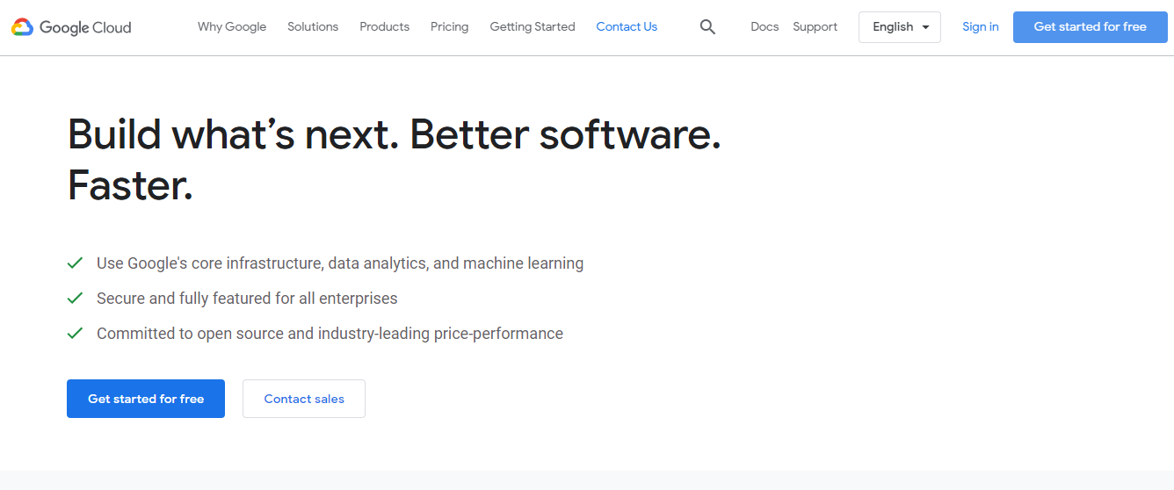

**Step 2:** Once free tier setup is completed – Please login into google cloud console

Step For creating the new project in GCP - Execute the commands one by one in **GCP-Project-Setup.sh .**

More details - <https://cloud.google.com/resource-manager/docs/creating-managing-projects>

Step 3 – Open gcloud shell editor, By clicking the highlighted icon



**Note for below steps please refer – GCP-IAAS-Setup.sh**

Step 4: **Configure the newly created project in cli by using the following command**

**Note – Already Project-ID is updated in CLI scripts**

**gcloud config set project [project_ID] -**

**Step 6:** Enable the compute engine API service in our project, if it’s already enabled please ignore this step.

**gcloud services enable compute.googleapis.com**

**Step 7:** Run the GCP CLI commands in same order to create Instance templates along with mediawiki application setup – embedded as startup scripts and managed instance group

**Step 8:** Once script execution completed – Please navigate to managed instance group. You can access the mediawiki application by using external IP address.

Note – It will take 1-2 mins after resource creation

**Step 9** - http://<External_IP_Address_of_Instances>/mediawiki you can select any one of instance External IP address. Click on “**Set up the wiki**”

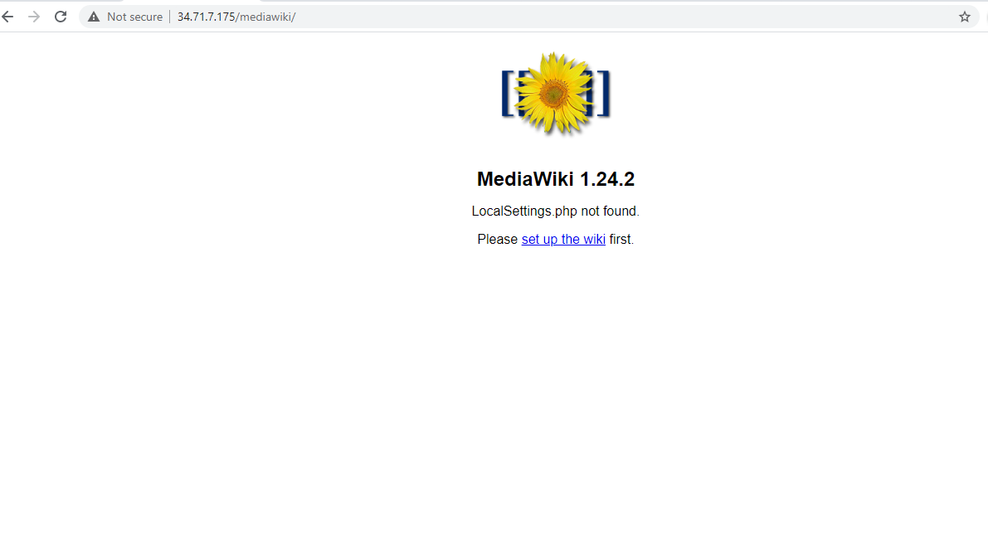

Step 7 - **Define the Language for MediaWiki** Click On Continue

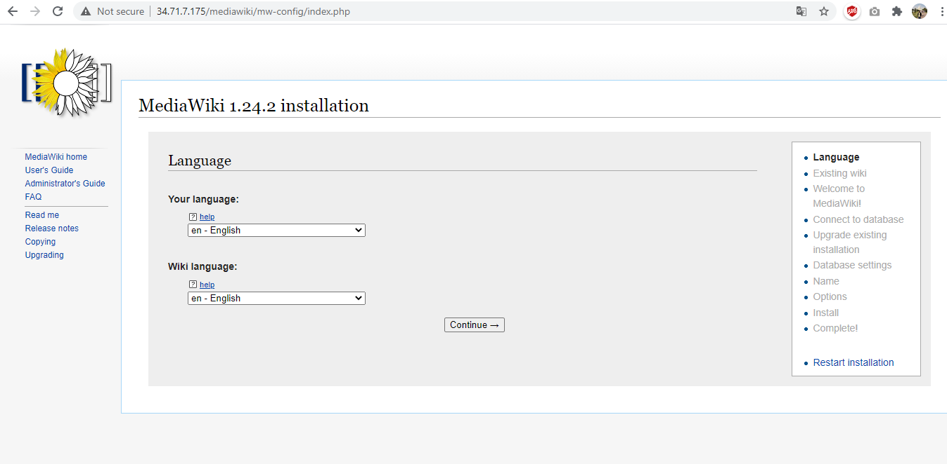

Step 8: **MediaWiki Environment Setup Check:** Click On Continue…

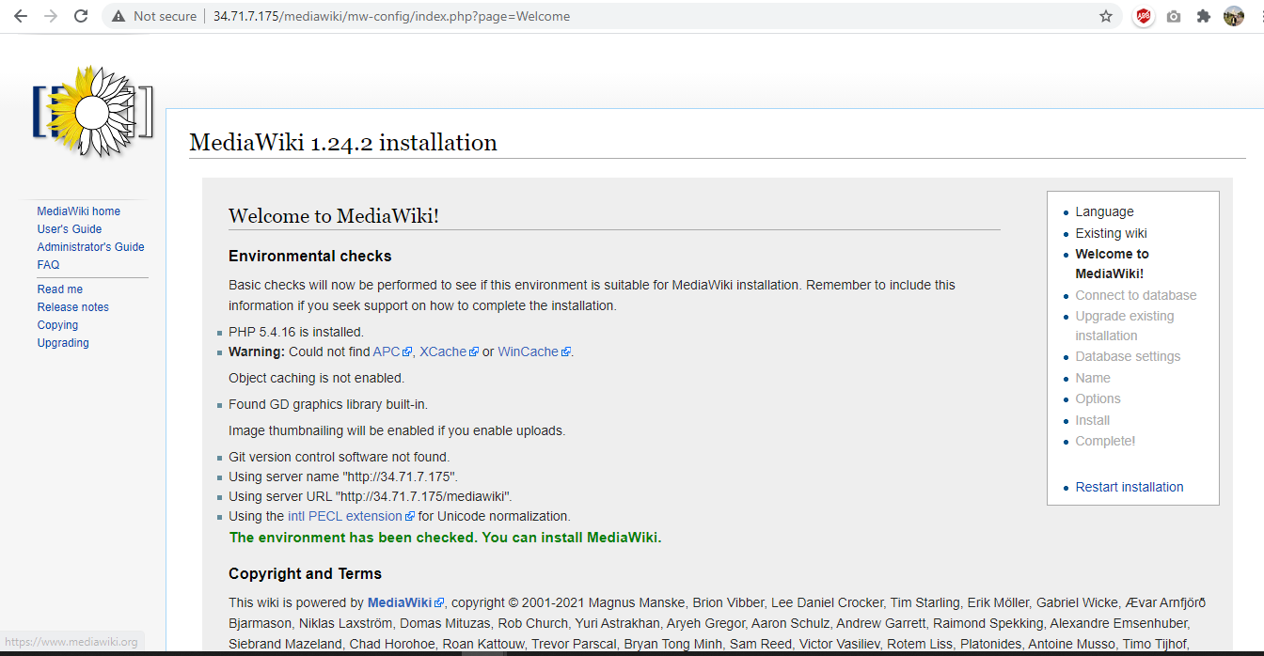

Step 9: **Define the Mediawiki database, database user name and Password.**

Database Host – **localhost**

Database Name - **mediawiki_db**

Databse Table Prefix **– Mysql_Wiki**

Database User **- wiki_user**

Database Password - **P@ssWord@123#**

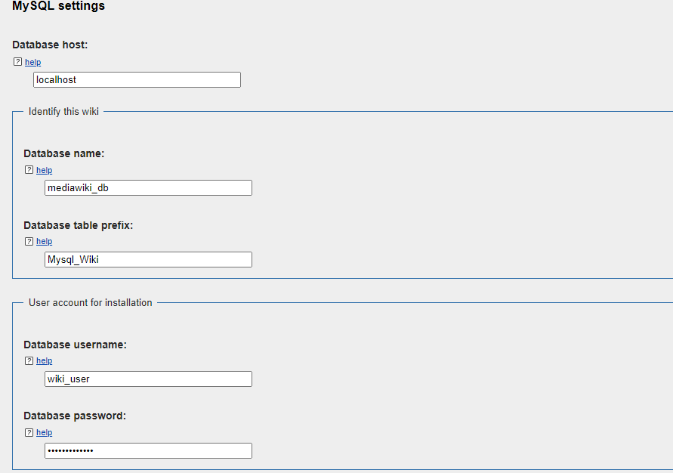

Step 10: **MediaWiki Database Settings. Click** On Continue…

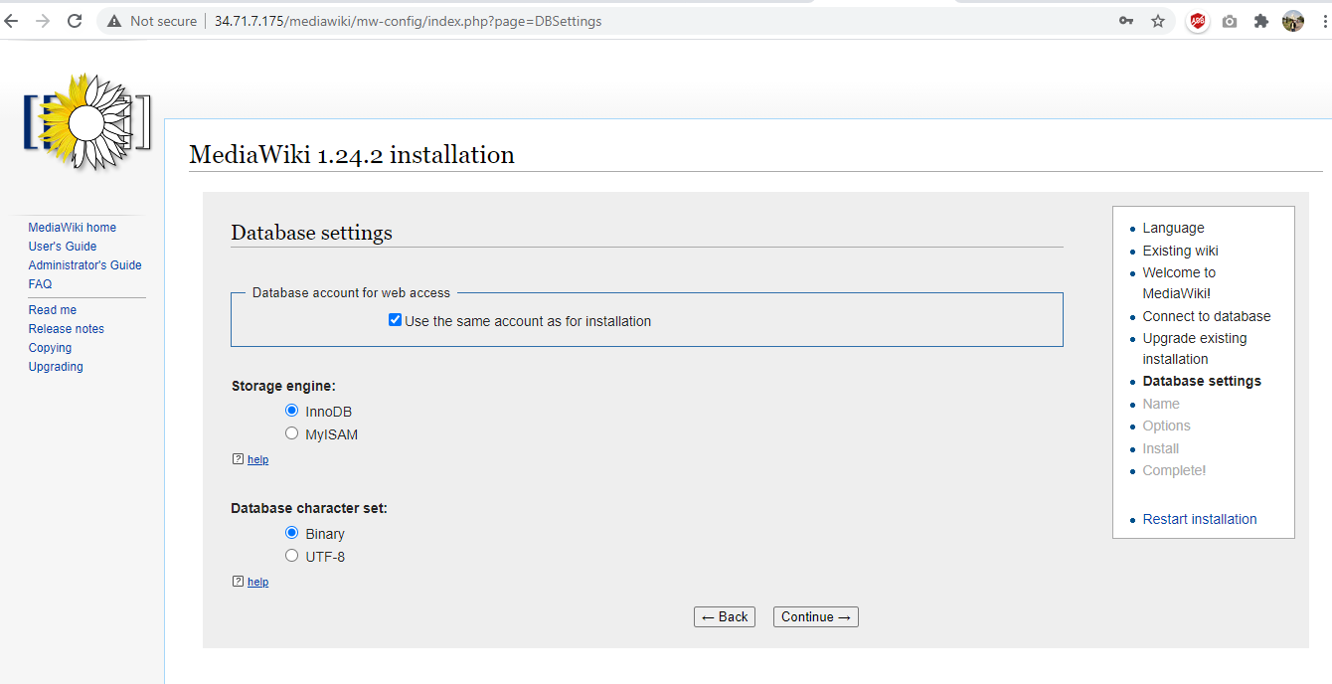

Step 11: **Define Name of Wiki and its Administrator Account**

Name : Linux Guide

Project Namespace : same as namespace

User name: Wiki_admin

Password: Pass@123456

Password: Pass@123456

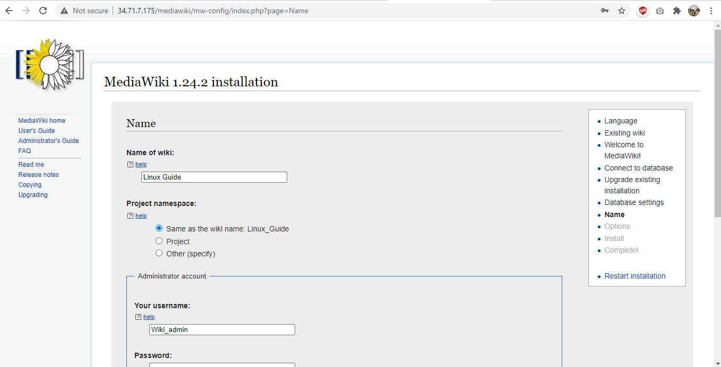

Step 12 : Click on Continue to finish the installation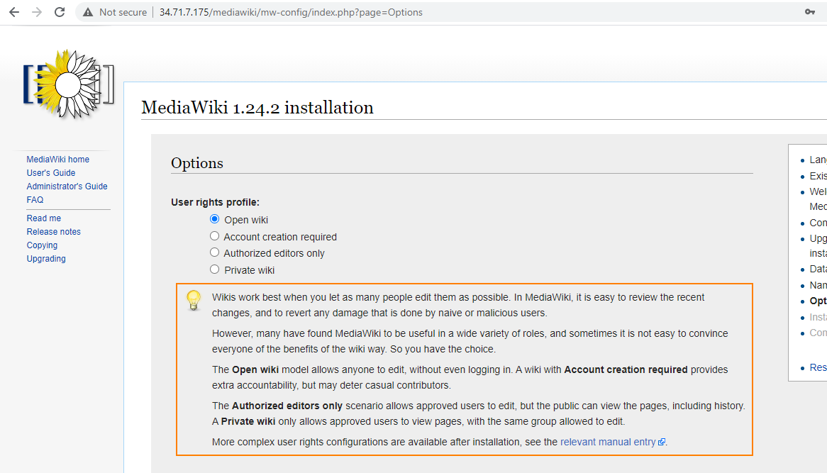

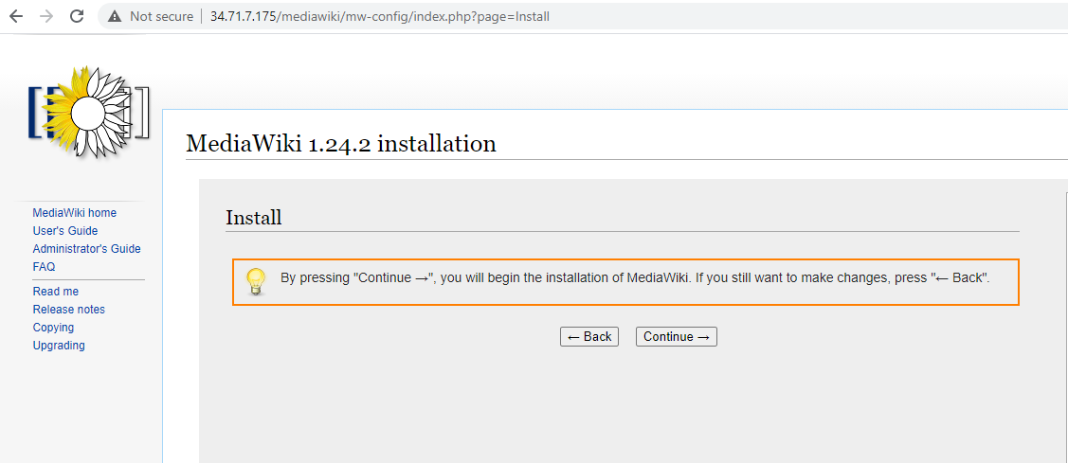

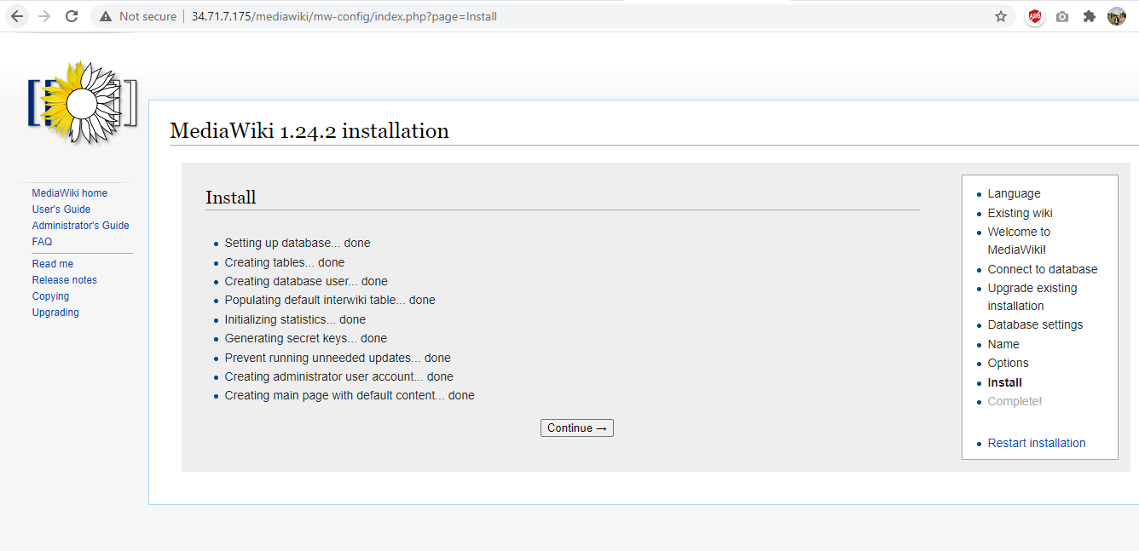

Step 13 : LocalSettings.php will be download – Navigate and place the file parallel to index.php

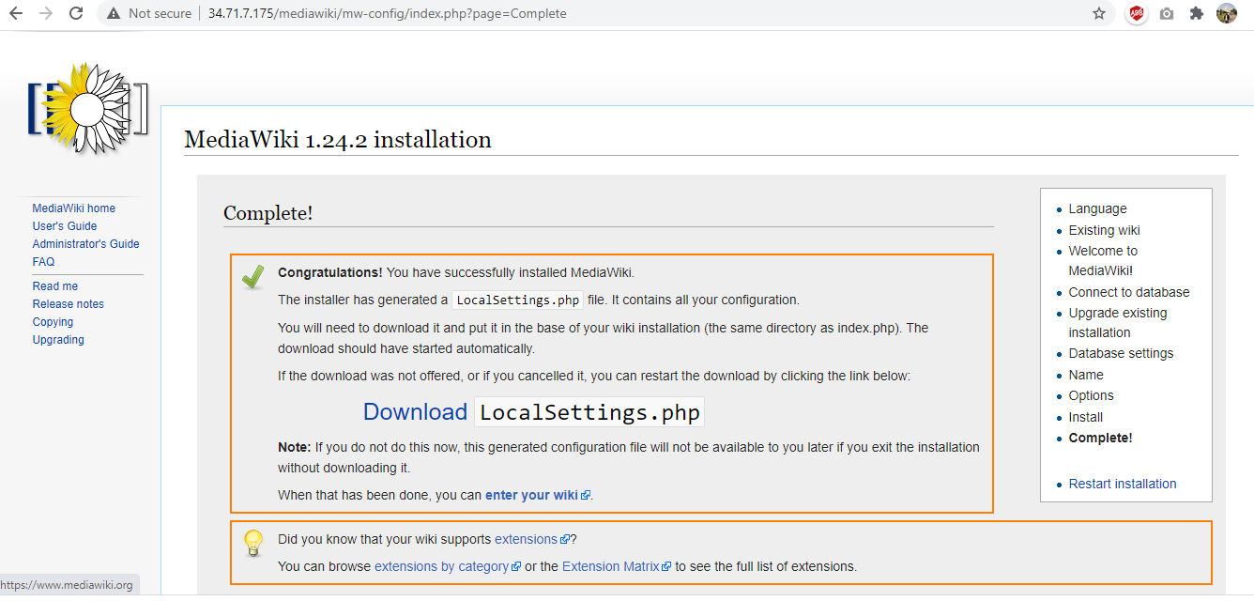

Step 14 : SSH to machine which we are accessed and downloaded the LocalSettings.php

Step 15: Upload the Localsettings.php via gcloud upload option

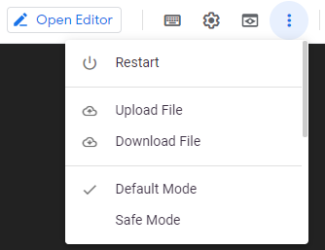

File will be uploaded in var/home/username/ - Note username will be current user

Commands to move the file to http server

**mv var/home/username/LocalSettings.php /var/www/html**

Provide access to the newly uploaded LocalSettings.Php

**sudo chmod 755 /var/www/html/mediawiki/**

**sudo getenforce**

**sudo restorecon -FR /var/www/html/mediawiki/**

Step 15 : Now visit the Main page ( http:/<instance ip_address>/ /mediawiki/index.php/Main_Page) and Login Admin Panel of Mediawiki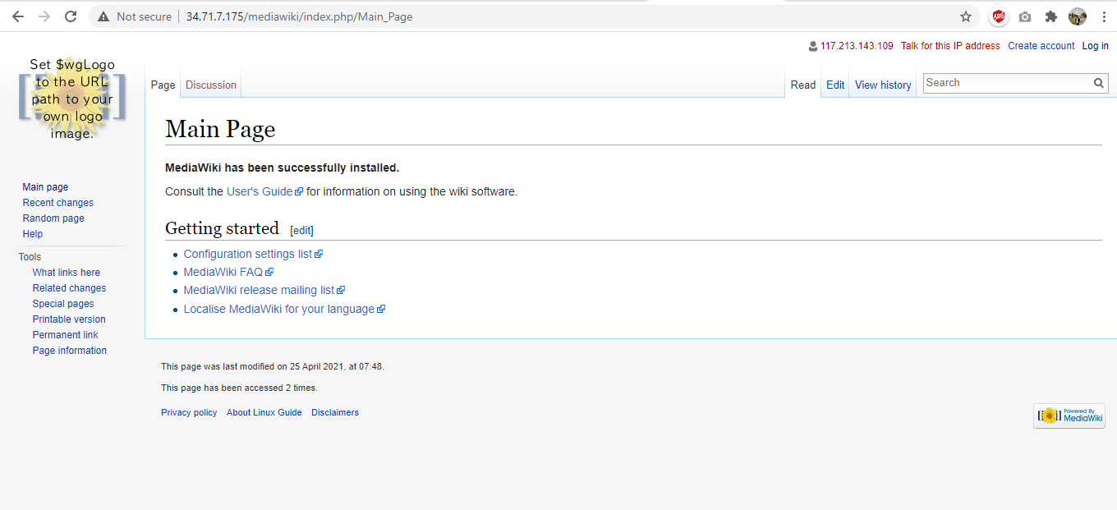

**Step 16**: Click on Log In. Enter the Admin Credentials that we have set during the installation.

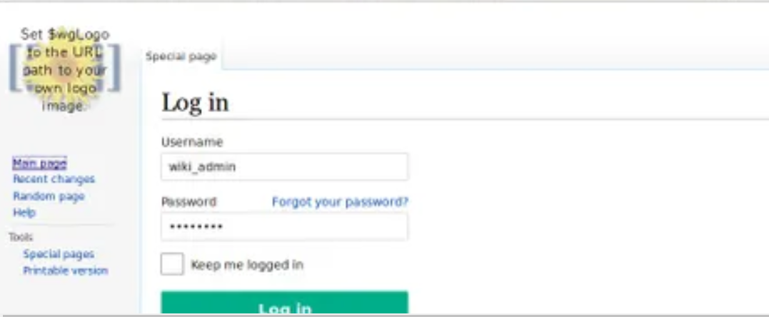

**Step 17 :** After successful log in – you are able to access the main page

Step 18 : If all working good – Please delete the instance template and managed group

Refer : project-cleanup.sh

**gcloud compute instance-templates delete mediawiki-instance-template**

**gcloud compute instance-groups managed delete mediawiki-instance-group --region=uscentral1**

# Conclusion

We can Integrate and automate the execution steps using Cloud Build or any other CICD in future.

Based on above two solution we have successfully hosted the application in google cloud.