## PHASE 3: DOCUMENTATION

Stock price prediction using data science by loading and preprocessing the dataset

We can use data science to determine the future events. you can choose the stock needed to do the investment with the help of data science. These data driven stock predictions by data science will be based on the trends in the past and also based on several patterns.

So these are the some of past data of the stocks from the big dataset.

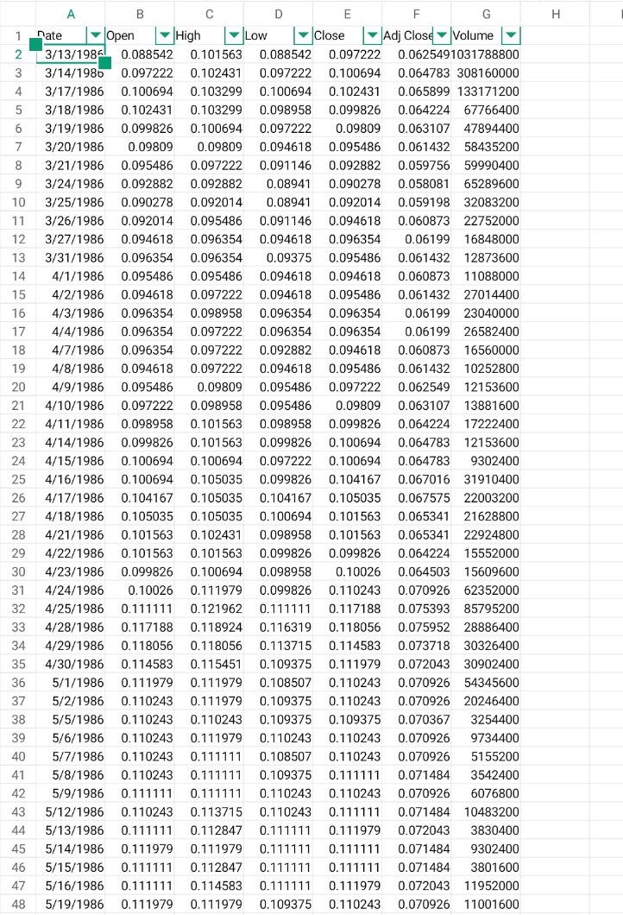

DATA INFORMATION:

The data.info() function in Python is used to provide concise information about a DataFrame, including the data types of each column, the number of non-null values, and memory usage.

DATA DESCRIPTION:

data.describe() in Python is used to generate descriptive statistics of a DataFrame. It provides a summary of the central tendency, dispersion, and shape of the distribution of each column's values.

MODEL DEPLOYMENT :

Here we deploy machine learning models for stock price prediction by setting up an infrastructure that allows us to make predictions based on new data

1)Multiple linear regression model:

Linear regression is a statistical and machine learning technique used for modeling and analyzing the relationship between a dependent variable (also known as the target or response variable) and one or more independent variables (predictors or features). It is a method for understanding and predicting the value of the dependent variable based on the values of the independent variables.

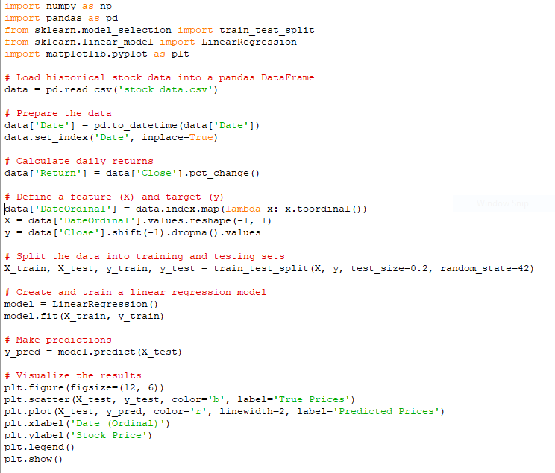

2) Decision tree model:

A Decision Tree model for stock price prediction is a machine learning algorithm that constructs a treelike structure where each internal node represents a feature or attribute, each branch represents a decision or rule, and each leaf node represents a predicted stock price. This model is designed to learn patterns and relationships between stocks (independent variables) and stock prices

(dependent variable) to make predictions based on new data

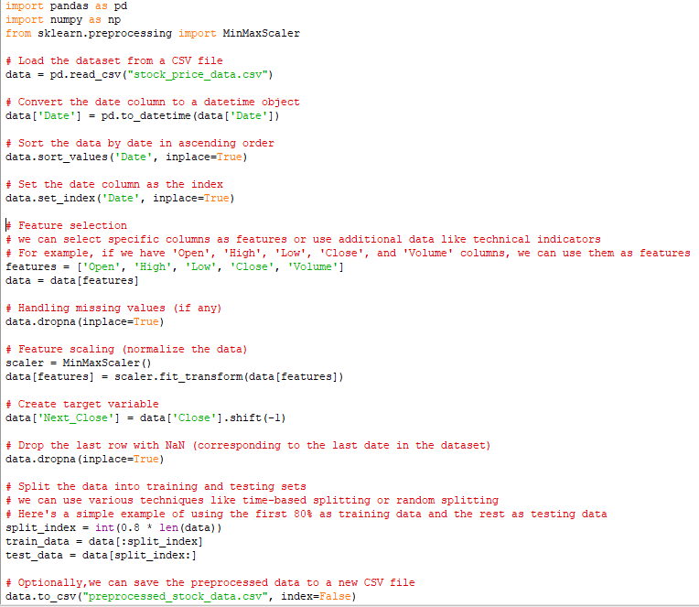

This is 2 of the 4 models which we are using in our projects for stock price prediction.

We use all 4 models and combine the results of all 4 models to get an efficient predict the stock prices.