(IOT_PHASE 4 )

**(Flood monitoring and early warning)**

***Introduction:***

**Creating a flood monitoring and early warning system is a complex project that involves various components, including data collection, analysis, and communication. Here are some key steps and considerations for such a project:**

**1. Data Collection:**

**- Implement a network of sensors to collect data on water levels, rainfall, weather conditions, and river flow.**

**- Use remote sensing technologies like satellites and radar to gather additional data.**

**- Ensure data accuracy and reliability through regular maintenance and calibration.**

**2. Data Analysis:**

**- Develop algorithms and models to analyze the collected data in real-time.**

**- Use historical data to identify trends and patterns that can help predict floods.**

**- Integrate meteorological and hydrological data to assess flood risk.**

**3. Early Warning System:**

**- Implement an early warning system that triggers alerts based on predetermined thresholds.**

**- Ensure that the system can send alerts to relevant authorities, emergency services, and the public through various communication channels (SMS, mobile apps, sirens, etc.).**

**4. Geospatial Information System (GIS):**

**- Utilize GIS to map flood-prone areas and create detailed flood risk maps.**

**- Combine GIS with real-time data to monitor and predict flood events accurately.**

**5. Community Engagement:**

**- Educate and engage local communities in understanding and responding to flood alerts.**

**- Provide guidelines for evacuation and safety measures.**

**6. Government and Stakeholder Collaboration:**

**- Collaborate with government agencies, NGOs, and local authorities to coordinate flood response efforts.**

**- Ensure the availability of resources and infrastructure for flood management.**

**7. Monitoring and Maintenance:**

**- Regularly monitor and maintain sensors and equipment to ensure they remain functional.**

**- Continuously update and improve the data analysis algorithms and early warning system.**

**8. Disaster Preparedness:**

**- Develop and implement disaster preparedness plans that include evacuation routes, shelters, and resource allocation.**

**9. Public Awareness:**

**- Conduct public awareness campaigns to educate the population about flood risks and the importance of early warning systems.**

**10. Regulatory Compliance:**

**- Ensure that the project complies with relevant environmental and data privacy regulations.**

**11. Scalability and Resilience:**

**- Design the system to be scalable, accommodating future expansion and technological advancements.**

**- Implement backup systems and redundant communication channels to ensure system reliability during adverse conditions.**

**12. Testing and Simulation:**

**- Conduct regular testing and simulations to evaluate the system’s effectiveness and response times.**

**13. Data Storage and Analysis:**

**- Establish robust data storage and backup systems to maintain historical data for analysis and research.**

**Remember that a successful flood monitoring and early warning project requires a multidisciplinary approach, involving experts in meteorology, hydrology, data science, and community outreach. Collaboration with relevant stakeholders and regular updates to the system are key to its long-term success.**

**Web Cod**

**Import time**

Import machine

Import dht

# Define GPIO pins

TRIG_PIN = machine.Pin(2, machine.Pin.OUT)

ECHO_PIN = machine.Pin(3, machine.Pin.IN)

BUZZER_PIN = machine.Pin(4, machine.Pin.OUT)

DHT_PIN = machine.Pin(5)

LED_PIN = machine.Pin(6, machine.Pin.OUT)

Def distance_measurement():

# Trigger ultrasonic sensor

TRIG_PIN.on()

Time.sleep_us(10)

TRIG_PIN.off()

# Wait for echo to be HIGH (start time)

While not ECHO_PIN.value():

Pass

Pulse_start = time.ticks_us()

# Wait for echo to be LOW (end time)

While ECHO_PIN.value():

Pass

Pulse_end = time.ticks_us()

# Calculate distance

Pulse_duration = time.ticks_diff(pulse_end, pulse_start)

Distance = pulse_duration / 58 # Speed of sound (343 m/s) divided by 2

Return distance

Def read_dht_sensor():

D = dht.DHT22(DHT_PIN)

d.measure()

return d.temperature(), d.humidity()

buzz_start_time = None # To track when the buzzer started

while True:

dist = distance_measurement()

temp, humidity = read_dht_sensor()

# Check if the distance is less than a threshold (e.g., 50 cm)

If dist < 50:

# Turn on the buzzer and LED

BUZZER_PIN.on()

LED_PIN.on()

Status = “Flooding Detected”

Buzz_start_time = time.ticks_ms()

Elif buzz_start_time is not None and time.ticks_diff(time.ticks_ms(), buzz_start_time) >= 60000: # 1 minute

# Turn off the buzzer and LED after 1 minute

BUZZER_PIN.off()

LED_PIN.off()

Status = “No Flooding Detected”

Else:

Status = “No Flooding Detected”

Print(f”Distance: {dist:.2f} cm”)

Print(f”Temperature: {temp:.2f}°C, Humidity: {humidity:.2f}%”)

Print(“Status:”, status)

Time.sleep

**Stimulation output**

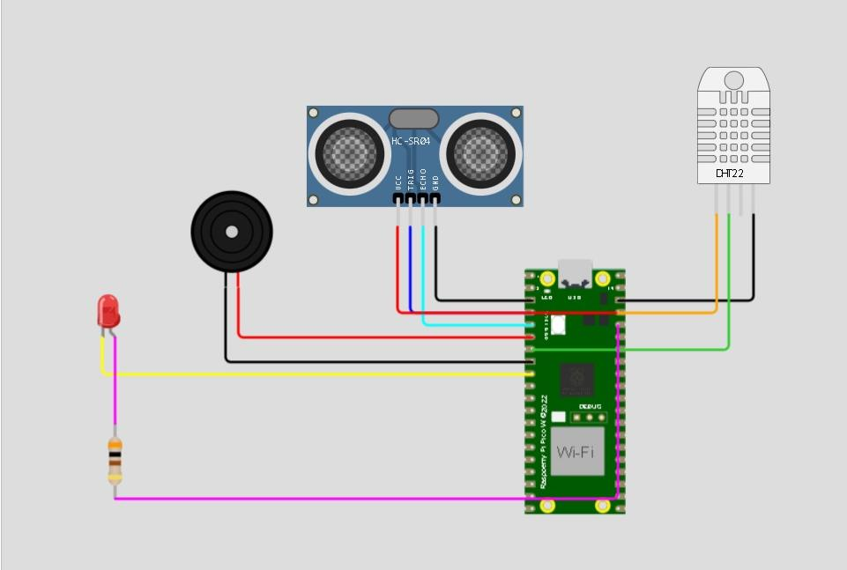

**Sample output:**

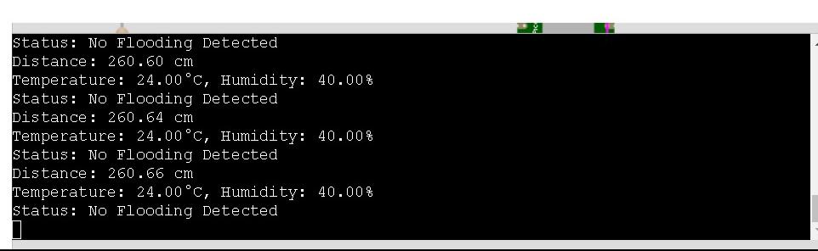

**Conclusion:**

In conclusion, developing a flood monitoring and early warning system is a critical endeavor to protect communities from the devastating impacts of floods. This project involves various components, from data collection and analysis to community engagement and collaboration with authorities. Key considerations include data accuracy, real-time analysis, reliable early warning systems, and public awareness.